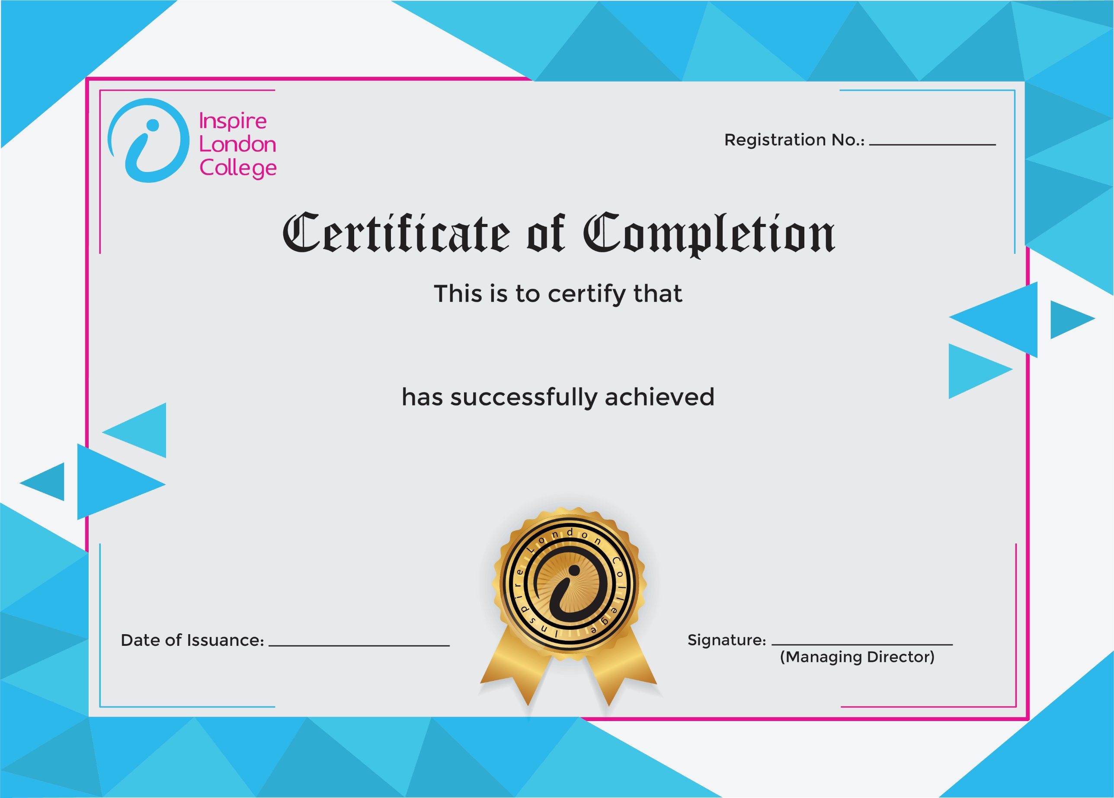
ILC50091

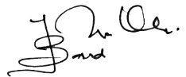
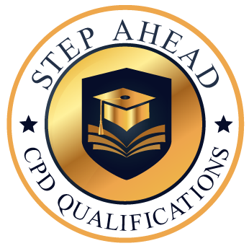
Level 5 Diploma in Customer Service
5 Feb 2026
Ahmed Khan

