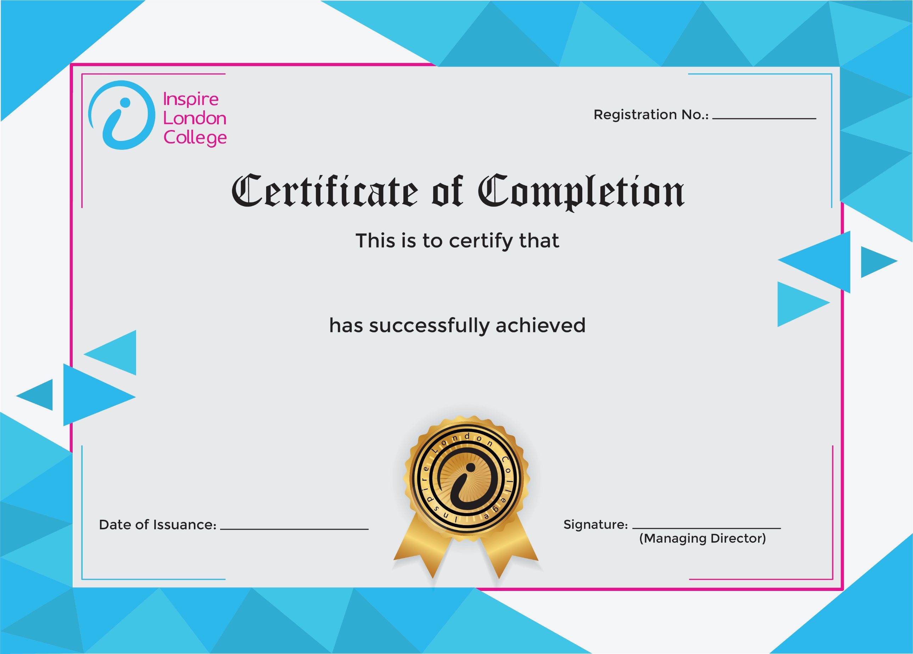
ILC50094

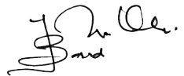
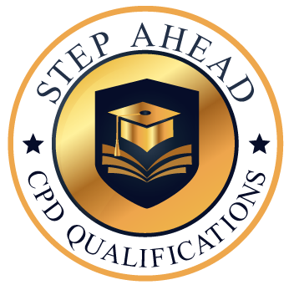
Level 7 Extended Diploma in Health and Safety
7 Feb 2026
Ahmed Khan

