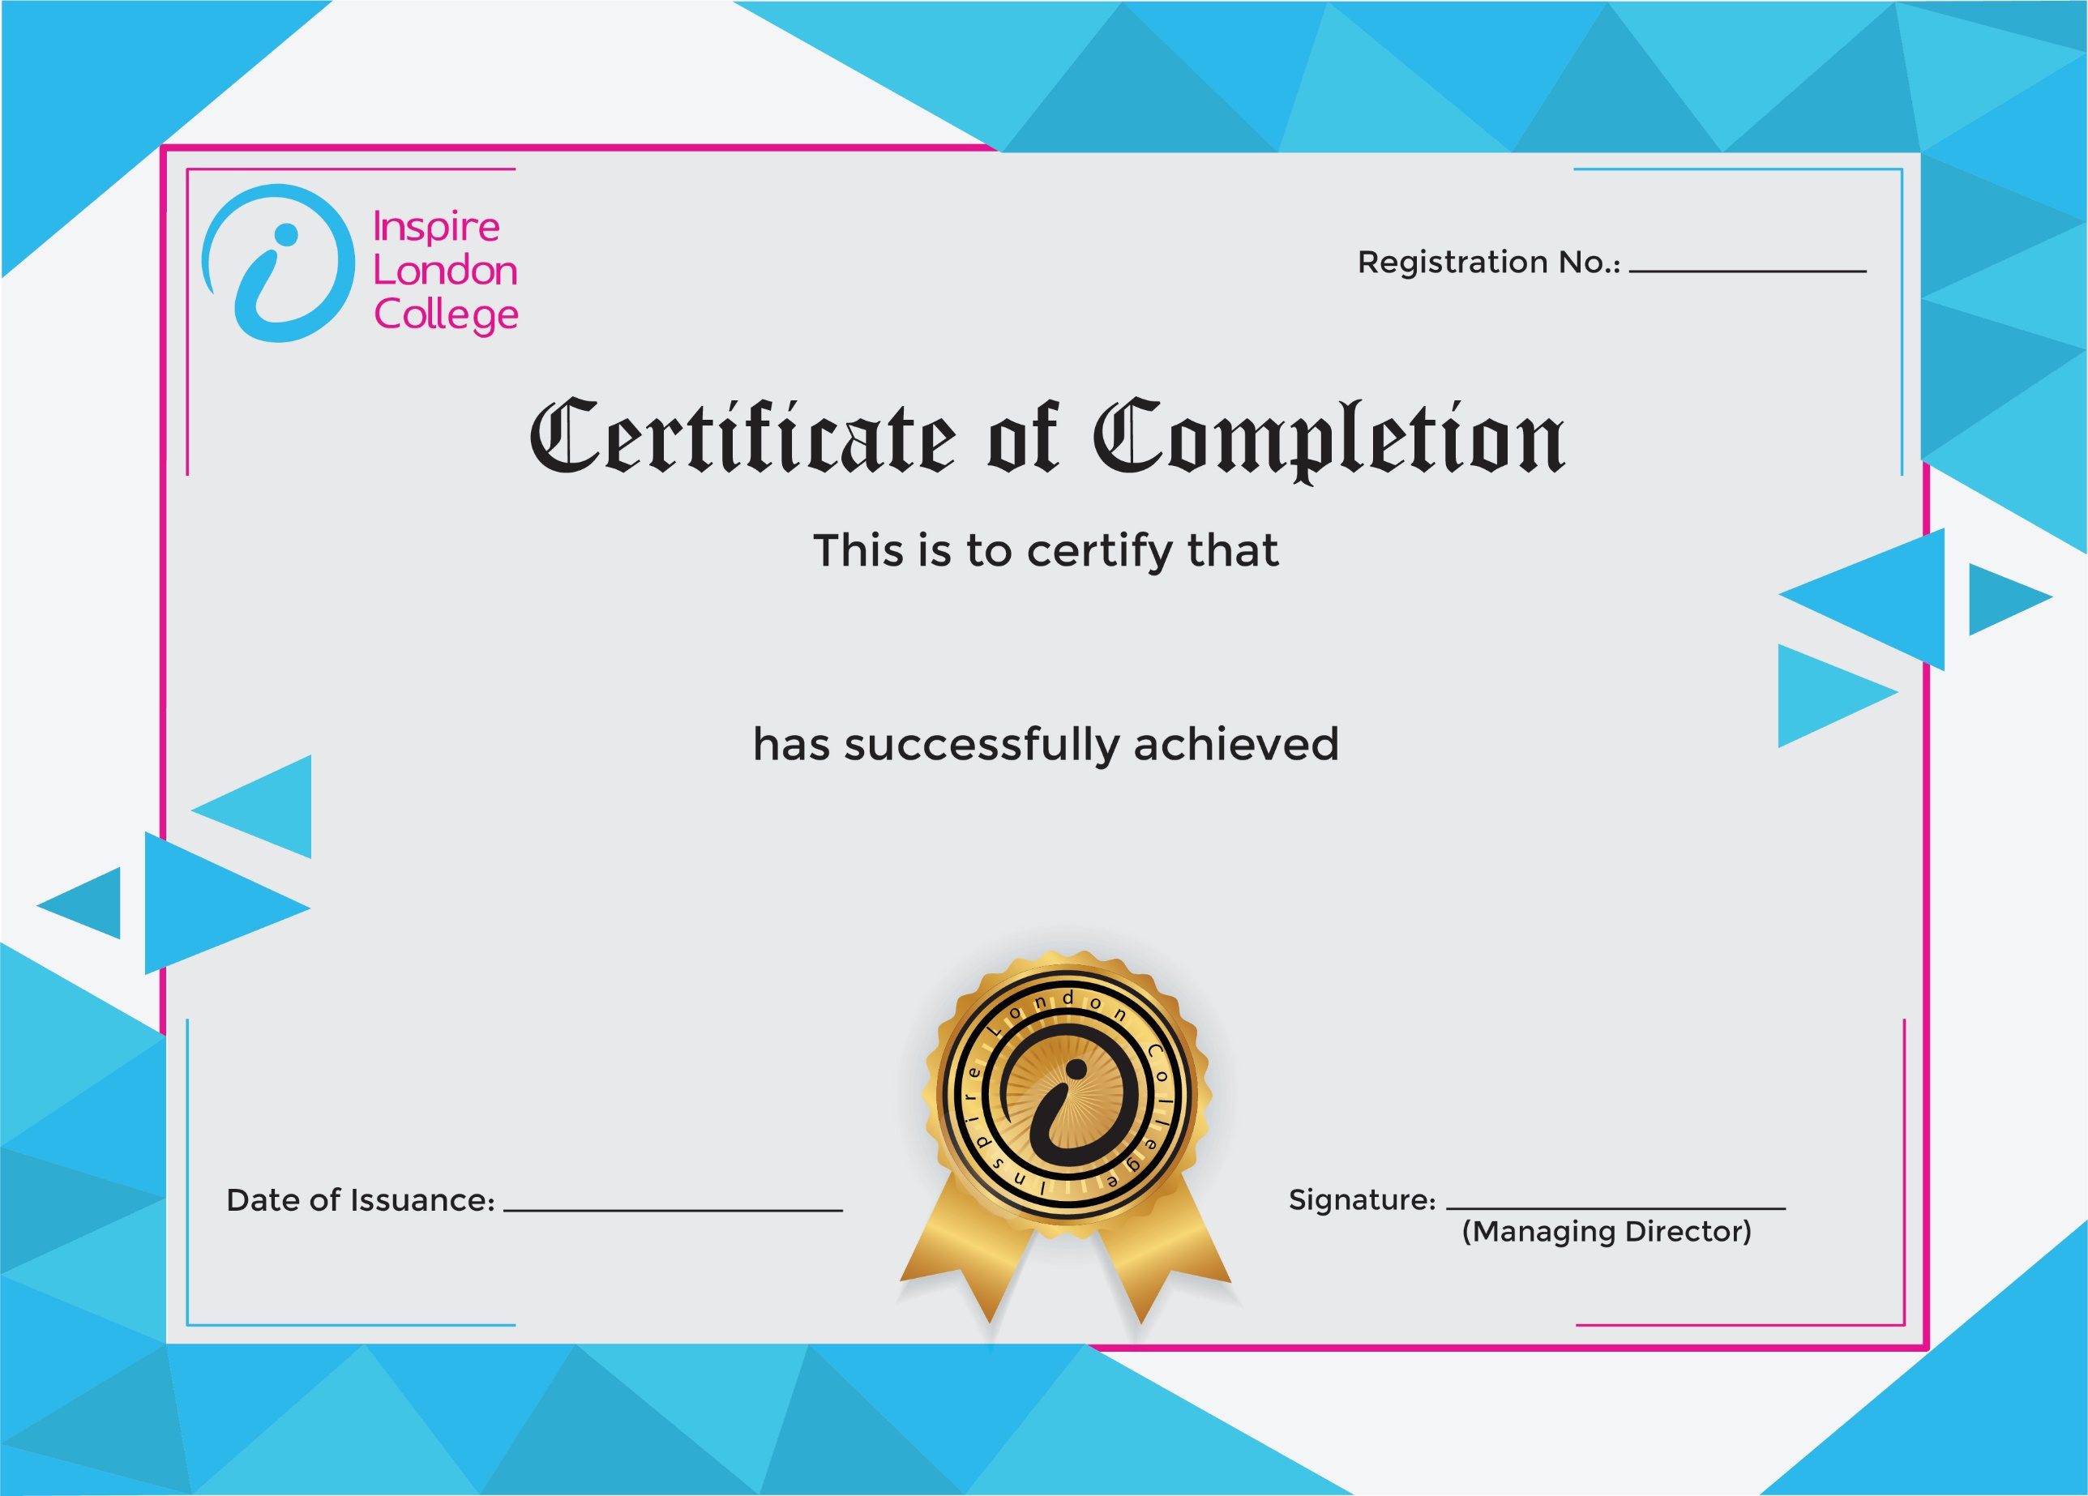
130

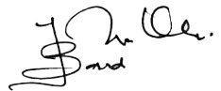
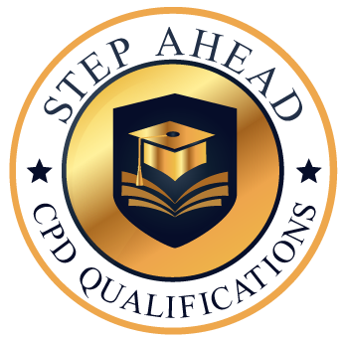
Level 2 Award in Principle of COSHH
10 Mar 2026
Asli hai Nakli

