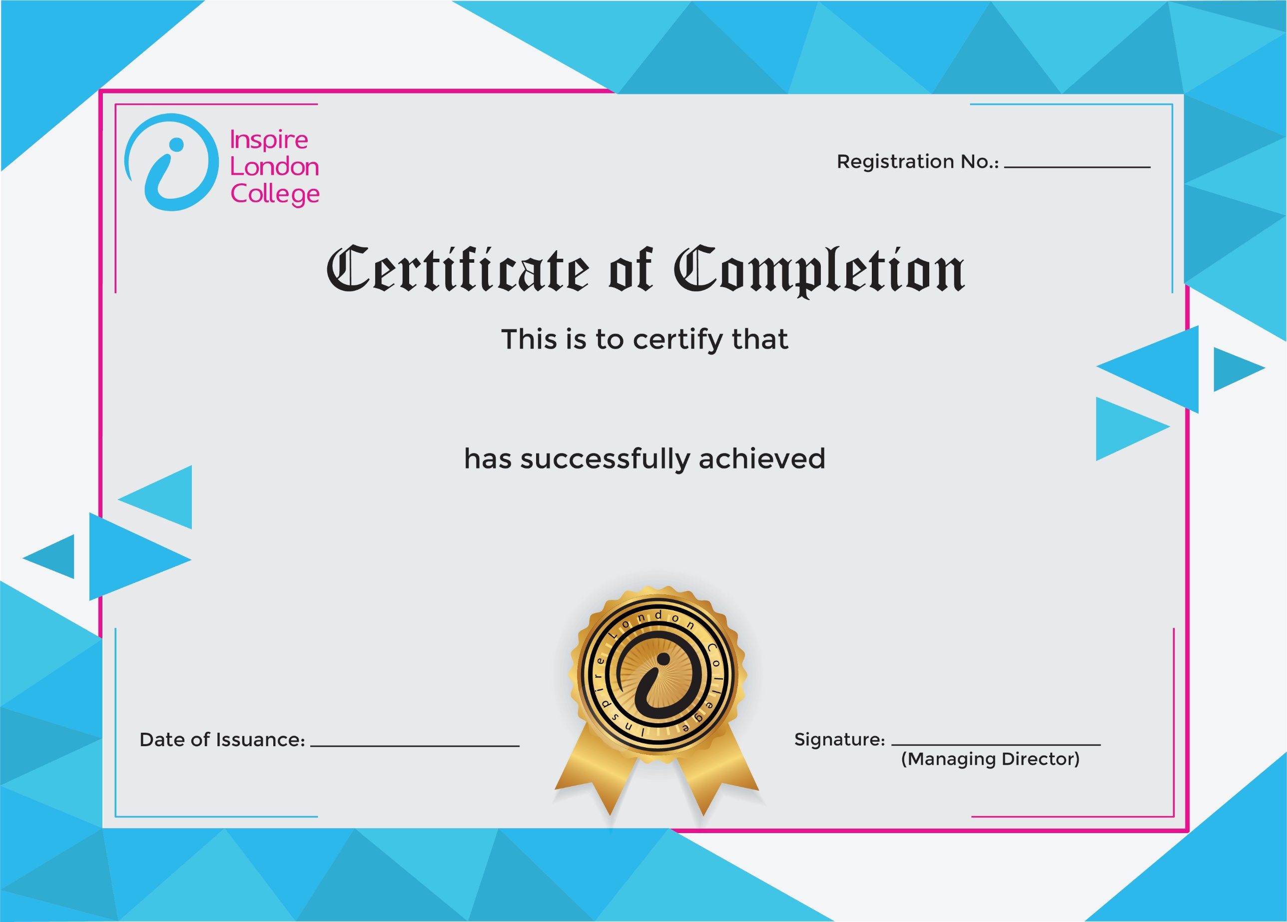
130

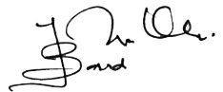
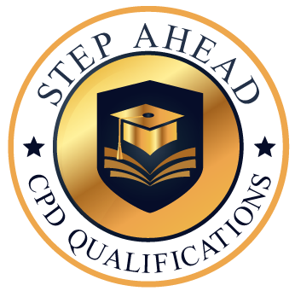
Certificate in Business Etiquette
10 Mar 2026
Asli hai Nakli

