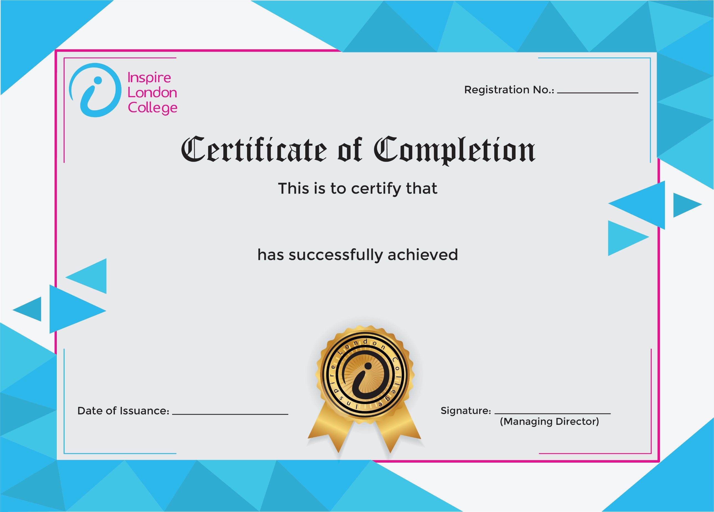
ILC-130

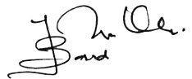
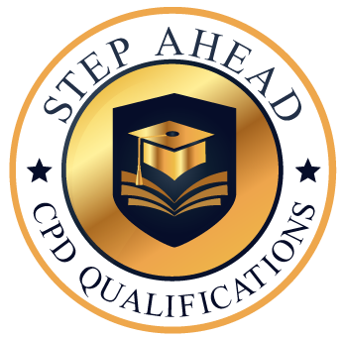
Level 2 Certificate in HR Management
3/10/2026
Asli hai Nakli

