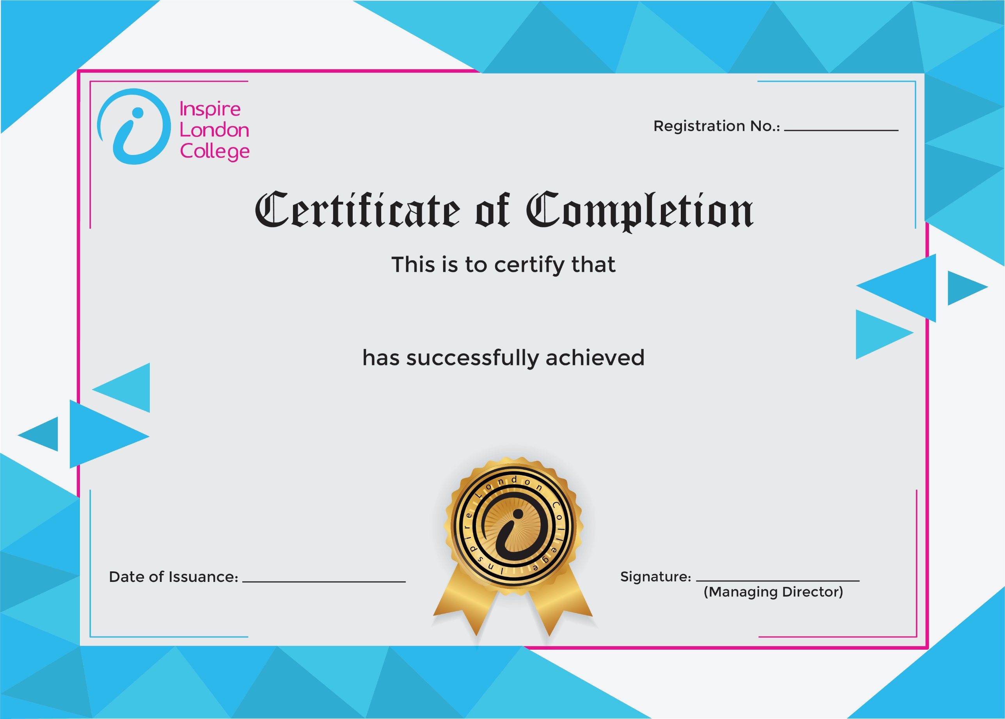
ILC-130

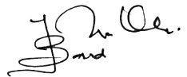
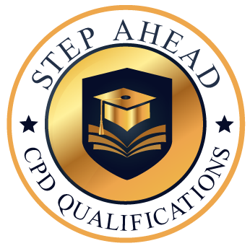
Certificate in Business Succession Planning
3/10/2026
Asli hai Nakli

