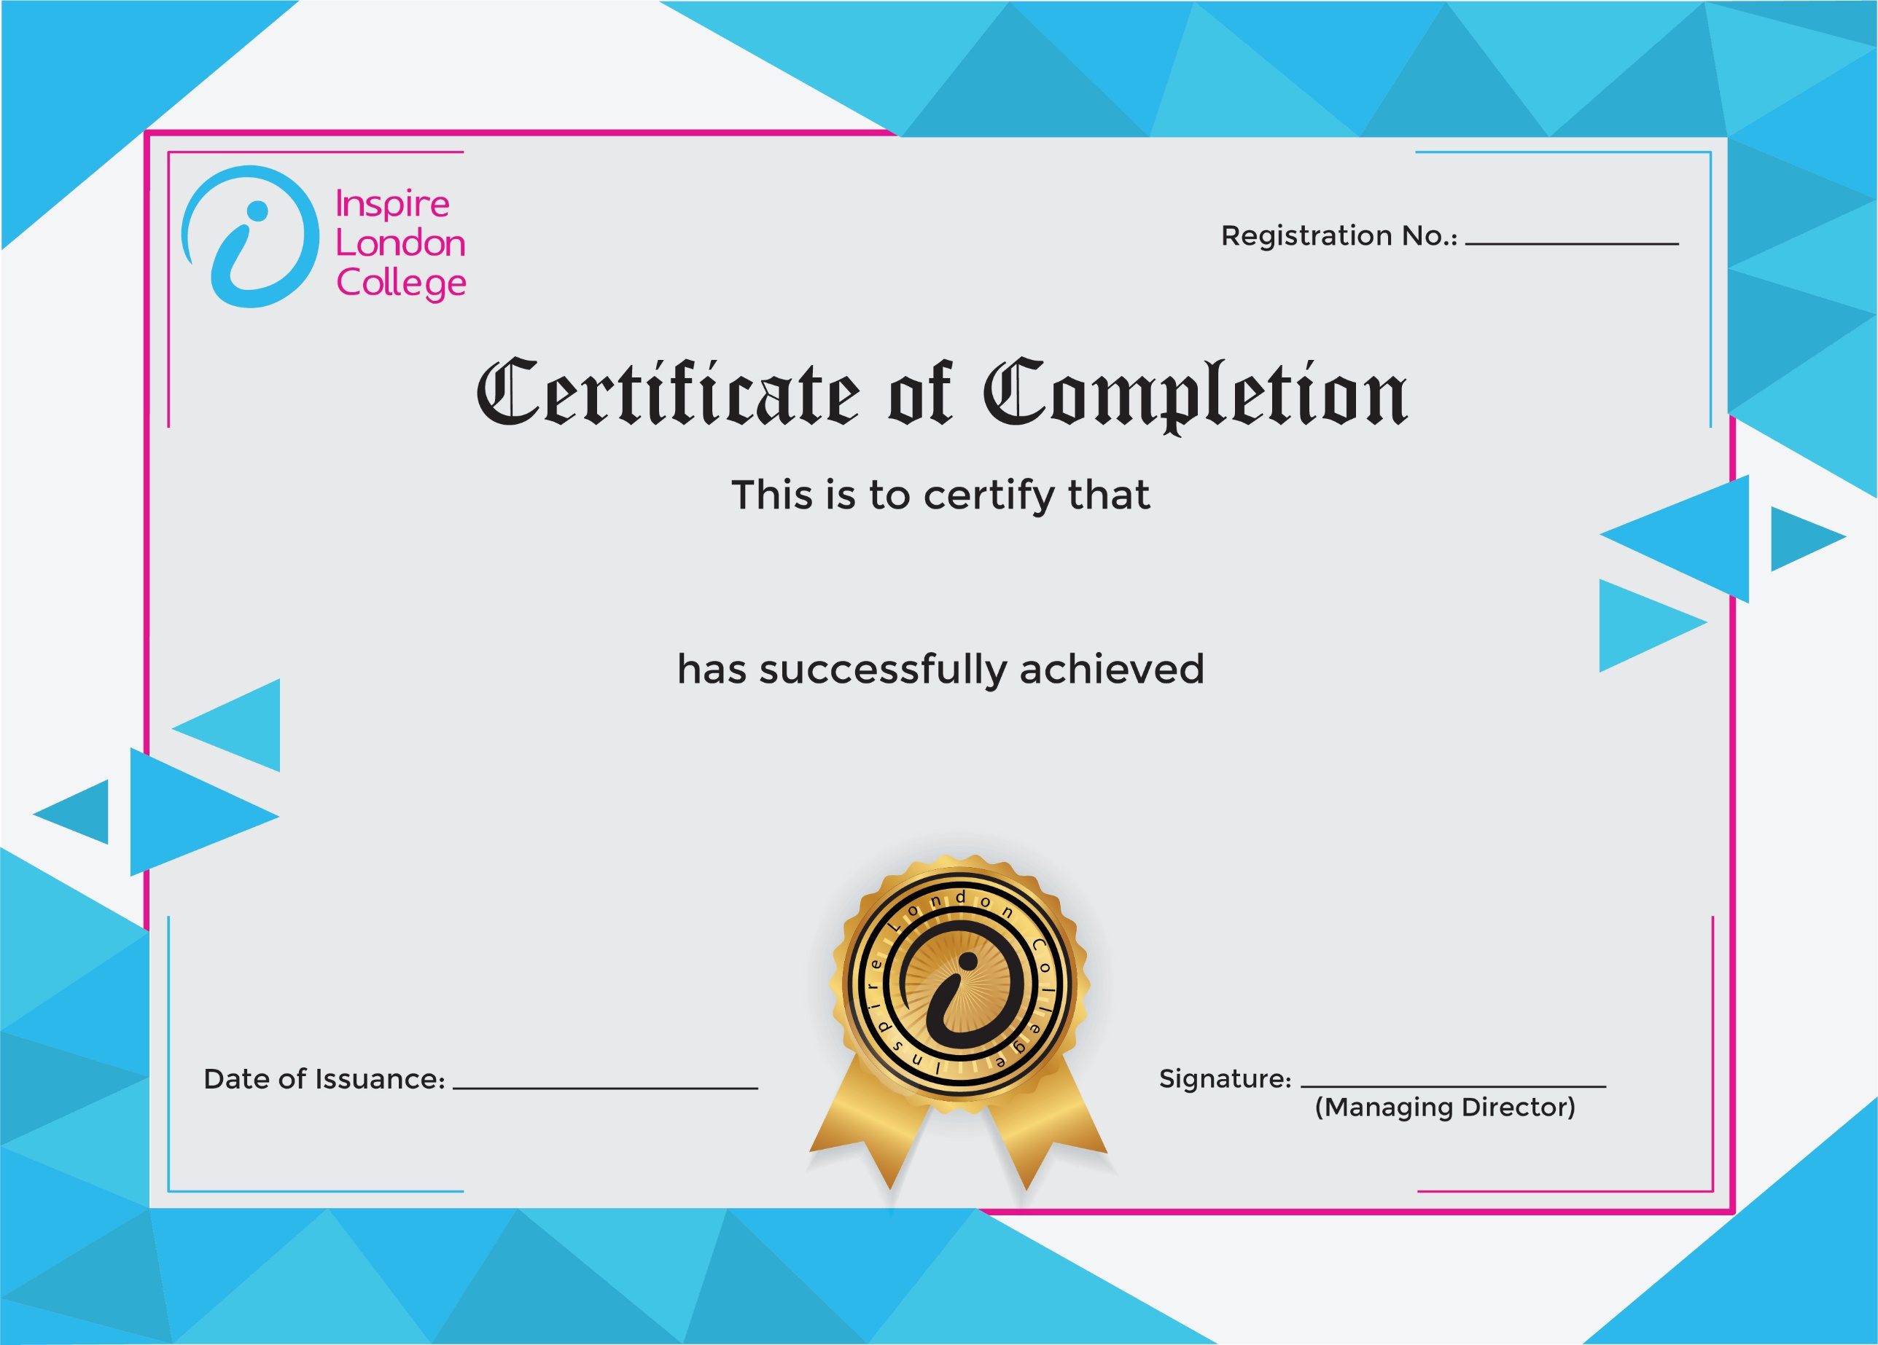
ILC-130

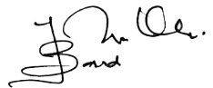
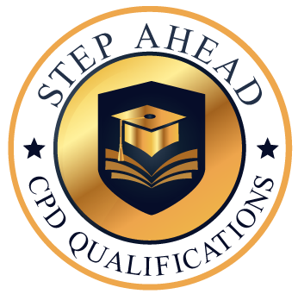
Certificate in Accounting and Finance
3/10/2026
Asli hai Nakli

