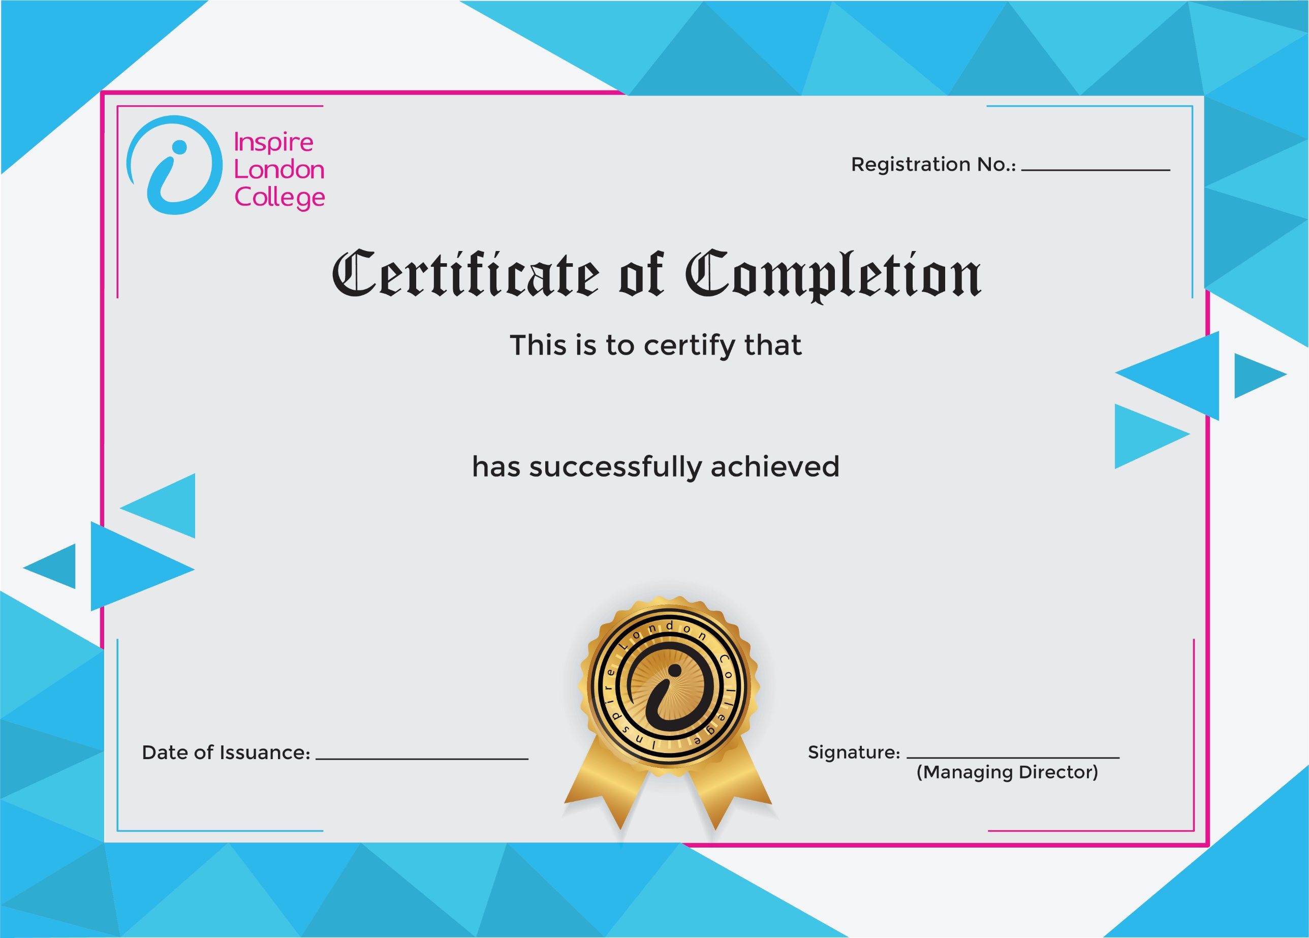
ILC-130

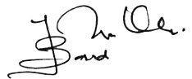
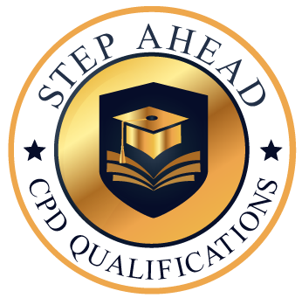
Level 1 Certificate in E-Commerce Management
3/10/2026
Asli hai Nakli

