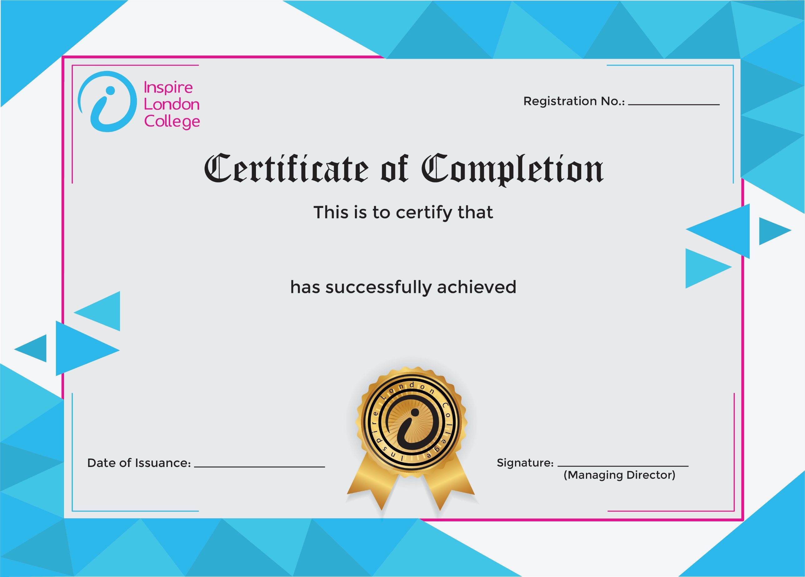
ILC-130

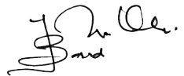
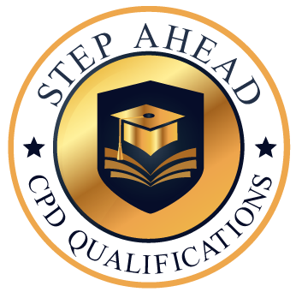
Level 1 Certificate in Construction Management
10/03/2026
Asli hai Nakli

