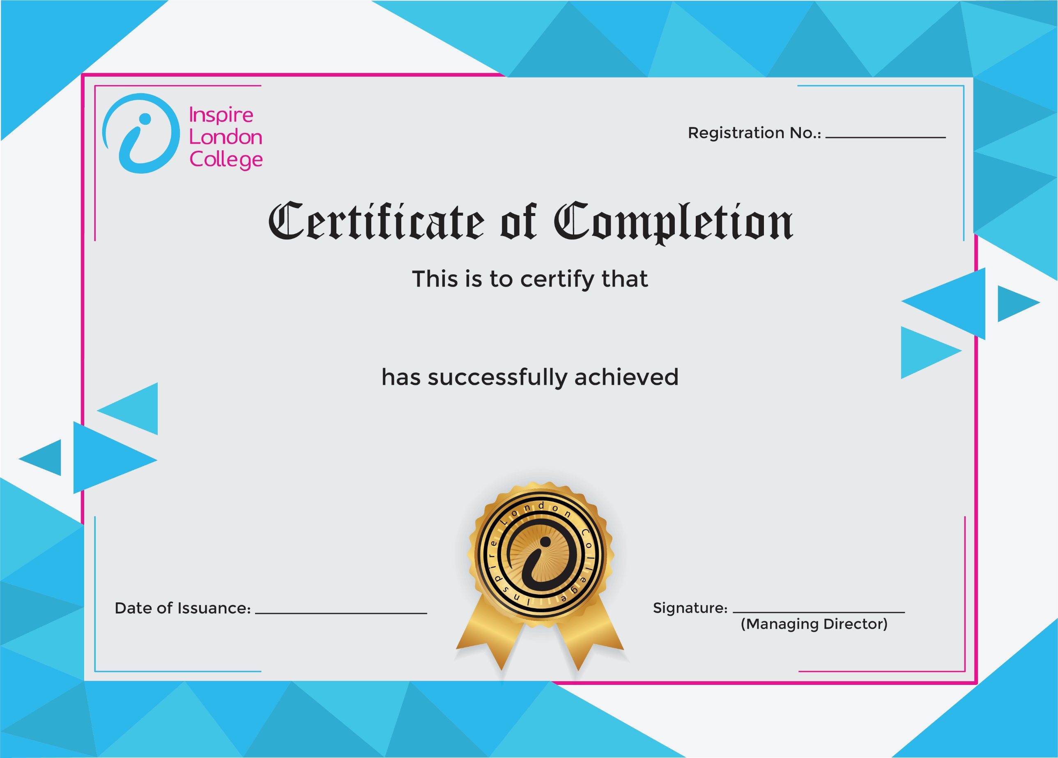
ILC-130

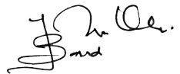
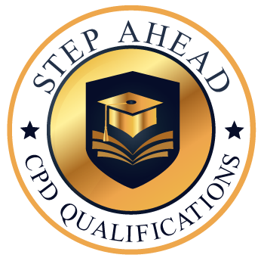
Level 1 Certificate in Beauty Therapy
12/03/2026
Asli hai Nakli

