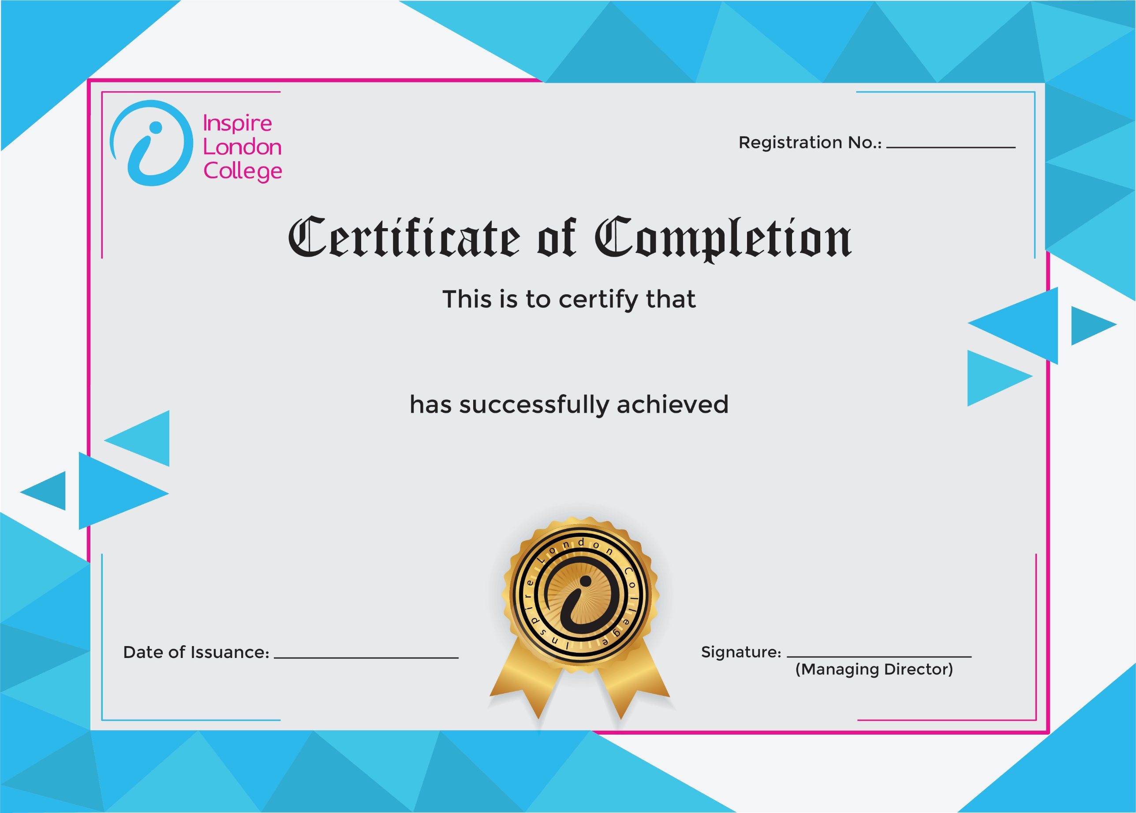
ILC-080

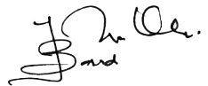
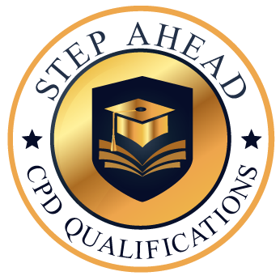
Level 5 Diploma in Restaurant Hospitality and Management
13/03/2026
AHMED KHAN

