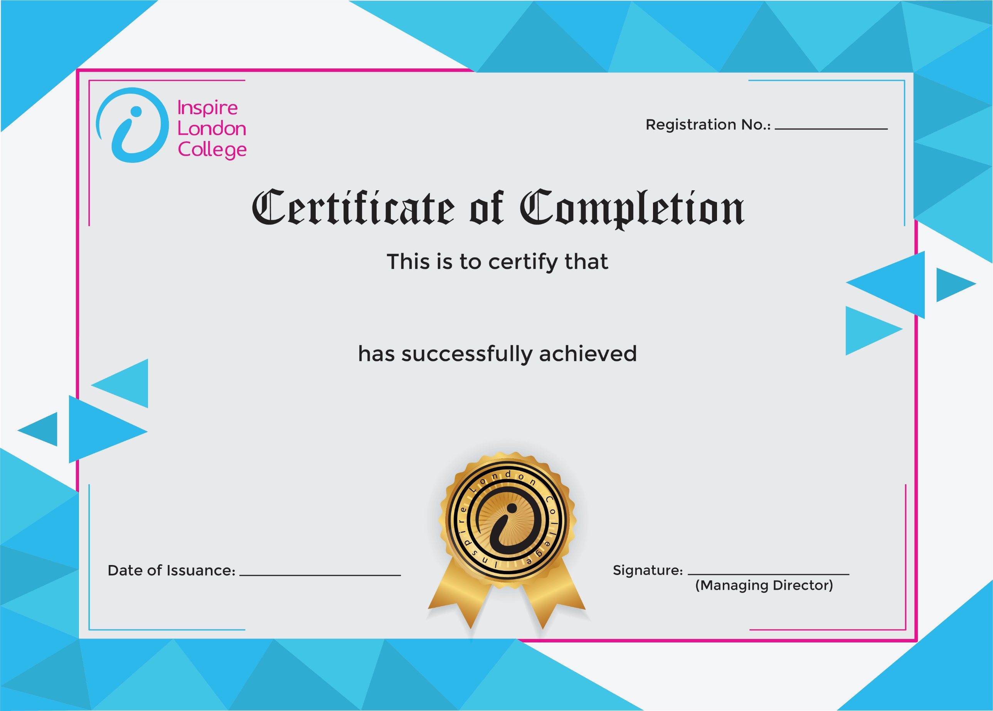
{REGISTRATION_NO}

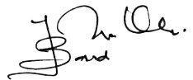

{COURSE_NAME}
{Date}
{STUDENT_NAME}

