**Name & ID**: Syed Asghar Abbas Zaidi **Date: 07201**

| **EE-424L Data Communication & Networking**  **Fall 2023**  **Habib University**  **Dhanani School of Science & Engineering** |
| --- |



**LAB 9: Static and Dynamic Routing Protocols**

| **Lab #9 Marks distribution:**   |  |  | **LR2=20** | **LR4=10** | **LR5=40** | **LR9=10** | **AR4=20** | | --- | --- | --- | --- | --- | --- | --- | | **In-Lab Tasks** | **Task 1** | 05 |  | 10 | 10 | 20 | | **Task 2** | 05 | 10 | 10 | | **Task 3** | 05 |  | 10 | | **Task 4** | 05 |  | 10 |  |  | | **Total Marks** | **100** | | | | | |   **Lab #9 Marks Obtained:**   |  |  | **LR2=20** | **LR4=10** | **LR5=40** | **LR9=10** | **AR4=20** | | --- | --- | --- | --- | --- | --- | --- | | **In-Lab Tasks** | **Task 1** |  |  |  |  |  | | **Task 2** |  |  |  | | **Task 3** |  |  |  | | **Task 4** |  |  |  |  |  | | **Marks Obt.** |  | | | | | | |
| --- | --- | --- | --- | --- | --- | --- | --- | --- | --- | --- | --- | --- | --- | --- | --- | --- | --- | --- | --- | --- | --- | --- | --- | --- | --- | --- | --- | --- | --- | --- | --- | --- | --- | --- | --- | --- | --- | --- | --- | --- | --- | --- | --- | --- | --- | --- | --- | --- | --- | --- | --- | --- | --- | --- | --- | --- | --- | --- | --- | --- | --- | --- | --- | --- | --- | --- | --- | --- | --- | --- |

| o**bjectives** | **The objective of this lab is to learn about Static and Dynamic Routing protocols and configure them on Routers.** |
| --- | --- |

|  |  | |
| --- | --- | --- |
|  | |  |

**Introduction:**

To send the traffic to the destination we can use **two types** of routing. The first one is **Static Routing** and the other one is [**Dynamic Routing**.](https://ipcisco.com/lesson/dynamic-routing-protocols-ccnp/) Static routes are the routes you manually add to the router’s routing table. The process of adding static routes to the routing table is known as static routing. It is a manual work that is done by network engineers. These types of routes work well with small networks. Because it is a manual work. For large scale networks Dynamic Routing will be a better choice. Dynamic Routing Protocol is divided into two main parts.

1. Interior Gateway Protocol
2. Exterior Gateway Protocol

| **Task 1:** |  | |
| --- | --- | --- |
|  | |  |

Today’s task is to interconnect all the routers so that communication can happen between them for this purpose out of many options one is to create Static Route which we will explore in this Lab given below is the network along with the IP addresses to be assigned to each port. There are **“four”** different Networks **11.0.0.0**, **12.0.0.0**, **13.0.0.0** and **14.0.0.0** as shown in Fig 1.

**Configure below network topology in Packet Tracer.**

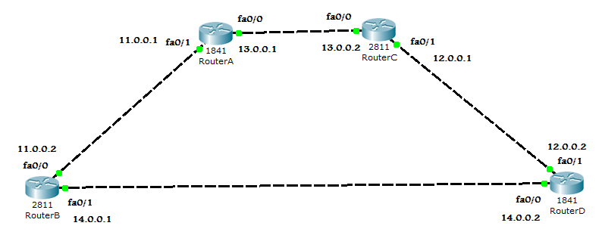

*Figure 1: Static Route Topology*

Figure 1 shows that:

Router A is connected to Network **11.0.0.1** and **13.0.0.1**

Router B is connected to Network **11.0.0.2** and **14.0.0.1**

Router C is connected to Network **13.0.0.2** and **12.0.0.1**

Router D is connected to Network **14.0.0.2** and **12.0.0.2**

**ROUTER A**

Router>en \\use en or enable to go to privilege mode

Router#config t \\ use config t to move to configuration mode

Router(config)#interface fa0/0

Router(config-if)#ip address 13.0.0.1 255.0.0.0 \\assigning IP address to this port

Router(config-if)#no shut \\ bringing the port to UP state

Router(config-if)#exit

Router(config)#interface fa0/1

Router(config-if)#ip address 11.0.0.1 255.0.0.0

Router(config-if)#no shut

Router(config-if)# exit

Now comes the part of telling Router A about those Router Networks that are not directly Connected to Router A. This is done through specifying “STATIC ROUTES” shown below:

RouterA(config)#ip route 12.0.0.0 255.0.0.0 13.0.0.2

Here **ip route** is the key word for specifying “Static Routes” after this key word mention the network address that is not directly connected to router then comes subnet mask after subnet mask is the address through which this router will access network 12.0.0.0 and in the end gateway for Router A i.e 13.0.0.2

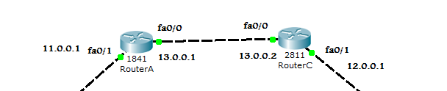

**Fig: Showing Router A’s gateway (13.0.0.2 at Router C) for network 12.0.0.0**

Similarly,

RouterA(config)#ip route 14.0.0.0 255.0.0.0 11.0.0.2

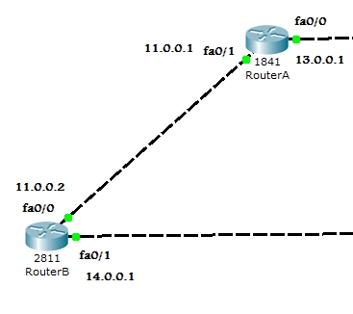

Router A use **11.0.0.2** as gateway for network 14.0.0.0

Repeat the above steps for Router B, C and D.

**Attach the screenshot of your Network topology and configuration of static routes in Router B, C and D.**

| Router A Configuration:    Router B Configuration:    Router C Configuration:    Router D Configuration:    Network Topology: |
| --- |

**Ping routers and attach the screen-shots.**

| **From Router A, I will be pinging every IP-address to make sure that everything is connected properly.** |
| --- |

**Run “show ip route” command in privilege mode on all routers and discuss the results.**

| **FOR ROUTER A:**    **FOR ROUTER B:**    **FOR ROUTER C:**    **For Router D:**    **DISCUSSING THE RESULTS:**  As can be seen from the IP-Route Table on each router, as two routers are connected at two end-point, we are connected to their “network domains” that way. Aside from that, we tell our routers about there existing two other network domains outside of just the local ones, which are accessible by other routers.  The S-symbol tells us that the network domain in-question is connected through other routers and not directly. While C-symbol tells us that the network domain in-question is connected directly and locally. |
| --- |

| **Task 2: Configure Static Routing** |  |
| --- | --- |

**Configure Static Routing on below network topology. Use appropriate cable to make connections between routers.**

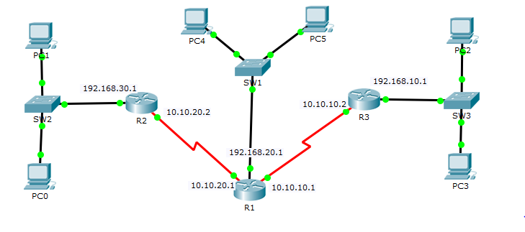

Fill the below table using information provided in above topology.

|  | **Available networks on local interfaces** | **Networks available on other Router’s interfaces** |
| --- | --- | --- |
| **R1** | 192.168.20.0, 10.10.20.0,10.10.10.0 | 192.168.30.0, 192.168.10.0 |
| **R2** | 192.168.30.0, 10.10.20.0 | 192.168.20.0,10.10.10.0, 192.168.10.0 |
| **R3** | 10.10.10.0, 192.168.10.0 | 192.168.20.0,10.10.20.0, 192.168.30.0 |

**Attach the screenshot of your Network topology and configuration of static routes in Router 1,2 and 3.**

| Network Topology:    R1 Configuration:      R2 Configuration:    R3 Configuration: |
| --- |

**Ping PC1 to PC5 and PC0 to PC2 and attach its Screenshot.**

| **Pinging from PC1 (192.168.30.2) to PC5 (192.168.20.3)**    **Pinging from PC0 (192.168.30.3) to PC2 (192.168.10.2)** |
| --- |

**Discuss and attach the screenshot of verification of Static Routing for R1, R2 and R3.**

| **To verify that I have configured every router, I will attaching their “show ip routes” tables which I get from the config-mode! Then I will explain how I decided upon the number of networks.**  **Router 1 “show ip route table”:**    **Router 2’s show ip route table:**    **Router 3 (R3’s show IP route table):**    **Further discussion:**  Upon first glance, when you will see 10.10.20.1 and IPs like that, you will instinctively think that it will belong to class A which is not correct. As our Router number 1 is getting multiple IP-addresses which belong to the same class, in its’ eyes, 10.10.20.1, 10.10.10.1 will look same cause only the starting 8-bits will be considered part of the network bits which is not correct. That’s why when we are assigning IPs, we also tell the router “the subnet mask”. Using that, we will tell our routers to treat all the IP Addresses as Class C, which will help route the data packages and so accordingly.  Aside from that, in the eyes of Router 2, telling the gateway for me to reach 192.168.10.0 (which is 10.10.20.1) isn’t enough. Cause if we were to try pinging router 3 directly by pinging 10.10.10.2, it will see its table, and go “there is no gateway defined for me to reach 10.10.10.2” even though it needs to go through that IP to reach 192.168.10.0. That’s why I also defined its gateway. Same logic applies to other routers. |
| --- |

| **Task 3: Routing Information Protocol (RIP)** |
| --- |

**RIP** (**R**outing **I**nformation **P**rotocol):

1. RIP is a Distance Vector Protocol
2. A Distance Vector Protocol is the one that select the best possible path by calculating the Distance and direction to its destination.
3. RIP uses the concept of “HOP COUNT”
4. HOP means “To Jump”. RIP calculates how many Networks (Routers) exist between source and destination.
5. Maximum Hop count of RIP is 15.
6. By default, it sends updates after every 30 seconds
7. These updates are important to cater for new updates in the network.

**Configure Task 1 network topology using RIP protocol.**

**For Router A:**

Router(config)#interface fa0/0 \\ to configure fa0/0 port first access it

Router(config-if)#ip address 13.0.0.1 255.0.0.0 \\assigning IP address to this port

Router(config-if)#no shut \\ bringing the port to UP state

Router(config-if)#exit \\ exiting interface after configuration

Router(config)#interface fa0/1 \\ to configure fa0/1 port first access it

Router(config-if)#ip address 11.0.0.1 255.0.0.0 \\assigning IP address to this port

Router(config-if)#no shut \\ bringing the port to UP state

Router(config-if)# exit \\ exiting interface after configuration

Router(config)# router rip \\ **RIP** (**R**outing **I**nformation **P**rotocol)

Router(config)#network 13.0.0.0 \\ Assigning network

Router(config)#network 11.0.0.0 \\ Assigning network

**Attach screenshots of configuration for each Router.**

| **Router A Configuration:**  **Router B Configuration:**    **Router C Configuration:**    **Router D Configuration:** |
| --- |

1. To verify which routing protocol is configured, use the **show ip protocols** command. Use the **debug ip rip** command to view the RIP messages being sent and received. Rip updates are sent every 30 seconds so you may have to wait for debug information to be displayed. Attach its screenshot below.

| **Router A:**    **Router B:**    **Router C:**    **Router D:** |
| --- |

1. Discontinue the debug output with the **undebug all** command.

|  |
| --- |

1. After the configuration, all the routers should be able to ping all the other routers. Check the routing table using show ip route command at each router and attach its screen shots.

| Router A:    **Router B:**    **Router C:**    **Router D:** |
| --- |

| **Task 4:** | **[15]** |
| --- | --- |

**Configure RIP Routing on below network topology.**



**Attach the screen shots of Network model along with IPs assigned to PCs in topology, configuration commands for RIP routing on R1, R2 and R3. Also, check the routing table on each Router and attach its screenshot.**

| **Network Topology:**    **R1:**    **R2:**  **R3:** |
| --- |

**IP ROUTE TABLE:**

| **R1:**  **R2:**    **R3:** |
| --- |

**Lab Evaluation Assessment Rubric**

**EE-424 Lab 9**

| **#** | **Assessment Elements** | **Level 1: Unsatisfactory**  **Points 0-1** | **Level 2: Developing**  **Points 2** | **Level 3: Good**  **Points 3** | **Level 4: Exemplary**  **Points 4** |
| --- | --- | --- | --- | --- | --- |
| **LR2** | **Program/Code/ Simulation Model/ Network Model** | Program/code/simulation model/network model does not implement the required functionality and has several errors. The student is not able to utilize even the basic tools of the software. | Program/code/simulation model/network model has some errors and does not produce completely accurate results. Student has limited command on the basic tools of the software. | Program/code/simulation model/network model gives correct output but not efficiently implemented or implemented by computationally complex routine. | Program/code/simulation /network model is efficiently implemented and gives correct output. Student has full command on the basic tools of the software. |
| **LR4** | **Data Collection** | Measurements are incomplete, inaccurate and imprecise. Observations are incomplete or not included. Symbols, units and significant figures are not included. | Measurements are somewhat inaccurate and imprecise. Observations are incomplete or vague. Major errors are there in using symbols, units and significant digits. | Measurements are mostly accurate. Observations are generally complete. Minor errors are present in using symbols, units and significant digits. | Measurements are both accurate and precise. Data collection is systematic. Observations are very thorough and include appropriate symbols, units and significant digits and task completed in due time. |
| **LR5** | **Results & Plots** | Figures/ graphs / tables are not developed or are poorly constructed with erroneous results. Titles, captions, units are not mentioned. Data is presented in an obscure manner. | Figures, graphs and tables are drawn but contain errors. Titles, captions, units are not accurate. Data presentation is not too clear. | All figures, graphs, tables are correctly drawn but contain minor errors or some of the details are missing. | Figures / graphs / tables are correctly drawn and appropriate titles/captions and proper units are mentioned. Data presentation is systematic. |
| **LR9** | **Report** | All the in-lab tasks are not included in report. | Most of the tasks are included in report but are not well explained. All the necessary figures / plots are not included. | Good summary of most of the in-lab tasks is included in report. The work is supported by figures and plots with explanations. | Detailed summary of the in-lab tasks is provided. All tasks are included and explained well. Data is presented clearly including all the necessary figures, plots and tables. |
| **AR4** | **\*Report Submission** | Late submission after 1 week and in between 2 weeks. | Late submission after 2 days and within a week. | Late submission after the lab timing and within 2 days of the due date. | Timely submission of the report and in the lab time. |

**\*Report:** Report will not be accepted after 1 week of due date