**Name & ID**: Syed Asghar Abbas Zaidi **Date:** 5th September 2023

|  |
| --- |
| **EE-424L Data Communication & Networking**  **Fall 2022**  **Habib University**  **Dhanani School of Science & Engineering** |

LAB 3: Deploying Network in Packet tracer using Switches, Fixed and Dynamic IP transmission using DHCP Server

|  |  |  |  |  |  |  |  |  |  |  |  |  |  |  |  |  |  |  |  |  |  |  |  |  |  |  |  |  |  |  |  |  |  |  |  |  |  |  |  |  |  |  |  |  |  |  |  |  |  |  |  |  |  |  |  |  |  |  |
| --- | --- | --- | --- | --- | --- | --- | --- | --- | --- | --- | --- | --- | --- | --- | --- | --- | --- | --- | --- | --- | --- | --- | --- | --- | --- | --- | --- | --- | --- | --- | --- | --- | --- | --- | --- | --- | --- | --- | --- | --- | --- | --- | --- | --- | --- | --- | --- | --- | --- | --- | --- | --- | --- | --- | --- | --- | --- | --- |
| **Lab #3 Marks distribution:**   |  |  |  |  |  |  |  | | --- | --- | --- | --- | --- | --- | --- | |  |  | **LR2=15** | **LR4=25** | **LR5=20** | **LR9=10** | **AR4=20** | | **In-Lab Tasks** | **Task 1** | 10 | 10 | 05 | 10 | 20 | | **Task 2** | 10 | 5 | 10 | | **Task 3** | 05 | 10 | 05 | | **Total Marks** | **100** | | | | | |   **Lab #3 Marks Obtained:**   |  |  |  |  |  |  |  | | --- | --- | --- | --- | --- | --- | --- | |  |  | **LR2=15** | **LR4=25** | **LR5=20** | **LR9=10** | **AR4=20** | | **In-Lab Tasks** | **Task 1** |  |  |  |  |  | | **Task 2** |  |  |  | | **Task 3** |  |  |  | | **Marks Obt.** |  | | | | | | |

|  |  |
| --- | --- |
| o**bjectives** | **The objective of this lab is to give basic understanding of Switch, create a network using Switch, configure DHCP server and verify the network connectivity using commands.** |

|  |  |  |
| --- | --- | --- |
| **Task 1:** | **[25]** | |
|  | |  |

**Making Switch Topology**

**Step 1:** Start Packet Tracer and Enter into Real time mode

**Step 2:** Build the Network Topology as given below–Adding 2 Generic PC, 2 Laptop from End devices

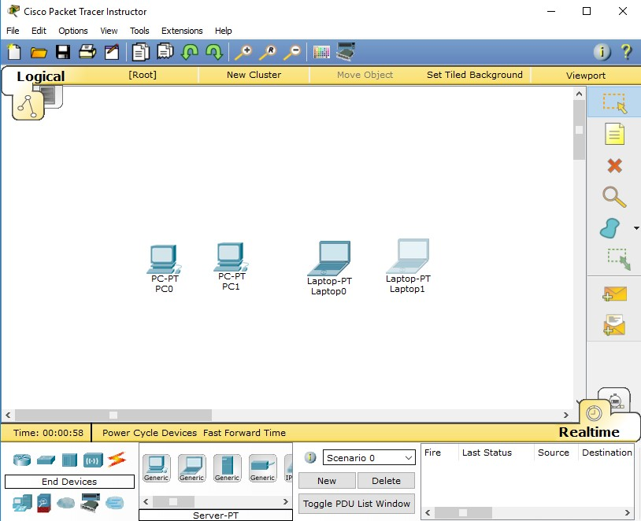

**Step 3: Add a Switch** Select a switch, by clicking on Switches and select 2950-24 switch.

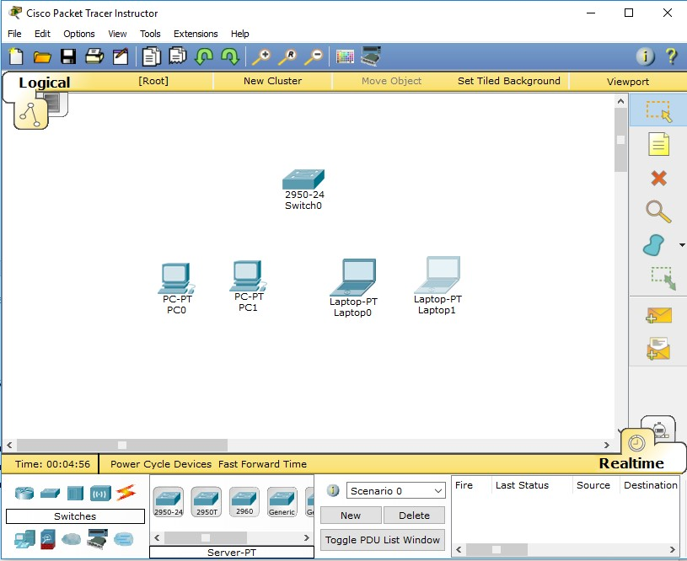

How many ports/interfaces of switch 2950-24 are available?

|  |
| --- |
| 24 Ethernet Ports! |

**Step 4****:** Building the Topology–Connecting the Hosts (end devices) to Switch. Connect Switch to PC0, PC1, Laptop0 and Laptop1 by first choosing automatic Connection type from Connections.

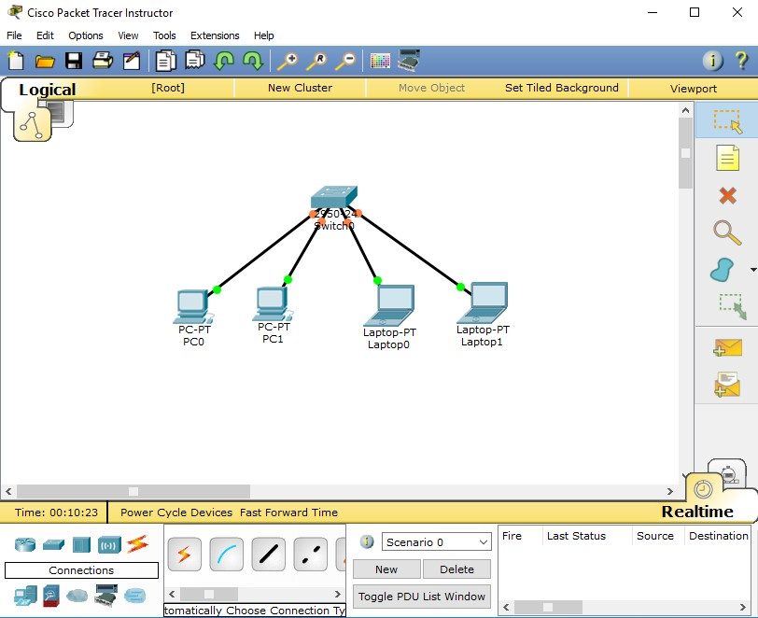

**Waiting for Spanning Tree Protocol (STP)**

Note: Because Packet Tracer also simulates the Spanning Tree Protocol, at times the switch may show amber lights on its interfaces. You will need to wait for the lights to turn green on the switches before they will forward any Ethernet frames.

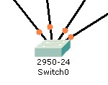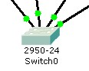

**Step 5****:** Configure IP Addresses and Subnet Masks on the Hosts

We need to configure IP Addresses and Subnet Masks on the devices to communicate between the hosts.

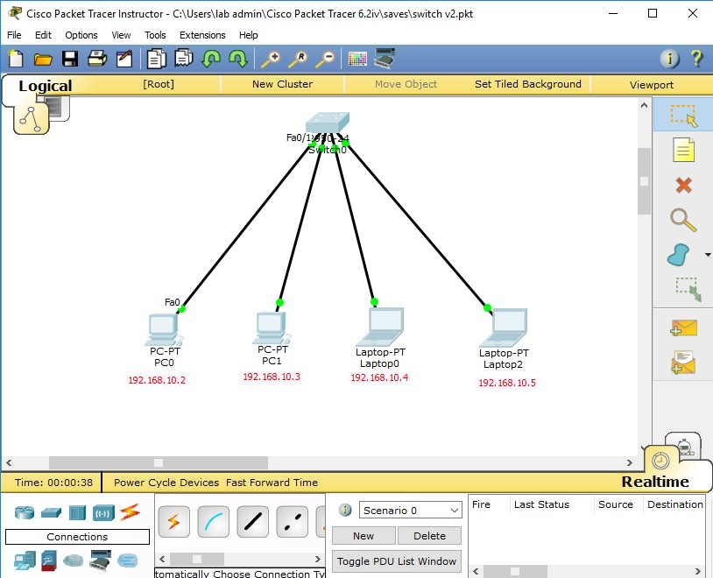

Use the information below for IP Addresses and Subnet Masks. 

|  |  |  |
| --- | --- | --- |
| Host | IP Address | Subnet Mask |
| PC0 | 192.168.10.2 | 255.255.255.0 |
| PC1 | 192.168.10.3 | 255.255.255.0 |
| Laptop0 | 192.168.10.4 | 255.255.255.0 |
| Laptop1 | 192.168.10.5 | 255.255.255.0 |

Verify the information: To verify the information that you entered, move the Select tool (arrow) over each host. 

 

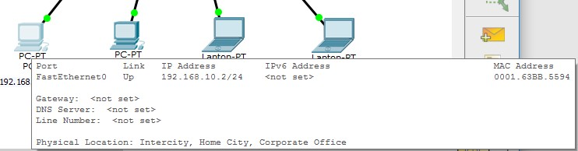 

* Simulate Packet data transfer between two devices. Check this task to RA during Lab session.

|  |
| --- |
| Verified. |

* Ping 2 devices from PC0 and PC 1. Attach Screen Shots

|  |
| --- |
| Our IP-Address of PC0 was 192.168.10.2, and we are pinging PC1 and Laptop1. Relevant Screenshots are attached below.  Our IP-Address of PC1 was 192.168.10.3, and we are pinging PC0 and Laptop2.  Relevant Screenshots are attached below. |

* Ping 192.168.10.10 from laptop 1. Write down your observations.

|  |
| --- |
| As there exists no device in our network that has the IP-address of 192.168.10.10, our data packet fail to reach that imaginary device, which then leads to our packet getting lost and us getting request timed out whenever we send a packet. |

* Does Switch broadcast the Packets? Explain and Support your answer with the help of making some network in Packet Tracer. Attach the screenshot of topology too.

|  |
| --- |
| Screenshot of my Topology:    Initially yes, Switch broadcast the Packets to every device so that it can remember their MAC addresses of the devices connected to its’ ports. When the switch receives a packet from a device, it looks into the “destination MAC address” in that packet and matches it in the ARP table which it saved, and then “smartly” sends the packet to its’ relevant destination without broadcasting the packet everywhere like “Hub” does. |

* If two end devices send the Packets simultaneously, will the Data Collide? Yes or No and why?

|  |
| --- |
| The Switch, is intelligently designed to forward the packet. As such that, when the packet is received at the end of “one port”, it correctly identifies the destination MAC address and forwards the packet ONLY to the port where the destination device of ours is connected. As such, the probability of a “collision” taking place drastically reduces. Why? Cause the need for devices to contend for access to the network decreases, and as such, more resources remain available, which again, decreases the possibility of collisions. |

|  |  |
| --- | --- |
| **Task 2: Configuring DHCP Server and examine ARP Table** | **[ 25]** |

Configure a DHCP Server with 1 Printer, 2 PCs and 2 Laptops

1. Attach the screenshot of topology with the manual. Make sure to Labelled all devices with IP addresses.

|  |
| --- |
| TOPOLOGY (**STAR**): |

1. Attach the screenshot of configuration of DHCP server. Check this task to RA during Lab session.

|  |
| --- |
|  |

1. Fill below table for the IP addresses assigned to Printer, PC and Laptops by DHCP Server.

|  |  |  |  |
| --- | --- | --- | --- |
|  | **IP address** | **Subnet Mask** | **Physical Address** |
| **PC0** | 192.168.10.2 | 255.255.255.0 | 0060.5C79.B278 |
| **PC1** | 192.168.10.3 | 255.255.255.0 | 0050.05BD.DBA9 |
| **Laptop0** | 192.168.10.4 | 255.255.255.0 | 00D0.D379.2A8A |
| **Laptop1** | 192.168.10.5 | 255.255.255.0 | 0001.C987.C562 |
| **Printer** | 192.168.10.6 | 255.255.255.0 | 0010.1115.6AE2 |

1. Examine the ARP table for each end device with the help of arp –a command. Write down your observations below.

|  |
| --- |
| I pinged the devices beforehand this activity, and as such I can’t show the screenshot of the results relevant to this. However, what we can expect to get from this command when we haven’t pinged any devices beforehand is that it shows “nothing” cause it has no history of pinging.  However, what happens if you ping all the devices in the network beforehand, for that, I have answered it in the next question. |

1. Now ping PC0-Laptop0 and run arp-a command in both end devices. Attach the screenshot and write down your observations.

|  |
| --- |
| **OBSERVATIONS:**  after pinging the relevant devices in the network, we can use the “arp -a” command to showcase the history of the relevant devices’ IP addresses and their MAC address. |

|  |  |
| --- | --- |
| **Task 3: Basic Switch Configuration** | **[20]** |

Write down the names of 5 command available in User mode.

|  |
| --- |
| Connect, disable, disconnect, enable, exit. |

Write down the names of 5 command available in Privileged mode.

|  |
| --- |
| clear, clock, configure, connect, copy |

Write down the names of 5 command available in Global Configuration mode.

|  |
| --- |
| access-list,banner,boot,cdp,clock |

**Set name on switch**

Switch name can be set from global configuration mode. Use **hostname [*desired hostname*]** command to set name on switch.

Set your name as hostname of switch and check this to RA. Write below the steps required for setting host name to a Switch.

|  |
| --- |
| * **enable** * **configure terminal** * **hostname EpiKpOg_GamIngZonE** |

**Set password on a Switch**

Passwords are used to restrict physical access to switch. Cisco switch supports console line for local login and VTYs for remote login. All supported lines need be secure for User Exec mode. For example, if you have secured VTYs line leaving console line unsecure, an intruder can take advantage of this situation in connecting with device. Once you are connected with device, all remaining authentication are same. No separate configuration is required for further modes.

Password can be set from their respective line mode. Enter in line mode from global configuration mode.

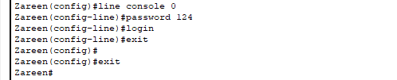

To remove the password:



Attach the screenshot of setting up Console password and verify by exit out of user mode.

|  |
| --- |
| **Verifying by exiting and trying to enter “Privileged Mode”.** |

Along with User Exec mode we can also secure Privilege Exec mode. Two commands are available for it.

**Switch(config)# enable password abc**

**or**

**Switch(config)# enable secret abc**

Set these passwords and check this to RA.

|  |
| --- |
| **Setting the password for the priviledged mode:**    **Verifying whether the password was successfully set or not.** |

**show mac-address-table**

Switch stores MAC address of devices those are attached with its interfaces. We can use *show mac-address-table* command to list all learned devices. Switch uses this table to make forward decision. This command ‘ll run in Privilege mode.

Attach the screenshot of mac-table in Report.

|  |
| --- |
|  |

**Show and Set Clock time**

Run show clock command in privilege mode and note down the time below.

Set clock time & mention its syntax below and check this to RA.

|  |
| --- |
| Following is the syntax for the clock command in privilege mode: ***clock set hh:mm:ss month day year***  Setting the Clock Time: |

**Show port configuration information**

To see the configuration information for just Fast Ethernet port 0/1, write the following command in privileged EXEC mode:

**Switch#show interface fastethernet 0/1**

|  |
| --- |
|  |

**THANK YOU!**

**Lab Evaluation Assessment Rubric**

**EE-424 Lab 3**

|  |  |  |  |  |  |
| --- | --- | --- | --- | --- | --- |
| **#** | **Assessment Elements** | **Level 1: Unsatisfactory**  **Points 0-1** | **Level 2: Developing**  **Points 2** | **Level 3: Good**  **Points 3** | **Level 4: Exemplary**  **Points 4** |
| **LR2** | **Program/Code/ Simulation Model/ Network Model** | Program/code/simulation model/network model does not implement the required functionality and has several errors. The student is not able to utilize even the basic tools of the software. | Program/code/simulation model/network model has some errors and does not produce completely accurate results. Student has limited command on the basic tools of the software. | Program/code/simulation model/network model gives correct output but not efficiently implemented or implemented by computationally complex routine. | Program/code/simulation /network model is efficiently implemented and gives correct output. Student has full command on the basic tools of the software. |
| **LR4** | **Data Collection** | Measurements are incomplete, inaccurate and imprecise. Observations are incomplete or not included. Symbols, units and significant figures are not included. | Measurements are somewhat inaccurate and imprecise. Observations are incomplete or vague. Major errors are there in using symbols, units and significant digits. | Measurements are mostly accurate. Observations are generally complete. Minor errors are present in using symbols, units and significant digits. | Measurements are both accurate and precise. Data collection is systematic. Observations are very thorough and include appropriate symbols, units and significant digits and task completed in due time. |
| **LR5** | **Results & Plots** | Figures/ graphs / tables are not developed or are poorly constructed with erroneous results. Titles, captions, units are not mentioned. Data is presented in an obscure manner. | Figures, graphs and tables are drawn but contain errors. Titles, captions, units are not accurate. Data presentation is not too clear. | All figures, graphs, tables are correctly drawn but contain minor errors or some of the details are missing. | Figures / graphs / tables are correctly drawn and appropriate titles/captions and proper units are mentioned. Data presentation is systematic. |
| **LR9** | **Report** | All the in-lab tasks are not included in report. | Most of the tasks are included in report but are not well explained. All the necessary figures / plots are not included. | Good summary of most of the in-lab tasks is included in report. The work is supported by figures and plots with explanations. | Detailed summary of the in-lab tasks is provided. All tasks are included and explained well. Data is presented clearly including all the necessary figures, plots and tables. |
| **AR4** | **\*Report Submission** | Late submission after 1 week and in between 2 weeks. | Late submission after 2 days and within a week. | Late submission after the lab timing and within 2 days of the due date. | Timely submission of the report and in the lab time. |

**\*Report:** Report will not be accepted after 1 week of due date