**5th October's 2023 Lab 7 Fall 2023 DCN LAB extra work update.**

We are in VLAN 20, Asghar laptop (169.255.211.57) was successfully able to ping Shaheer's laptop 169.255.211.59 [within the same VLAN]

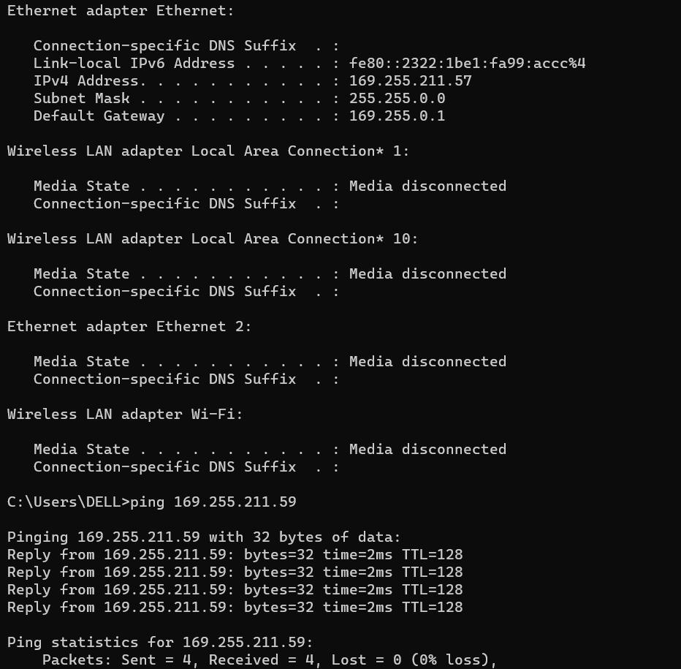

This is a computer which is pinging to another computer on the same VLAN 10, however, before inter-routing was implemented, we tried pinging to the device in VLAN 20, and it failed as expected

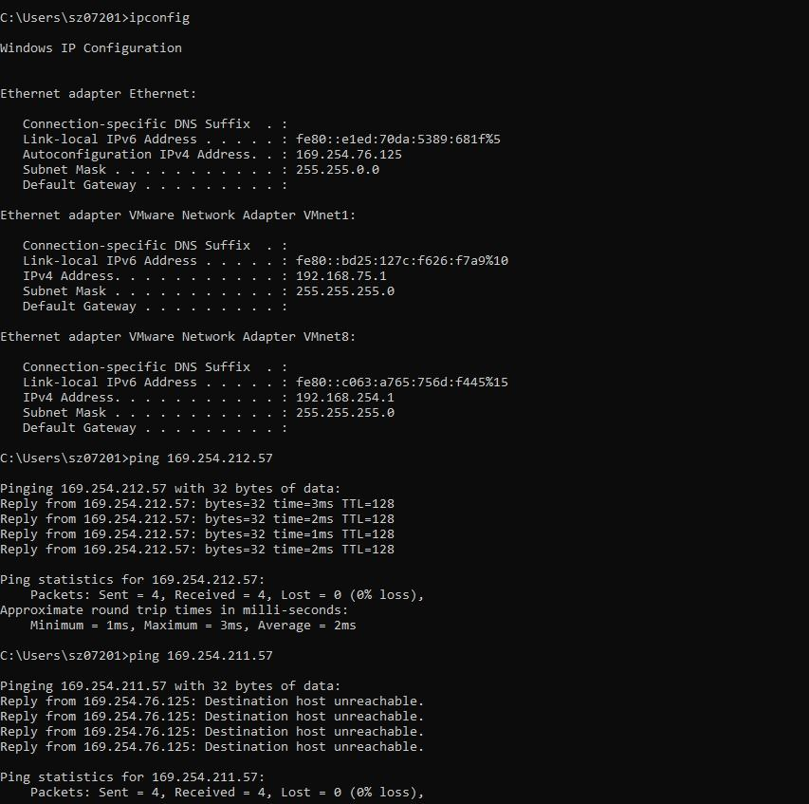

inter-vlan pinging from (169.255.211.57) from ip (169.254.211.59)

Observe that this is a **Class B network**, as such to change the network we are changing the SECOND field. Vlan 10 is on XXX.254.XXX.XXX while VLAN 20 is on XXX.255.XXX.XXX

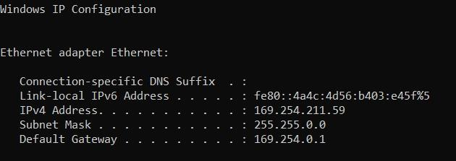

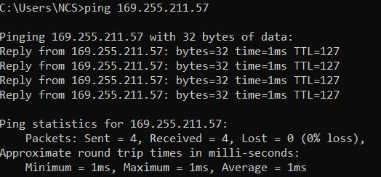

.

OUR PICS OF US WORKING IN LAB TODAY!