Configuration of VLANS:

|  |
| --- |
| Assignment of ports to VLANs:    Pinging from PC0 to PC1 and PC2 (before inter-routing was implemented):  After it was implemented: |

**Switch to router trunking**  
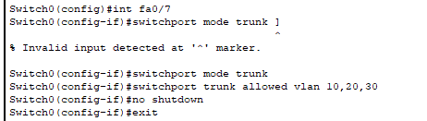

Setting PC0 for email

|  |
| --- |
|  |

**SHOWING INTER-VLAN ROUTING SUCCESSFULLY  
TASK1**

|  |
| --- |
|  |
|  |

**Email**

|  |
| --- |
| **Recieving hi from Finance (PC2) to Admins (PC0). Even though they both exist on different vlans, they are still able to say hi**    **PC2 receiving the reply from PC0**  **In this case, user0 is pc0, user3 is pc2, user2 was assigned to pc1** |

**TASK2:**

|  |
| --- |
|  |

**TASK 3**

|  |
| --- |
|  |