*Packet tracer file for each task has been documented separately and each subsequent task built upon each other. However, if you just want to see the Final version of this lab, just refer to “DCN_Exam2_Task4_sz07201_FinalTake”*

*At the end of the report,* ***Appendix*** *section has been attached for additional documentation for the configurations and verifications which can be verified.*

**Task1:**

**Topology:**

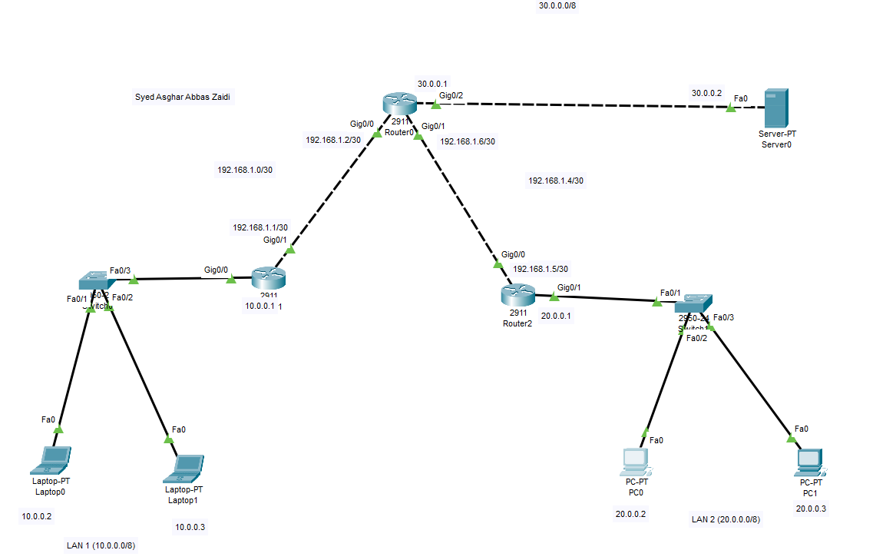

**Pinging from LAN1, Laptop0 to HTTP Server:**

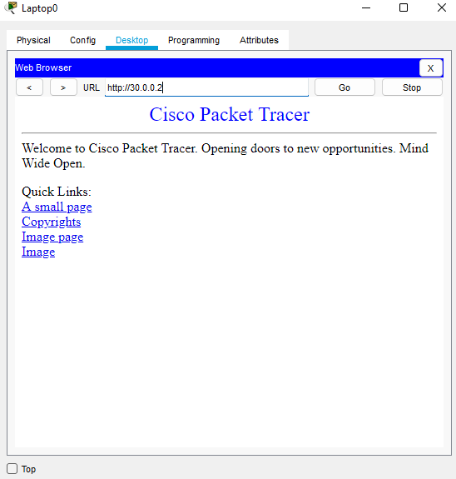

**Pinging from LAN2, PC0 to HTTP server:**

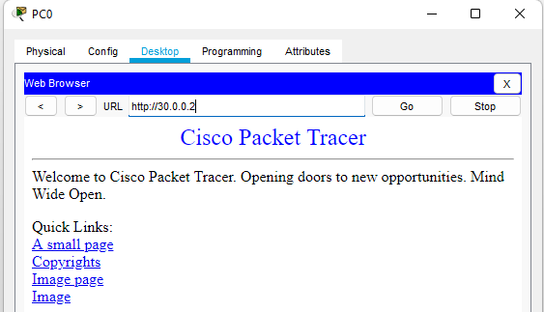

**Task2**

**The direction, location, and the router at which this was done (respectively) were:**

**“IN” from Gig0/0 of Router0.**

**Proof:**



**Task3**

**Pinging from Server to PC0:**

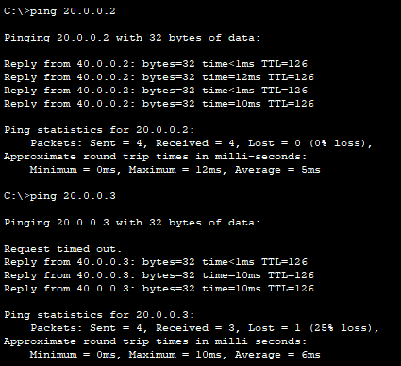

**Configuration of Router2, as well as the verification of NAT:**

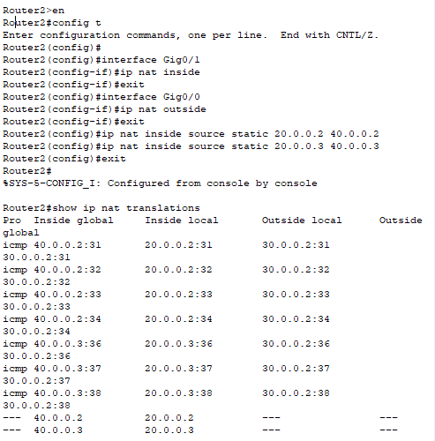

**Task4**

*Defined static routing for 40.0.0.0 packets on Router0, the configuration steps and why it was necessary to do has been explained in the Appendix section of Task4!*

**Pinging from PC0 to HTTP Server:**

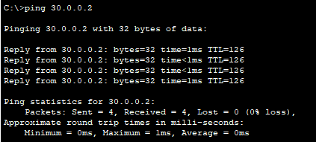

**Router2’s show ip nat translations:**

I have ran show ip nat translations three times. The first time, I only pinged server from PC0 and PC1 to Server.

Second time, I pinged from server to PC0.

Third time, I pinged from server to PC1 as well. I have attached and explain this for further documentation and explain the concept of Inside global, inside local, outside local, outside global.

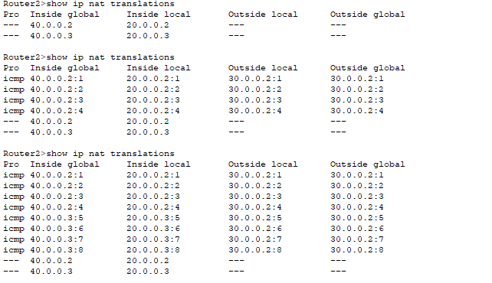 However, this didn’t effect the ip nat statistics a lot, only the numbers of hits and misses varied.

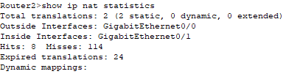

**Router2’s show ip nat statistics:**

We didn’t configure NAT on Router2 so this output makes sense.



**Explanation of Inside global, inside local, outside local, outside global:**

We get these columns when we run “show ip nat translations”, as the name suggests, it informs of the translation of IP addresses that the router is responsible for doing.

Inside Local refers to the IP-address of an end-device within the network of the router, and Inside Global tells us about the “new IP-address” of that device when it goes **out** globally after the translation.

Like our computers have IP-addresses 20.0.0.2 and 20.0.0.3 but as can be observed, they are translated to 40.0.0.2 and 40.0.0.3 respectively. In task 3, when we pinged 20.0.0.2 from the server (30.0.0.2), the answer we got from was 40.0.0.2. The reason for that is “Globally” or outside the network, 20.0.0.2 is represented as 40.0.0.2. Thus, it can be inferred that “inside” refers to inside the network.

We were only getting Inside Local and Inside Global initially. However, when I pinged from Server to PCs, new additional entries of Outside Local and Outside Global were added. As NAT translation is not being done on Router 0, 30.0.0.2 isn’t ever translated and is represented as itself “outside it’s network”. From the perspective of Router2, we got a “ping” from OUTSIDE the network and it isn’t aware that it was ever translated thus, 30.0.0.2 is put inside the column of “**outside** global” and ”**outside** local”.

**THANK YOU!**

***APPENDIX***

**CONFIGURATION OF ROUTER 1:**

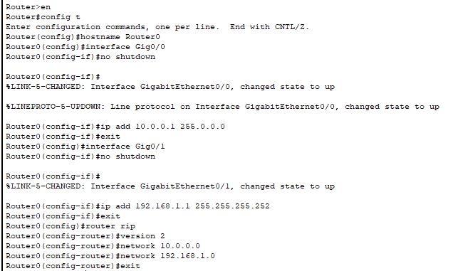

**ROUTER 2:**

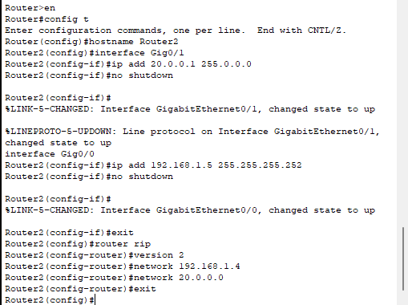

**ROUTER 0:**

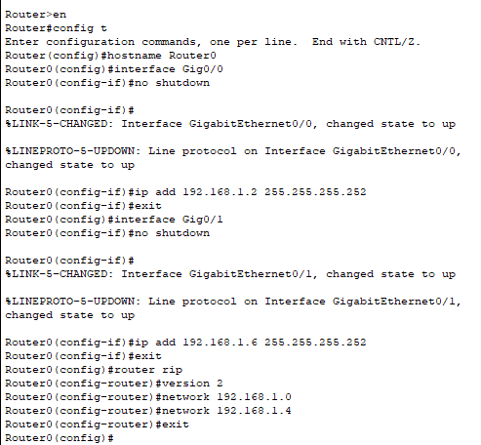

**TASK2:**

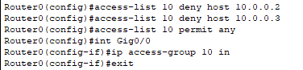

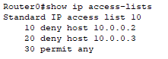

**Task3:**

Configuration of Router 2 was asked as part of the task so it has already been attached.

**Task4**

**Without Static IP routing, and telling Router 0 that it can expect packets from 40.0.0.0, it will lead to Lan2 failing to ping the server, cause Router0 doesn’t have paths defined for those packets.**

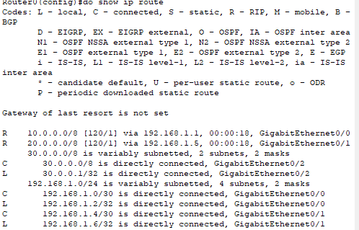

**Server will still be able to ping**

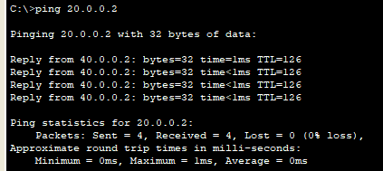

**However for PCs to Server:**

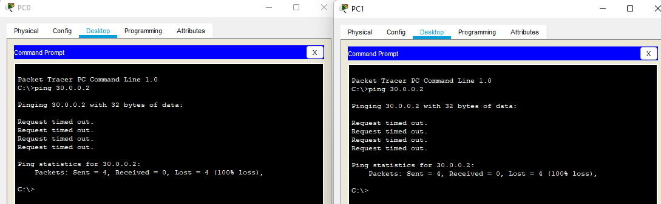

**To Solve this, defining static routing at Router 0:**

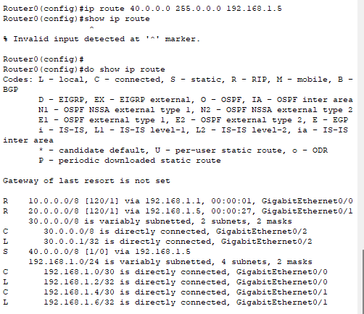

**Showing Pinging of PC0 and PC1 to Server0:  
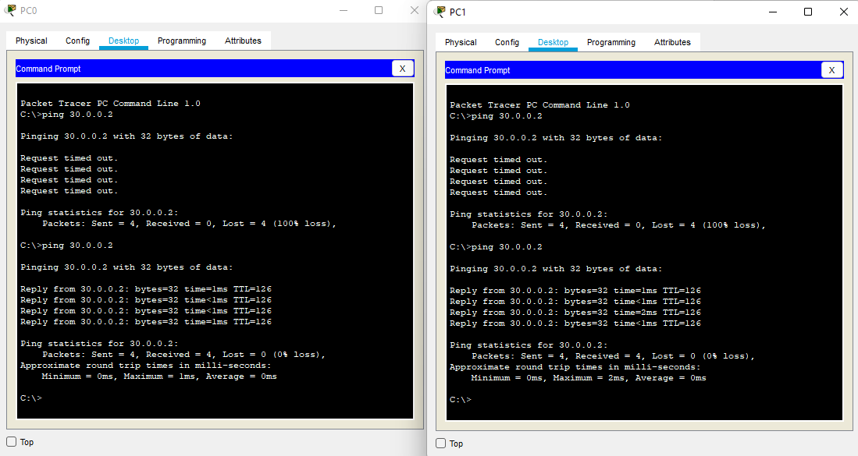**

**Final Topology:**

