**Topology:**

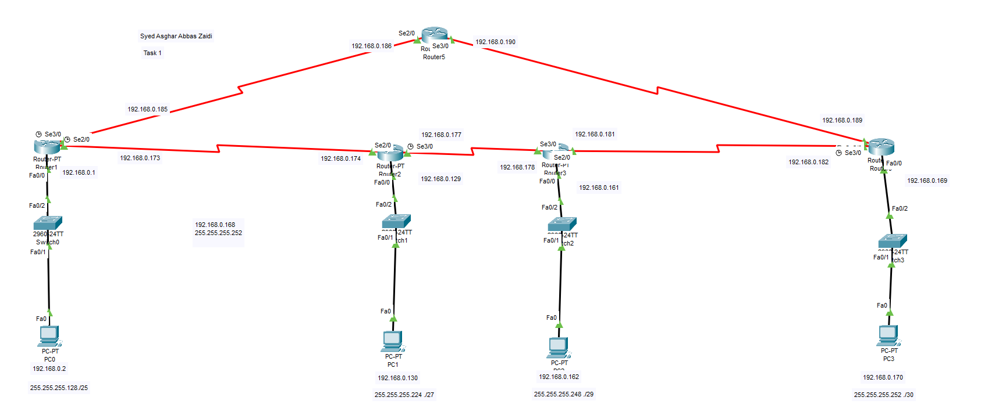

**Configuration:**

**R1:**

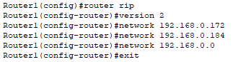

**R2:**

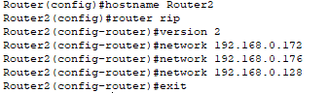

**R3:**

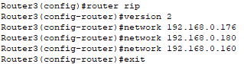

**R4:**

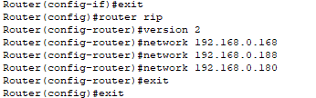

**R5:**



**Ping from PC0 to PC3:**

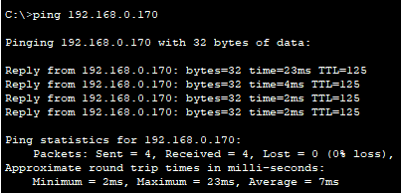

**Side cases verified by Miss:**

