

4/26/2026


COMPUTER COMMUNICATIONNETWORKS
Lab

Name: Neha Khatri Roll No: TCT-022
Batch: 2023 Department: Computer Science


Lab # 05

Objective
The objective of this lab is to configure Inter-VLAN routing using the Router-on-a-Stick technique. This enables communication between devices located in different VLANs (VLAN 10 and VLAN 20) through a single physical router interface by utilizing sub-interfaces and VLAN tagging.

Physical Connections

Source Device | Port | Destination Device | Port
PC1 | Fa0 | Switch (LSW2) | Fa0/1
PC2 | Fa0 | Switch (LSW2) | Fa0/2
PC3 | Fa0 | Switch (LSW2) | Fa0/3
PC4 | Fa0 | Switch (LSW2) | Fa0/4
Switch | Fa0/6 | Router (R1) | Fa0/0
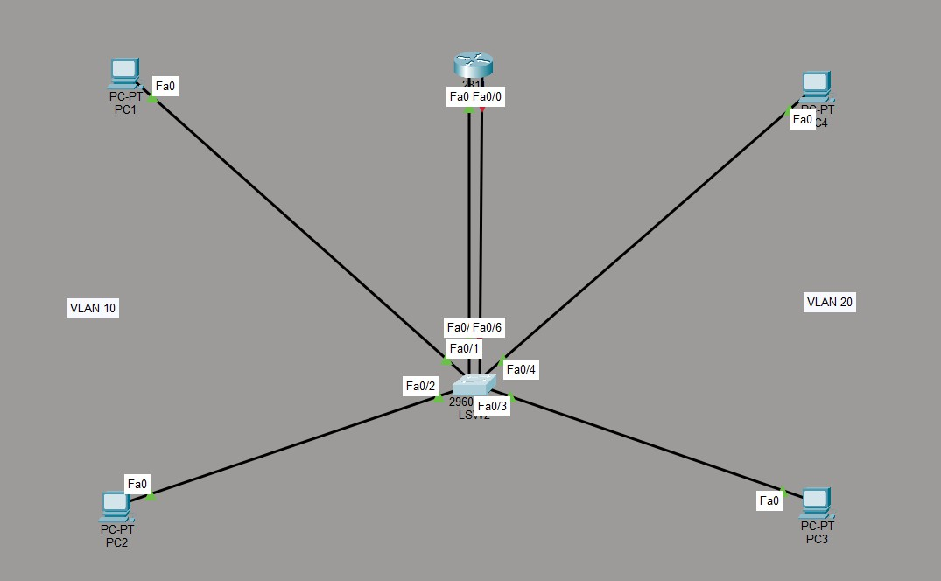

- Switch Configuration (LSW2)

VLAN Creation
enable
configure terminal vlan 10
name VLAN10 exit
vlan 20
name VLAN20 exit

  - Port Assignment interface fastEthernet 0/1 switchport mode access switchport access vlan 10 exit
interface fastEthernet 0/2 switchport mode access switchport access vlan 10 exit
interface fastEthernet 0/3 switchport mode access switchport access vlan 20 exit

interface fastEthernet 0/4 switchport mode access switchport access vlan 20 exit

  - Trunk Configuration interface fastEthernet 0/6 switchport mode trunk
switchport trunk allowed vlan 10,20 no shutdown
exit

Verification Commands

show vlan brief
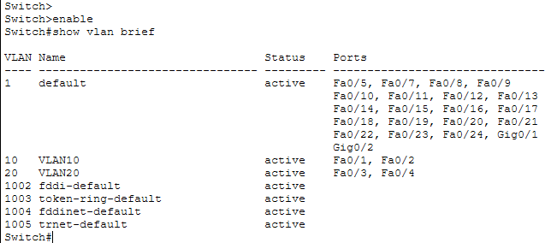
show interfaces trunk

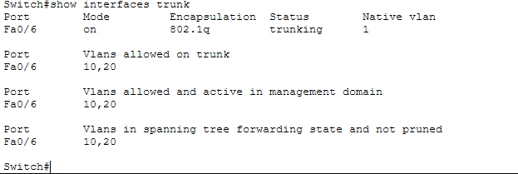

Router Configuration (R1)

Enable Interface
enable
configure terminal interface fastEthernet 0/0 no shutdown
exit

Sub-interface Configuration (VLAN 10)
interface fastEthernet 0/0.10 encapsulation dot1Q 10
ip address 192.168.10.150 255.255.255.0
exit

Sub-interface Configuration (VLAN 20)
interface fastEthernet 0/0.20 encapsulation dot1Q 20
ip address 192.168.20.150 255.255.255.0
exit

Save Configuration
end
write memory

Verification Commands

show ip interface brief
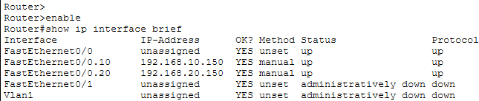
show running-config | section interface FastEthernet0/0
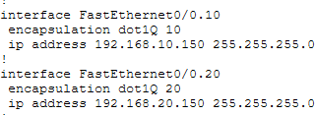

show ip route
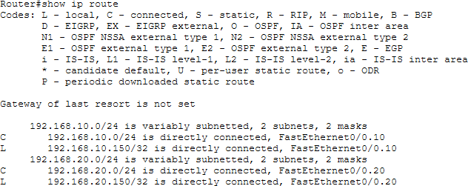

PC Configuration
Each PC was configured with an IP address, subnet mask, and default gateway according to its VLAN.

Testing and Verification

Same VLAN Communication

PC1 successfully communicated with PC2 (0% packet loss), confirming correct VLAN configuration.
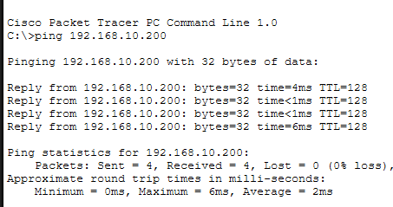

Conclusion
In this lab, Inter-VLAN routing was successfully implemented using the Router-on-a-Stick method.

VLAN 10 and VLAN 20 were created on the switch, and ports were assigned correctly. A trunk link was configured between the switch and router to allow multiple VLANs to pass through a single interface. On the router, sub-interfaces were created and configured using 802.1Q encapsulation.

All devices were assigned proper IP addresses and default gateways. Communication within the same VLAN (intra-VLAN) and between different VLANs (inter-VLAN) was tested and worked successfully.

The traceroute result confirmed that traffic between VLANs passes through the router, which verifies that Inter-VLAN routing is working correctly.
