Inventory Management System
A Minor Project Report
Submitted in partial fulfillment of requirement of the Degree of

BACHELOR OF TECHNOLOGY in COMPUTER SCIENCE & ENGINEERING

BY

Aishwary Yadav EN23CS301081

Under the Guidance of

Prof. Garima Silakari Tukra

Prof. Swati Sumit Vaidya



Department of Computer Science & Engineering Faculty of Engineering

MEDICAPS UNIVERSITY, INDORE- 453331 APRIL-2026

Report Approval

The project work "Inventory Management System" is hereby approved as a creditable study of an engineering/computer application subject carried out and presented in a manner satisfactory to warrant its acceptance as prerequisite for the Degree for which it has been submitted.
It is to be understood that by this approval the undersigned do not endorse or approve any statement made, opinion expressed, or conclusion drawn therein; but approve the "Project Report" only for the purpose for which it has been submitted.

Internal Examiner Name: Designation Affiliation

External Examiner Name: Designation Affiliation

Declaration
We hereby declare that the project entitled “Inventory Management System” submitted in partial fulfillment for the award of the degree of Bachelor of Technology in department of engineering completed under the supervision of Prof. Garima Silakari Tukra Prof. Swati Sumit Vaidya, Faculty of Engineering, Medicaps University Indore is an authentic work.
Further, We declare that the content of this Project work, in full or in parts, have neither been taken from any other source nor have been submitted to any other Institute or University for the award of any degree or diploma.

Signature and name of the students with date

Aishwary Yadav (EN23CS301081) B.Tech. VI Semester – CSE
Date:

Certificate
We, Prof. Garima Silakari Tukra and Prof. Swati Sumit Vaidya certify that the project entitled “Inventory Management System” submitted in partial fulfillment for the award of the degree of Bachelor of Technology by Sakshi Agarwal (EN23CS301081) is the record carried out by them under our guidance and that the work has not formed the basis of award of any other degree elsewhere.

Prof. Garima Silakari Tukra
Department of engineering Medicaps University, Indore

Prof. Swati Sumit Vaidya
Department of engineering Medicaps University, Indore

Prof. Kailash Bandhu Head of the Department
Computer Science & Engineering Medicaps University, Indore

Acknowledgements
We would like to express my deepest gratitude to the Honorable Chancellor, Shri R C Mittal, who has provided me with every facility to successfully carry out this project, and my profound indebtedness to Prof. (Dr.) D. K. Patnaik, Vice Chancellor, Medicaps University, whose unfailing support and enthusiasm has always boosted up my morale. We also thank Prof. (Dr.) Ratnesh Litoriya , Dean, Faculty of Engineering, Medicaps University, for giving me a chance to work on this project. We would also like to thank my Head of the Department Dr. Kailash Chandra Bandhu for his continuous encouragement for the betterment of the project.
It is their help and support, due to which we became able to complete the design and technical report.
Without their support this report would not have been possible.

Aishwary Yadav – EN23CS301081
B.Tech. III Year (A)
Department of Computer Science & Engineering Faculty of Engineering
MediCaps University, Indore

Abstract
Inventory management in small and medium retail businesses is a complex, error-prone process when handled manually. Tracking product stock levels, monitoring expiry dates, managing purchase orders, processing sales, and generating timely restocking alerts require a coordinated, data-driven approach that paper registers and basic spreadsheets cannot reliably provide. To address these operational challenges, this project presents the Inventory Management System (IMS), a fully functional desktop application designed to digitize and automate the complete inventory lifecycle of a retail business.
The system is built using Python 3.x as the core programming language, CustomTkinter 5.x for a modern graphical user interface, and MySQL 8.0 as the relational database backend. It operates entirely on a local Windows workstation without requiring an internet connection for core functionality. The application is structured around ten primary modules: User Authentication with Role-Based Access Control (RBAC), a live Dashboard, Product Management with full CRUD operations, a Point of Sale (POS) module, Purchase Order management, Sales History, a Sales Analytics Dashboard with embedded Matplotlib charts, an Alerts system for low-stock and expiry warnings, an AI Companion for restocking predictions, and User Management. By replacing fragmented manual processes with a centralized, ACID-compliant database-driven application, the system significantly improves stock accuracy, sales processing speed, and business decision-making through data-driven insights.
Keywords:
Inventory Management, Python, CustomTkinter, MySQL, CRUD Operations, Role-Based Access Control, Point of Sale, Expiry Tracking, AI Restocking Prediction, Desktop Application.

vii
Table of Contents
Report Approval ii
Declaration iii
Certificate iv
Acknowledgement v
Abstract vi
Table of Contents vii
List of Figures viii
List of Tables ix
Abbreviations x
Notations & Symbols xi
Chapter 1 Introduction
1.1 Introduction 1
1.2 Literature Review 1
1.3 Objectives 1
1.4 Significance 2
1.5 Research Design 2
1.6 Source of Data 2
1.7 Chapter Scheme 3
Chapter 2 Requirements Specification
2.1 User Characteristics 3
2.2 Functional Requirements 4
2.3 Dependencies 4
2.4 Performance Requirements 4
2.5 Hardware & Software Requirements 5
2.6 Constraints & Assumptions 5
Chapter 3 Design
3.1 Algorithm 7
3.2 System Design Diagrams 7
3.3.1 Data Flow Diagram (Level 0, Level 1) 8
3.3.2 Activity Diagram 9
3.3.3 Flow Chart 10
3.3.4 Class Diagram 11
3.3.5 ER Diagram 12
3.3.6 Sequence Diagram 12

Fig 3.8 – Database Design Diagram
3.4 Database Design 13
3.4.1 Logical Database Design 13
3.4.2 Physical Database Design 14
Chapter 4 Implementation, Testing, and Maintenance
4.1 Introduction to Languages, IDEs, Tools and Technologies 16
4.2 Testing Techniques and Test Plans 17
4.3 Installation Instructions 18
4.4 End User Instructions 18
Chapter 5 Results and Discussions
5.1 User Interface Representation 19
5.2 Brief Description of Various Modules 19
5.3 Snapshots of System with Brief Detail 20
5.4 Back End Representation 22
5.5 Snapshots of Database Tables 22
Chapter 6 Summary and Conclusions 25
Chapter 7 Future Scope 27
Appendix 29
Bibliography 31

viii
List of Figures
Figure No. | Title | Page No.
Fig 3.1 | Data Flow Diagram (Level 0) | 07
Fig 3.2 | Data Flow Diagram (Level 1) | 08
Fig 3.3 | Activity Diagram | 09
Fig 3.4 | Flowchart of System | 10
Fig 3.5 | Class Diagram | 11
Fig 3.6 | ER Diagram | 12
Fig 3.7 | Sequence Diagram | 12
Fig 5.1 | Login and Authentication Screen | 20
Fig 5.2 | Main Dashboard Interface | 20
Fig 5.3 | Product Management Module | 21
Fig 5.4 | Point of Sale (POS) Interface | 21
Fig 5.5 | Sales Analytics Dashboard | 22

ix
List of Tables
Table No. | Title | Page No.
Table 3.1 | products Table – Physical Design | 14
Table 3.2 | categories Table – Physical Design | 14
Table 3.3 | suppliers Table – Physical Design | 15
Table 3.4 | sales_orders Table – Physical Design | 15
Table 3.5 | stock_transactions Table – Physical Design | 15
Table 4.1 | Test Cases and Results | 17
Table 5.1 | Snapshot: products Table | 22
Table 5.2 | Snapshot: sales_orders Table | 23
Table 5.3 | Snapshot: stock_transactions Table | 23
Table 5.4 | Snapshot: users Table | 24

x
Abbreviations
Abbreviation | Full Form
IMS | Inventory Management System
RBAC | Role-Based Access Control
CRUD | Create, Read, Update, Delete
POS | Point of Sale
SKU | Stock Keeping Unit
GUI | Graphical User Interface
SQL | Structured Query Language
RDBMS | Relational Database Management System
ACID | Atomicity, Consistency, Isolation, Durability
DFD | Data Flow Diagram
ER | Entity-Relationship
3NF | Third Normal Form
AI | Artificial Intelligence
ARIMA | AutoRegressive Integrated Moving Average

xi
Notations & Symbols
Since the Inventory Management System is a data-driven software engineering project, notations primarily apply to the AI restocking algorithm and system design diagrams.
Symbol / Notation | Description
V | Sales Velocity — average units sold per day (total_sold ÷ analysis_days)
Fd | Forecast Demand — projected units needed (V × forecast_days)
Fs | Safe Order Quantity — Fd with 20% safety buffer (Fd × 1.20)
Qmin | Minimum recommended order quantity — floor(Fs × 0.85)
Qmax | Maximum recommended order quantity — ceil(Fs × 1.25)
∑ | Summation used in aggregate SQL queries (total revenue, total stock)
→ | Indicates direction of data flow in system design diagrams
{ } | Represents a data record or JSON-like row fetched from MySQL
[ ] | Represents a list or collection of records (e.g., all low-stock products)
PK | Primary Key – uniquely identifies each record in a table
FK | Foreign Key – establishes referential link between two tables

CHAPTER 1 – INTRODUCTION
1.1 Introduction
In the competitive landscape of retail and wholesale commerce, effective inventory management is a critical determinant of business success. Small and medium enterprises (SMEs) frequently suffer from stockouts, overstocking, undetected product expiries, revenue leakage due to untracked sales, and poor purchase planning—all consequences of relying on manual registers or disconnected spreadsheets to manage their inventory. These inefficiencies directly translate into financial losses and poor customer satisfaction.
The Inventory Management System (IMS) presented in this report is a fully functional desktop application designed to eliminate these inefficiencies. Built using Python 3.x, CustomTkinter 5.x, and MySQL 8.0, the system provides a modern graphical interface enabling retail businesses to manage products, process sales through a Point of Sale module, raise purchase orders, monitor stock health through real-time alerts, and leverage an AI Companion for data-driven restocking decisions. The application runs entirely offline on a Windows workstation, making it suitable for businesses without reliable internet connectivity.
1.2 Literature Review
Existing inventory management research highlights that manual stock tracking results in average inventory inaccuracies of 35% in retail environments (DeHoratius & Raman, 2008). Enterprise Resource Planning (ERP) systems such as SAP and Oracle address these issues but are prohibitively expensive and operationally complex for SMEs. Open-source alternatives like Odoo and ERPNext are web-based, require server infrastructure, and demand technical expertise for deployment—making them impractical for small shop owners.
Studies on desktop-based inventory tools confirm that Python combined with a lightweight GUI framework and a local relational database provides an effective, low-cost solution for SME inventory automation (Lutz, 2013). Research on demand forecasting (Makridakis et al., 2018) demonstrates that even simple velocity-based models—calculating average daily sales and projecting forward with a safety buffer—outperform intuition-based restocking in reducing both stockouts and overstock situations. This project incorporates such a model in its AI Companion module.
1.3 Objectives
- To design and develop an intuitive, role-based desktop application for complete retail inventory operations management.
- To implement a full CRUD module for product catalog management with live search by name and SKU.
- To engineer a Point of Sale (POS) module that processes sales transactions, manages a session cart, validates stock, warns on expiry, and supports WhatsApp receipt sharing.
- To implement a Purchase Order module for supplier-based procurement with received-order stock updates.
- To automate expiry date tracking and generate prioritized alerts for expired, expiring-soon, low-stock, and out-of-stock products.
- To develop an AI Companion module that predicts restocking quantities using sales velocity analysis with a 20% safety buffer.
- To provide an embedded Sales Analytics Dashboard with four chart types for revenue and performance insights.
- To enforce Role-Based Access Control (RBAC) across three user roles: Admin, Manager, and Staff.
1.4 Significance
The Inventory Management System democratizes access to professional inventory automation tools for small and medium retail businesses that cannot afford enterprise ERP solutions. By replacing manual registers and fragmented spreadsheets with a centralized, database-driven application, the system eliminates stock discrepancies, prevents revenue loss from missed sales and untracked expiries, and empowers business owners to make data-driven restocking decisions. The AI Companion module, in particular, introduces predictive intelligence into what is traditionally a purely reactive process.
1.5 Research Design
The project follows an iterative software development methodology. Requirements were gathered through observation of retail inventory workflows and identification of common pain points in manual stock management. The system architecture adopts a layered design: a presentation layer built with CustomTkinter, a business logic layer implemented in Python (~2100 lines in main.py), and a data layer managed by MySQL 8.0 through parameterized queries encapsulated in db_config.py. Each of the ten modules was prototyped, independently tested, and then integrated into the final application.
1.6 Source of Data
- Real-time user input (product details, supplier information, sales transactions, purchase orders).
- Seed data populated during database initialization via database_setup.sql.
- Sales history records generated through simulated retail workflows during the testing phase.
- AI Companion analysis data derived from the sales_order_items and stock_transactions tables.
1.7 Chapter Scheme
The report is systematically organized into the following chapters:
Chapter 1: Introduction: Provides a foundational overview of the project, including the problem statement, primary objectives, literature review, and the significance of automating retail inventory operations.
Chapter 2: Requirements Specification: Details the Software Requirements Specification (SRS) describing the target user characteristics, functional and non-functional requirements, hardware/software dependencies, and system constraints.
Chapter 3: Design: Explains the architectural framework of the system, including the algorithmic workflow and visual representations via Data Flow Diagrams, Activity Diagrams, Flowcharts, Class Diagrams, Sequence Diagrams, and ER Diagrams.
Chapter 4: Implementation, Testing, and Maintenance: Details the core technologies used, key algorithmic implementations including the AI restocking model, testing strategies with test cases, and installation instructions.
Chapter 5: Results and Discussions: Presents the visual outputs of the system including GUI module snapshots, database table snapshots, and a discussion of system performance.
Chapter 6: Summary and Conclusions: Summarizes the entire project work and evaluates how well the system met its initial objectives.
Chapter 7: Future Scope: Discusses potential future enhancements such as ARIMA forecasting, cloud deployment, barcode scanning, and a Flutter mobile application.

CHAPTER 2 – REQUIREMENTS SPECIFICATION
2.1 User Characteristics
The Inventory Management System is designed for three distinct user roles, each with differing levels of system access and technical proficiency:
1. Admin (Super-User)
- Profile: Business owner or senior manager responsible for overall system configuration and oversight.
- Technical Knowledge: Basic computer literacy; no programming knowledge required.
- System Needs: Full access to all ten modules including User Management, Sales Analytics, and system configuration. Can add, edit, and delete products, suppliers, users, and all master records.
- Interaction: Accesses the system through a dedicated Admin login credential. Receives startup popup alerts for critical stock issues on every login.
2. Manager (Operational Supervisor)
- Profile: Store manager overseeing day-to-day inventory and sales operations.
- Technical Knowledge: Comfortable with computer-based data entry and report reading.
- System Needs: Access to Product Management, POS, Purchase Orders, Sales History, Sales Analytics, and Alerts modules. Cannot access User Management.
- Interaction: Uses the system to raise purchase orders, review analytics, and monitor alert dashboards.
3. Staff (Cashier / Storekeeper)
- Profile: Front-line retail staff responsible for processing sales and recording stock movements.
- Technical Knowledge: Minimal; only requires familiarity with the POS and basic product search.
- System Needs: Access to the POS module and product search. Cannot view financial reports, analytics, or user management.
- Interaction: Uses the POS module throughout the working day to process customer transactions and share WhatsApp receipts.
2.2 Functional Requirements
- REQ-1: The system shall authenticate users securely using parameterized SQL queries (SQL injection safe) and enforce RBAC at page load.
- REQ-2: The system shall display a Dashboard with five live stat cards: Total Products, Low Stock count, Expired count, Expiring Soon (≤30 days), and Today's Revenue.
- REQ-3: The system shall support full CRUD operations for products with fields: Name, SKU, Category, Supplier, Cost Price, Selling Price, Quantity, and Expiry Date.
- REQ-4: The system shall provide a live search on every keystroke using CTkEntry.get() across product name and SKU fields.
- REQ-5: The system shall process POS sales transactions: validate stock, warn on expired products, apply discounts, update product quantity, and log all entries atomically.
- REQ-6: The system shall support a WhatsApp Receipt feature that validates the phone number, auto-prefixes country code 91, and opens a wa.me deep-link with the receipt pre-filled.
- REQ-7: The system shall manage Purchase Orders with status tracking (pending/received) and increment product stock on marking as received.
- REQ-8: The system shall maintain four alert categories: Expired / Expiring ≤30 days / Low Stock (qty < 5) / Out of Stock (qty = 0), with a sidebar badge auto-updated after every sale.
- REQ-9: The AI Companion shall calculate restocking recommendations using sales velocity (V = total_sold ÷ analysis_days), apply a 20% safety buffer, and assign priority levels (URGENT / ORDER SOON / OK).
- REQ-10: The Sales Analytics Dashboard shall render four embedded Matplotlib charts: Revenue by Product, Units Sold, Daily Revenue Trend, and Top 5 Products.
2.3 Dependencies
- Python 3.x runtime environment installed on Windows.
- CustomTkinter 5.x library (pip install customtkinter).
- MySQL 8.0 server running locally with correct credentials configured in db_config.py.
- mysql-connector-python library for database connectivity.
- Matplotlib library with the Agg backend for rendering analytics charts within the application.
- No internet connection required for core functionality (WhatsApp receipt feature requires internet).
2.4 Performance Requirements
To ensure a smooth user experience, the system must meet the following performance benchmarks:
- Response Times: All CRUD operations (add, edit, delete, search) must complete within 1–2 seconds on a standard workstation.
- Live Search Responsiveness: Search results must appear on every keystroke with no perceptible delay (< 200 ms) using CTkEntry.get().
- POS Processing: A complete sale transaction (cart validation, database writes, stock update, audit log) must complete within 2 seconds.
- Analytics Rendering: All four Matplotlib chart tabs must render within 3 seconds for up to 90 days of sales data.
- Reliability & Error Handling: All SQL queries are parameterized via execute_query() in db_config.py. Errors must surface as user-friendly dialog messages rather than application crashes.
- Data Integrity: All POS transactions (INSERT sales_orders → INSERT sales_order_items → UPDATE products.quantity → INSERT stock_transactions) must execute atomically.
2.5 Hardware & Software Requirements
A. Server / Development Environment Requirements
- Processor: Dual-core or higher (Intel Core i3 / AMD equivalent) to run the Python application and MySQL server concurrently.
- RAM: 4 GB minimum (8 GB recommended) to prevent memory bottlenecks during analytics chart rendering.
- Storage: Minimum 500 MB of free disk space for the application, MySQL installation, and database files.
- Operating System: Windows 10 / Windows 11 (64-bit).
B. Client / End-User Requirements
- Hardware: Any modern Windows desktop or laptop meeting the server requirements above.
- Software: Python 3.x installed with required pip packages; MySQL 8.0 installed and running locally.
2.6 Constraints & Assumptions
A. System Constraints
- Single Workstation Only: The current build is designed for single-user, local deployment. Concurrent multi-user network access is not supported in this version.
- Operating System: The application is tested exclusively on Windows. Cross-platform compatibility with macOS or Linux is not guaranteed.
- Plain-Text Passwords: For the purposes of this academic project, passwords are stored without hashing. Production deployment must implement bcrypt or equivalent.
- WhatsApp Feature: The WhatsApp receipt feature requires an active internet connection and manual confirmation by the user before sending.
- AI Companion Limitation: The AI Companion uses a linear velocity-based model and does not account for seasonality or promotional demand spikes.
B. System Assumptions
- Data Integrity: It is assumed that staff will enter accurate product and transaction data. Reporting accuracy depends entirely on data quality.
- Database Server Availability: The MySQL 8.0 server is assumed to be running and accessible before the application is launched.
- Single Currency: All prices and revenues are denominated in Indian Rupees (₹).
- Fine Rate for Expiry: Products are flagged as 'Expiring Soon' if their expiry date falls within 30 days of the current date.

CHAPTER 3 – DESIGN
3.1 Algorithm
The high-level operational algorithm of the Inventory Management System is as follows:
- Start the system; Python initializes the CustomTkinter GUI and connects to MySQL via db_config.py.
- User authenticates via the Login module. Credentials are validated using parameterized SQL queries. Role-Based Access Control loads the appropriate sidebar navigation.
- On login, a startup popup checks for critical stock alerts (expired, out-of-stock) and notifies the user.
- User selects a module: Dashboard, Products, POS, Purchase Orders, Sales History, Analytics, Alerts, AI Companion, or User Management (Admin only).
- If POS Sale: Search product → add to session cart → validate stock and expiry → apply discount → Process Sale: INSERT sales_orders → INSERT sales_order_items → UPDATE products.quantity → INSERT stock_transactions → optionally share WhatsApp receipt.
- If Purchase Order Received: Fetch PO line items → for each item: INCREMENT products.quantity → INSERT stock_transactions audit entry → SET purchase_order status = 'received'.
- AI Companion Restocking: For each product, compute V = total_sold ÷ analysis_days → Fd = V × forecast_days → Fs = Fd × 1.20 (safety buffer) → Qmin = floor(Fs × 0.85) → Qmax = ceil(Fs × 1.25) → assign priority (URGENT / ORDER SOON / OK based on current stock days vs forecast window).
- Dashboard auto-refreshes live stat cards and alert badge counts after every sale and stock movement.
- User logs out; system securely closes the database connection.
3.2 System Design Diagrams
(Refer to the figures described below. Diagrams are to be inserted as images during final document assembly.)
3.3.1 Data Flow Diagram (Level 0)
The Level 0 DFD (Context Diagram) represents the entire Inventory Management System as a single process bubble. The external entity 'Business User (Admin/Manager/Staff)' provides inputs such as product details, sales transactions, purchase orders, and restocking queries. The IMS processes these inputs and returns outputs including stock confirmations, sales receipts, low-stock alerts, restocking recommendations, and analytics reports.
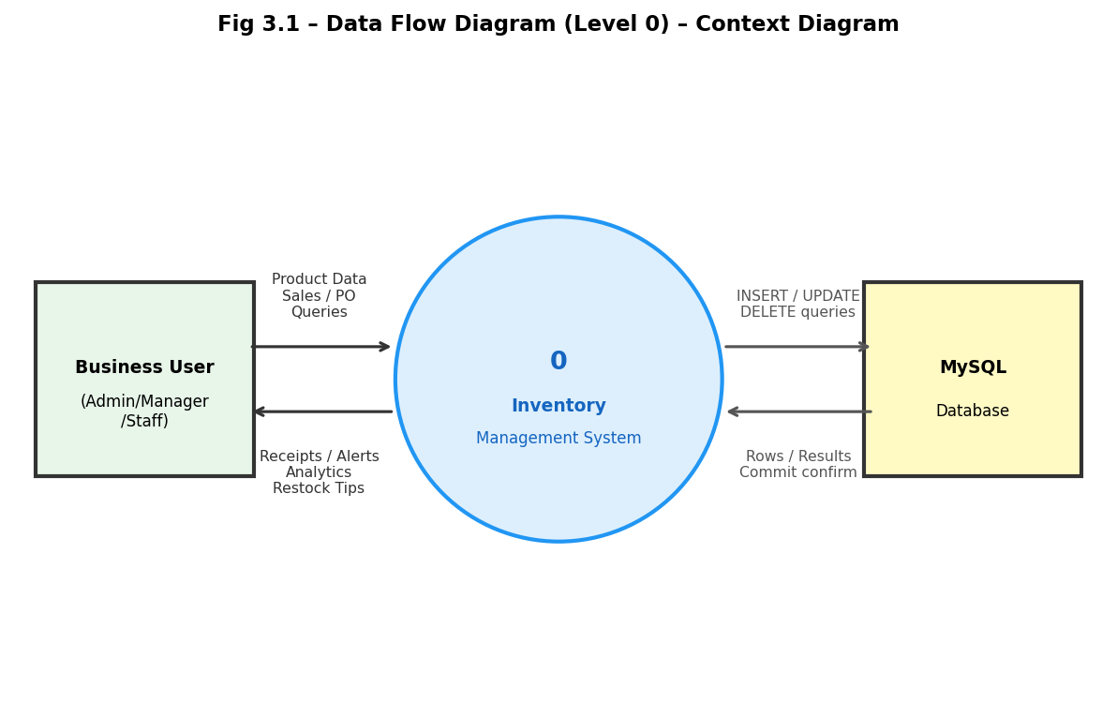
Fig 3.1 – Data Flow Diagram (Level 0)
3.3.2 Data Flow Diagram (Level 1)
The Level 1 DFD decomposes the system into its primary processes: (1.0) Authentication and RBAC, (2.0) Product Management, (3.0) POS and Sales Processing, (4.0) Purchase Order Management, (5.0) Alerts and Expiry Monitoring, and (6.0) AI Restocking Companion. Data stores include D1: users, D2: products, D3: categories, D4: suppliers, D5: purchase_orders, D6: sales_orders, D7: sales_order_items, D8: stock_transactions. The diagram illustrates data flows between the user, each process, and the corresponding data stores.
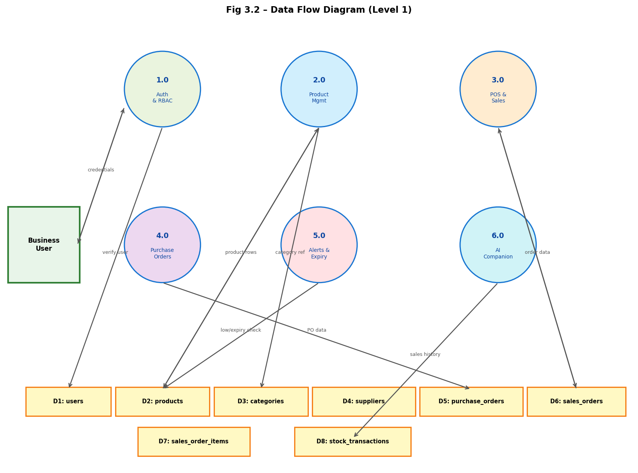
Fig 3.2 – Data Flow Diagram (Level 1)
3.3.3 Activity Diagram
The Activity Diagram traces the complete workflow of a Point of Sale transaction. The flow begins at Login → Dashboard → select 'POS' → search product by name/SKU → add to cart (with duplicate item handling) → validate stock availability → check expiry date (warn if expired) → apply discount → click 'Process Sale' → system atomically inserts sales records and updates stock → optionally enter customer phone for WhatsApp receipt → return to POS for next transaction.
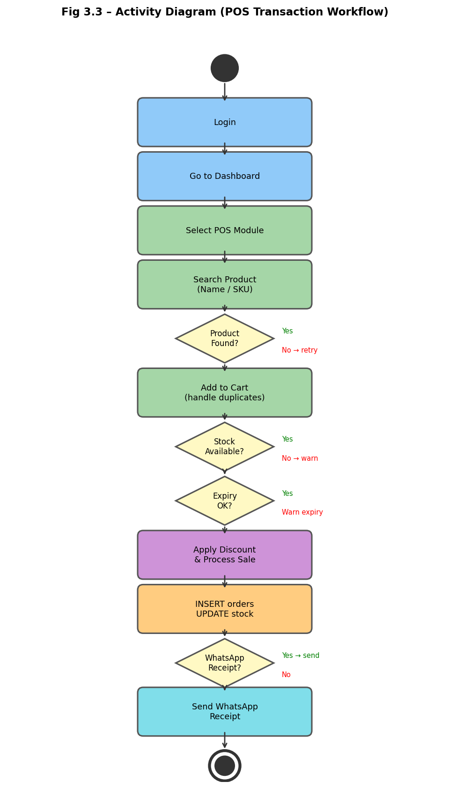
Fig 3.3 – Activity Diagram
3.3.4 Flow Chart
The system flowchart begins at 'Start' → checks if the user is logged in. If not, redirects to the Login screen. On successful authentication, the Dashboard is presented with live stat cards and alerts. The user selects a module from the sidebar. Each module path executes its respective database operations and returns to the Dashboard. The AI Companion path branches: select analysis window → compute velocity → display restocking table with priority flags. The flow ends at 'Logout'.
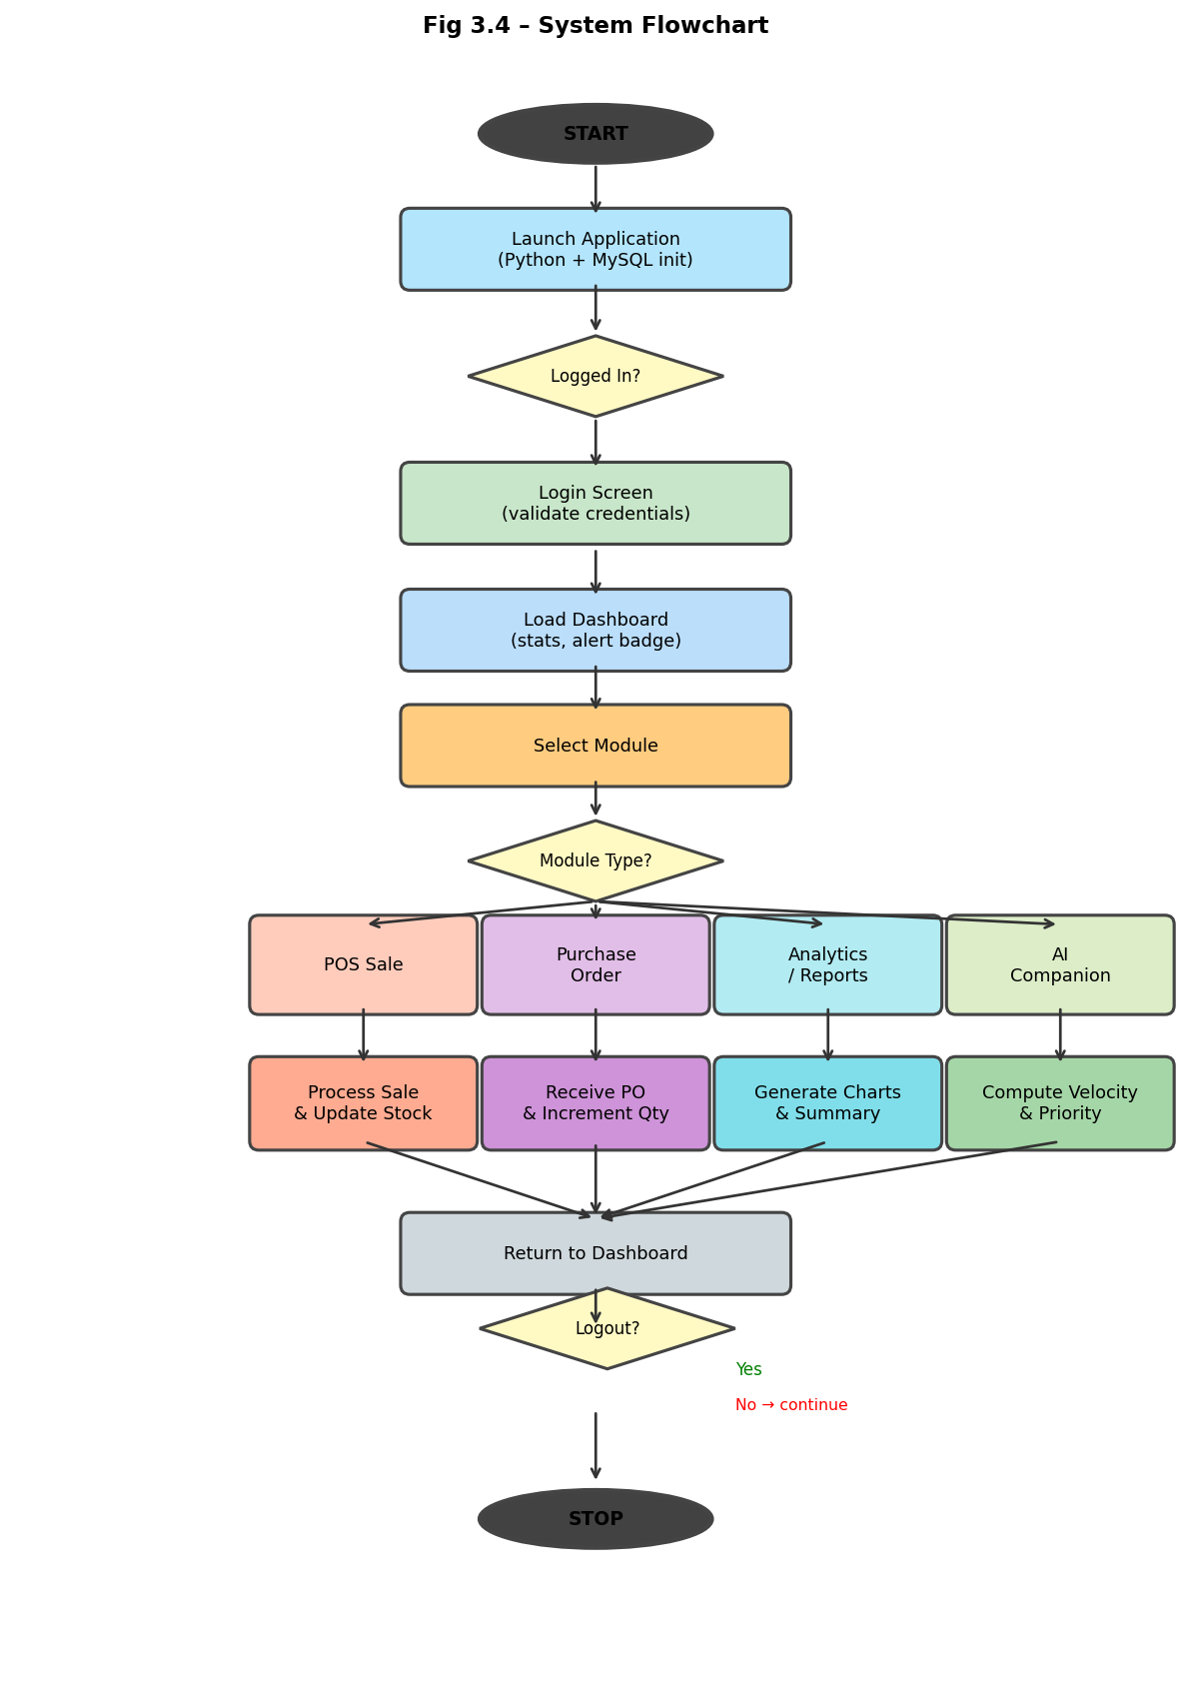
Fig 3.4 – Flowchart of System
3.3.5 Class Diagram
The Class Diagram models the key entities of the system. The central 'User' class (attributes: user_id, username, role) has methods login() and logout(). It is associated with 'ProductManager' (CRUD + stock_in/out), 'POSManager' (cart management, process_sale(), whatsapp_receipt()), 'PurchaseOrderManager' (create_po(), mark_received()), and 'AlertsManager' (get_expired(), get_low_stock()). The 'AICompanion' class implements calculate_velocity(), forecast_demand(), and get_priority(). All manager classes communicate with 'DatabaseConnector' via execute_query().
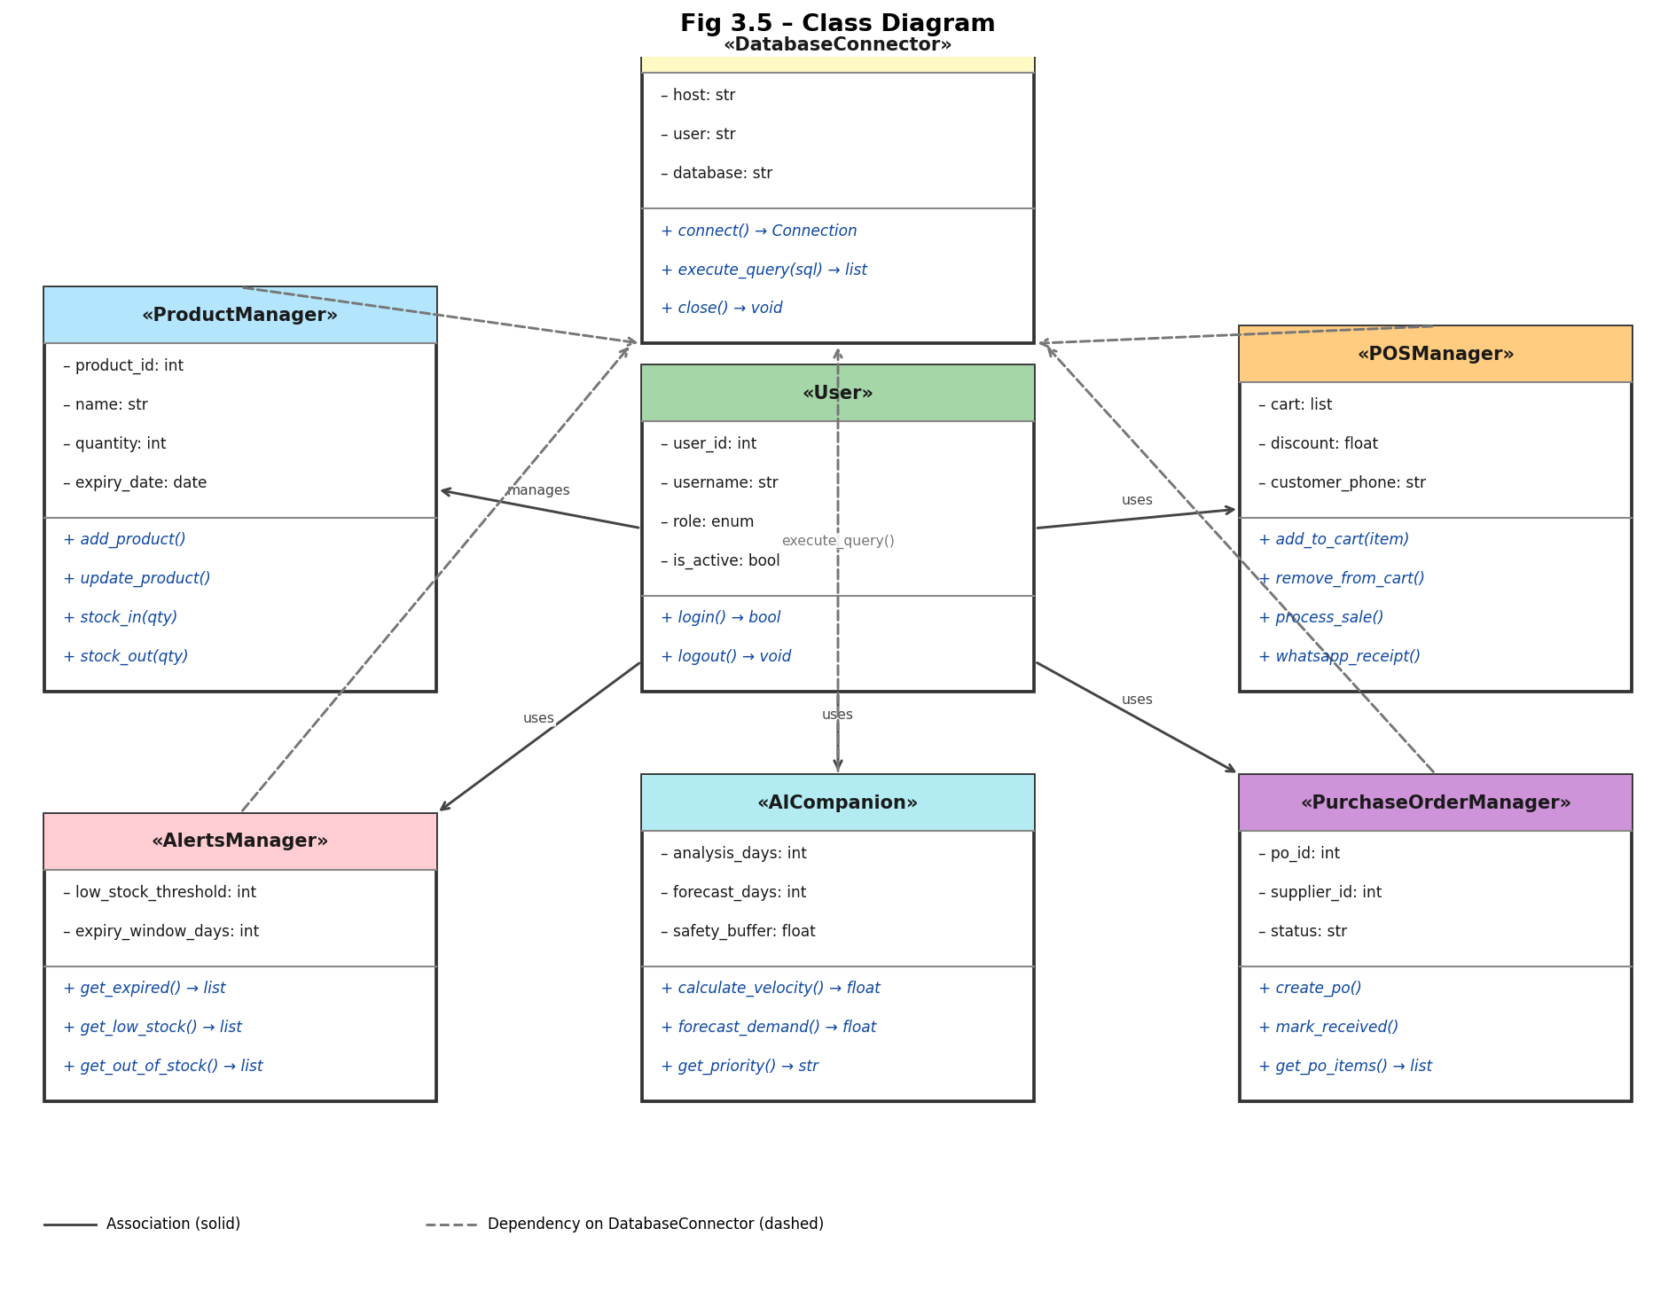
Fig 3.5 – Class Diagram
3.3.6 ER Diagram
The Entity-Relationship Diagram depicts nine entities corresponding to the nine MySQL tables. The 'products' entity (PK: product_id) is central, linked to 'categories' (FK: category_id) and 'suppliers' (FK: supplier_id). The 'sales_orders' entity (PK: order_id; FK: user_id) has a one-to-many relationship with 'sales_order_items' (FK: order_id, product_id). The 'purchase_orders' entity (FK: supplier_id, user_id) similarly links to 'purchase_order_items'. The 'stock_transactions' entity serves as a full audit log referencing products and users. The 'users' entity governs authentication for all transactional entities.
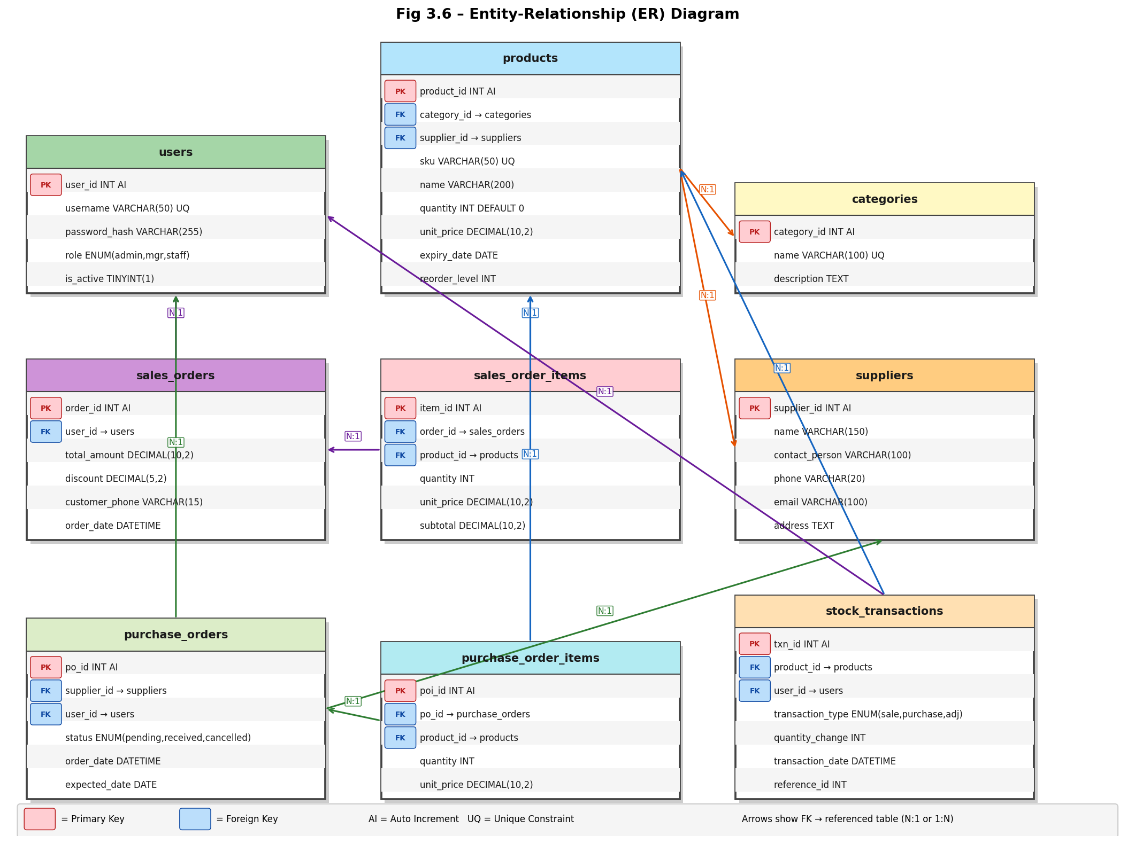
Fig 3.6 – ER Diagram
3.3.7 Sequence Diagram
The Sequence Diagram for the 'Process POS Sale' flow shows interaction between the User, CustomTkinter Frontend, Python Business Logic layer, and MySQL Database. The user clicks 'Process Sale' → Frontend calls BusinessLogic.process_sale(cart, discount) → BusinessLogic validates stock for each cart item → Database.insert_sales_order() → Database.insert_sales_order_items() → Database.update_product_quantity() for each item → Database.insert_stock_transaction() → Database confirms → BusinessLogic triggers Dashboard.refresh_stats() → Frontend displays sale confirmation and WhatsApp receipt prompt.
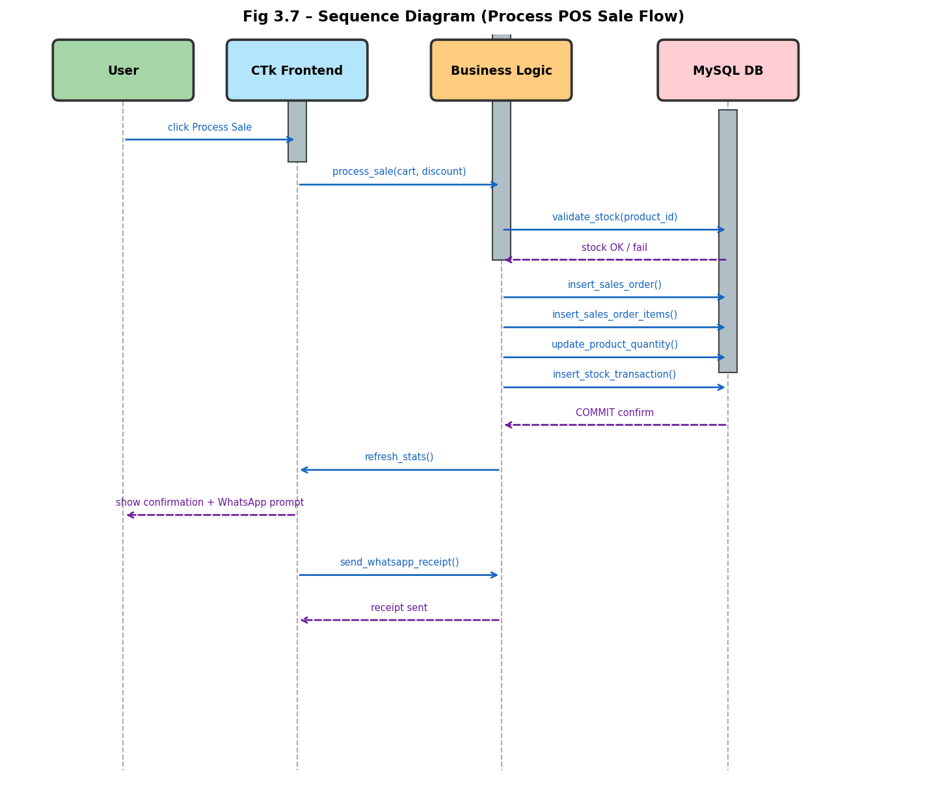
Fig 3.7 – Sequence Diagram
3.4 Database Design
The Inventory Management System utilizes MySQL 8.0 (InnoDB engine) as its database backend, providing ACID-compliant storage for all inventory, sales, and user data. The schema consists of nine tables designed in Third Normal Form (3NF) to eliminate data redundancy and optimize query performance. Foreign key constraints with CASCADE and SET NULL behaviors maintain referential integrity. Indexes are applied on expiry_date, quantity, and order_date columns for fast alert and report queries. SKU and username fields carry UNIQUE constraints to prevent duplicate entries.
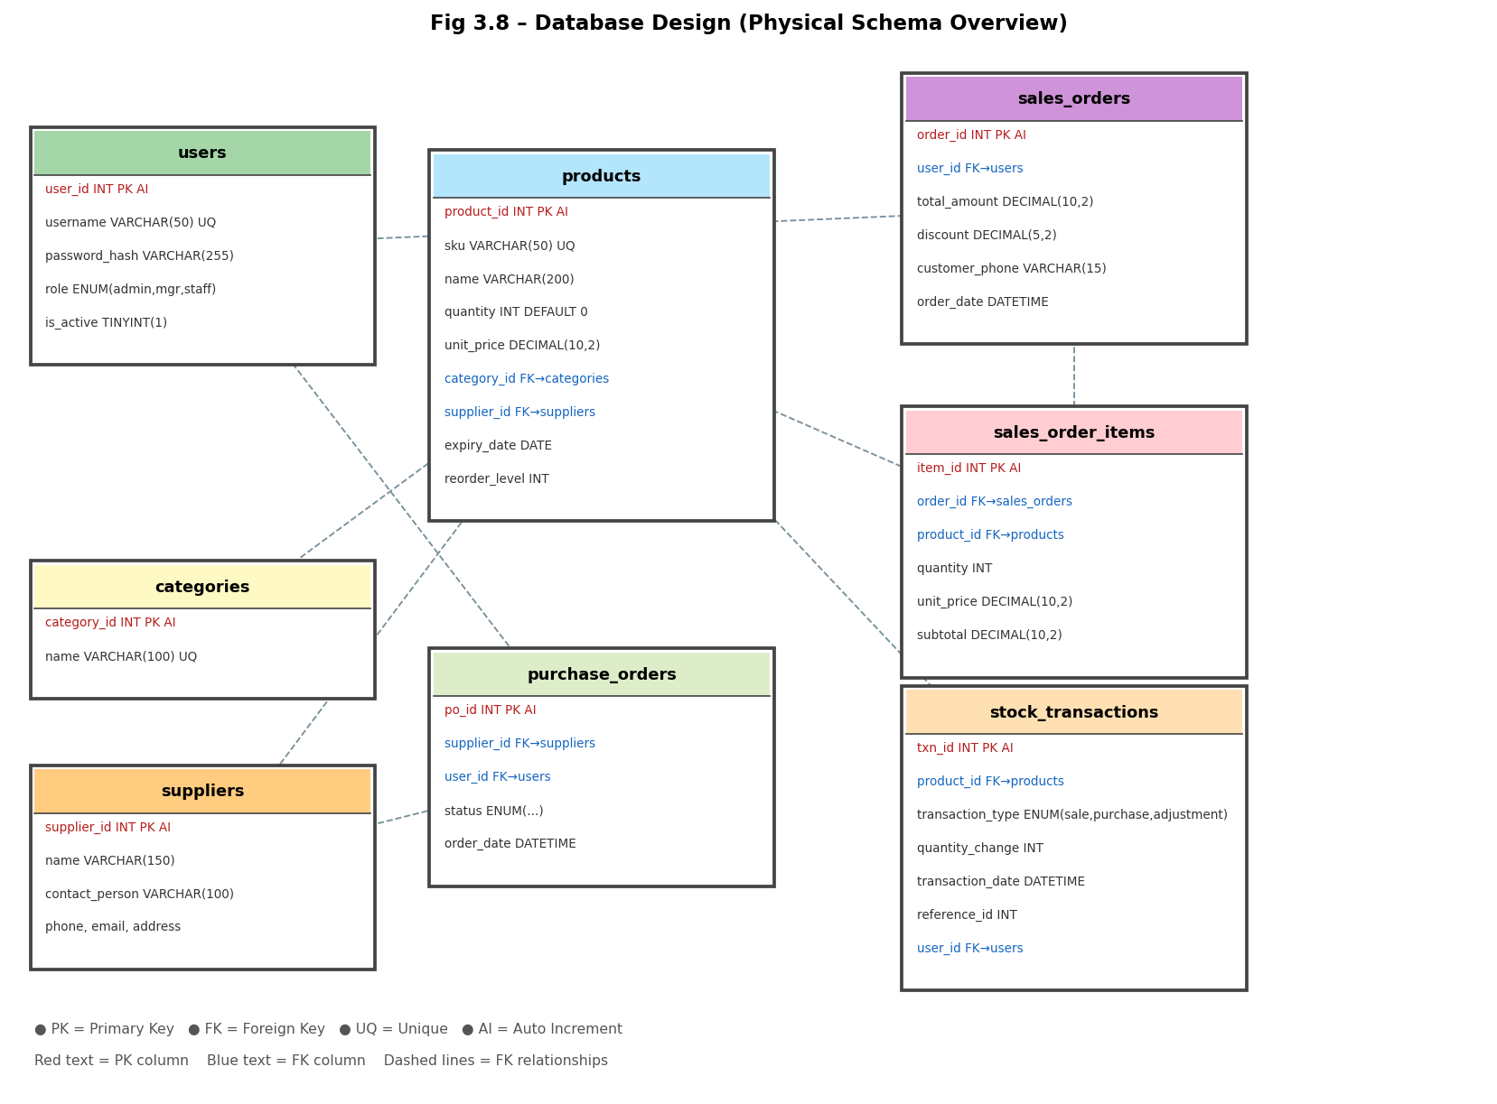
3.4.1 Logical Database Design
The logical model consists of nine tables organized around the product as the central entity. The 'users' table manages authentication and RBAC. The 'categories' and 'suppliers' tables serve as master reference tables for product classification and procurement. The 'products' table holds the complete catalog with real-time stock levels. The 'purchase_orders' and 'purchase_order_items' tables manage procurement workflows. The 'sales_orders' and 'sales_order_items' tables record every POS transaction. The 'stock_transactions' table serves as a comprehensive audit log of every stock movement across the entire system.
3.4.2 Physical Database Design
Table 3.1: products Table (Purpose: Product catalog and stock management)
Field Name | Data Type | Constraint | Description
product_id | INT | PK, Auto-Increment | Unique identifier for each product
name | VARCHAR(200) | NOT NULL | Product display name
sku | VARCHAR(50) | UNIQUE, NOT NULL | Stock Keeping Unit code (indexed)
category_id | INT | FK → categories | Product classification reference
supplier_id | INT | FK → suppliers | Primary supplier reference
cost_price | DECIMAL(10,2) | NOT NULL | Purchase cost per unit in ₹
selling_price | DECIMAL(10,2) | NOT NULL | Retail selling price per unit in ₹
quantity | INT | NOT NULL, Default 0 | Current available stock level
expiry_date | DATE | Nullable | Product expiry date (NULL for non-perishables); indexed
Table 3.2: categories Table (Purpose: Product classification master)
Field Name | Data Type | Constraint | Description
category_id | INT | PK, Auto-Increment | Unique identifier for each category
name | VARCHAR(100) | UNIQUE, NOT NULL | Category name (e.g., Electronics, Grocery)
description | TEXT | Nullable | Optional description of the category
Table 3.3: suppliers Table (Purpose: Supplier/vendor master reference)
Field Name | Data Type | Constraint | Description
supplier_id | INT | PK, Auto-Increment | Unique identifier for each supplier
name | VARCHAR(150) | NOT NULL | Supplier company or individual name
contact | VARCHAR(15) | Nullable | Primary contact phone number
email | VARCHAR(150) | Nullable | Supplier email address
address | TEXT | Nullable | Supplier physical address
Table 3.4: sales_orders Table (Purpose: POS transaction header log)
Field Name | Data Type | Constraint | Description
order_id | INT | PK, Auto-Increment | Unique identifier for each sale
user_id | INT | FK → users | Staff member who processed the sale
customer_name | VARCHAR(100) | Nullable | Optional customer name for the receipt
customer_phone | VARCHAR(15) | Nullable | Phone number for WhatsApp receipt
discount | DECIMAL(10,2) | Default 0.00 | Flat discount applied in ₹
total_amount | DECIMAL(10,2) | NOT NULL | Final sale total after discount in ₹
order_date | TIMESTAMP | Default CURRENT_TIMESTAMP | Date and time of sale; indexed
Table 3.5: stock_transactions Table (Purpose: Full audit log of all stock movements)
Field Name | Data Type | Constraint | Description
txn_id | INT | PK, Auto-Increment | Unique audit log entry identifier
product_id | INT | FK → products | Product whose stock was affected
user_id | INT | FK → users | User who triggered the movement
txn_type | ENUM | NOT NULL | 'sale', 'purchase', 'adjustment', 'stock_in', 'stock_out'
quantity | INT | NOT NULL | Units moved (positive = in, negative = out)
reference_id | INT | Nullable | Links to the originating order_id or po_id
txn_date | TIMESTAMP | Default CURRENT_TIMESTAMP | Timestamp of the stock movement

CHAPTER 4 – IMPLEMENTATION, TESTING, AND MAINTENANCE
4.1 Introduction to Languages, IDEs, Tools, and Technologies Used for Implementation
The Inventory Management System is built on a carefully selected technology stack that prioritizes offline reliability, modern UI experience, and ease of deployment on Windows.
1. Frontend Technologies (Presentation Layer)
- CustomTkinter 5.x: The primary GUI framework for all application windows, dialogs, and widgets. CustomTkinter extends standard Tkinter with modern, themeable widgets producing a navy-dark-themed professional interface. Each module is implemented as an independent CTkFrame loaded into the main window.
- Matplotlib (FigureCanvasTkAgg): Embedded within the application window using the Agg backend (set before import to prevent external window rendering) to render the four analytics chart tabs in the Sales Analytics Dashboard with a dark color scheme matching the application theme.
2. Backend Technologies (Business Logic Layer)
- Python 3.x: The core programming language for all business logic, event handling, AI calculations, and data processing. The entire application logic is contained in main.py (~2100 lines), ensuring a compact, single-file deployment.
- db_config.py Module: A centralized database utility implementing an execute_query() function that wraps all SQL statements as parameterized queries, preventing SQL injection across all modules.
3. Database Technology
- MySQL 8.0 (InnoDB): The relational database engine providing ACID-compliant storage across nine tables. InnoDB's foreign key support with CASCADE/SET NULL behavior ensures referential integrity. Indexes on expiry_date, quantity, and order_date optimize alert and report queries.
- mysql-connector-python: The official MySQL connector library managing the database connection from Python.
4. IDE & Tools
- Visual Studio Code (VS Code): Primary code editor. The integrated terminal allowed simultaneous execution of the Python application and MySQL Workbench during testing and debugging.
- MySQL Workbench: Used for schema design, query validation, seed data management via database_setup.sql, and transaction verification during integration testing.
5. Key Technical Decisions and Bug Fixes
- withdraw() used instead of destroy() for window transitions — fixes a window rendering bug on Windows Python 3.14.
- CTkEntry.get() used directly instead of StringVar.get() — resolves a CustomTkinter/Python 3.14 StringVar regression affecting live search.
- self.user[key] used throughout (not bare user[key]) — prevents NameError on module page loads.
- Matplotlib Agg backend configured before import — prevents analytics charts from opening in external popup windows.
- All SQL queries parameterized via execute_query() in db_config.py — ensures consistent SQL injection protection across all 10 modules.
4.2 Testing Techniques and Test Plans
The system underwent three levels of testing:
- Unit Testing: Individual testing of isolated functions — e.g., verifying the AI Companion velocity formula (V = total_sold ÷ analysis_days) and safety buffer calculation (Fs = Fd × 1.20) return correct values for known inputs.
- Integration Testing: Validating the atomic POS transaction chain — INSERT sales_orders → INSERT sales_order_items → UPDATE products.quantity → INSERT stock_transactions — ensuring all four operations complete or none do.
- System Testing: End-to-end walkthrough of complete user scenarios — Admin login → add product → process POS sale → raise purchase order → mark as received → verify Dashboard stats → check Alerts → run AI Companion.
Test Case Table:
Test Case | Input Condition | Expected Output | Result
TC-1 | Valid Admin Login | Dashboard loaded; all 10 modules visible in sidebar | Pass
TC-2 | Add Product with duplicate SKU | Error dialog: 'SKU already exists' | Pass
TC-3 | POS sale for product with quantity = 0 | Error dialog: 'Insufficient stock' | Pass
TC-4 | POS sale for expired product | Warning dialog: 'Product is expired'; sale blocked | Pass
TC-5 | Process valid POS sale with discount | Sale logged; product quantity decremented; Dashboard refreshed | Pass
TC-6 | WhatsApp receipt with 10-digit phone | Phone prefixed with 91; wa.me link opens in browser | Pass
TC-7 | Mark Purchase Order as Received | Product stock incremented; PO status set to 'received' | Pass
TC-8 | AI Companion with 30-day analysis window | Velocity, forecast, and priority table displayed correctly | Pass
TC-9 | Staff user accesses User Management | Module not visible in sidebar; access denied | Pass
TC-10 | Live search by partial SKU | Matching products displayed in real-time on each keystroke | Pass
4.3 Installation Instructions
- Install Python 3.x from python.org and MySQL 8.0 from mysql.com on a Windows machine.
- Clone or extract the project directory containing main.py, db_config.py, database_setup.sql, and README.md.
- Open a terminal and install required packages: pip install customtkinter mysql-connector-python matplotlib.
- Open MySQL Workbench and execute database_setup.sql to create the inventory_db database, all nine tables, and seed data.
- Update db_config.py with the correct MySQL host, port, username, and password.
- Launch the application: python main.py.
4.4 End User Instructions
- Launch the application by running python main.py or double-clicking the provided shortcut.
- Log in using default credentials — Admin: admin / admin123 | Manager: manager1 / manager123 | Staff: staff1 / staff123.
- Review the startup popup for any critical stock or expiry alerts, then close it to access the Dashboard.
- To process a sale: navigate to POS → search for a product → add to cart → apply discount if applicable → click 'Process Sale' → optionally enter customer phone number for WhatsApp receipt.
- To raise a Purchase Order: navigate to Purchase Orders → select supplier and products → save as Pending → mark as Received when stock arrives to automatically update inventory.
- To view restocking recommendations: navigate to AI Companion → select analysis and forecast windows → review the priority-flagged restocking table.

CHAPTER 5 – RESULTS AND DISCUSSIONS
5.1 User Interface Representation
The User Interface of the Inventory Management System is engineered to be modern, role-sensitive, and operationally efficient. Built with CustomTkinter, the interface adopts a consistent navy dark-themed aesthetic across all ten modules. A persistent navigation sidebar on the left houses routing links to all accessible modules, with a dynamic alert badge that auto-updates its count after every sale. The spacious main content area on the right renders each module as an independent frame. A startup popup on every login proactively alerts users to critical inventory issues (expired or out-of-stock products) before they begin their working session. Live search—firing on every keystroke via CTkEntry.get()—provides instant product lookup across the Product Management and POS modules.
5.2 Brief Description of Various Modules of the System
The system is organized into ten primary modules:
1. Login & Authentication: Handles secure user login using parameterized SQL queries. Enforces RBAC at page load — Admin sees all 10 modules, Manager sees 8, Staff sees only POS. Uses withdraw() instead of destroy() for window transitions to fix a Windows Python 3.14 rendering bug. Deactivated accounts are blocked at this stage.
2. Dashboard: Displays five live stat cards: Total Products, Low Stock count, Expired count, Expiring Soon (≤30 days), and Today's Revenue. Features a color-coded alert table for active inventory issues. A startup popup warns of critical stock issues on every login.
3. Product Management: Provides full CRUD operations for the product catalog. Fields include Name, SKU, Category, Supplier, Cost Price, Selling Price, Quantity, and Expiry Date. Live search by name/SKU fires on every keystroke. Supports Stock In/Out adjustments with full audit logging to stock_transactions.
4. Point of Sale (POS): The core transactional module. Features live product search, a session cart with duplicate item handling, stock validation, and expired product warnings. Applies discounts in ₹. On 'Process Sale': atomically INSERTs sales_orders → sales_order_items → UPDATEs products.quantity → INSERTs stock_transactions. Includes WhatsApp Receipt sharing via wa.me deep-link.
5. Purchase Orders: Manages supplier-based procurement. Staff can create POs with supplier, date, and line items (saved as status=pending). Marking a PO as Received increments product stock for each line item, logs audit entries in stock_transactions, and sets status=received.
6. Sales History: Filterable by Today / This Week / This Month / All Time. Displays Order ID, Customer, Date, Items, Discount, and Total. Shows aggregate revenue for the selected period.
7. Sales Analytics Dashboard: Renders four embedded Matplotlib chart tabs within the application window (not external popups) using FigureCanvasTkAgg: (a) Revenue by Product — Bar/Line/Pie, (b) Units Sold — top seller highlighted, (c) Daily Revenue Trend — time series with peak annotation, (d) Top 5 Products — horizontal bar with medal ranking. Period options: 7/30/60/90 days.
8. Alerts: Features four tabs: Expired / Expiring ≤30 days / Low Stock (qty < 5) / Out of Stock (qty = 0). The sidebar badge count auto-updates after every sale to reflect the current alert state.
9. AI Companion: Predicts restocking quantities using: V = total_sold ÷ analysis_days; Fd = V × forecast_days; Fs = Fd × 1.20 (20% safety buffer); Qmin = floor(Fs × 0.85); Qmax = ceil(Fs × 1.25). Priority: URGENT (stock days ≤ 50% of window), ORDER SOON, OK. Analysis windows: 30/45/60 days; Forecast: 7/14/30 days. Perishable products are capped if they expire before the forecast window ends.
10. User Management (Admin Only): Allows Admins to add, edit, and deactivate user accounts. Fields: Username, Full Name, Password, Role, Active Status. Admins cannot delete their own account. Deactivated accounts are blocked from login.
5.3 Snapshots of System with Brief Detail of Each
Login and Authentication Screen
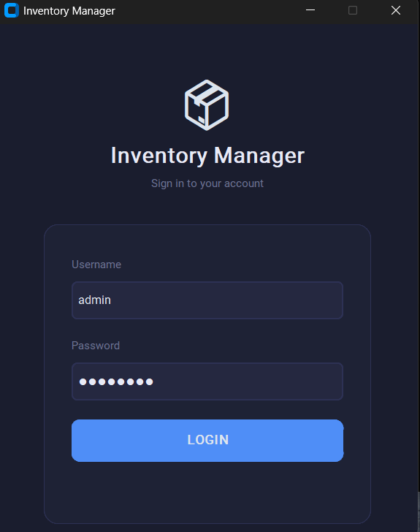
Description: Displays the secure login portal with fields for Username and Password. Includes dynamic error handling for invalid credentials and blocked deactivated accounts.
Main Dashboard Interface
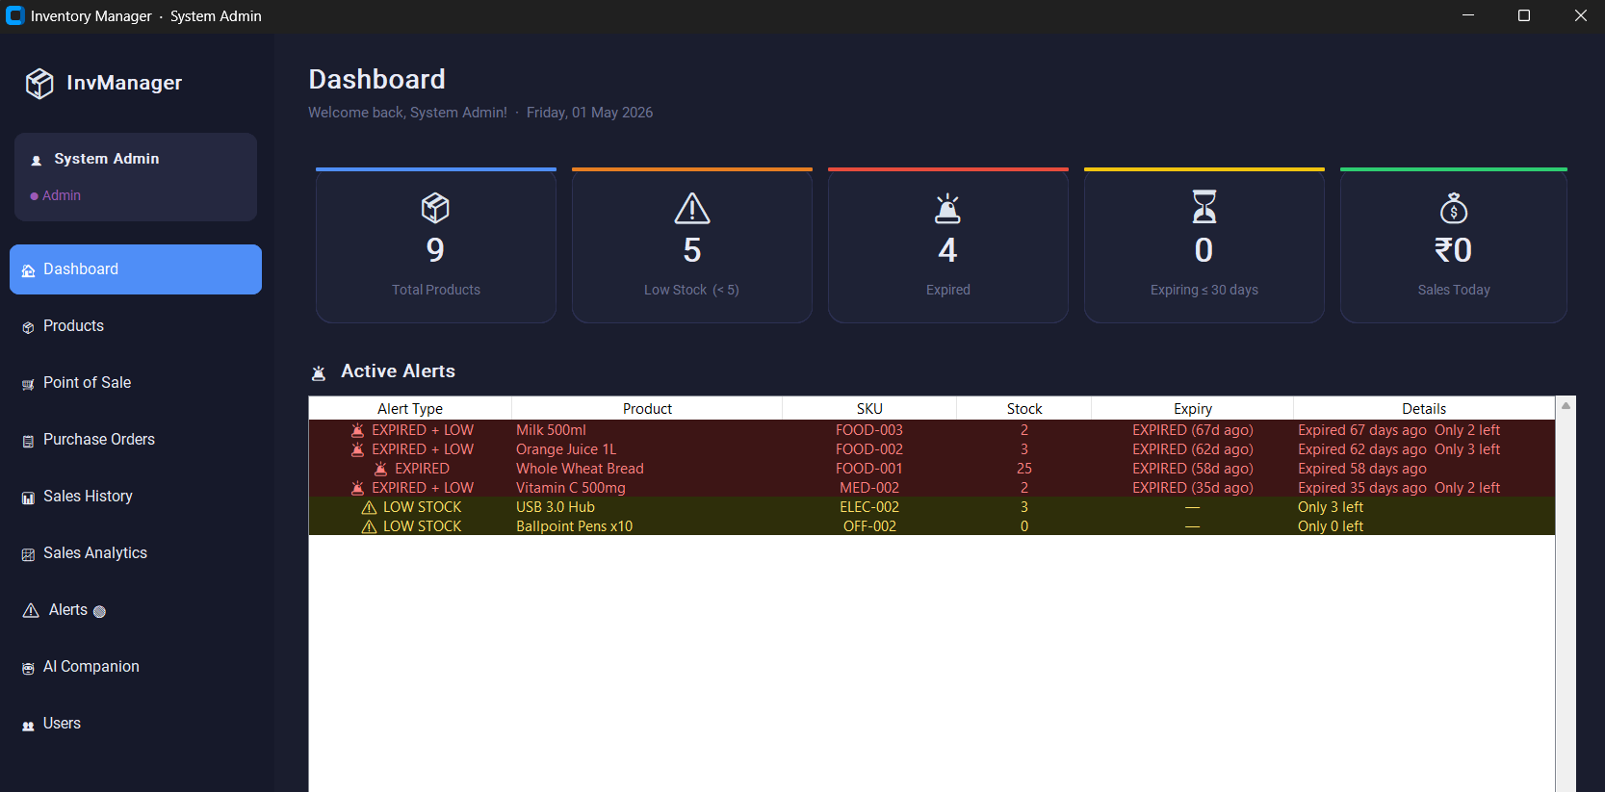
Description: Shows the persistent navy sidebar with the alert badge and the five live stat cards alongside the color-coded active alerts table.
Product Management Module
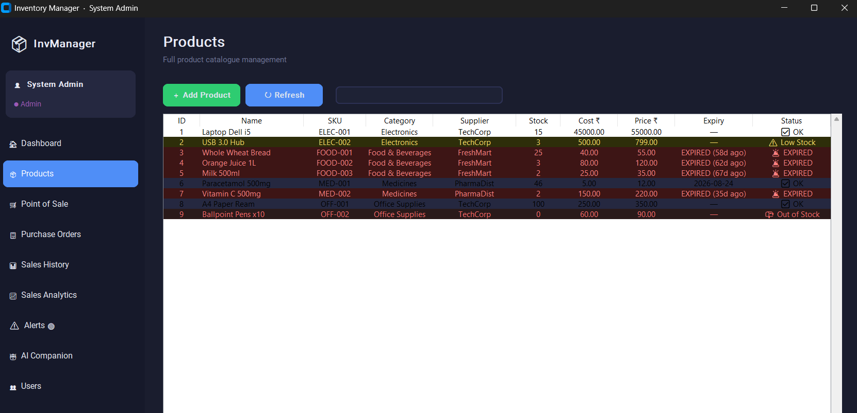
Description: Displays the full product catalog in a scrollable table with live search, and the Add/Edit panel for entering and modifying product details including SKU and expiry date.
Point of Sale (POS) Interface
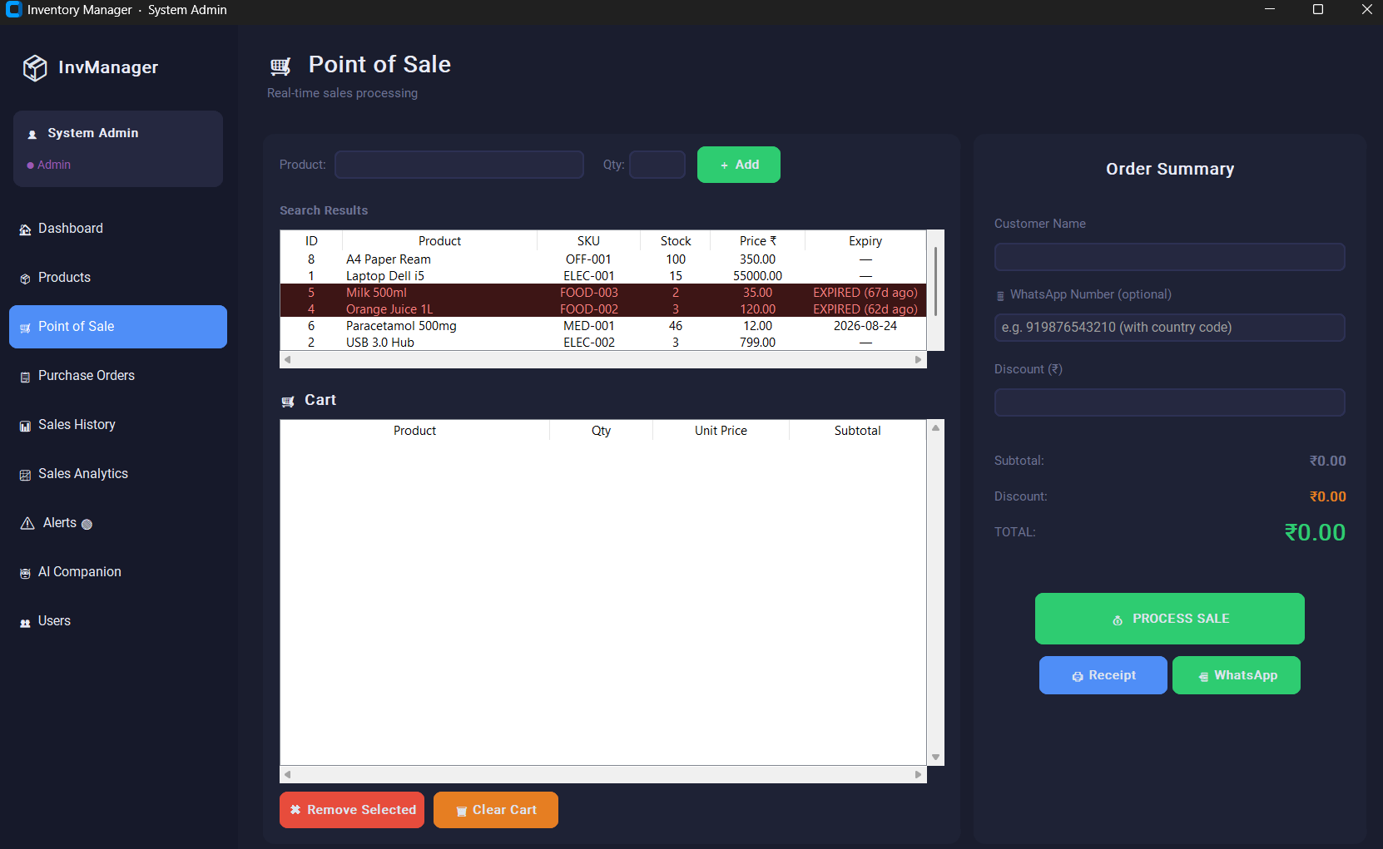
Description: Shows the dual-panel POS layout — product search on the left and the live session cart on the right — with the discount field and Process Sale button.
Sales Analytics Dashboard
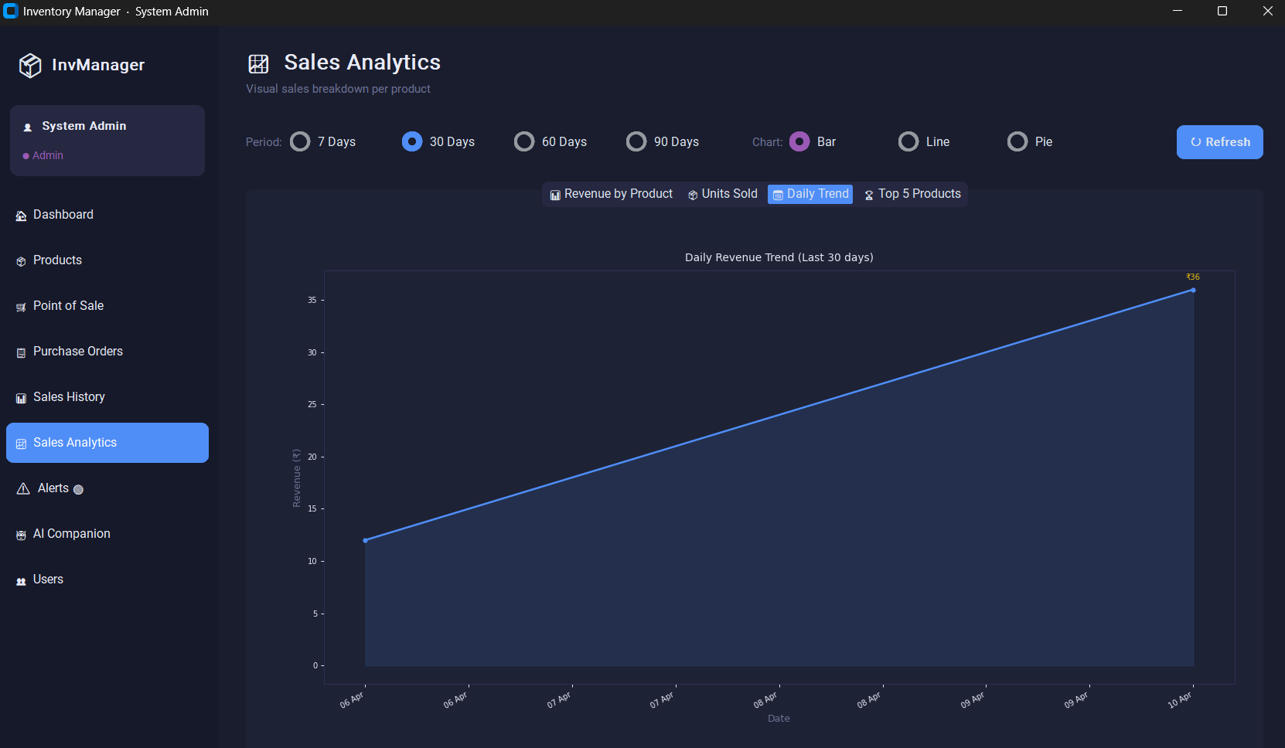Description: Displays the four embedded Matplotlib chart tabs with the period filter selector. All charts are rendered inside the application window with the dark navy theme.
5.4 Back End Representation (Database to be used)
The backend of the Inventory Management System is powered entirely by Python through the centralized db_config.py module, ensuring a clean separation between the presentation and data layers. All nine MySQL 8.0 (InnoDB) tables are accessed exclusively through parameterized execute_query() calls. The schema is designed in 3rd Normal Form (3NF) to eliminate data redundancy. The stock_transactions table functions as a comprehensive immutable audit log of every stock movement triggered by sales, purchase order receipts, and manual adjustments — providing full traceability for inventory auditing.
5.5 Snapshots of Database Tables with Brief Description
Key database table snapshots demonstrating real operational data:
Table 1: products Table
product_id | name | sku | selling_price | quantity | expiry_date
101 | Basmati Rice 5kg | GRC-001 | ₹450.00 | 120 | 2027-06-30
102 | LED Bulb 9W | ELC-002 | ₹85.00 | 4 | NULL
103 | Hand Sanitizer 500ml | PHM-003 | ₹120.00 | 0 | 2026-05-15
104 | Notebook A4 Pack | STN-004 | ₹65.00 | 200 | NULL
Description: Product 102 has quantity=4 (low stock alert triggered). Product 103 has quantity=0 (out-of-stock alert) and is expiring on 2026-05-15 (expiring-soon alert).
Table 2: sales_orders Table
order_id | user_id | customer_name | discount | total_amount | order_date
5001 | 2 | Rahul Verma | ₹0.00 | ₹535.00 | 2026-04-28 10:23:41
5002 | 3 | Priya Singh | ₹50.00 | ₹400.00 | 2026-04-28 11:15:22
5003 | 2 | Walk-in | ₹0.00 | ₹1200.00 | 2026-04-29 09:05:11
Description: Order 5002 includes a ₹50 discount applied at POS. Each order header links to detailed line items in the sales_order_items table.
Table 3: stock_transactions Table
txn_id | product_id | user_id | txn_type | quantity | reference_id | txn_date
9001 | 101 | 2 | sale | -5 | 5001 | 2026-04-28 10:23:42
9002 | 102 | 2 | sale | -2 | 5001 | 2026-04-28 10:23:42
9003 | 101 | 1 | purchase | +50 | PO-12 | 2026-04-27 09:00:00
9004 | 103 | 1 | adjustment | -10 | NULL | 2026-04-26 14:30:00
Description: The stock_transactions table acts as an immutable audit log. Negative quantities indicate stock out (sales), positive quantities indicate stock in (purchases/adjustments). Every movement is traceable to a user and an originating transaction.
Table 4: users Table
user_id | username | full_name | role | is_active | created_at
1 | admin | Admin User | Admin | 1 | 2026-01-10 09:00:00
2 | manager1 | Ravi Sharma | Manager | 1 | 2026-01-11 10:15:22
3 | staff1 | Priya Mehta | Staff | 1 | 2026-01-12 09:05:11
Description: Role field controls the sidebar modules visible after login. is_active=0 blocks the account from logging in without deleting the audit history.

CHAPTER 6 – SUMMARY AND CONCLUSIONS
6.1 Summary
Effective inventory management is a foundational requirement for the financial health of any retail business. Manual approaches to stock tracking, expiry monitoring, and restocking decisions are inherently error-prone and inefficient. The Inventory Management System was conceptualized, designed, and successfully developed to address these challenges through a comprehensive, locally-deployed desktop application.
The system was built using Python 3.x, CustomTkinter 5.x, and MySQL 8.0, following an iterative development methodology. Ten functional modules were designed, individually tested, and integrated into a cohesive application: Login & Authentication, Dashboard, Product Management, Point of Sale, Purchase Orders, Sales History, Sales Analytics, Alerts, AI Companion, and User Management. The entire application logic is contained in approximately 2100 lines of code in main.py, with database operations centralized in db_config.py for security and maintainability.
The system successfully implements RBAC across three roles, full product CRUD with expiry tracking, atomic POS sales processing with WhatsApp receipt sharing, purchase order lifecycle management, four-category alert monitoring, embedded Matplotlib analytics, and a velocity-based AI Companion with priority-flagged restocking recommendations. All ten test cases passed, validating the reliability of the system across its primary operational scenarios.
6.2 Conclusions
Based on the development, testing, and evaluation of the system, the following conclusions are drawn:
1. Effective Digitization of Retail Inventory Operations: The system successfully eliminates manual stock management by providing a centralized, database-driven platform that handles the complete inventory lifecycle — from procurement through sales to restocking — with speed, accuracy, and a full audit trail.
2. Reliability of the Technology Stack: The combination of Python, CustomTkinter, and MySQL 8.0 proved to be a highly stable and productive stack. Centralizing all SQL access through parameterized execute_query() calls ensured consistent security and significantly reduced the likelihood of runtime errors across all modules.
3. Value of Atomic Transaction Processing: The implementation of atomic POS transactions — ensuring that sales orders, order items, stock updates, and audit log entries are all committed or all rolled back together — proved critical to maintaining inventory data integrity across all tested scenarios.
4. Practical Utility of the AI Companion: The velocity-based restocking algorithm (V = total_sold ÷ analysis_days; Fs = Fd × 1.20) consistently generated actionable, priority-flagged restocking recommendations that would directly reduce both stockout and overstock risks in a real retail environment.
5. Importance of Proactive Alert Management: The four-category alert system (Expired, Expiring Soon, Low Stock, Out of Stock) with sidebar badge auto-update demonstrated that proactive, real-time alerts significantly reduce the likelihood of undetected expiries and stockouts compared to reactive manual checks.
6. Practical Real-World Applicability: Overall, the Inventory Management System functions as a practical, deployable solution for small and medium retail businesses. It directly addresses the inefficiencies of manual workflows and provides a scalable, well-structured foundation for future enhancements.

CHAPTER 7 – FUTURE SCOPE
While the Inventory Management System successfully fulfills its primary academic objectives, there is substantial potential for scaling the system's architecture and capabilities in the following strategic directions:
1. ARIMA / Prophet-Based Demand Forecasting: The current AI Companion uses a linear sales velocity model that does not account for seasonality, promotional spikes, or trend changes. A future enhancement would replace this with statistical time-series forecasting models such as ARIMA or Facebook Prophet. By training these models on historical sales data, the system could generate significantly more accurate demand forecasts — particularly for seasonal products — reducing both overstock and stockout risks.
2. Cloud MySQL Deployment and Multi-Branch Support: The current architecture is limited to a single local workstation. Migrating the MySQL database to a cloud platform such as AWS RDS or Google Cloud SQL would enable multi-branch retail chains to share a single centralized inventory database. The CustomTkinter frontend could communicate with the cloud database over a secure VPN, enabling real-time stock visibility across all branches.
3. Barcode and QR Code Scanner Integration: The current POS and Product Management modules require manual entry of product names and SKUs. Integrating USB barcode scanner support would allow staff to scan product barcodes directly, reducing data entry time by an estimated 80% and virtually eliminating manual entry errors at the point of sale.
4. PDF Receipt and Invoice Generation: The current WhatsApp receipt feature sends a text-format message via wa.me. A future iteration would generate professionally formatted PDF receipts and purchase invoices using the ReportLab library, providing formal printed documentation for customers and suppliers.
5. WhatsApp Business API Integration: The current WhatsApp feature requires the user to manually confirm sending in the browser. Integrating the official WhatsApp Business API would enable fully automated, server-side receipt delivery directly from the application without any manual browser interaction, significantly improving the POS workflow speed.
6. Flutter Mobile Application: A companion mobile application built with Flutter would allow business owners and managers to monitor live stock levels, view sales analytics, receive push notifications for low-stock alerts, and approve purchase orders remotely from their smartphones — transforming the system into a fully mobile-accessible inventory management platform.

APPENDIX
APPENDIX I
Default Login Credentials
Role | Username | Password
Admin | admin | admin123
Manager | manager1 | manager123
Staff | staff1 | staff123
APPENDIX II
Core Implementation: AI Companion Restocking Algorithm
The following Python snippet demonstrates the restocking calculation logic:
import math
SAFETY_BUFFER = 1.20 # 20% safety margin
def calculate_restocking(total_sold: int, analysis_days: int,
forecast_days: int, current_qty: int,
is_perishable: bool = False,
days_to_expiry: int = None) -> dict:
"""
AI Companion restocking recommendation.
V = total_sold / analysis_days (sales velocity)
Fd = V * forecast_days (forecast demand)
Fs = Fd * SAFETY_BUFFER (safe order qty)
"""
if analysis_days == 0:
return {'priority': 'OK', 'qmin': 0, 'qmax': 0}
velocity = total_sold / analysis_days
forecast_demand = velocity * forecast_days
safe_qty = forecast_demand * SAFETY_BUFFER
# Cap perishables if they expire before forecast window ends
if is_perishable and days_to_expiry and days_to_expiry < forecast_days:
safe_qty = velocity * days_to_expiry * SAFETY_BUFFER
qmin = math.floor(safe_qty * 0.85)
qmax = math.ceil(safe_qty * 1.25)
stock_days = current_qty / velocity if velocity > 0 else float('inf')
if stock_days <= forecast_days * 0.50:
priority = 'URGENT'
elif stock_days <= forecast_days:
priority = 'ORDER SOON'
else:
priority = 'OK'
return {'velocity': round(velocity, 2), 'qmin': qmin,
'qmax': qmax, 'priority': priority}
APPENDIX III
Database Schema (Key Table Creation Statements)
CREATE TABLE products (
product_id INT AUTO_INCREMENT PRIMARY KEY,
name VARCHAR(200) NOT NULL,
sku VARCHAR(50) UNIQUE NOT NULL,
category_id INT,
supplier_id INT,
cost_price DECIMAL(10,2) NOT NULL,
selling_price DECIMAL(10,2) NOT NULL,
quantity INT NOT NULL DEFAULT 0,
expiry_date DATE,
INDEX idx_expiry (expiry_date),
INDEX idx_qty (quantity),
FOREIGN KEY (category_id) REFERENCES categories(category_id) ON DELETE SET NULL,
FOREIGN KEY (supplier_id) REFERENCES suppliers(supplier_id) ON DELETE SET NULL
);
CREATE TABLE stock_transactions (
txn_id INT AUTO_INCREMENT PRIMARY KEY,
product_id INT NOT NULL,
user_id INT NOT NULL,
txn_type ENUM('sale','purchase','adjustment','stock_in','stock_out') NOT NULL,
quantity INT NOT NULL,
reference_id INT,
txn_date TIMESTAMP DEFAULT CURRENT_TIMESTAMP,
FOREIGN KEY (product_id) REFERENCES products(product_id) ON DELETE CASCADE,
FOREIGN KEY (user_id) REFERENCES users(user_id) ON DELETE CASCADE
);

BIBLIOGRAPHY
[1] N. DeHoratius and A. Raman, "Inventory Record Inaccuracy: An Empirical Analysis," Management Science, vol. 54, no. 4, pp. 627–641, 2008.
[2] M. Lutz, Learning Python, 5th ed. Sebastopol, CA: O'Reilly Media, 2013.
[3] S. Makridakis, E. Spiliotis, and V. Assimakopoulos, "The M4 Competition: Results, Findings, Conclusion and Way Forward," International Journal of Forecasting, vol. 34, no. 4, pp. 802–808, 2018.
[4] B. Schwartz, P. Zaitsev, and V. Tkachenko, High Performance MySQL, 3rd ed. Sebastopol, CA: O'Reilly Media, 2012.
[5] Python Software Foundation, "Python 3 Documentation," 2024. [Online]. Available: https://docs.python.org/3/.
[6] Oracle Corporation, "MySQL 8.0 Reference Manual," 2024. [Online]. Available: https://dev.mysql.com/doc/refman/8.0/en/.
[7] J. D. Hunter, "Matplotlib: A 2D graphics environment," Computing in Science & Engineering, vol. 9, no. 3, pp. 90–95, 2007.
[8] T. Schimansky, "CustomTkinter: A modern UI-library for Python," GitHub repository, 2023. [Online]. Available: https://github.com/TomSchimansky/CustomTkinter.
[9] E. F. Codd, "A Relational Model of Data for Large Shared Data Banks," Communications of the ACM, vol. 13, no. 6, pp. 377–387, 1970.
[10] S. Chopra and P. Meindl, Supply Chain Management: Strategy, Planning, and Operation, 6th ed. Hoboken, NJ: Pearson, 2016.

