Final Technical Documentation
Agentic Clinical Deterioration & Escalation Copilot
Intra IIT Tech Meet 1.0 - PS-1
This document describes the final runnable prototype, its architecture, the data flow, the demo path, tests and known limitations.

1. Problem and objective
The system monitors a synthetic stream of patient observations, maintains an evolving per-patient state, detects multi-parameter deterioration instead of reacting to one reading, reduces repetitive alerts, retrieves supporting guideline text and produces a concise escalation explanation. A clinician can act on an alert and the decision is recorded.

2. Final architecture
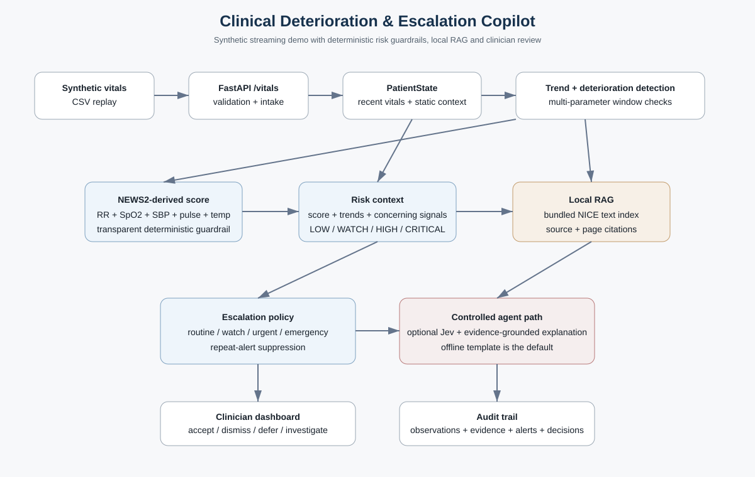
The implementation keeps the main stages proposed in the midterm plan: streaming -> state -> trend detection -> scoring -> RAG -> controlled escalation -> clinician action -> audit.

3. Data and state
Static context comes from data/patient_profiles/patient_demographics.csv. It contains synthetic age, gender, admission diagnosis, history, medications, recent labs, procedures and notes. Live data comes from data/raw/synthetic_vitals.csv and is replayed one observation at a time.
PatientState keeps a bounded recent history. Readings are ordered by timestamp; duplicate timestamps are ignored and out-of-order observations are still accepted. The latest derived trend, deterioration result, NEWS2-derived score, risk context, retrieval evidence and escalation result are stored on the patient state.

4. Detection and scoring
Trend detection compares two windows of recent observations. The detector flags directions that are concerning for the prototype: rising heart rate, rising respiratory rate, falling systolic blood pressure, falling oxygen saturation and rising temperature. A strong trajectory is defined as at least three concerning directions.
The scoring layer calculates a deterministic NEWS2-derived total from the variables available in this synthetic dataset: respiratory rate, SpO2, systolic blood pressure, pulse and temperature. It does not fabricate unavailable inputs such as consciousness or oxygen-support status.

5. RAG and agent path
Guideline text is stored locally. A prebuilt JSON chunk index is used by the demo so the web server does not need to parse PDFs when the first vital arrives. Retrieval uses token overlap and returns source/page information with each passage.
The controlled agent path is optional. A structured Jev integration is available through an environment key; the default path uses a deterministic local heuristic. The explanation layer is also offline by default and creates a transparent template from the score, trend evidence, static context and retrieved passages. Anthropic can be enabled explicitly through ANTHROPIC_API_KEY.

6. Escalation and alert suppression
- Insufficient history: no escalation decision is made.
- Low-risk state: continue routine monitoring.
- Intermediate deterioration: increase monitoring.
- NEWS2-derived score 5-6: raise an urgent response.
- NEWS2-derived score 7 or above: preserve an emergency guardrail and provide supporting evidence.
- Strong multi-parameter deterioration at a lower score: consult the structured judge before clinical review.
- Repeated alerts with the same priority/action/source inside the 30-minute suppression window are suppressed.

7. Clinician loop and audit
The dashboard supports Accept, Dismiss, Defer and Investigate actions. Events are appended to data/audit/events.jsonl. The audit record includes processed observations, deterministic evidence, retrieved passages, alerts, rejected stream records and clinician decisions.

8. API and demo
Start the backend with:
python -m uvicorn src.api.main:app --host 127.0.0.1 --port 8001
Then open http://127.0.0.1:8001/ and start the stream with:
python src/streaming/streamer.py
The default streamer starts near the deterioration phase of synthetic patient 3, so the dashboard reaches an alert state quickly during the demo.

9. Testing
The final local test run contains 20 passing tests. Coverage includes scoring boundaries, trend detection, insufficient-data behavior, escalation branches, pipeline integration, duplicate timestamps, out-of-order readings, impossible values and repeated-alert suppression.

10. Changes from the midterm plan
- The RAG layer uses a local keyword retriever and prebuilt JSON index instead of a hosted vector database.
- Jev and Anthropic are optional integrations; deterministic offline behavior is the default.
- The clinician loop and audit trail are implemented directly in FastAPI.
- The frontend is a same-origin HTML/JavaScript dashboard with a WebSocket live feed, avoiding a separate frontend build.

11. Limitations
- All patient data are synthetic.
- Trend rules are prototype heuristics and have not been clinically validated.
- The NEWS2-derived calculation uses only fields available in the prototype dataset.
- Keyword retrieval is not semantic vector retrieval.
- No clinical deployment validation, governance review or certification has been performed.

