**Exercise 2: E-commerce Platform Search Function**

**CODE**

ANS) using System;

using System.Collections.Generic;

using System.Linq;

// Product Class

public class Product

{

public string Name { get; set; }

public decimal Price { get; set; }

public Product(string name, decimal price)

{

Name = name;

Price = price;

}

}

// Main Program

class Program

{

static void Main(string[] args)

{

// Sample product list

List<Product> products = new List<Product>

{

new Product("Apple iPhone 15", 999.99m),

new Product("Samsung Galaxy S24", 899.50m),

new Product("Google Pixel 8", 799.00m),

new Product("OnePlus 12", 649.99m),

new Product("Sony Headphones", 199.99m),

new Product("Apple Watch", 399.00m)

};

Console.Write("Enter product name to search: ");

string keyword = Console.ReadLine();

// Case-insensitive search using LINQ

var results = products

.Where(p => p.Name.IndexOf(keyword, StringComparison.OrdinalIgnoreCase) >= 0)

.ToList();

// Display results

if (results.Count > 0)

{

Console.WriteLine("\nSearch Results:");

foreach (var product in results)

{

Console.WriteLine($"- {product.Name} (${product.Price})");

}

}

else

{

Console.WriteLine("\nNo products found.");

}

}

}

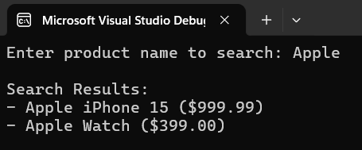

**Exercise 7: Financial Forecasting**

**Code**

ANS)using System;

class Program

{

static void Main(string[] args)

{

// Input: Initial revenue

Console.Write("Enter initial monthly revenue: ₹");

decimal revenue = Convert.ToDecimal(Console.ReadLine());

// Input: Growth rate

Console.Write("Enter monthly growth rate (%): ");

decimal growthRate = Convert.ToDecimal(Console.ReadLine());

// Input: Forecast period in months

Console.Write("Enter number of months to forecast: ");

int months = Convert.ToInt32(Console.ReadLine());

Console.WriteLine("\n📈 Financial Forecast:");

Console.WriteLine("----------------------------");

for (int i = 1; i <= months; i++)

{

revenue += revenue * (growthRate / 100);

Console.WriteLine($"Month {i}: ₹{Math.Round(revenue, 2)}");

}

}

}

