# ReactJS-HOL Handson

## **Objectives**

* List the features of ES6
* Explain JavaScript let
* Identify the differences between var and let
* Explain JavaScript const
* Explain ES6 class fundamentals
* Explain ES6 class inheritance
* Define ES6 arrow functions
* Identify set(), map()

In this hands-on lab, you will learn how to:

* Use map() method of ES6
* Apply arrow functions of ES6
* Implement Destructuring features of ES6

## **Prerequisites**

The following is required to complete this hands-on lab:

* Node.js
* NPM
* Visual Studio Code

**Code):- App.js**

// App.js

import React from "react";

import ListofPlayers from "./components/ListofPlayers";

import IndianPlayers from "./components/IndianPlayers";

function App() {

  const flag = true; // Change to false to switch component

  return (

    <div className="App">

      <h1>Cricket App</h1>

      {flag ? <ListofPlayers /> : <IndianPlayers />}

    </div>

  );

}

export default App;

**Output:-**

When flag == true;

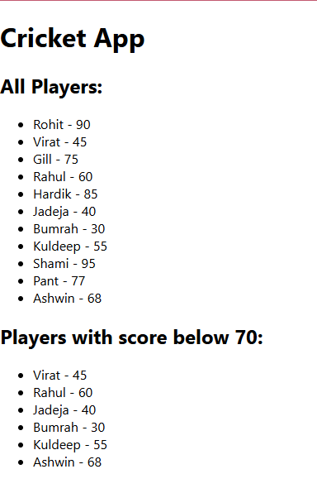

When flag == false;

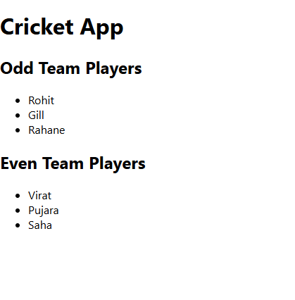

# ReactJS-HOL Handson

## **Objectives**

* Define JSX
* Explain about ECMA Script
* Explain React.createElement()
* Explain how to create React nodes with JSX
* Define how to render JSX to DOM
* Explain how to use JavaScript expressions in JSX
* Explain how to use inline CSS in JSX

In this hands-on lab, you will learn how to:

* Use JSX syntax in React applications
* Use inline CSS in JSX

## **Prerequisites**

The following is required to complete this hands-on lab:

* Node.js
* NPM
* Visual Studio Code

**Code:-**

**App.js**

import React from 'react';

function App() {

  const heading = <h1>Office Space Rentals</h1>;

  const officeImage = "https://via.placeholder.com/300x150?text=Office+Space";

  const office = {

    name: "Tech Hub Office",

    rent: 55000,

    address: "Sector 21, Bangalore"

  };

  const officeList = [

    { name: "Innovate Tower", rent: 45000, address: "Delhi" },

    { name: "Startup Bay", rent: 62000, address: "Mumbai" },

    { name: "Cloud View", rent: 70000, address: "Hyderabad" },

    { name: "Idea Space", rent: 30000, address: "Chennai" }

  ];

  const getRentStyle = (rent) => {

    return {

      color: rent >= 60000 ? 'green' : 'red',

      fontWeight: 'bold'

    };

  };

  return (

    <div className="App">

      {heading}

      <img src={officeImage} alt="Office" style={{ width: '300px', height: '150px' }} />

      <h2>Main Office:</h2>

      <p><strong>Name:</strong> {office.name}</p>

      <p><strong>Rent:</strong> <span style={getRentStyle(office.rent)}>{office.rent}</span></p>

      <p><strong>Address:</strong> {office.address}</p>

      <h2>Other Available Offices:</h2>

      <ul>

        {officeList.map((o, index) => (

          <li key={index}>

            <p><strong>Name:</strong> {o.name}</p>

            <p>

              <strong>Rent:</strong>{" "}

              <span style={getRentStyle(o.rent)}>{o.rent}</span>

            </p>

            <p><strong>Address:</strong> {o.address}</p>

            <hr />

          </li>

        ))}

      </ul>

    </div>

  );

}

export default App;

**Output:-**

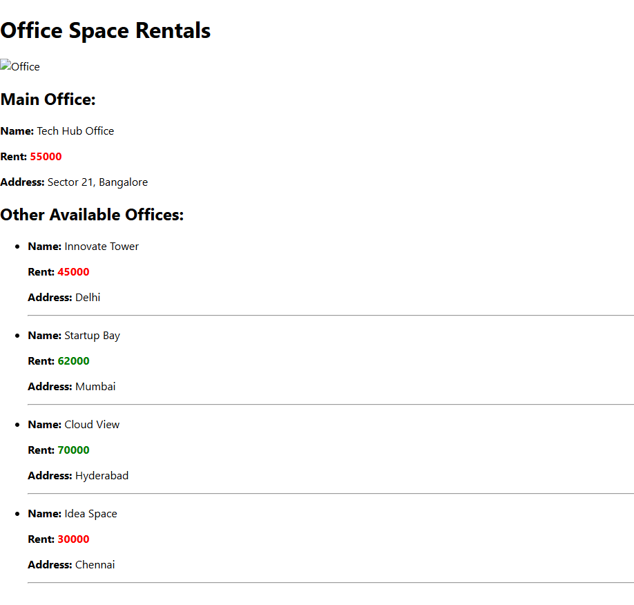

# ReactJS-HOL Handson

## **Objectives**

* Explain React events
* Explain about event handlers
* Define Synthetic event
* Identify React event naming convention

In this hands-on lab, you will learn how to:

* Implement Event handling concept in React applications
* Use this keyword
* Use synthetic event

## **Prerequisites**

The following is required to complete this hands-on lab:

* Node.js
* NPM
* Visual Studio Code

**Code:-**

**App.js**

import React, { useState } from "react";

import CurrencyConvertor from "./CurrencyConvertor";

function App() {

  const [count, setCount] = useState(0);

  const increment = () => {

    setCount(prev => prev + 1);

    sayHello();

  };

  const decrement = () => setCount(prev => prev - 1);

  const sayHello = () => {

    console.log("Hello! Counter updated.");

  };

  const sayWelcome = (message) => {

    alert(message);

  };

  const handleSyntheticEvent = (event) => {

    alert("I was clicked");

    console.log("Synthetic event type:", event.type);

  };

  return (

    <div className="App">

      <h1>React Event Handling Demo</h1>

      <h2>Counter: {count}</h2>

      <button onClick={increment}>Increment</button>{" "}

      <button onClick={decrement}>Decrement</button>

      <br /><br />

      <button onClick={() => sayWelcome("Welcome to the Event App!")}>Say Welcome</button>

      <br /><br />

      <button onClick={handleSyntheticEvent}>Synthetic Event: OnPress</button>

      <br /><br />

      <CurrencyConvertor />

    </div>

  );

}

export default App;

**CurrencyConverter.js**

import React, { useState } from "react";

function CurrencyConvertor() {

  const [rupees, setRupees] = useState("");

  const [euros, setEuros] = useState(null);

  const handleSubmit = () => {

    const rate = 0.011; // Example rate: 1 INR = 0.011 EUR

    const converted = (parseFloat(rupees) * rate).toFixed(2);

    setEuros(converted);

  };

  return (

    <div>

      <h2>Currency Convertor (INR → EUR)</h2>

      <input

        type="number"

        placeholder="Enter INR"

        value={rupees}

        onChange={(e) => setRupees(e.target.value)}

      />

      <button onClick={handleSubmit}>Convert</button>

      {euros !== null && (

        <p>{rupees} INR = {euros} EUR</p>

      )}

    </div>

  );

}

export default CurrencyConvertor;

**Output:-**

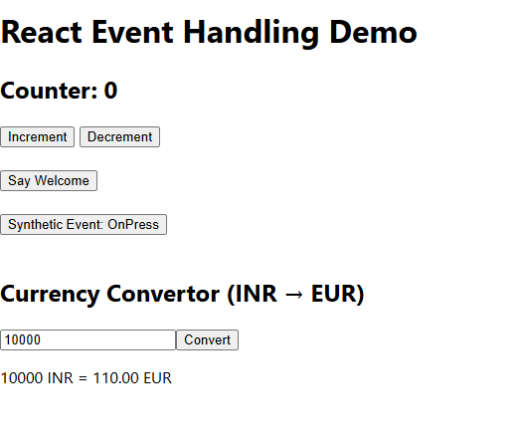

# ReactJS-HOL Handson

## **Objectives**

* Explain about conditional rendering in React
* Define element variables
* Explain how to prevent components from rendering

In this hands-on lab, you will learn how to:

* Implement conditional rendering in React applications

## **Prerequisites**

The following is required to complete this hands-on lab:

* Node.js
* NPM
* Visual Studio Code

**Code:-**

**App.js**

import React, { useState } from 'react';

import GuestPage from './GuestPage';

import UserPage from './UserPage';

function App() {

  const [isLoggedIn, setIsLoggedIn] = useState(false);

  let pageToDisplay;

  if (isLoggedIn) {

    pageToDisplay = <UserPage />;

  } else {

    pageToDisplay = <GuestPage />;

  }

  return (

    <div className="App">

      <h1>🎫 Ticket Booking App</h1>

      <div style={{ marginBottom: '20px' }}>

        {isLoggedIn ? (

          <button onClick={() => setIsLoggedIn(false)}>Logout</button>

        ) : (

          <button onClick={() => setIsLoggedIn(true)}>Login</button>

        )}

      </div>

      {pageToDisplay}

    </div>

  );

}

export default App;

**UserPage.js**

// src/UserPage.js

import React from 'react';

const UserPage = () => {

  return (

    <div>

      <h2>Welcome Back, User!</h2>

      <p>You can now book tickets:</p>

      <button>Book Flight to Delhi</button>

      <button>Book Flight to Mumbai</button>

    </div>

  );

};

export default UserPage;

**GuestPage.js**

// src/GuestPage.js

import React from 'react';

const GuestPage = () => {

  return (

    <div>

      <h2>Welcome, Guest!</h2>

      <p>Here are available flights:</p>

      <ul>

        <li>✈️ Delhi → Mumbai at 10:00 AM</li>

        <li>✈️ Bangalore → Hyderabad at 2:00 PM</li>

        <li>✈️ Kolkata → Chennai at 6:30 PM</li>

      </ul>

      <p><strong>Login to book tickets.</strong></p>

    </div>

  );

};

export default GuestPage;

**Ouput:-**

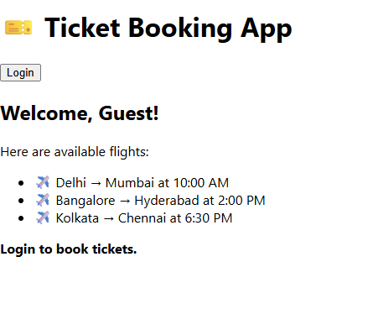

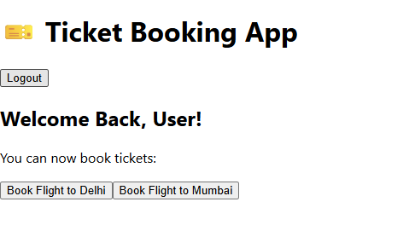

# ReactJS-HOL Handson

## **Objectives**

* Explain various ways of conditional rendering
* Explain how to render multiple components
* Define list component
* Explain about keys in React applications
* Explain how to extract components with keys
* Explain React Map, map() function

In this hands-on lab, you will learn how to:

* Implement conditional rendering in React applications

## **Prerequisites**

The following is required to complete this hands-on lab:

* Node.js
* NPM
* Visual Studio Code

**Code:-**

**App.js**

import React, { useState } from 'react';

import BookDetails from './components/BookDetails';

import BlogDetails from './components/BlogDetails';

import CourseDetails from './components/CourseDetails';

function App() {

  const [page, setPage] = useState("book");

  // 1. Element variable

  let content;

  if (page === "book") {

    content = <BookDetails />;

  } else if (page === "blog") {

    content = <BlogDetails />;

  } else {

    content = <CourseDetails />;

  }

  return (

    <div className="App">

      <h1>📘 Blogger App</h1>

      {/* 2. Button switch for conditional rendering */}

      <button onClick={() => setPage("book")}>Show Books</button>

      <button onClick={() => setPage("blog")}>Show Blogs</button>

      <button onClick={() => setPage("course")}>Show Courses</button>

      <hr />

      {/* 3. Ternary Operator Rendering */}

      {page === "book"

        ? <BookDetails />

        : page === "blog"

        ? <BlogDetails />

        : <CourseDetails />

      }

      <hr />

      {/* 4. Element variable rendering */}

      {content}

    </div>

  );

}

export default App;

**BookDetails.js**

import React from 'react';

const BookDetails = () => {

  const books = [

    { id: 1, title: "Clean Code", author: "Robert C. Martin" },

    { id: 2, title: "You Don't Know JS", author: "Kyle Simpson" }

  ];

  return (

    <div>

      <h2>📚 Book Details</h2>

      <ul>

        {books.map(book => (

          <li key={book.id}>{book.title} — {book.author}</li>

        ))}

      </ul>

    </div>

  );

};

export default BookDetails;

**BlogDetails.js**

import React from 'react';

const BlogDetails = () => {

  const blogs = [

    { id: 1, title: "React Performance Tips" },

    { id: 2, title: "JavaScript ES6 Features" }

  ];

  return (

    <div>

      <h2>📝 Blog Details</h2>

      <ul>

        {blogs.map(blog => (

          <li key={blog.id}>{blog.title}</li>

        ))}

      </ul>

    </div>

  );

};

export default BlogDetails;

**CourseDetails.js**

import React from 'react';

const CourseDetails = () => {

  const courses = [

    { id: 1, name: "ReactJS", duration: "4 weeks" },

    { id: 2, name: "NodeJS", duration: "6 weeks" }

  ];

  return (

    <div>

      <h2>🎓 Course Details</h2>

      <ul>

        {courses.map(course => (

          <li key={course.id}>{course.name} — {course.duration}</li>

        ))}

      </ul>

    </div>

  );

};

export default CourseDetails;

**Output:-**



