Assignment

**Task 1:** Derive top 5 actionable insights from the data

* Fields like user_name, designation, region_1, region_2 have lots of missing values.
* Values of points are distributed between 80 to 100 following a gaussian-like (normal) distribution.
* Prices have a high difference between the values and a high standard deviation with the Interquartile Range (IQR) as 25.
* The distribution of prices can be converted to a normal distribution by performing a logarithmic transformation on the feature.
* 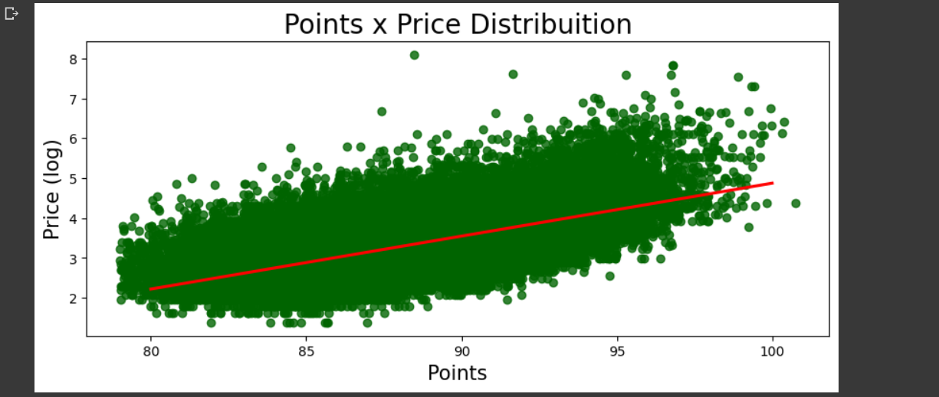
* The above scatterplot tells us that points and prices are somewhat linearly related. Same goes for description length and price feature.
* 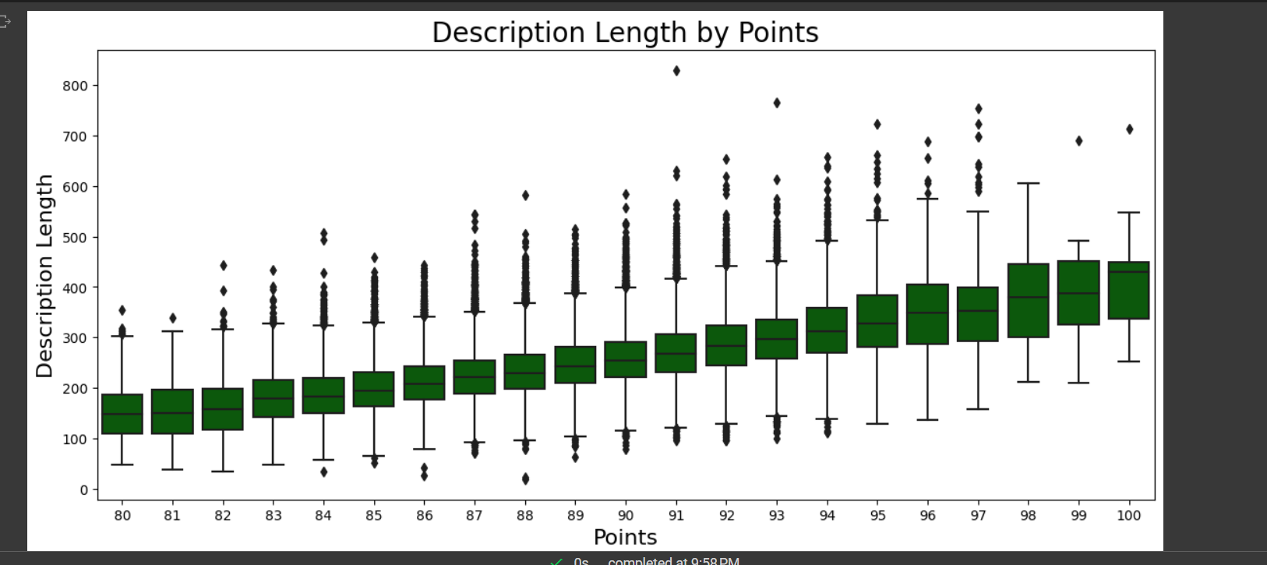
* The above boxplot shows us that the wines with the highest points also have the longest description.
* The most popular wine varieties include Pinot Noir, Chardonnay, Cabernet Sauvignon, Red Blend, Bordeaux-Style Red Blend.
* The varieties which have positive sentiment in their reviews tend to have greater price and the ones with negative sentiments tend to be cheaper.