Panic Engine: Warning Time, Alert Reach and
Route Choice in Pedestrian Evacuation
Aasritha Lakshmi Dakshinyam  aasritha.dakshinyam@gmail.com | Jagruthi Bachuwar  jagruthibachuwar@gmail.com | Jasmitha Devi Budithi  jashdev26@gmail.com | Lavanya Goura  g_lavanya@av.amrita.edu

Abstract—How many people get out of danger when a sudden threat appears depends on when they are warned, how many hear the warning and which routes they take. We present Panic Engine, an open agent-based simulator that runs on open map data, and apply it to the Amrita Vishwa Vidyapeetham campus at Amaravati and to Mangalagiri, 4.2 km away. Four scenarios run on identical crowds with three routing rules and ten random crowds per setting. On the campus the share caught fell from 21.3% at a 60 s warning to 6.5% at 180 s and 0% at 300 s; in Mangalagiri it fell from 6.2% at 30 s to 0.0% at 180 s. A lower bound from the model matches this: a warning must exceed the longest reaction delay plus the walk out of the blast circle, about 220 s on the campus and 140 s in Mangalagiri. Routing changed the number caught by about half a percentage point on the campus, which is not significant after correction. When everybody starts at one point and paths hold 0.25 persons per metre, shortest-path routing evacuated only 94.0% (campus) and 79.6% (Mangalagiri) of the crowd in 30 minutes, against 100% for the other rules; at 0.5 persons per metre, or with people spread over many start points, every rule evacuated everyone. With 30% of people holding a phone, 28.1% of the campus crowd evacuated, and neighbours passing the word raised this to 85.8%. The parameters are assumed and the model is uncalibrated.
Index Terms—evacuation simulation, agent-based modelling, warning time, alert channels, congestion-aware routing, OpenStreetMap.
I. Introduction
A fire, a flood or a reported explosive device can leave only minutes between the first warning and the moment the threat takes effect. How many people reach safety in that time depends on when they are warned, how many of them hear the warning, and which routes they take. None of this can be tested at full scale, so a simulation is a sensible first step before a drill.
SUMO [1] and MATSim [2] can represent evacuations, but they were built around vehicle flows and need work to fit a single neighbourhood. A campus safety office or a town office would want something lighter: a tool that runs on a laptop, reads open map data, keeps every run for replay and audit, and lets a non-specialist change one setting and see what happens. Panic Engine was written for that. Work on tsunami evacuation found that warning parameters change pedestrian outcomes and used a sensitivity analysis to show it [3]; we take the same approach to a point hazard in two places in Andhra Pradesh, India, the Amrita Vishwa Vidyapeetham campus at Amaravati and the town of Mangalagiri, about 4.2 km away. The two places differ in road density, in how many residents live inside the blast circle and in how far the safe stops are, so we can see whether a conclusion depends on the place, but not which of these differences causes it. Despite its name, the model has no panic behaviour: people follow planned routes and never push or trample.
We make four contributions. (1) The model is written as equations, each implemented in the code and checked against it; two simple results, a lower bound on the people caught and a discharge time for a shared route, serve as consistency checks of the simulator. (2) Three routing rules run on identical stored crowds, so differences are paired and come with 95% confidence intervals. (3) Four scenarios run on both areas with ten random crowds per setting, plus sensitivity runs that show which results depend on assumed values. (4) The code is open and includes a dashboard, a 3-D replay and a phone-style alert screen.
II. Related Work
Detailed models of individual motion in continuous space suit a room or a bottleneck, and recent reviews cover, for example, how social groups change crowd dynamics and how this is modelled [4]. A systematic review of agent-based evacuation models [5] shows how many modelling choices exist. At the scale of a campus or a town, what limits people is the footpath network, the time a path takes to cross and the capacity of the safe places, so we model movement on a graph and ignore contact between individuals. Carles et al. studied how warning parameters change tsunami evacuation outcomes [3]; we vary one factor at a time in the same way for a point blast, and add alert channels and routing rules. The Bureau of Public Roads (BPR) function relates link travel time to the ratio of load to capacity [6]; its constants for road traffic are 0.15 and 4, but footpaths differ, so we treat them as settings and vary them. Wardrop’s principle that travellers choose the cheapest route given what others do, reviewed in [7], underlies congestion-aware routing, and routes are found with Dijkstra’s algorithm [8].
III. Study Areas and Data
Both areas use the OpenStreetMap footpath network (map data © OpenStreetMap contributors), downloaded with OSMnx [9] and held as a directed graph in the NetworkX library. The first is a 6 km radius around the Amrita campus (16.45606° N, 80.53816° E), the second a 3 km radius around the centre of Mangalagiri (16.43182° N, 80.56881° E); the centres are 4.24 km apart (7). Table I gives their size. Over the whole map Mangalagiri has 126 nodes and 26.8 km of directed road per square kilometre and the campus 61 nodes and 14.9 km (Fig. 1). Inside the 525 m alert circle, where the residents live, the figures are 480 nodes/km² and 62.7 km/km² against 43 nodes/km² and 18.0 km/km², so the town is far denser near the bomb. A synthetic grid of 80 nodes serves only as a benchmark in the crowd-stress test.
The drill is set up the same way in both real areas. The bomb is placed at the road node nearest the map centre. Residents start at road nodes inside the alert radius from which a safe stop can be reached on foot, thinned to at most 60 start nodes. Three safe stops are chosen by a fixed rule (in each third of the compass, the node whose walking distance from the centre is closest to 1 km, or to 0.6 times the farthest reachable distance if that is smaller). They are hypothetical places, marked as such in the database, and not the official assembly points of either area. The campus stops lie inside the 525 m alert circle; this is intended, because the circle is the area that receives the alert and a stop only has to lie outside the 150 m blast circle.
TABLE I
THE TWO STUDY AREAS
Property | Campus | Mangalagiri
Radius of the map | 6 km | 3 km
Nodes | 6,916 | 3,576
Directed road segments | 18,526 | 9,812
Start nodes of residents | 37 | 60
Start nodes in the blast circle | 9 of 37 | 4 of 60
Straight-line distance, bomb to stops A, B, C (m) | 291, 480, 500 | 731, 748, 789

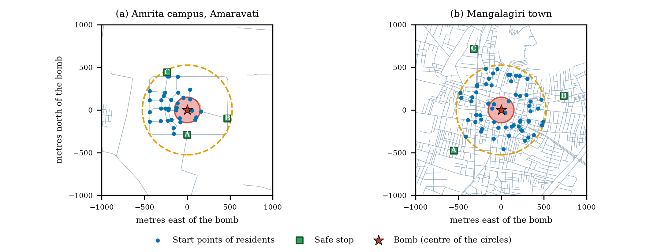
Fig. 1. The two study areas around the bomb. Map data © OpenStreetMap contributors. Blue-grey lines are footpaths and roads, the dashed orange circle is the 525 m alert radius, the red disc the 150 m blast radius, blue dots are the start points of the residents and green squares the three safe stops.
IV. Mathematical Model
The walking network is a directed graph G = (N, E); segment e has length L_{e} and an OpenStreetMap class c. Times are in seconds and lengths in metres. OpenStreetMap does not record how many people a path can hold, so capacity is an assumption that grows with length and with a class width factor w_{c},
$C_{e}=\max\left(2,\operatorname{round}\left(ρw_{c}L_{e}\right)\right),$ (1)
ρ = 0.25 persons per metre and w_{c} from 0.3 (steps) to 2.0 (primary roads), with 1.0 for residential roads; a 100 m residential road holds 25 people. With ρ fixed, the flow a full residential road can pass is ρw_{c}v/(1 + α) = 0.22 persons per second whatever its length (Property 4), which is probably below what real footpaths carry, so Section VIII-C varies ρ. With walking speed v (1.4 m/s) the free-flow time is
$t_{e}^{0}=\frac{L_{e}}{v}.$ (2)
A person stepping onto e when n_{e} people are on it needs the Bureau of Public Roads time [6], fixed at entry from the load before that person joins, with load ratio r_{e} = n_{e}/C_{e}:
$t_{e}=t_{e}^{0}\left(1+αr_{e}^{β}\right).$ (3)
A segment can be entered only if n_{e} < C_{e}; otherwise the person waits at its tail node. Hence r_{e} ≤ 1 and t_{e} ≤ (1 + α)t_{e}⁰. We use α = 0.6 and β = 2.
The crowd has N people; person i starts at a node o_{i} drawn uniformly from the start set O. With strike time τ_{s} and warning lead time λ the alert is sent at
$τ_{a}=\max\left(0,τ_{s}−λ\right).$ (4)
Person i hears the alert at time a_{i} (a_{i} = τ_{a} when everybody hears it at once, as in the bomb drills), waits a reaction delay δ_{i} uniform on [0, δ_{max}] and sets off at
$d_{i}=a_{i}+δ_{i}, P\left(δ_{i}≤x\right)=\frac{x}{δ_{max}}.$ (5)
The mean delay is δ_{max}/2 and the variance δ_{max}²/12; with δ_{max} = 90 s these are 45 s and 675 s². In the alert-channel scenario a person has a phone with probability φ and then hears the alert at τ_{a} + u_{i} (u_{i} uniform on [0, 15] s). Others hear nothing unless a person within ρ_{n} metres who already knows tells them h seconds later (people stand on their start node, so those on one node are 0 m apart, except in the spread-out run of Section VIII-D),
$a_{j}=\min_{i: dist(i,j) ≤ ρn}\left(a_{i}+h\right),$ (6)
solved as a shortest-path problem over the people; someone nobody reaches never moves. Distances use the haversine formula on a sphere of radius R = 6,371,000 m,
$\operatorname{dist}\left(p,q\right)=2R\arcsin{\sqrt{\sin^{2}\left(\frac{Δφ}{2}\right)+\cos\left(φ_{p}\right)\cos\left(φ_{q}\right)\sin^{2}\left(\frac{Δλ}{2}\right)}}$ (7)
A hazard at h has blast radius R_{b} and alert radius R_{a} = max(3.5 R_{b}, 200 m), giving the blast and alert areas
$B=\left\{p:dist(p,h)≤R_{b}\right\}, A=\left\{p:dist(p,h)≤R_{a}\right\}.$ (8)
At τ_{s} every segment with both ends in B closes and safe stops inside B are lost. Let I_{s} be the people not yet finished and x_{i}(τ_{s}) the position of person i; the people caught (no injury is modelled, so this is the only harm we count) are
$K=\left\{i∈I_{s}:x_{i}\left(τ_{s}\right)∈B\right\}.$ (9)
A route is a least-cost path found with Dijkstra’s algorithm [8]. The three rules differ only in segment cost and in how a stop is chosen. Shortest path uses c_{SP}(e) = t_{e}⁰; the congestion-aware rule adds the current load and the number q_{e} of people waiting to enter,
$c_{CA}\left(e\right)=t_{e}^{0}\left(1+αr_{e}^{β}\right)+γ\frac{q_{e}t_{e}^{0}}{C_{e}},$ (10)
with γ = 1. In every rule, segments in the blast area (set E_{B}, both ends in B) carry a penalty so nobody is sent toward the bomb when another way exists,
$c^{′}\left(e\right)=c(e)+Π·1\left(e∈E_{B}\right), Π=600 s.$ (11)
The congestion-aware and load-balanced rules also penalise crowded stops: if m_{j} other people head for stop j of capacity K_{j}, the penalty is
$π_{j}=W\frac{m_{j}}{K_{j}}, W=300 s,$ (12)
and a person at node o chooses among open stops (available and not full) with least route cost D_{c}:
$j_{i}^{*}={argmin}_{j}\left[D_{c}\left(o,j\right)+π_{j}\right].$ (13)
Shortest path has π_{j} = 0. The dynamic rules re-plan every 30 s and switch only if the new score S_{new} is clearly better than the current one, S_{cur},
$S^{new}<\left(1−θ\right)S^{cur}, θ=0.15,$ (14)
and at once when the next segment closes or the stop becomes full or lost. The load-balanced rule differs in who decides: a planner assigns every person a stop before the run, in departure order, by
$j_{i}^{*}={argmin}_{j}\left[f_{j},D_{c}\left(o,j\right)+W\frac{m_{j}}{K_{j}},j\right],$ (15)
compared lexicographically, where m_{j} now counts the people already assigned to stop j and f_{j} = 1 if that count has reached K_{j} and 0 otherwise. A stop admits 8 people per 5 s time step up to K_{j} = 300; people queue at its gate. In each step the engine closes due roads, delivers alerts, applies the strike, completes crossings, releases departures, admits people at stops and lets waiting people enter their next road.
With ℰ the people admitted to a stop and t_{i} their admission times, we report the shares caught and evacuated and the median time from the alert T_{med} = median(t_{i} − τ_{a}) over ℰ:
$P_{K}=\frac{100|K|}{N}, P_{ℰ}=\frac{100|ℰ|}{N}.$ (16)
The three rules run on the same n crowds, so rules A and B are compared by the per-crowd differences d_{k} = x_{k}(A) − x_{k}(B), with mean d̄, sample standard deviation s_{d} and 95% interval
$d̄±t_{0.975, n−1}\frac{s_{d}}{\sqrt{n}},$ (17)
t_{0.975, 9} = 2.2622 for ten crowds, computed by inverting the Student distribution.
Property 1 (free-flow bound). With D₀ the least free-flow time and r_{e} ≥ 0, the time in (3) satisfies t_{e} ≥ t_{e}⁰, so a person admitted to stop j_{i} satisfies
$t_{i}≥d_{i}+D_{0}\left(o_{i},j_{i}\right).$ (18)
Property 2 (blast bound). A boundary node is a node of B with a road to a node outside B; T_{o} is the least free-flow time from o to one. A person cannot be outside B before reaching a boundary node, so when everybody hears the alert at τ_{a} the bound holds for every rule:
$|K|≥N_{LB}=|\left\{i: o_{i}∈B, δ_{i}+T_{o}>λ\right\}|.$ (19)
Property 3 (expectation). The bound is zero once λ ≥ λ* = δ_{max} + max T_{o} over o ∈ O ∩ B, the planning lead time. For uniform delays a person starting at o ∈ B meets the condition with probability min{1, max{0, 1 − (λ − T_{o})/δ_{max}}}, so
$E\left[N_{LB}\right]=\frac{N}{|O|}\sum_{o∈O∩B}{\min\left\{1,\max\left\{0,1−\frac{λ−T_{o}}{δ_{max}}\right\}\right\}}$ (20)
Property 4 (bottleneck discharge). If all N people set off together along one route, a segment holds at most C_{e} people who each need at least t_{e}, so by Little’s law its throughput is at most C_{e}/t_{e}, and at full load t_{e} = (1 + α)t_{e}⁰. The narrowest segment passes about
$q=\min_{e∈route}\frac{C_{e}}{\left(1+α\right)t_{e}^{0}}, T_{k}≈T_{0}+\frac{k}{q},$ (21)
with T₀ the free-flow walking time of the route and T_{k} the admission time of the k-th person. This is an approximation, since other segments and the stop gate also hold people back.
V. Scenarios and Parameters
Every scenario runs on both areas with the three rules on ten random crowds (seeds 1 to 10) of 250 people; each crowd is stored once and used by all three rules. S1, bomb drill: a 150 m bomb at the map centre goes off at τ_{s} = 420 s and residents walk to the safe stops; λ = 60, 180, 300, 400 s on the campus and 30, 60, 120, 180, 300 s in Mangalagiri. S2, crowd stress: no hazard; all people (300 on the grid) start at the single start point, set off after their reaction delay and the run stops at 1800 s. S3, road closure: as S2, but a 150 m danger zone centred on the middle of the free-flow shortest route to the nearest stop closes its roads at 300 s; people on a closed road finish it. S2 and S3 are deterministic for shortest path, so we add S2′ and S3′ with the crowd spread over the 37 or 60 start nodes of the drill and, in S3′, the closure on the route from a randomly drawn start node (the same for every rule). We also vary the path capacity ρ in S2. S4, partial alert reach: as S1 with λ = 180 s (campus) or 60 s (Mangalagiri), but only a share φ = 100%, 60% or 30% of the crowd hears the alert on a phone, or 30% with neighbours passing the word (50 m, 20 s per hop).
Table II lists the parameters. Most are assumptions: OpenStreetMap does not contain path capacities, reaction delays or stop capacities, and we did not measure them. We vary the important ones in Section VIII and do not present absolute results as predictions. Walking speed varies with age, group and crowd density, as a systematic review shows [10], so we vary it from 1.0 to 1.8 m/s around the default; α and β differ from the road-traffic values [6].
TABLE II
MODEL PARAMETERS (ALL ASSUMED)
Parameter | Value (varied)
Walking speed v | 1.4 m/s (1.0 to 1.8)
Capacity ρ; width factors w_{c} | 0.25/m (0.5 to 2); 0.3 to 2.0
BPR α, β; queue weight γ | 0.6, 2; 1
Longest reaction delay δ_{max} | 90 s (30 to 180 s)
Phone spread; relay ρ_{n}, h | 15 s; 50 m, 20 s
Blast R_{b}; alert R_{a} | 150 m (100, 200); max(3.5 R_{b}, 200 m)
Strike τ_{s}; lead time λ | 420 s; 30 to 400 s
Penalties Π, W; θ; re-plan | 600 s, 300 s; 0.15; 30 s
Stop capacity K_{j}; admission | 300 (150); 8 per step
Time step; time limits | 5 s; 2400 s (S1, S4), 1800 s (S2, S3)
Crowd size N | 250 (300 grid); 400 tested

VI. Software and Interface
Panic Engine is written in Python. A scenario builder sets the start points, stops, hazard, closures and alert channels, and a seeded generator draws and stores the crowd. The engine of Section IV writes every run to an SQLite database, which the dashboard, the replay and the result tables read. The dashboard has quick controls (routing rule, walking speed, RUN, COMPARE ALL 3, PHONE) and a sidebar for the bomb, alert channels and crowd (Fig. 2a). The deck.gl replay (Fig. 2b–d) draws the alert and blast areas, every person and extruded buildings from 21,250 cached OpenStreetMap footprints, which cover 99% of the Mangalagiri road nodes. A phone-style screen shows what one tracked person sees.
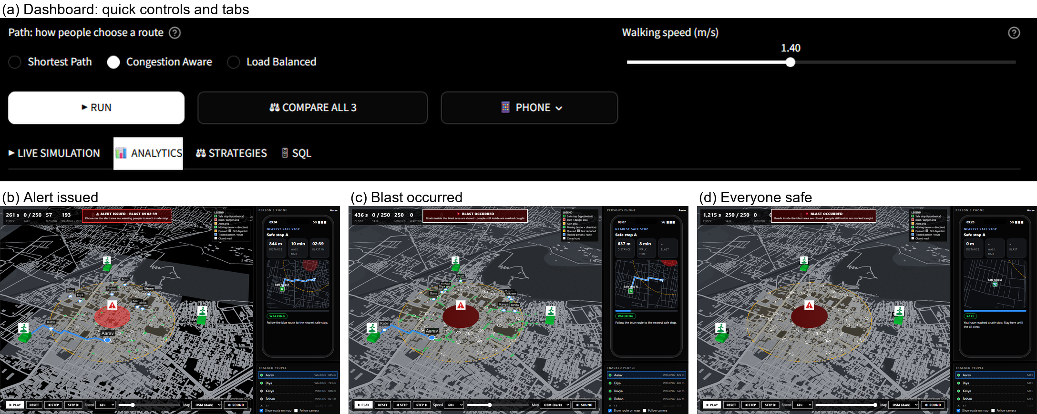
Fig. 2. The interface. (a) Quick controls and tabs of the dashboard. (b)–(d) The 3-D replay of a drill in Mangalagiri with the phone-style screen of a tracked person: the alert is issued, the blast has occurred, and everyone has reached a safe stop.
VII. Verification
We checked that the code does what Section IV says; this is verification, not validation against real events (Section IX). 82 automated tests pass, and rerunning the formula checks and the paired statistics reproduced the saved results. Table III gives seven formula checks (scripts/verify_model.py).
TABLE III
NUMERICAL CHECKS OF THE FORMULAS
Check | Result
V1 ((1), (3)) | Six cases: largest code-formula difference 0.0 s; 100 m of footway, residential, tertiary, primary road hold 15, 25, 32, 50 people
V2 ((7)) | Campus to Mangalagiri 4,235.66 m; flat projection differs by 6 × 10⁻⁹ (relative)
V3 ((5)) | 20,000 delays: mean 44.9 s (expected 45.0), variance 684 s² (675)
V4 ((18)) | Holds for every evacuated person in all 63 runs; smallest slack 0.05 s
V5 ((19)) | Caught ≥ bound in all 63 runs and rules; bound is 71% (Mangalagiri) and 53% (campus) of the simulated count
V6 ((20)) | Expected vs mean realised bound. Mangalagiri 30 s: 13.9 vs 13.3; 60 s: 9.1 vs 8.3; campus 60 s: 34.1 vs 34.1; 180 s: 3.1 vs 4.0 people
V7 ((21)) | Median time, predicted vs simulated: campus 1072 vs 1105 s (−3.0%); Mangalagiri 1256 vs 1305 s (−3.8%)

The blast bound ignores crowding and detours, so the simulator catches more, and that it never catches fewer (63 of 63 runs) is the check. The discharge formula is close for the median but over-predicts the share of the campus crowd evacuated in 30 minutes (99.7% against 94.0%), because the other roads and the stop gate also hold people back.
VIII. Results
A. Warning time (S1)
Table IV and Fig. 3 give the share caught at the strike. On the campus 21.3% are caught with a 60 s warning, 6.5% with 180 s and nobody with 300 s or more; in Mangalagiri the share is 6.2% at 30 s, 5.2% at 60 s, 1.5% at 120 s and 0.0% at 180 s. The most that can be caught is the share of residents who start inside the blast circle, 9 of 37 start nodes (24.3%) on the campus and 4 of 60 (6.7%) in Mangalagiri. Measured against these shares, the campus catches 87% of them at 60 s and 27% at 180 s, and Mangalagiri 94% at 30 s.
This result is largely fixed by two assumed values. By (19) the lower bound is zero once λ ≥ λ* = δ_{max} + max T_{o}, the longest reaction delay plus the longest time to walk out of the blast circle; λ* is 222 s on the campus and 137 s in Mangalagiri. The simulated shares follow this: nobody is caught at 300 s on the campus, and only 0.04% (one person in one crowd) at 180 s in Mangalagiri, where crowding and detours still catch a few above λ*. The simulator thus confirms a planning rule more than it adds to it. Nobody in Mangalagiri reaches a stop before the strike, because the stops are 731 to 789 m away, whereas on the campus 6.6%, 16.2%, 24.0% and 35.6% are safe at 60, 180, 300 and 400 s; these shares are the same for all rules. The areas differ in several ways at once (Table I), so these comparisons are descriptive.
TABLE IV
PEOPLE CAUGHT AT THE STRIKE (%, MEAN ± SD OVER 10 CROWDS)
Area, lead time | Shortest | Congestion | Balanced
Campus, 60 s | 21.3 ± 4.0 | 20.8 ± 4.0 | 20.8 ± 4.0
Campus, 180 s | 6.5 ± 1.9 | 5.9 ± 1.8 | 5.8 ± 1.8
Campus, 300 s | 0.0 ± 0.0 | 0.0 ± 0.0 | 0.0 ± 0.0
Campus, 400 s | 0.0 ± 0.0 | 0.0 ± 0.0 | 0.0 ± 0.0
Mangalagiri, 30 s | 6.2 ± 1.5 | 6.2 ± 1.5 | 6.2 ± 1.5
Mangalagiri, 60 s | 5.2 ± 1.9 | 5.2 ± 1.8 | 5.2 ± 1.8
Mangalagiri, 120 s | 1.5 ± 1.1 | 1.5 ± 1.1 | 1.5 ± 1.1
Mangalagiri, 180 s | 0.0 ± 0.1 | 0.0 ± 0.1 | 0.0 ± 0.1
Mangalagiri, 300 s | 0.0 ± 0.0 | 0.0 ± 0.0 | 0.0 ± 0.0

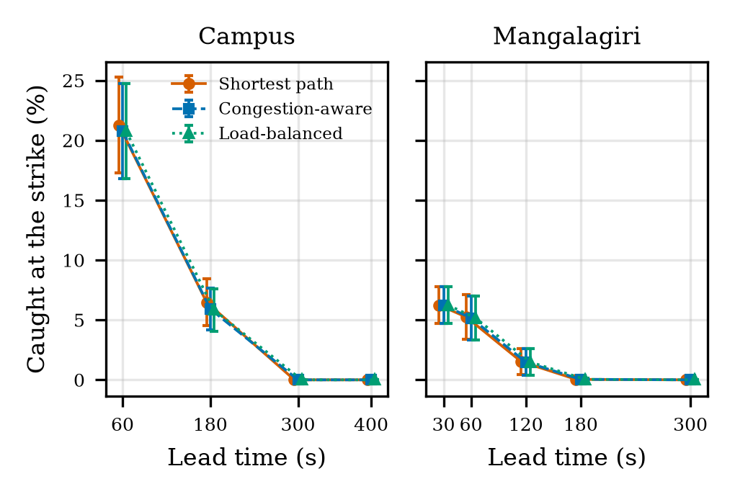
Fig. 3. People caught at the strike against the warning lead time (mean and standard deviation over ten crowds).
B. Routing rule in the bomb drills
The rules run on the same crowds, so we compare them by paired differences (17). These comparisons are exploratory. On the campus shortest path caught 0.52 [0.16, 0.88] percentage points more people than congestion-aware routing at a 60 s lead (mean difference and unadjusted 95% interval; more in 8 of 10 crowds, fewer in none) and 0.56 [0.03, 1.09] at 180 s, about 1.4 people of 250. Across the nine bomb-drill comparisons the Holm-adjusted p-values are 0.085 (60 s) and 0.31 (180 s), so neither survives the correction, and in Mangalagiri no interval excludes zero (60 s: 0.08 [−0.04, 0.20]). We therefore do not claim that the routing rule changes the number caught in the drills. Among those who reached a stop, the median time from the alert was 15.0 [4.4, 25.6] s shorter with congestion-aware routing at 180 s on the campus (unadjusted); the load-balanced rule did not differ from it (0.08 [−0.10, 0.26] points caught).
C. Crowd stress and road closure (S2, S3)
In S2 and S3 everybody starts at one point and uses one route, so shortest path gives the same result in all ten crowds: the narrowest road fixes when people arrive, whatever their delays. The ten crowds are then one outcome, not ten independent samples, and Table V gives no spread for those rows. With path capacity ρ = 0.25 shortest path evacuated 94.0% of the campus crowd within 30 minutes against 100.0% for the other rules, and half of all people had arrived after 1150 s against 805 s (congestion-aware) and 842 s (load-balanced); in Mangalagiri the shares were 79.6% and 100%. A closure on the shortest route gave 82.4% against 100% on the campus and 75.6% against 97.2% in Mangalagiri. By Property 4 the campus route passes 0.17 people per second at its narrowest segment, so the last of 250 people arrives about 1,800 s after the alert, the end of the 30 minutes.
TABLE V
PEOPLE EVACUATED WITHIN 30 MINUTES, NO HAZARD (%)
Scenario | Shortest | Congestion | Balanced
Campus, stress | 94.0 | 100.0 | 100.0
Campus, closure | 82.4 | 100.0 | 100.0
Mangalagiri, stress | 79.6 | 100.0 | 100.0
Mangalagiri, closure | 75.6 | 97.2 | 97.2
Grid, stress (300) | 60.7 ± 0.2 | 78.1 ± 1.7 | 78.0 ± 1.7
Campus, stress, many starts | 100.0 | 100.0 | 100.0
Campus, closure, many starts | 88.0 ± 7.5 | 91.8 ± 3.5 | 91.7 ± 3.6
Mangalagiri, stress, many starts | 100.0 | 100.0 | 100.0
Mangalagiri, closure, many starts | 94.9 ± 4.0 | 95.0 ± 3.6 | 95.0 ± 3.6

The large gaps therefore depend on two assumptions. Table VI gives, for shortest path, the share evacuated and the time by which half of all people had arrived, followed by the same time for congestion-aware routing (SP / CA, ρ in persons per metre). With the path capacity raised to ρ = 0.5 persons per metre, shortest path already evacuated everyone in both areas and only the times differ, and at ρ = 2 all three rules gave the same times on the campus. With the crowd spread over the 37 or 60 start nodes of the drill (S2′, S3′; the closure is centred on the route from a randomly drawn start node, the same for every rule) all rules evacuated everyone in the stress test. In the closure test the rules differ on the campus (shortest path −3.76 [−6.69, −0.83] points relative to congestion-aware, unadjusted) and not in Mangalagiri (Table V). The single-start figures are a worst case, not a general result about routing.
TABLE VI
EFFECT OF PATH CAPACITY ON THE STRESS TEST
ρ | Campus evac. (%) | Campus half, SP / CA (s) | Mang. evac. (%) | Mang. half, SP / CA (s)
0.25 | 94.0 | 1150 / 805 | 79.6 | 1430 / 1120
0.5 | 100.0 | 775 / 643 | 100.0 | 1130 / 974
1 | 100.0 | 580 / 551 | 100.0 | 981 / 889
2 | 100.0 | 465 / 465 | 100.0 | 890 / 840

D. How far the alert reaches (S4)
People who hear nothing never move, so the share evacuated is close to the phone share (Table VII): 28.1% on the campus and 28.2% in Mangalagiri with 30% phone reach. With a phone for everyone the campus share caught is 7.5%, above the 6.5% of S1 at the same lead, because a phone alert arrives up to 15 s late (Mangalagiri: 5.6% against 5.2%). Only people in the blast circle are caught, so the campus share rises from 7.5% to 18.6% as phones fall from 100% to 30%, while Mangalagiri barely changes (5.6% to 6.2%). Neighbours passing the word raised the share evacuated to 85.8% and 80.8% and cut the campus share caught to 8.6%; in Mangalagiri the relay was too slow for the 60 s lead. The relay used start nodes, so about 7 people on the campus stood at one point; spreading each person at random up to 100 m from the node lowered the shares evacuated only to 83.6% and 77.6%, so stacking does not explain the relay effect. The rules differ by under one point.
TABLE VII
EFFECT OF THE SHARE OF PEOPLE WITH A PHONE (SHORTEST PATH, %)
Phone share | Campus caught | Campus evac. | Mang. caught | Mang. evac.
100% | 7.5 | 92.5 | 5.6 | 94.4
60% | 14.0 | 55.1 | 6.0 | 55.8
30% | 18.6 | 28.1 | 6.2 | 28.2
30% + relay | 8.6 | 85.8 | 6.2 | 80.8
30% + relay, spread | 8.3 | 83.6 | 6.2 | 77.6

E. Sensitivity to the assumed values
Table VIII changes one factor at a time around the campus drill with a 180 s lead, on stored crowds. Reaction delay, walking speed and blast radius move the outcome far more than the routing rule: with delays up to 30 s only 1.8% are caught against 11.8% at 180 s, and slow walking (1.0 m/s) leaves 10.0% caught against 2.9% at 1.8 m/s; a 100 m blast radius leaves 1.0%. The ranking of the rules is not stable: with a 200 m blast radius congestion-aware routing caught more (13.0% against 11.3%; shortest path minus congestion-aware −1.68 [−2.32, −1.04] points, unadjusted). In the stress test shortest path evacuated 68.0% at α = 1.2, 62.8% with half-size stops and 58.8% with 400 people (94.0% at the base values), against 100% for congestion-aware routing in all three; as Table VI shows, these results depend strongly on the assumed path capacity.
TABLE VIII
PEOPLE CAUGHT ON THE CAMPUS (%), LEAD TIME OF 180 SECONDS, ONE FACTOR CHANGED
Change | Shortest | Congestion
Base case | 6.5 ± 1.9 | 5.9 ± 1.8
Walking 1.0 m/s | 10.0 ± 2.4 | 9.5 ± 2.5
Walking 1.8 m/s | 2.9 ± 1.2 | 2.4 ± 1.3
Reaction delay ≤ 30 s | 1.8 ± 1.5 | 1.8 ± 1.5
Reaction delay ≤ 180 s | 11.8 ± 2.6 | 11.0 ± 2.4
Blast radius 200 m | 11.3 ± 2.8 | 13.0 ± 2.9

IX. Limitations
We have not calibrated or validated the model against field data. We did not time real walks, observe a drill or compare the output with another simulator, so verification only shows that the code implements the equations, not that the equations describe real people. Capacities, admission rates, reaction delays and congestion constants are assumed (Table II), and the crowd-stress results depend strongly on the path capacity (Table VI); absolute numbers should not be quoted as predictions for either place. Several simplifications matter. People do not touch each other, and a waiting person does not block the road behind, so gridlock is understated. Everybody in a run walks at the same speed, so slower walkers appear only as a lower average speed. The crowd is synthetic (250 to 400 people), the safe stops are hypothetical, the blast is a circle without shielding, and no injury is modelled. People who hear no alert stay where they are; they count as caught if they are inside the blast at the strike and otherwise as neither caught nor evacuated. OpenStreetMap may be incomplete in a new area [11]. The alert is a single time and reach per person, whereas recent work reviews how communication and social behaviour are modelled in agent-based evacuation [5] and implements the notification procedures of emergency services in a large-scale model [12]. The two areas differ at once in road density, share of people in the blast circle, stop distance and map radius, so differences between them cannot be tied to one cause. We study two places and one hazard type, with the bomb at the map centre. Only the nine bomb-drill comparisons of Section VIII-B are corrected for multiple testing; all other comparisons are exploratory.
X. Conclusion
Panic Engine lets us compare warning times, alert reach and routing rules on identical crowds. The model is written as equations, and a lower bound on the people caught and a discharge time for a shared route were checked, with the other equations, against the simulator. On the campus and in Mangalagiri, a warning longer than the longest reaction delay plus the walk out of the blast circle (about 220 s and 140 s) removed or nearly removed the people caught. Shorter reaction delays and faster average walking cut the number caught sharply, and the reach of the alert decided how many people moved at all. The routing rule changed the number caught by about half a point on the campus, which is not significant after correction, and by nothing measurable in Mangalagiri. It decided whether a crowd got out in time only when everybody started at one point on narrow paths or a closure sat on the shortest route. With wider paths or a spread-out crowd the differences were small. Next we would calibrate the model with timed walks and a drill, measure path capacities, give people individual walking speeds, compare with SUMO or MATSim on the same network, and use the official assembly points.
Code and results: https://github.com/Ash19123/panic-engine (seeds 1 to 10 fix all random choices).
References
[1] Y. Chen, S. Y. Shafi, and Y.-f. Chen, “Simulation pipeline for traffic evacuation in urban areas and emergency traffic management policy improvements through case studies,” Transp. Res. Interdiscip. Perspect., vol. 7, Art. no. 100210, Sep. 2020, doi: 10.1016/j.trip.2020.100210.
[2] D. Singh, L. Padgham, and K. Nagel, “Using MATSim as a component in dynamic agent-based micro-simulations,” in Engineering Multi-Agent Systems (Lecture Notes in Computer Science). Cham, Switzerland: Springer, 2020, pp. 85–105, doi: 10.1007/978-3-030-51417-4_5.
[3] N. Carles, K. Chapuis, J. Douvinet, M. Péroche, and E. Bopp, “An agent-based model to simulate the effects of tsunami warnings on pedestrian evacuation: Sensitivity analysis and early findings,” in PRIMA 2024: Principles and Practice of Multi-Agent Systems (Lecture Notes in Computer Science, vol. 15395), R. Arisaka, V. Sanchez-Anguix, S. Stein, R. Aydoğan, L. van der Torre, and T. Ito, Eds. Cham, Switzerland: Springer Nature Switzerland, 2025, pp. 369–384, doi: 10.1007/978-3-031-77367-9_28.
[4] A. Nicolas and F. H. Hassan, “Social groups in pedestrian crowds: Review of their influence on the dynamics and their modelling,” Transportmetrica A, Transp. Sci., vol. 19, no. 1, Art. no. 1970651, Jan. 2023, doi: 10.1080/23249935.2021.1970651.
[5] A. Templeton, H. Xie, S. Gwynne, A. Hunt, P. Thompson, and G. Köster, “Agent-based models of social behaviour and communication in evacuations: A systematic review,” Saf. Sci., vol. 176, Art. no. 106520, Aug. 2024, doi: 10.1016/j.ssci.2024.106520.
[6] N. Gore, S. Arkatkar, G. Joshi, and C. Antoniou, “Modified Bureau of Public Roads link function,” Transp. Res. Rec., vol. 2677, no. 5, pp. 966–990, May 2023, doi: 10.1177/03611981221138511.
[7] V. Morandi, “Bridging the user equilibrium and the system optimum in static traffic assignment: A review,” 4OR, vol. 22, no. 1, pp. 89–119, Mar. 2024, doi: 10.1007/s10288-023-00540-w.
[8] M. Thorup, “Dijkstra’s single source shortest path algorithm,” in Edsger Wybe Dijkstra: His Life, Work, and Legacy, K. R. Apt and T. Hoare, Eds. New York, NY, USA: ACM, 2022, pp. 21–26, doi: 10.1145/3544585.3544589.
[9] G. Boeing, “Modeling and analyzing urban networks and amenities with OSMnx,” Geogr. Anal., vol. 57, no. 4, pp. 567–577, Oct. 2025, doi: 10.1111/gean.70009.
[10] M. Giannoulaki and Z. Christoforou, “Pedestrian walking speed analysis: A systematic review,” Sustainability, vol. 16, no. 11, Art. no. 4813, Jun. 2024, doi: 10.3390/su16114813.
[11] M. Moradi, S. Roche, and M. A. Mostafavi, “Exploring five indicators for the quality of OpenStreetMap road networks: A case study of Québec, Canada,” Geomatica, vol. 75, no. 4, pp. 1–31, Dec. 2021, doi: 10.1139/geomat-2021-0012.
[12] P. J. Lawrence, L. Filippidis, A. Veeraswamy, D. Blackshields, M. Marzoli, and S. Marsella, “Implementing notification strategies in the urbanEXODUS large-scale evacuation model,” Saf. Sci., vol. 187, Art. no. 106854, Jul. 2025, doi: 10.1016/j.ssci.2025.106854.

