Warning Time, Alert Reach and Route Choice in Pedestrian Evacuation: An Agent-Based Simulation of a University Campus and a Nearby Town
Aasritha Lakshmi Dakshinyam  aasritha.dakshinyam@gmail.com | Jagruthi Bachuwar  jagruthibachuwar@gmail.com | Jasmitha Devi Budithi  jashdev26@gmail.com | Lavanya Goura  Project Guide  g_lavanya@av.amrita.edu
Amrita Vishwa Vidyapeetham, Amaravati, India
Abstract— When a sudden threat appears in a populated area, the number of people who get out of danger depends on how early they are warned, how many the warning reaches, and which routes they walk. This paper presents Panic Engine, an open agent-based simulator that runs on a laptop and uses open map data, and applies it to the Amrita Vishwa Vidyapeetham campus at Amaravati and the town of Mangalagiri, 4.2 km away. We state the model mathematically, derive a lower bound on the number of people caught by a hazard and a formula for the discharge time of a shared route, and check both against the simulator. Four scenarios (bomb drill with a warning time, crowd stress, road closure, partial alert reach) are run on identical crowds with three routing rules, ten random crowds per setting. On the campus, the share caught fell from 21.3% at a 60 s warning to 6.5% at 180 s and 0% at 300 s; in Mangalagiri it fell from 6.2% at 30 s to 0.0% at 180 s. Routing changed the number caught by about half a percentage point on the campus, but when roads were loaded or closed, shortest-path routing evacuated only 94.0% (campus) and 79.6% (Mangalagiri) of the crowd within 30 minutes, against 100% for the other two rules. With 30% of people holding a phone, 28.1% of the campus crowd moved; neighbours passing the word raised this to 85.8%. The parameters are assumptions and the model is not calibrated with field data, so the results compare factors and are not forecasts.
Keywords— evacuation simulation, agent-based modelling, warning time, alert channels, congestion-aware routing, campus safety, OpenStreetMap.
I. INTRODUCTION
When a sudden threat appears in a populated area, such as a fire, a flood, or a reported explosive device, the time between the first warning and the moment the threat takes effect is short. Three things then decide how many people get out of danger: how early they are warned, how many of them the warning actually reaches, and which routes they walk. Authorities can influence all three, but none of them can be tested at full scale in real life without danger and cost. Simulation is therefore the practical way to compare options before a drill is planned.
General traffic simulators such as SUMO [1] and MATSim [2] can represent evacuations, but they are built for vehicle flows, need detailed input, and take effort to adapt to a single neighbourhood. A campus safety office or a town administration needs a smaller tool that runs on a laptop, uses open map data, stores every run so that it can be replayed and audited, and lets a non-specialist change one setting and see the result. Panic Engine was written for this purpose. It models people as agents on the footpath network of the area and measures how many are still inside a danger zone when a hazard takes effect.
Earlier agent-based work on tsunami evacuation has shown that warning parameters change pedestrian outcomes and that a sensitivity analysis is a useful way to study them [3]. We follow the same approach for a point hazard in two places in Andhra Pradesh, India: the campus of Amrita Vishwa Vidyapeetham at Amaravati, and Mangalagiri, a town about 4.2 km away. The two differ strongly in road density, so they test whether a conclusion depends on the place.
The contributions are: (1) a mathematical formulation of the model in which every equation is implemented in the code and checked numerically against it; (2) two analytic results that can be checked against the simulator, a lower bound on the number of people caught by the hazard and a formula for the time a crowd needs to pass the narrowest road of a shared route; (3) a paired experiment design in which three routing rules are run on identical stored crowds, with per-crowd differences reported with 95% confidence intervals; (4) four scenarios (bomb drill with warning time, crowd stress, road closure, partial alert reach) run on both areas, with ten random crowds per setting and a one-at-a-time sensitivity study; and (5) an open code base with a dashboard, a 3-D browser replay and a phone-style alert screen, and saved result files from which every table can be regenerated.
II. RELATED WORK
A. Crowd and evacuation models
Helbing, Farkas and Vicsek showed that the movement of a panicking crowd can be reproduced by treating each person as a particle with a desired speed and repulsive interactions [4]. Force-based models like this describe a room or a bottleneck well. Reviews of building evacuation models, such as the one by Kuligowski, Peacock and Hoskins [5], show how many modelling choices exist and how they differ in purpose. At the scale of a campus or a town, the limits are mainly the footpath network, how long each path takes to cross, and how many people a safe place can take, so we represent movement on a graph and do not model contact between individuals.
B. Traffic simulators
SUMO is an open microscopic traffic simulator with a large user base [1]. MATSim simulates whole populations as agents that choose among daily plans and repeats the simulation until plans settle [2]. Both are strong for city-scale work. Panic Engine is much smaller. It trades their detail for a short set-up, a stored crowd that can be replayed under different rules, and a browser view that a non-specialist can use.
C. Warnings, travel time and route choice
Carles et al. built an agent-based model of tsunami evacuation and used a sensitivity analysis to show how warning parameters change pedestrian outcomes [3]; we vary one factor at a time around a base case in the same way, for a point blast with a strike time, and add alert channels and routing rules. The Bureau of Public Roads function describes how the travel time on a link grows with the ratio of load to capacity [6]. The constants commonly used for road traffic are 0.15 and 4; footpaths are different, so we treat them as model settings and vary them in Section VIII. Wardrop’s principle that travellers choose the cheapest route given what others do is the idea behind congestion-aware routing [7], and routes are found with Dijkstra’s algorithm [8].
III. STUDY AREAS AND DATA
Both areas use the OpenStreetMap [9] footpath network downloaded with OSMnx [10] and stored as a directed graph with NetworkX [11]. The first is a 6 km radius around the Amrita Vishwa Vidyapeetham campus, Amaravati (16.45606° N, 80.53816° E). The second is a 3 km radius around the centre of Mangalagiri (16.43182° N, 80.56881° E). The two centres are 4.24 km apart, computed with Eq. (8) below. Table I gives their size. Measured over the whole download circle, the campus network has 61 nodes and 14.9 km of directed road per square kilometre, and Mangalagiri has 126 nodes and 26.8 km, so the town is about twice as dense (Fig. 1).
A third, artificial map, a synthetic grid of 80 nodes and 248 directed road segments, is used only as a benchmark in the crowd stress test. In both real areas a hypothetical drill is set up in the same way. The bomb is placed at the road node nearest to the centre of the map. Residents start at road nodes inside the alert radius that can reach a safe stop on foot, thinned to at most 60 start nodes. Three safe stops are chosen by a fixed rule: in each third of the compass, the road node whose walking distance from the centre of the map is closest to 1 km, or to 0.6 times the farthest reachable distance if that is smaller. They are hypothetical places chosen for the experiment and are marked as such in the database; they are not the official assembly points of either area.
TABLE I. THE TWO STUDY AREAS (FROM THE SAVED NETWORKS)
Property | Campus | Mangalagiri
Radius of the map | 6 km | 3 km
Nodes | 6,916 | 3,576
Directed road segments | 18,526 | 9,812
Start nodes of residents | 37 | 60
Distance bomb to safe stops A, B, C (m) | 291, 480, 500 | 731, 748, 789
Road nodes inside the 150 m blast circle | 9 | 23
Start nodes inside the blast circle | 9 of 37 | 4 of 60

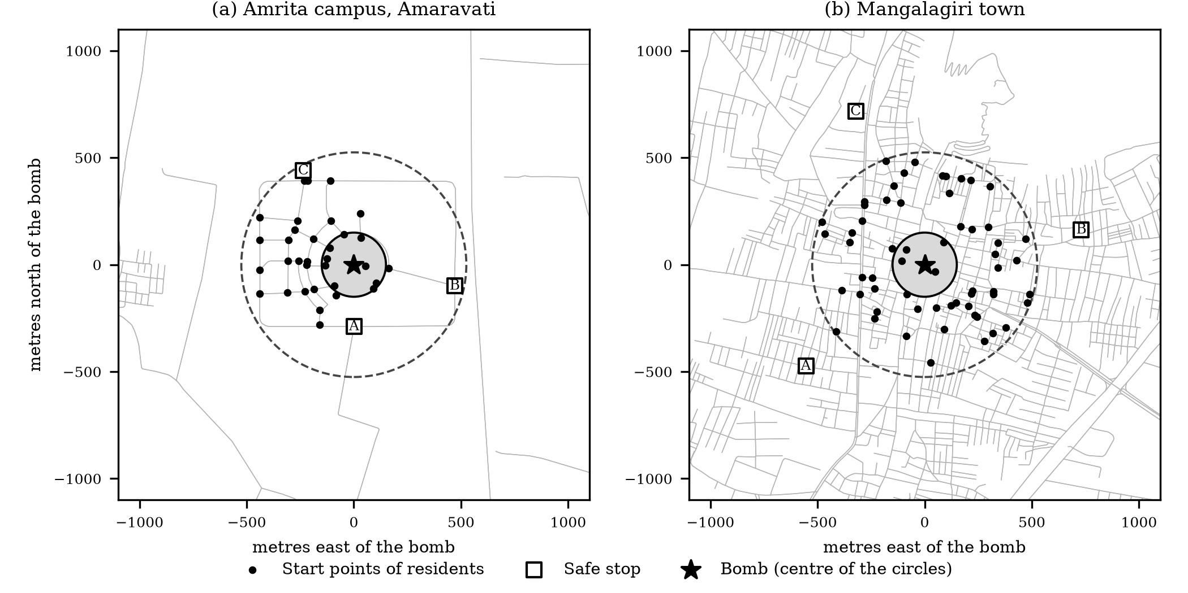
Fig. 1. The two study areas around the bomb: (a) the Amrita campus at Amaravati and (b) Mangalagiri. Grey lines are footpaths and roads from OpenStreetMap, the dashed circle is the 525 m alert radius, the grey disc the 150 m blast radius, dots are the start points of the residents and squares are the three safe stops.
IV. MATHEMATICAL MODEL
This section states the model. Symbols are listed where they are first used, and the parameter values are collected in Table II. All times are in seconds and all lengths in metres.
A. Road network and capacity
The walking network is a directed graph G = (N, E). Road segment e ∈ E has length L_{e} and an OpenStreetMap class c. OpenStreetMap does not record how many people a path can hold, so the capacity is a model assumption: it grows with length and with a width factor w_{c} that depends on the class,
$C_{e}=\max\left(2,\operatorname{round}\left(ρw_{c}L_{e}\right)\right),$ (1)
ρ = 0.25 persons per metre, and w_{c} = 0.3 (steps), 0.5 (path), 0.6 (footway, cycleway, track), 0.8 (service), 1.0 (residential, living street, unclassified and unknown classes), 1.3 (tertiary), 1.5 (pedestrian), 1.6 (secondary) and 2.0 (primary, trunk). A 100 m residential road therefore holds 25 people, a footway 15, a tertiary road 32 and a primary road 50. These values are assumptions of the model and are not measured.
B. Walking time and congestion
With walking speed v (1.4 m/s unless stated), the free-flow time of a segment is
$t_{e}^{0}=\frac{L_{e}}{v}.$ (2)
Let n_{e}(t) be the number of people on segment e at time t. The load ratio is
$r_{e}\left(t\right)=\frac{n_{e}\left(t\right)}{C_{e}}.$ (3)
A person who steps onto segment e at time t needs the Bureau of Public Roads time [6], fixed at the moment of entry from the load before that person joins,
$t_{e}=t_{e}^{0}\left(1+αr_{e}^{β}\right).$ (4)
A segment can be entered only if n_{e} < C_{e}; otherwise the person waits at the node at its tail. Because n_{e} ≤ C_{e} always, r_{e} ≤ 1 and t_{e} ≤ (1 + α) t_{e}⁰. We use α = 0.6 and β = 2 and vary them in Section VIII.
C. People, reaction delay and alerts
The crowd has N people. Person i starts at a node o_{i} drawn uniformly, with replacement, from the set O of start nodes. A hazard has strike time τ_{s} and the warning lead time λ is the gap between alert and strike, so the alert is sent at
$τ_{a}=\max\left(0,τ_{s}−λ\right).$ (5)
A person who is alerted waits a reaction delay δ_{i} drawn uniformly from [0, δ_{max}] and sets off at
$d_{i}=τ_{a}+δ_{i}, P\left(δ_{i}≤x\right)=\frac{x}{δ_{max}}.$ (6)
Hence the mean delay is δ_{max}/2 and its variance δ_{max}²/12. With δ_{max} = 90 s these are 45 s and 675 s².
In the alert-channel scenario, person i has a phone at hand with probability φ and then hears the alert at a_{i} = τ_{a} + u_{i}, where u_{i} is uniform on [0, 15] s. People without a phone hear nothing unless a neighbour tells them: a person within ρ_{n} metres of someone who already knows is told h seconds after that person, which gives
$a_{j}=\min_{i: dist(i,j) ≤ ρn}\left(a_{i}+h\right).$ (7)
Equation (7) is solved as a shortest-path problem over the people. Someone nobody reaches never starts to move.
D. Hazard and the people it catches
Distances between map points use the haversine formula on a sphere of radius R = 6,371,000 m,
$\operatorname{dist}\left(p,q\right)=2R\arcsin{\sqrt{\sin^{2}\left(\frac{Δφ}{2}\right)+\cos\left(φ_{p}\right)\cos\left(φ_{q}\right)\sin^{2}\left(\frac{Δλ}{2}\right)}}$ (8)
A hazard at point h has a blast radius R_{b} and an alert radius R_{a} = max(3.5 R_{b}, 200 m) in all our scenarios. The blast and alert areas are
$B=\left\{p:dist(p,h)≤R_{b}\right\}, A=\left\{p:dist(p,h)≤R_{a}\right\}.$ (9)
At time τ_{s} every segment with both ends in B is closed and the safe stops inside B are lost. Let I_{s} be the set of people who have not yet finished (reached a stop or failed) at τ_{s} and x_{i}(τ_{s}) the position of person i then. Everyone in I_{s} whose position lies in B is counted as caught,
$K=\left\{i∈I_{s}:x_{i}\left(τ_{s}\right)∈B\right\}.$ (10)
A person who is still waiting to depart, or still walking, is inside the blast at the strike if that is where they stand; the position of a walker is interpolated along the shape of the road. We use the word “simulated deaths” only for this count; no injury is modelled.
E. Route choice
A route is a least-cost path found with Dijkstra’s algorithm [8]. The three rules differ only in the cost of a segment and in how a safe stop is chosen. Shortest path uses the free-flow time,
$c_{SP}\left(e\right)=t_{e}^{0},$ (11)
whereas the congestion-aware rule uses the current load and the number q_{e} of people waiting to enter the segment,
$c_{CA}\left(e\right)=t_{e}^{0}\left(1+αr_{e}^{β}\right)+γ\frac{q_{e}t_{e}^{0}}{C_{e}},$ (12)
with γ = 1. Segments in the blast area carry a fixed penalty in every rule, so that nobody is sent toward the bomb when another way exists,
$c^{′}\left(e\right)=c(e)+Π·1\left(e∈E_{B}\right), Π=600 s,$ (13)
where E_{B} is the set of segments with both ends in B. The congestion-aware and the load-balanced rule also add a penalty for crowded safe stops. If a_{j} people already head for stop j and it holds K_{j} people, the penalty is
$π_{j}=W\frac{a_{j}}{K_{j}}, W=300 s.$ (14)
When person i plans from node o, the stop is
$j_{i}^{*}={argmin}_{j open}\left[D_{c}\left(o,j\right)+π_{j}\right],$ (15)
where D_{c} is the least route cost and a stop is open if it is available and not full. For shortest path, π_{j} = 0. After the first plan, the dynamic rules look again every 30 s and switch only if the new plan is clearly better,
$S^{new}<\left(1−θ\right)S^{cur}, θ=0.15,$ (16)
where S is the plan score, route cost plus stop penalty. A plan is renewed at once when the next segment is closed or the chosen stop becomes full or lost. The load-balanced rule differs in who decides: a planner assigns every person a stop before the run, in departure order, by
$j_{i}^{*}={argmin}_{j}\left[f_{j},D_{c}\left(o,j\right)+W\frac{a_{j}}{K_{j}},j\right] (lexicographic),$ (17)
where f_{j} = 1 if stop j is already full and 0 otherwise, so a stop that still has room always wins over a full one, then the lowest score, then the lowest index.
F. Safe stops and the time step
Stop j admits at most 8 people per time step and a total of K_{j} = 300. People who reach a stop wait in a queue at its gate. The clock advances in steps of 5 s. In each step the engine closes due roads, delivers alerts, applies the strike, completes road crossings, releases people who depart, admits people at the stops, and lets waiting people enter their next road if it has room. Arrival times are processed at step boundaries, so a person can wait up to one step between roads.
G. Outcome measures and statistics
Let ℰ be the set of people admitted to a safe stop by the end of the run, with admission times t_{i}. The measures are
$caught=\frac{100|K|}{N}, evacuated=\frac{100|ℰ|}{N}, T_{med}=\operatorname{median}\left(t_{i}−τ_{a}\right).$ (18)
The median is taken over i ∈ ℰ and is counted from the alert, so it excludes the quiet time before the alert. For n crowds the mean and the sample standard deviation of a measure x are
$x̄=\frac{1}{n}\sum_{k=1}^{n}{x_{k}}, s=\sqrt{\frac{1}{n−1}\sum_{k=1}^{n}{{\left(x_{k}−x̄\right)}^{2}}}$ (19)
Because the three rules are run on the same n crowds, we compare two rules A and B by the per-crowd differences d_{k} = x_{k}(A) − x_{k}(B), whose mean has the 95% confidence interval
$d̄±t_{0.975, n−1}\frac{s_{d}}{\sqrt{n}},$ (20)
with s_{d} the sample standard deviation of the differences and t_{0.975, 9} = 2.2622 for ten crowds (computed by inverting the Student distribution, see Section VII).
H. Analytic properties
Property 1 (free-flow bound). Let D₀(o, j) be the least free-flow time from o to stop j. Since r_{e} ≥ 0 in Eq. (4), every road takes at least its free-flow time, so a person who sets off at d_{i} and is admitted to stop j_{i} at t_{i} satisfies
$t_{i}≥d_{i}+D_{0}\left(o_{i},j_{i}\right).$ (21)
Property 2 (blast bound). Call a node of B a boundary node if a road leads from it to a node outside B, and let T_{o} be the least free-flow time from o to a boundary node. A person cannot be outside B before reaching a boundary node, so a person who starts in B and has δ_{i} + T_{o} > λ is still inside at the strike. Therefore, for every routing rule,
$|K|≥N_{LB}=|\left\{i: o_{i}∈B, δ_{i}+T_{o}>λ\right\}|.$ (22)
Property 3 (expected blast bound). Because the delay is uniform, a person starting at o ∈ B satisfies the condition of Property 2 with probability min{1, max{0, 1 − (λ − T_{o})/δ_{max}}}, so
$E\left[N_{LB}\right]=\frac{N}{|O|}\sum_{o∈O∩B}{\min\left\{1,\max\left\{0,1−\frac{λ−T_{o}}{δ_{max}}\right\}\right\}}$ (23)
Property 4 (bottleneck discharge). Suppose all N people set off together along the same route, as under shortest-path routing in the stress test. Whatever the load, a segment holds at most C_{e} people and each needs at least t_{e} to cross, so by Little’s law its throughput cannot exceed C_{e}/t_{e}. At full load Eq. (4) gives t_{e} = (1 + α) t_{e}⁰. The narrowest segment of the route therefore passes people at about
$q=\min_{e∈route}\frac{C_{e}}{\left(1+α\right)t_{e}^{0}}, T_{k}≈T_{0}+\frac{k}{q},$ (24)
where T₀ is the free-flow walking time of the route and T_{k} the time at which the k-th person is admitted. This is an approximation, because other segments and the stop gate also hold people back; Section VII compares it with the simulator.
V. SCENARIOS AND PARAMETERS
A. The four scenarios
Every scenario is run on both areas with the three routing rules, on ten random crowds (seeds 1 to 10) of 250 people. For each seed the crowd is generated once, stored in the database, and used by all three rules, so that differences come from the rule alone.
S1, bomb drill with a warning time. A bomb with a 150 m blast radius is placed at the centre of the map and goes off at τ_{s} = 420 s. The alert is sent λ seconds before. Residents of the alert area walk to the safe stops. We test λ = 60, 180, 300 and 400 s on the campus and 30, 60, 120, 180 and 300 s in Mangalagiri; the lead times differ because the two areas differ in how long people need to leave the blast circle.
S2, crowd stress. There is no hazard. All 250 people leave the single start point at the centre of the map at the same moment (the grid map has 300 people). The run stops after 1800 s, and the measure is the share who reach a safe stop in that time.
S3, road closure. As S2, but a circular danger zone of 150 m radius, centred on the middle of the free-flow shortest route from the start to the nearest safe stop, closes all roads inside it at 300 s, when people are already walking. People on a closed road finish it; nobody enters it afterwards.
S4, partial alert reach. As S1 with a fixed lead time (180 s on the campus, 60 s in Mangalagiri), but only a share φ of the crowd hears the alert on a phone. We test φ = 100%, 60% and 30%, and 30% with neighbours passing the word within 50 m with a delay of 20 s per hop (Eq. 7). In the 100% case the same channel model is used, so the 15 s delivery spread is present in all four cases.
B. Parameters and their basis
Table II lists every parameter of the model. Most of them are assumptions: OpenStreetMap does not contain path capacities, reaction delays or safe-stop capacities, and we did not measure them. We therefore state them as assumptions, we vary the ones that matter in Section VIII, and we do not present absolute results as predictions.
TABLE II. PARAMETERS OF THE MODEL AND THEIR BASIS
Parameter | Symbol | Value | Basis
Walking speed | v | 1.4 m/s | Model default, close to the mean free walking speed of about 1.34 m/s commonly attributed to the review in [12], see also [13]; varied 1.0 to 1.8
Persons per metre of road | ρ | 0.25 | Assumed
Width factor by road class | w_{c} | 0.3 to 2.0 | Assumed (Eq. 1)
Congestion constants | α, β | 0.6, 2 | Assumed; road-traffic values are 0.15 and 4 [6]; varied
Queue weight in route cost | γ | 1 | Assumed
Longest reaction delay | δ_{max} | 90 s | Assumed; varied 30 to 180 s
Phone delivery spread / neighbour relay | — / ρ_{n}, h | 15 s / 50 m, 20 s | Assumed (scenario S4 only)
Blast radius | R_{b} | 150 m | Assumed; varied 100 and 200 m
Alert radius | R_{a} | max(3.5 R_{b}, 200 m) | Assumed (525 m for R_{b} = 150 m)
Strike time | τ_{s} | 420 s | Assumed
Warning lead time | λ | 30 to 400 s | Experimental factor
Blast penalty on a road | Π | 600 s | Design choice; keeps routes out of the blast area
Safe-stop penalty | W | 300 s | Design choice
Re-plan interval, improvement threshold | —, θ | 30 s, 0.15 | Design choice
Safe-stop capacity, admission rate | K_{j}, — | 300, 8 per 5 s step | Assumed; capacity 150 tested
Time step, time limits | Δt, — | 5 s; 2400 s (S1, S4), 1800 s (S2, S3) | Numerical choice
Crowd size | N | 250 (300 on the grid) | Assumed; 150 and 400 tested
Earth radius in Eq. (8) | R | 6,371,000 m | Mean radius

VI. SOFTWARE AND INTERFACE
Panic Engine is written in Python (Fig. 2). The map is read from OpenStreetMap and converted to the graph of Section IV. A scenario builder sets the start points, safe stops, hazard, closures and alert channels, and a crowd generator draws the people from a seeded random generator and stores them. The timestep engine of Section IV runs the scenario and writes every event and position snapshot to an SQLite database with eighteen tables, foreign keys and CHECK constraints; the dashboard, the replay and all result tables read from that database.
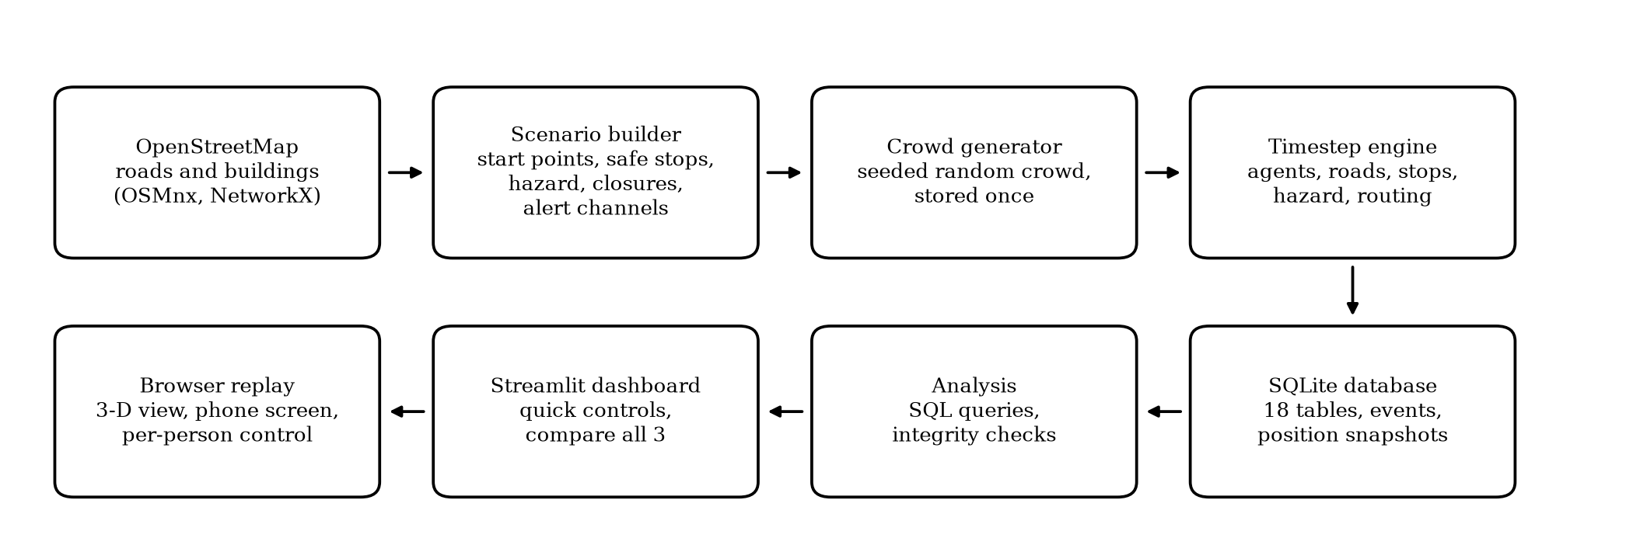
Fig. 2. Architecture of Panic Engine. The engine writes every event to the database; the analysis, the dashboard and the browser replay all read from it.
The Streamlit dashboard (Fig. 3) has a bar of quick controls (routing rule, walking speed, RUN, COMPARE ALL 3, which runs the three rules on the same crowd, and PHONE, which opens the phone page) and a sidebar for the map, safe stops, bomb, alert channels (phone share, sirens, neighbour relay), danger zones and crowd.
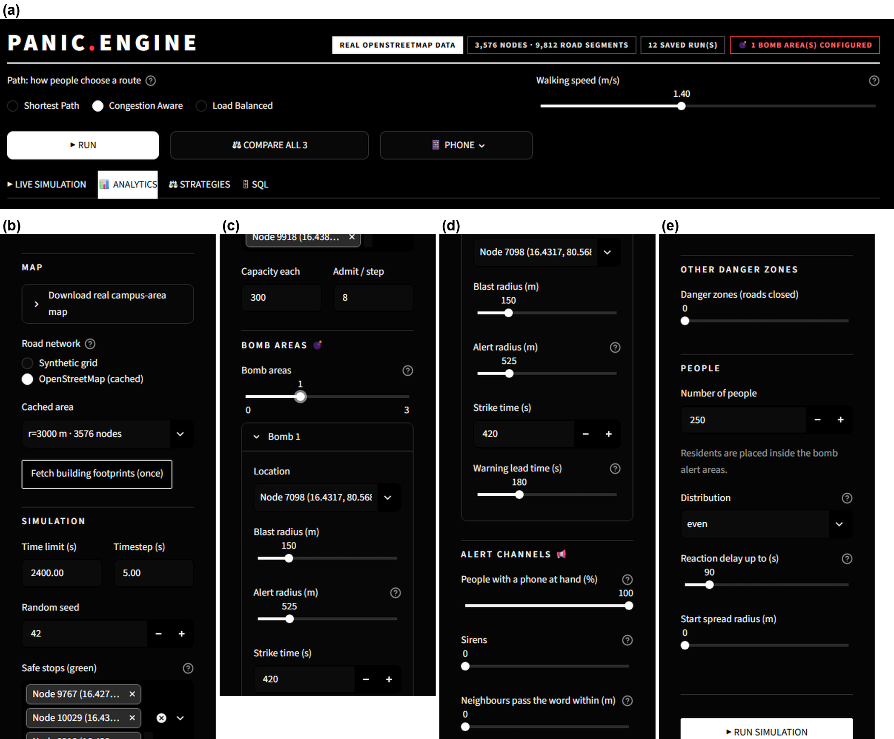
Fig. 3. The dashboard. (a) Quick controls at the top of the page and the four tabs. (b)–(e) The sidebar: map and safe stops, the bomb (blast radius, alert radius, strike time, lead time), the alert channels (phone share, sirens, neighbour relay), danger zones and the crowd.
Replays are drawn in the browser with deck.gl (Fig. 4): extruded building outlines, roads, alert and blast areas, safe stops, every person, a clock and counters. A phone-style screen shows what one tracked person would see (the alert, nearest safe stop, walking distance and time, and a countdown), and the user can take control of that person to choose the destination and walking speed.
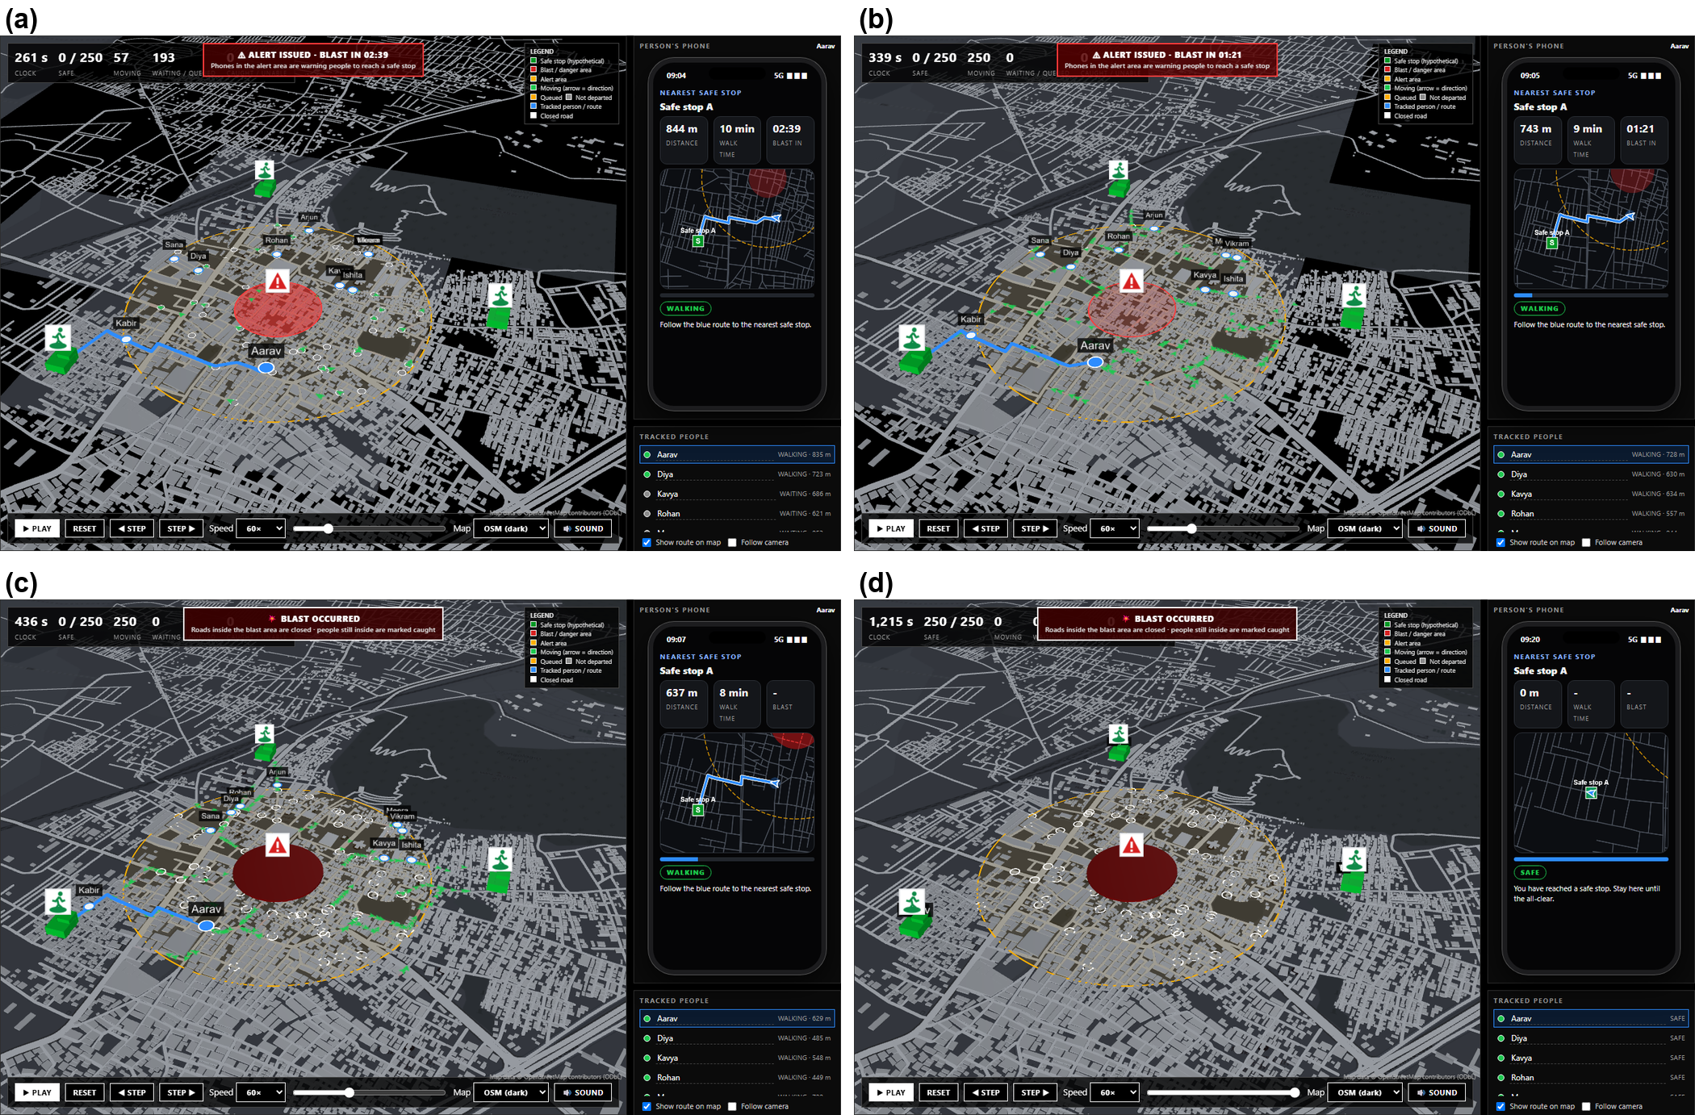
Fig. 4. The 3-D replay of a bomb drill in Mangalagiri at four moments: (a) the alert is issued and the phone screen of a tracked person shows the route and a countdown to the strike; (b) people are walking to the safe stops; (c) the blast has occurred and the roads inside it are closed; (d) everyone has reached a safe stop.
The Analytics tab reports a run (Fig. 5). The Strategies tab compares saved runs and counterfactuals, and the SQL tab shows the stored queries and nine integrity checks. Buildings in the 3-D views come from a cached download of OpenStreetMap footprints around the campus (21,250 within 6 km), which also covers about 90% of the Mangalagiri road network.
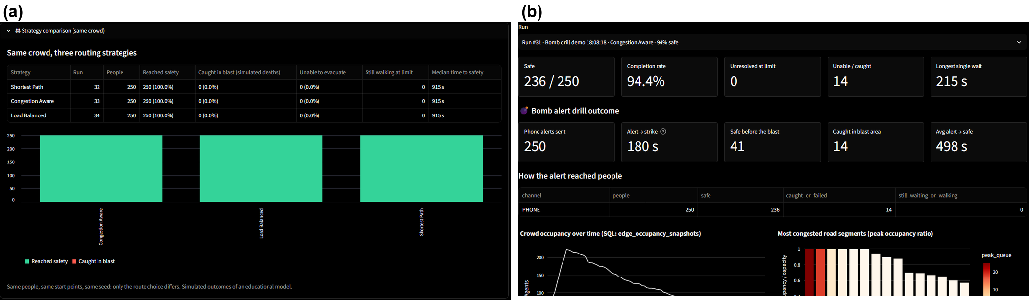
Fig. 5. Analysis screens. (a) COMPARE ALL 3 runs the three rules on the same crowd. (b) The Analytics tab shows the drill outcome, how the alert reached people, crowd occupancy over time and the bottleneck ranking.
VII. VERIFICATION OF THE IMPLEMENTATION
Before running the experiments we checked that the code does what Section IV says. This is verification, not validation against real events (Section IX).
Tests. An automated suite of 82 tests covers the state machine, capacity, closures, routing, hazards, alert channels, the database and the replay code. All pass.
Randomised conservation check. 120 runs with random bombs, closures, alert channels, crowd sizes (1 to 400) and walking speeds (0.6 to 2.5 m/s) kept every conservation rule and passed nine integrity checks.
Formula checks. Seven checks compare an equation of Section IV with the code or the simulator (Table III); scripts/verify_model.py produces them. All hold.
Reproducibility. The campus bomb drills were run twice, before and after the comparison script was extended; every mean share caught and mean median time was identical for all four lead times and three rules.
TABLE III. NUMERICAL CHECKS OF THE FORMULAS (ALL FROM scripts/verify_model.py)
Check | Equation or property | Result
V1 | Eq. (1) capacity and Eq. (4) travel time | Six (α, β, load) cases: largest difference between code and formula 0.0 s (for example 78.3 s at α = 0.6, β = 2, 10 of 25 people). 100 m of footway, residential, tertiary and primary road hold 15, 25, 32 and 50 people, as Eq. (1) gives.
V2 | Eq. (8) haversine distance | One degree of latitude: 111194.93 m, equal to 2πR/360 = 111194.93 m. Campus to Mangalagiri: 4235.66 m, against 4235.66 m from an independent flat projection (relative difference 6.2e-9).
V3 | Eq. (6) reaction delay | 20,000 sampled delays with δ_{max} = 90 s: mean 44.9 s (expected 45.0 s), variance 683.9 s² (expected 675.0 s²).
V4 | Property 1, Eq. (21) free-flow bound | Holds for every evacuated person in all 63 runs (45 in Mangalagiri, 18 on the campus). Smallest slack 0.05 s on the campus and 13.9 s in Mangalagiri.
V5 | Property 2, Eq. (22) blast bound | Simulated caught ≥ bound in all 63 runs, for all three rules. The bound is 71% of the simulated count in Mangalagiri and 53% on the campus (Fig. 6).
V6 | Property 3, Eq. (23) expected bound | Expected bound against the mean realised bound over ten crowds. Mangalagiri, lead time 30 s: 13.9 vs 13.3; 60 s: 9.1 vs 8.3; 120 s: 0.8 vs 1.1; 180 s: 0.0 vs 0.0 people. Campus, 60 s: 34.1 vs 34.1; 180 s: 3.1 vs 4.0; 300 s: 0.0 vs 0.0 people.
V7 | Property 4, Eq. (24) discharge time | Shortest-path stress test, median time from the alert, predicted against simulated: campus 1072 s against 1105 s (-3.0%); Mangalagiri 1256 s against 1305 s (-3.8%). Share evacuated within 30 min, predicted against simulated: campus 99.7% against 94.0%; Mangalagiri 83.5% against 79.6%.

The blast bound is a bound, not an estimate: it counts only people who cannot leave the circle even at full speed along the quickest road, and ignores crowding and detours, so the simulator catches more; that it never catches fewer (63 of 63 runs) is the check. The discharge formula is close for the median but over-predicts the campus share evacuated within 30 minutes (99.7% against 94.0%), because it treats the narrowest road as the only limit while the other roads and the stop gate also hold people back.
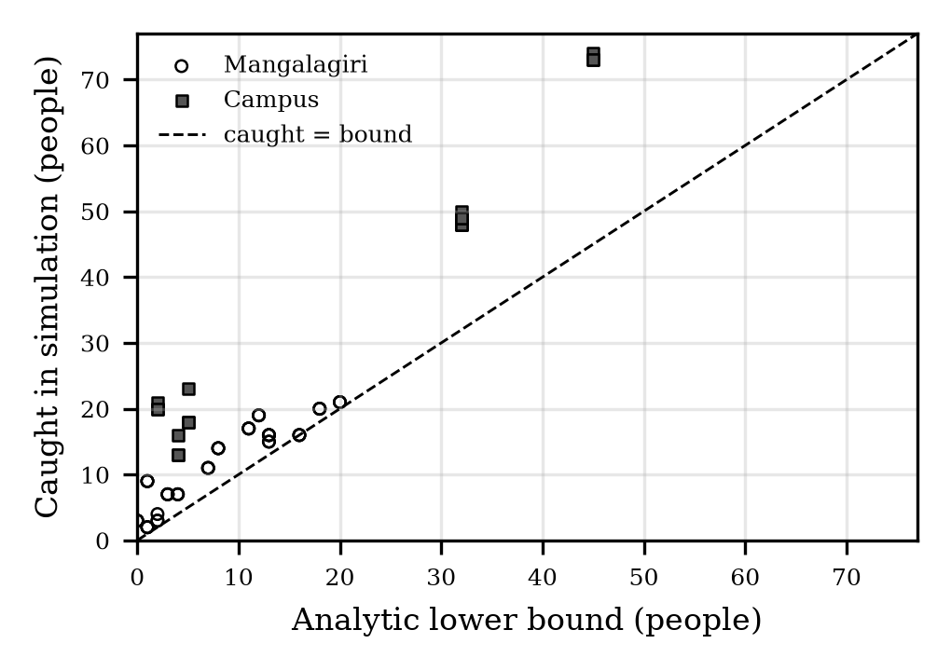
Fig. 6. Simulated number of people caught against the analytic lower bound of Eq. (22), for 63 runs. Every point lies on or above the dashed line.
VIII. RESULTS
A. Warning time (scenario S1)
Table IV and Fig. 7 give the share of the crowd caught at the strike. In both areas the share falls steeply with the lead time and reaches zero. On the campus, 21.3% are caught with a 60 s warning, 6.5% with 180 s, and nobody with 300 s or more. In Mangalagiri the share is 6.2% at 30 s, 5.2% at 60 s, 1.5% at 120 s, and 0.0% at 180 s.
The two areas differ in an informative way. The most that can be caught is the share of residents who start inside the 150 m blast circle: 9 of the 37 start nodes (24.3%) on the campus and 4 of the 60 (6.7%) in Mangalagiri. At the shortest lead times nearly all of them are caught (21.3% on the campus at 60 s and 6.2% in Mangalagiri at 30 s). The campus is also slower to clear: even at full walking speed some campus residents need more than the lead time minus their delay to leave the circle, and the expected bound of Eq. (23) is 3.1 people at 180 s, against 0.0 in Mangalagiri. Nobody in Mangalagiri reaches a safe stop before the strike with a lead time up to 180 s (0.0% safe), because the stops are 731 to 789 m from the bomb; what matters there is leaving the circle. On the campus, 6.6% are at a safe stop before the strike with 60 s, 16.2% with 180 s, 24.0% with 300 s and 35.6% with 400 s. These shares are the same for all three rules, because they depend on who has started walking and how far they must go, not on the route.
TABLE IV. PEOPLE CAUGHT AT THE STRIKE (%, MEAN ± SD OVER 10 CROWDS)
Area, lead time | Shortest | Congestion | Balanced
Campus, 60 s | 21.3 ± 4.0 | 20.8 ± 4.0 | 20.8 ± 4.0
Campus, 180 s | 6.5 ± 1.9 | 5.9 ± 1.8 | 5.8 ± 1.8
Campus, 300 s | 0.0 ± 0.0 | 0.0 ± 0.0 | 0.0 ± 0.0
Campus, 400 s | 0.0 ± 0.0 | 0.0 ± 0.0 | 0.0 ± 0.0
Mangalagiri, 30 s | 6.2 ± 1.5 | 6.2 ± 1.5 | 6.2 ± 1.5
Mangalagiri, 60 s | 5.2 ± 1.9 | 5.2 ± 1.8 | 5.2 ± 1.8
Mangalagiri, 120 s | 1.5 ± 1.1 | 1.5 ± 1.1 | 1.5 ± 1.1
Mangalagiri, 180 s | 0.0 ± 0.1 | 0.0 ± 0.1 | 0.0 ± 0.1
Mangalagiri, 300 s | 0.0 ± 0.0 | 0.0 ± 0.0 | 0.0 ± 0.0

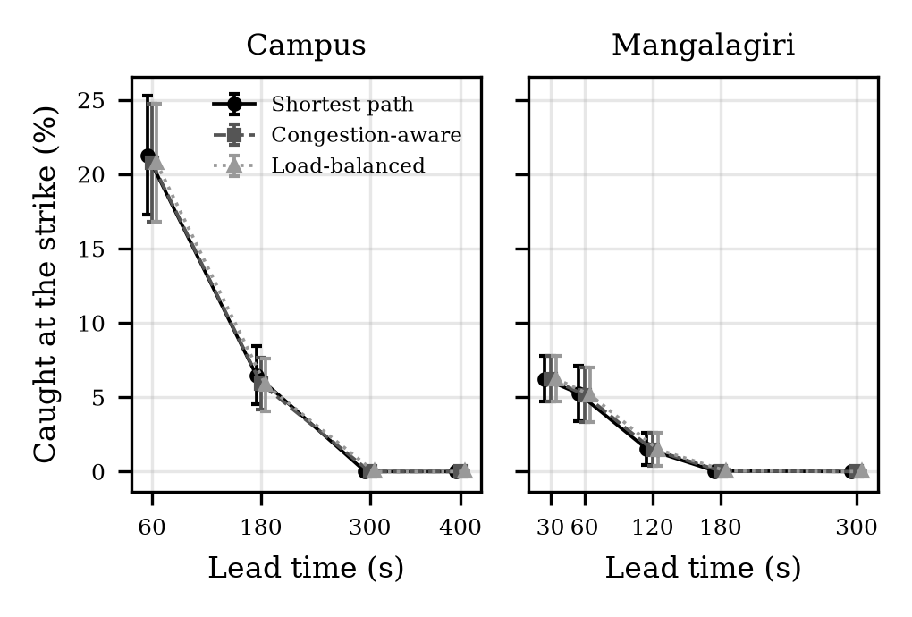
Fig. 7. People caught at the strike against the warning lead time (mean and standard deviation over ten crowds).
B. Routing rule in the bomb drills
Because the rules are run on the same crowds, we compare them by paired differences (Eq. 20). On the campus, shortest-path routing caught 0.52 [0.16, 0.88] percentage points more people than congestion-aware routing at a 60 s lead (mean difference and 95% interval, in 8 of 10 crowds more and in none fewer), and 0.56 [0.03, 1.09] at 180 s. The interval excludes zero but the effect is small: about 1.4 people out of 250. Judged by the standard deviation across crowds, which is about four points at a 60 s lead, the difference would look negligible; pairing removes the variation from crowd to crowd and reveals it. In Mangalagiri no interval excludes zero (60 s: 0.08 [-0.04, 0.20]).
The rules differ more in time than in deaths. On the campus, congestion-aware routing shortened the median walking time from the alert by 15.0 [4.4, 25.6] s at a 180 s lead, and the load-balanced rule did not differ from it (0.08 [-0.10, 0.26] percentage points caught). On the campus the median time from the alert at a 60 s and a 180 s lead was 486 and 507 s for shortest path and 481 and 492 s for congestion-aware routing; in Mangalagiri at 60 s it was 639 s for both.
C. Crowd stress and road closure (S2, S3)
When everyone leaves at once, the rule matters a great deal (Table V). On the campus, shortest-path routing sends the whole crowd along the same roads. Within 30 minutes only 94.0% were evacuated, against 100.0% for the other two rules, and the median time from the alert was 1105 s against 805 s (congestion-aware) and 843 s (load-balanced). In Mangalagiri the shares were 79.6% and 100%. The road closure made the difference larger: 82.4% against 100.0% on the campus and 75.6% against 97.2% in Mangalagiri. In every one of the ten crowds shortest path evacuated fewer people than congestion-aware routing in all four of these scenarios (paired differences between -6.0 and -21.6 points).
The two smarter rules perform alike in the shares evacuated. In time they differ, and not in the same direction in the two areas: on the campus, congestion-aware routing was faster than load-balanced routing by 38 [34, 42] s in the stress test, and in Mangalagiri load-balanced routing was faster by 15 [14, 16] s.
The size of the shortest-path failure is predicted by Property 4. On the campus the whole crowd must pass a route whose narrowest segment lets through about 0.17 people per second, so the 250 people need about 1,460 s to get through after the 344 s of walking, and the last would arrive roughly 1,800 s after the alert, the end of the 30 minutes available; in Mangalagiri the corresponding rate is 0.19 people per second. Table III (V7) compares the predictions with the simulator.
TABLE V. PEOPLE EVACUATED WITHIN 30 MINUTES, NO HAZARD (%, MEAN ± SD)
Scenario | Shortest | Congestion | Balanced
Campus, crowd stress | 94.0 ± 0.0 | 100.0 ± 0.0 | 100.0 ± 0.0
Campus, road closure | 82.4 ± 0.0 | 100.0 ± 0.0 | 100.0 ± 0.0
Mangalagiri, crowd stress | 79.6 ± 0.0 | 100.0 ± 0.0 | 100.0 ± 0.0
Mangalagiri, road closure | 75.6 ± 0.0 | 97.2 ± 0.0 | 97.2 ± 0.0
Grid, crowd stress (300) | 60.7 ± 0.2 | 78.1 ± 1.7 | 78.0 ± 1.7

D. How far the alert reaches (S4)
Table VI shows what happens when only part of the crowd has a phone. People who hear nothing never move, so the share evacuated is close to the phone share: 28.1% of the campus crowd and 28.2% of the Mangalagiri crowd reached a safe stop when 30% had a phone. Those who never move are not all caught: only people inside the blast circle are. On the campus, the share caught rose from 7.5% with full phone reach to 18.6% with 30%. In Mangalagiri it changed little (5.6% to 6.2%), because with a 60 s lead time most of the people in the blast circle are caught even with a phone.
Neighbours passing the word changed the picture. With 30% phone reach and a relay of 20 s per hop within 50 m, the share evacuated rose from 28.1% to 85.8% on the campus and from 28.2% to 80.8% in Mangalagiri, and on the campus the share caught fell from 18.6% to 8.6%. In Mangalagiri the relay was too slow to change the number caught within the 60 s lead time. The routing rules differ by less than one point here, as in S1.
TABLE VI. EFFECT OF THE SHARE OF PEOPLE WITH A PHONE (%, MEAN OVER 10 CROWDS)
Area, phone share | Caught SP | Caught CA | Evac. SP | Evac. CA
Campus, 100% | 7.5 | 6.7 | 92.5 | 93.3
Campus, 60% | 14.0 | 13.6 | 55.1 | 55.5
Campus, 30% | 18.6 | 18.5 | 28.1 | 28.2
Campus, 30% + relay | 8.6 | 8.0 | 85.8 | 86.4
Mangalagiri, 100% | 5.6 | 5.5 | 94.4 | 94.5
Mangalagiri, 60% | 6.0 | 5.9 | 55.8 | 55.8
Mangalagiri, 30% | 6.2 | 6.2 | 28.2 | 28.2
Mangalagiri, 30% + relay | 6.2 | 6.2 | 80.8 | 80.8

E. Sensitivity to the assumed values
Table VII changes one factor at a time around the campus drill with a 180 s lead. Three factors move the outcome far more than the routing rule does. Faster walking reduces the share caught from 10.0% at 1.0 m/s to 2.9% at 1.8 m/s under shortest path. A shorter reaction delay has a larger effect: with delays of up to 30 s only 1.8% are caught, against 11.8% when delays reach 180 s. The blast radius matters as expected: 1.0% at 100 m and 11.3% at 200 m.
TABLE VII. PEOPLE CAUGHT ON THE CAMPUS, 180 s LEAD, ONE FACTOR CHANGED (%, MEAN ± SD)
Change | Shortest | Congestion | Balanced
Base (1.4 m/s, 90 s, 150 m, 250) | 6.5 ± 1.9 | 5.9 ± 1.8 | 5.8 ± 1.8
Walking 1.0 m/s | 10.0 ± 2.4 | 9.5 ± 2.5 | 9.8 ± 2.5
Walking 1.8 m/s | 2.9 ± 1.2 | 2.4 ± 1.3 | 2.4 ± 1.2
Reaction ≤ 30 s | 1.8 ± 1.5 | 1.8 ± 1.5 | 1.8 ± 1.5
Reaction ≤ 180 s | 11.8 ± 2.6 | 11.0 ± 2.4 | 11.0 ± 2.4
Blast 100 m | 1.0 ± 0.6 | 1.0 ± 0.6 | 1.0 ± 0.6
Blast 200 m | 11.3 ± 2.8 | 13.0 ± 2.9 | 13.0 ± 2.9
150 people | 6.7 ± 2.2 | 6.1 ± 2.0 | 6.1 ± 2.0
400 people | 7.9 ± 1.3 | 7.7 ± 1.4 | 7.2 ± 1.3

The ranking of the rules is not stable across these changes: with the 200 m blast radius the congestion-aware and load-balanced rules caught more people (13.0%) than shortest path (11.3%). These runs were saved without the individual crowds, so there is no paired interval, and we did not investigate the cause. With 400 people the median time from the alert was 643 s for shortest path and 559 s for congestion-aware routing.
Table VIII repeats the crowd-stress test with one assumed value changed. The rule matters in every row, and shortest path suffers most when crowding is costlier or stops are smaller: with α = 1.2 it evacuated 68.0% (94.0% at the base value), with half-size stops 62.8%, and with 400 people 58.8%, while congestion-aware routing evacuated 100.0%, 100.0% and 100.0%. β acts the other way (Eq. 4, load ratio below one): 88.4% at β = 1 and 100.0% at β = 4. Smarter routing helps across the range tried, but the size of the benefit depends strongly on the assumed constants.
TABLE VIII. PEOPLE EVACUATED WITHIN 30 MINUTES ON THE CAMPUS, NO HAZARD, ONE VALUE CHANGED (%, MEAN ± SD)
Change | Shortest | Congestion | Balanced
Base (α 0.6, β 2, cap 300) | 94.0 ± 0.0 | 100.0 ± 0.0 | 100.0 ± 0.0
α = 0.3 | 100.0 ± 0.0 | 100.0 ± 0.0 | 100.0 ± 0.0
α = 1.2 | 68.0 ± 0.0 | 100.0 ± 0.0 | 98.8 ± 0.0
β = 1 | 88.4 ± 0.1 | 100.0 ± 0.0 | 100.0 ± 0.0
β = 4 | 100.0 ± 0.0 | 100.0 ± 0.0 | 100.0 ± 0.0
Stop capacity 150 | 62.8 ± 0.1 | 100.0 ± 0.0 | 100.0 ± 0.0
400 people | 58.8 ± 0.0 | 100.0 ± 0.0 | 97.8 ± 0.0

IX. LIMITATIONS
The model has not been calibrated or validated against field data. We did not time real walks on either area, observe a real drill, or compare the output with another simulator on the same network. Verification (Section VII) shows that the code implements the equations; it does not show that the equations describe real people. The congestion constants, path capacities, stop capacities, admission rates and reaction delays are assumed values (Table II), and the sensitivity study shows which results depend on them without removing the assumption. For the same reason the absolute numbers, such as the share caught at a given lead time, should not be quoted as predictions for either place.
Further limits: agents do not touch each other and a person waiting at a node does not block the road behind, so gridlock is understated; time advances in 5 s steps; the crowd is 150 to 400 synthetic people at the start nodes inside the alert area, not the real population; the safe stops are hypothetical; the blast is a circle with no shielding by buildings and no injury model; people who hear no alert stay where they are, so outside the blast they count neither as caught nor as evacuated; OpenStreetMap may be incomplete for paths in a new area; and we study two places and one hazard type, with the bomb at the centre of each map.
The statistics also have limits: ten crowds give wide intervals for small effects, the intervals of Eq. (20) assume roughly normal differences, many comparisons are reported without correction for multiple testing, and the sensitivity runs have no paired intervals.
X. CONCLUSION AND FUTURE WORK
Panic Engine compares warning times, alert reach and routing rules on the same crowd and the same road network, and stores every run for replay. We formulated the model, derived a lower bound on the people caught by a hazard and a discharge formula for a shared route, and checked both, together with the other equations, against the simulator. In experiments on the Amrita campus and the town of Mangalagiri, a longer warning removed all simulated deaths in both areas, a shorter reaction delay and faster walking reduced them sharply, and the alert reach decided how many people moved at all. The routing rule changed the number caught by about half a point on the campus and by nothing measurable in Mangalagiri, but it decided whether a crowd got out in time when roads were loaded or closed. Walking speed also mattered: on the campus about 10.0% were caught at 1.0 m/s against 2.9% at 1.8 m/s, so people who walk slowly need earlier help or nearer safe places. A design lesson from the development of the model is that a routing rule must be given every cost that matters: an early version that ignored the hazard sometimes sent people toward the blast area until the penalty of Eq. (13) was added.
Future work includes calibration with timed walks and an announced drill on the campus, a comparison with SUMO or MATSim on the same network, spill-back so that a full road blocks the one behind it, the official assembly points and the real population, and a test of alert wording and channels with real students.
DATA AND CODE AVAILABILITY
The source code, the saved result files for every table and figure (scripts/results) and the scripts that regenerate them (compare_strategies, run_scenarios.sh, verify_model, paired_stats) are available at https://github.com/Ash19123/panic-engine. All random choices are fixed by the seeds 1 to 10.
ACKNOWLEDGMENT
The authors thank their project guide, Ms. Lavanya Goura, for her guidance throughout this work, and the OpenStreetMap contributors for the map data used in the experiments.
REFERENCES
[1] P. Alvarez Lopez et al., “Microscopic traffic simulation using SUMO,” in Proc. 21st IEEE Int. Conf. Intelligent Transportation Systems (ITSC), 2018, pp. 2575–2582, doi: 10.1109/ITSC.2018.8569938.
[2] A. Horni, K. Nagel and K. W. Axhausen, Eds., The Multi-Agent Transport Simulation MATSim. London, U.K.: Ubiquity Press, 2016, doi: 10.5334/baw.
[3] N. Carles, K. Chapuis, J. Douvinet, M. Péroche and E. Bopp, “An agent-based model to simulate the effects of tsunami warnings on pedestrian evacuation: Sensitivity analysis and early findings,” in PRIMA 2024: Principles and Practice of Multi-Agent Systems, R. Arisaka, V. Sanchez-Anguix, S. Stein, R. Aydoğan, L. van der Torre and T. Ito, Eds., Lecture Notes in Computer Science, vol. 15395. Cham, Switzerland: Springer Nature, 2025, pp. 369–384, doi: 10.1007/978-3-031-77367-9_28.
[4] D. Helbing, I. Farkas and T. Vicsek, “Simulating dynamical features of escape panic,” Nature, vol. 407, no. 6803, pp. 487–490, Sep. 2000, doi: 10.1038/35035023.
[5] E. D. Kuligowski, R. D. Peacock and B. L. Hoskins, “A review of building evacuation models, 2nd edition,” National Institute of Standards and Technology, Gaithersburg, MD, USA, NIST Technical Note 1680, Nov. 2010.
[6] Bureau of Public Roads, Traffic Assignment Manual: For Application with a Large, High Speed Computer. Washington, DC, USA: U.S. Department of Commerce, Urban Planning Division, 1964.
[7] J. G. Wardrop, “Road paper. Some theoretical aspects of road traffic research,” Proc. Institution of Civil Engineers, Part II, vol. 1, no. 3, pp. 325–362, 1952.
[8] E. W. Dijkstra, “A note on two problems in connexion with graphs,” Numerische Mathematik, vol. 1, pp. 269–271, 1959, doi: 10.1007/BF01386390.
[9] OpenStreetMap contributors, “OpenStreetMap,” OpenStreetMap Foundation. [Online]. Available: https://www.openstreetmap.org
[10] G. Boeing, “OSMnx: New methods for acquiring, constructing, analyzing, and visualizing complex street networks,” Computers, Environment and Urban Systems, vol. 65, pp. 126–139, 2017, doi: 10.1016/j.compenvurbsys.2017.05.004.
[11] A. A. Hagberg, D. A. Schult and P. J. Swart, “Exploring network structure, dynamics, and function using NetworkX,” in Proc. 7th Python in Science Conf. (SciPy), 2008, pp. 11–15.
[12] U. Weidmann, Transporttechnik der Fussgänger, Schriftenreihe des Instituts für Verkehrsplanung, Transporttechnik, Strassen- und Eisenbahnbau (IVT), no. 90, 2nd ed. Zürich, Switzerland: ETH Zürich, 1993.
[13] E. Bosina and U. Weidmann, “Estimating pedestrian speed using aggregated literature data,” Physica A: Statistical Mechanics and its Applications, vol. 468, pp. 1–29, 2017, doi: 10.1016/j.physa.2016.09.044.

