**LAB REPORT**

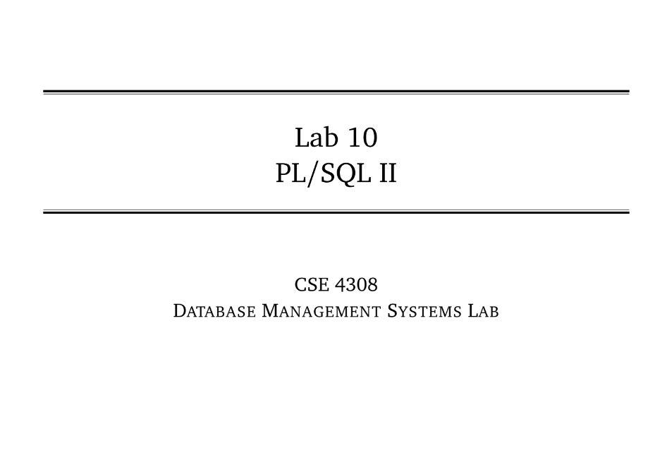

**NAME: CHOWDHURY ASHFAQ**

**STUDENT ID: 200042123**

**PROGRAM: SWE**

**GROUP: 1A**

**DATE: 13/11/22**

**Tasks:**

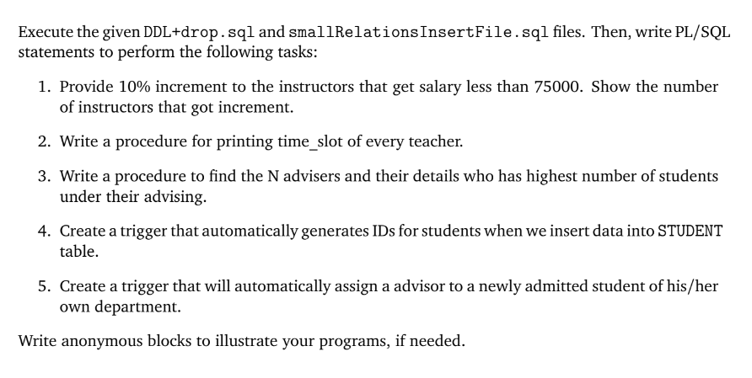

**Analysis of the problem:**

We had to write some queries in PL/SQL.

**Solution:**

