**LAB REPORT**

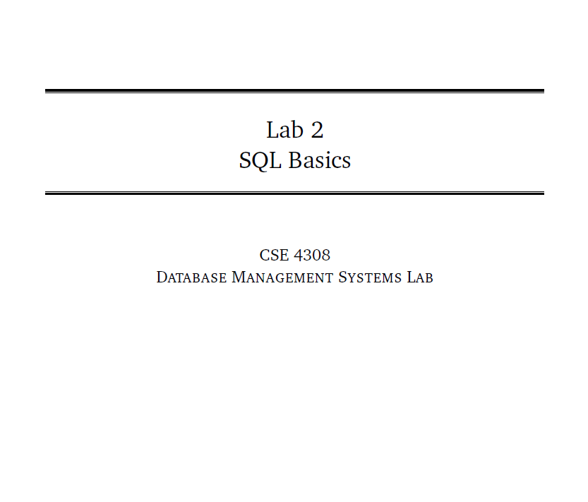

**NAME: CHOWDHURY ASHFAQ**

**STUDENT ID: 200042123**

**PROGRAM: SWE**

**GROUP: 1A**

**DATE: 04/09/22**

**Tasks:**

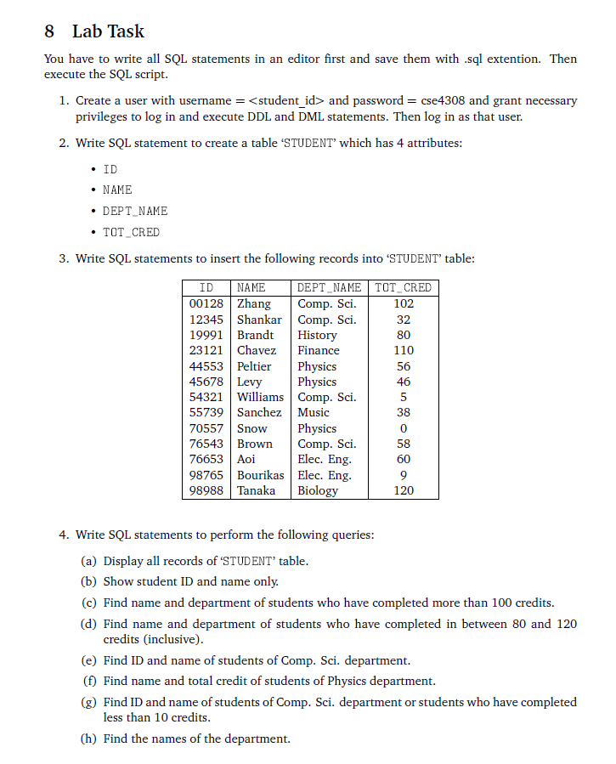

In this Lab Task we were given to perform the most basic tasks of Database Management System. We need to create a user and a password and later create a TABLE or Relation with 4 different fields or attributes ID,NAME,DEPT_NAME and TOT_CRED. Then we need to perform various queries like selecting all of the items in the STUDENT Table, selecting only ID and name from the table etc. All these have to be done with DDL and DML.

**Analysis of the problem:**

First we need to create a table which is a part of DDL. The table contains 4 fields namely ID,NAME,DEPT_NAME and TOT_CRED. There domains are varchar2(10), varchar2(10), varchar2(20) and varchar2(5) respectively.

Then the problem tells us to insert various values or tuples into the table which would be done with DML.

After that we need to select various data from the table which is done according to the user. 8 different selection operations or queries need to be performed. This will also be done with the help of DML.

**Solution:**

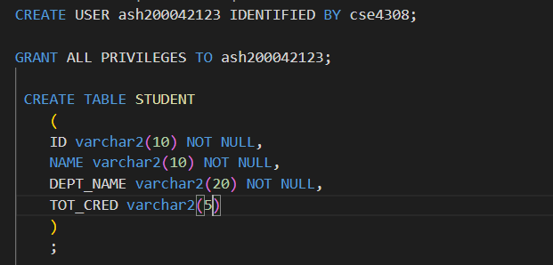

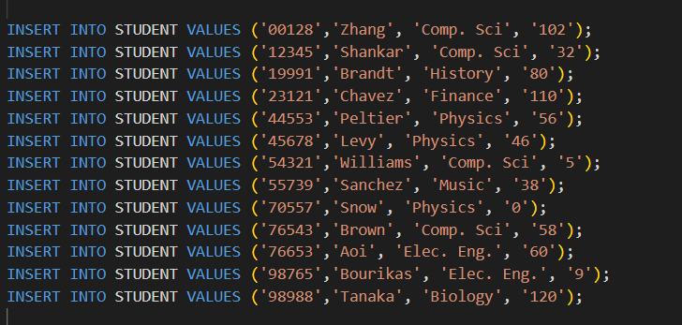

**OUTPUT:**



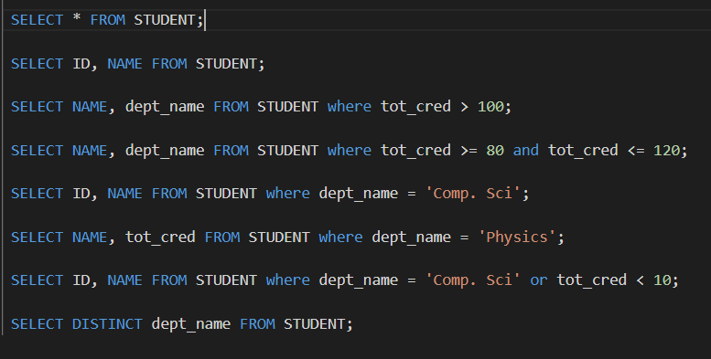

**OUTPUT:**

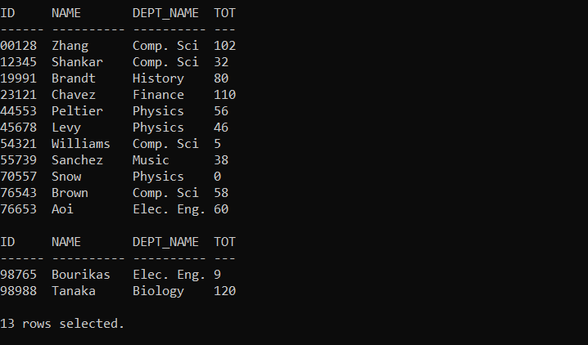

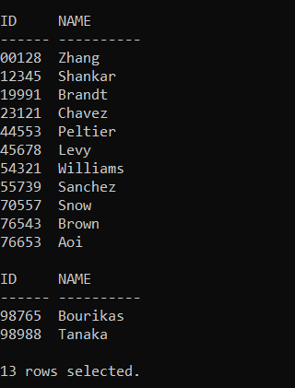

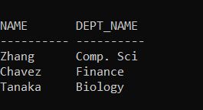

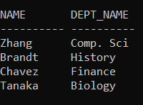

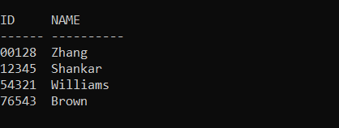

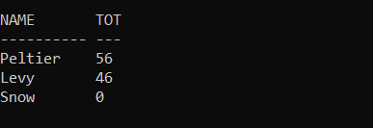

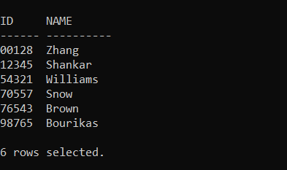

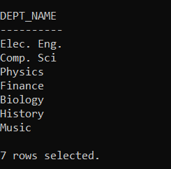

**Explanation:**

* At first we create a new user named as ‘ash20042123’ with password ‘cse4308’. The command for the action is :

CREATE USER ash200042123 IDENTIFIED BY cse4308;

* Next we grant all privileges to the new user through the command:

GRANT ALL PRIVILEGES TO ash200042123;

* Then we are to create a table named as STUDENT which will have 4 attributes or columns. To create the columns the domain of each attribute have to be mentioned too.

CREATE TABLE STUDENT

    (

    ID varchar2(10) NOT NULL,

    NAME varchar2(10) NOT NULL,

    DEPT_NAME varchar2(20) NOT NULL,

    TOT_CRED varchar2(5)

    )

    ;

The domain of all the attributes here is varchar2 and the max length of them are 10, 10, 20, and 5 respectively. ID, name and dept_name are assigned NOT NULL which means the value of it can never be null.

Creation of a relation or table is part of DDL.

* After creating the table we are to insert data of different students into the table. For insert data we need to use the INSERT keyword. The format is: “INSERT INTO TABLE_NAME VALUES()”.

The following command is used to insert data in the table.

INSERT INTO STUDENT VALUES ('00128','Zhang', 'Comp. Sci', '102');

In this way we need to insert all of the data one by one.

* After all of the rows or tuples have been inserted we need to perform some query. At first we try to select all of the fields from the table. For that the code would be:

 SELECT * FROM STUDENT;

In this way we perform all of the operations stated.

* Command to Select ID and Name from Student table.

SELECT ID, NAME FROM STUDENT;

* Command to Select Name and dept_name from Student table of those student who have completed more than 100 credits.

SELECT NAME, dept_name FROM STUDENT where tot_cred > 100;

* Command to Name and dept_name from Student table for those students who have completed 80 or more credit but not more than 120 credit.

 SELECT NAME, dept_name FROM STUDENT where tot_cred >= 80 and tot_cred <= 120;

* Command to Select ID and Name from Student table for the students of Comp. Sci department.

SELECT ID, NAME FROM STUDENT where dept_name = 'Comp. Sci';

* Command to Select Name, total_credit from Student table for students of Physics department.

 SELECT NAME, tot_cred FROM STUDENT where dept_name = 'Physics';

* Command to Select ID and Name from Student table for students of Comp sci department or those who have completed less than 10 credit.

SELECT ID, NAME FROM STUDENT where dept_name = 'Comp. Sci' or tot_cred < 10;

* Command to Select all the different dept_names from Student table.

 SELECT DISTINCT dept_name FROM STUDENT;

**Interesting Findings:**

* SQL is case-insensitive.

**Problems faced and solution:**

* Installed Oracle 19c in my system previously but I forgot the username and password so I had to face lots of difficulties. I tried to uninstall oracle 19c and it was almost impossible as the task is very complex but after watching YouTube for 2 days finally I could uninstall it, Later I installed Oracle 11g and now the problem is solved.