**LAB REPORT**

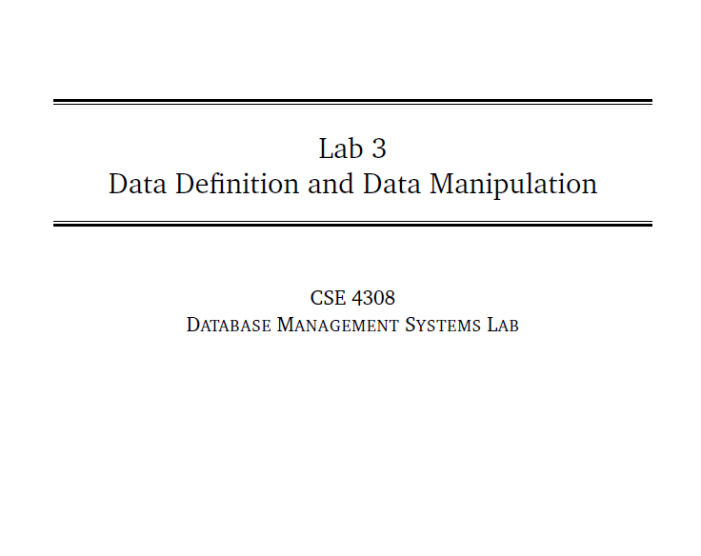

**NAME: CHOWDHURY ASHFAQ**

**STUDENT ID: 200042123**

**PROGRAM: SWE**

**GROUP: 1A**

**DATE: 11/09/22**

**Tasks:**

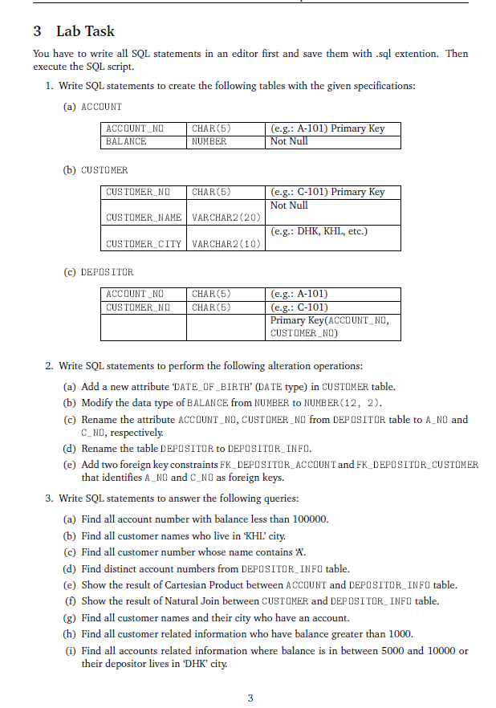

In this Lab Task we were given to perform various DDL (Data Definition Language) and DML ( Data Modification Language) operations.

**Analysis of the problem:**

At first 5 subtasks where given which needed to be performed through DDL. These 5 subtasks include renaming a table and attribute, adding a attribute to a table, modifying the data type of an attribute and adding foreign key constraints to a table.

Next there was 9 tasks which where to be done by DML. The 9 tasks included selection of various attributes from different tables.

**Solution:**

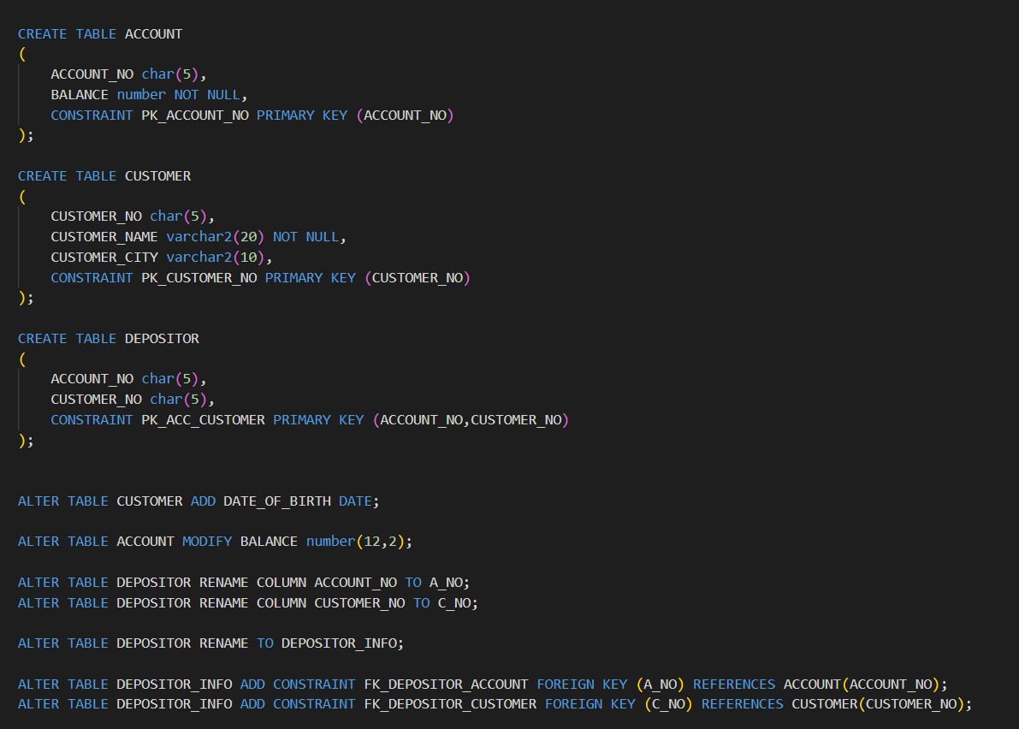

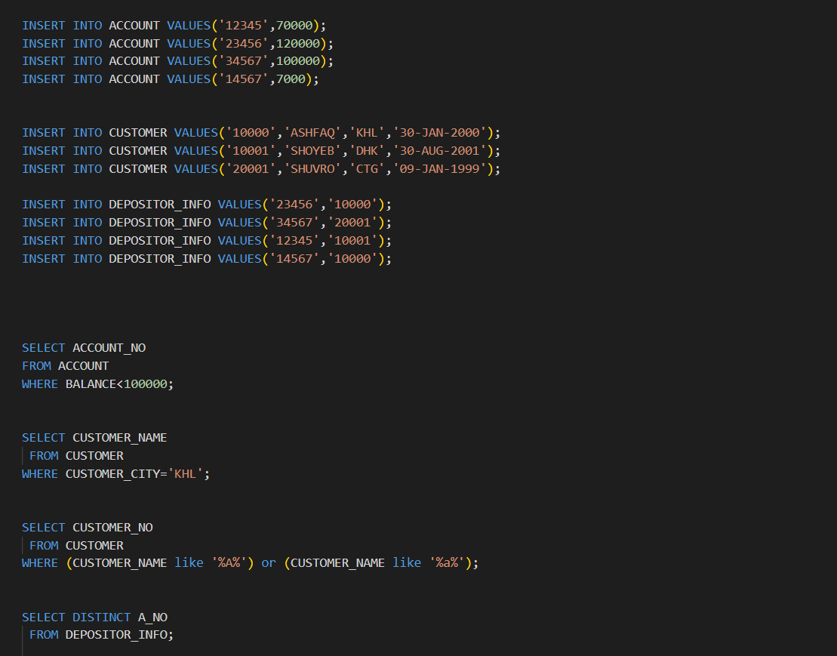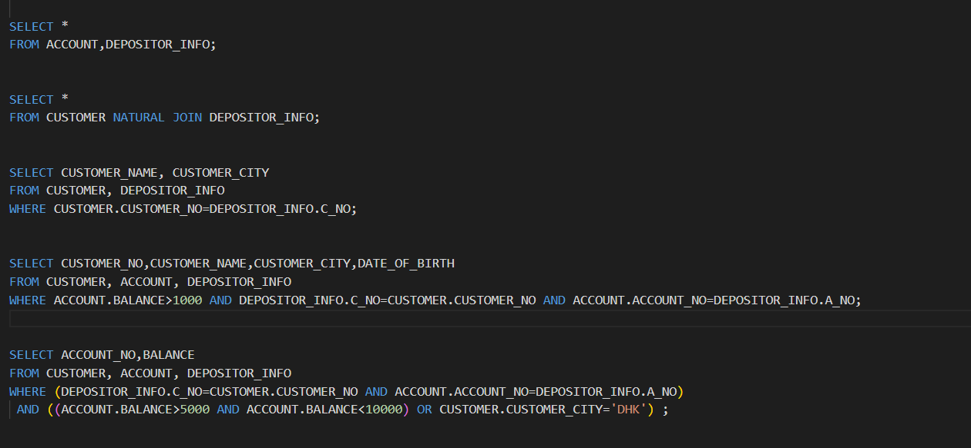

**OUTPUT:**

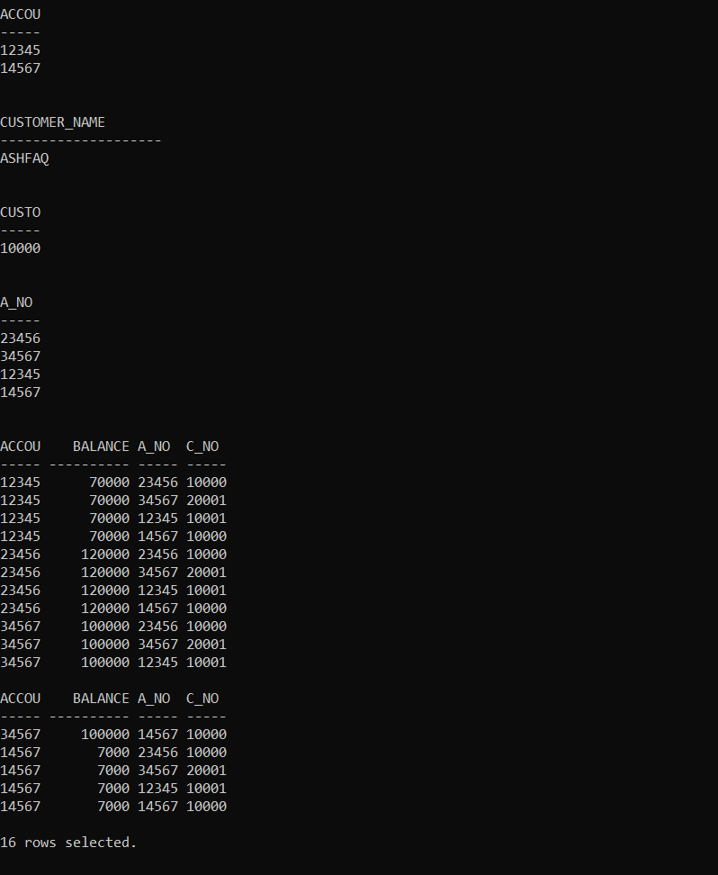

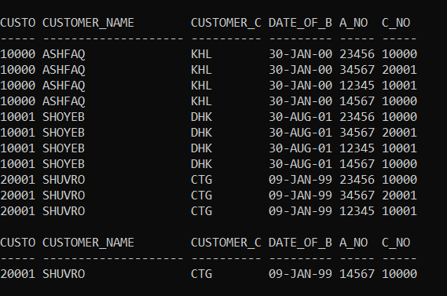

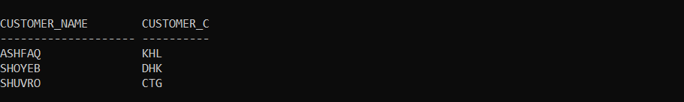

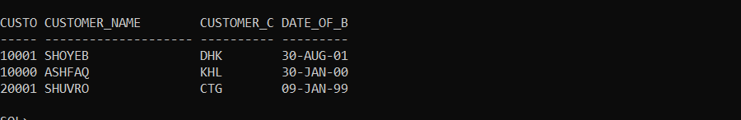

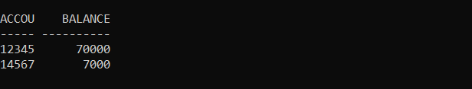

**Explanation:**

* At first we create a new user named as ‘ash20042123’ with password ‘cse4308’. The command for the action is :

CREATE USER ash200042123 IDENTIFIED BY cse4308;

* Next we grant all privileges to the new user through the command:

GRANT ALL PRIVILEGES TO ash200042123;

* Then we are to create 3 tables named as ACCOUNT, CUSTOMER and DEPOSITOR.

ACCOUNT table has two columns ACCOUNT_NO and BALANCE whose domain are char(5) and number respectively. We also give a constraint PRIMARY KEY which is ACCOUNT_NO.

CUSTOMER table has three columns CUSTOMER_NO, CUSTOMER_NAME and CUSTOMER_CITY whose domain are char(5), varchar2(20) and varchar2(10) respectively. We also give a constraint PRIMARY KEY which is CUSTOMER_NO.

Next the DEPOSITOR table has ACCOUNT_NO and CUSTOMER_NO of domain char(5). Both of them are selected together as PRIMARY KEY.

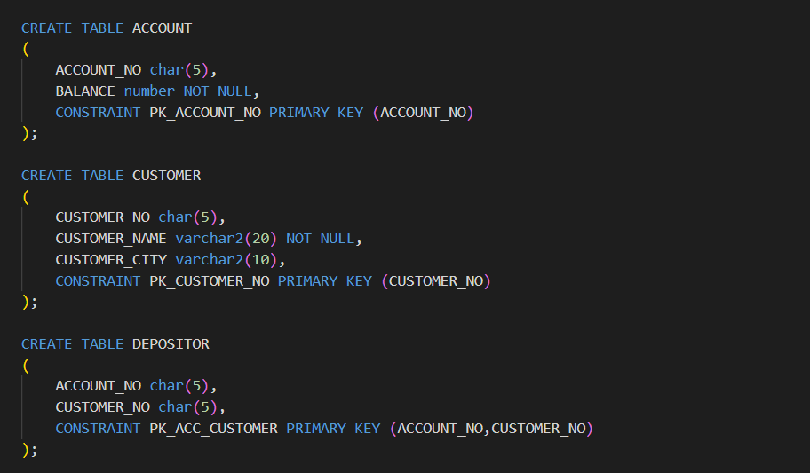

* Next we have to perform some DDL operations.

At first, we add a column DATE_OF_BIRTH to CUSTOMER table for which ALTER TABLE is used and with the help of ADD keyword.

Secondly, we modify the domain of BALANCE attribute of ACCOUNT table to number(12,2) from number using MODIFY keyword.

Thirdly, we rename the column name of ACCOUNT_NO and CUSTOMER_NO of DEPOSITOR table to A_NO and C_NO respectively with RENAME keyword.

After that we convert the name of DEPOSITOR table to DEPOSITOR_INFO with RENAME keyword.

Lastly, we are to add to FOREIGN KEY CONSTRAINTS to the table DEPOSITOR_INFO which are named as FK_DEPOSITOR_ACCOUNT and FK_DEPOSITOR_CUSTOMER and applied to A_NO and C_NO referencing ACCOUNT_NO of ACCOUNT table and CUSTOMER_NO of CUSTOMER table respectively.

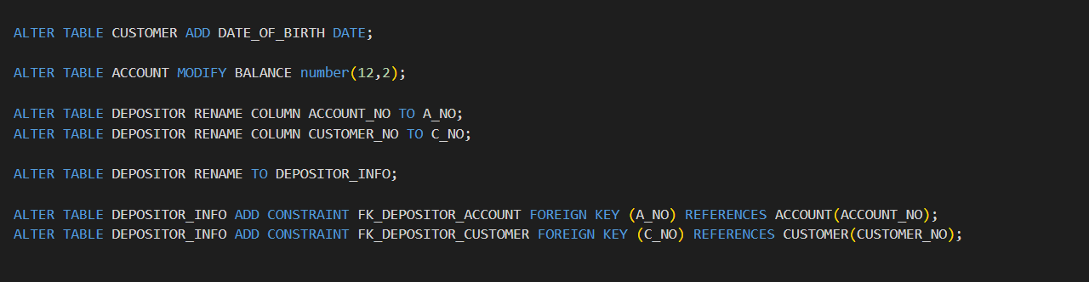

* Next we insert some values to the 3 tables to perform the DML operations later on.

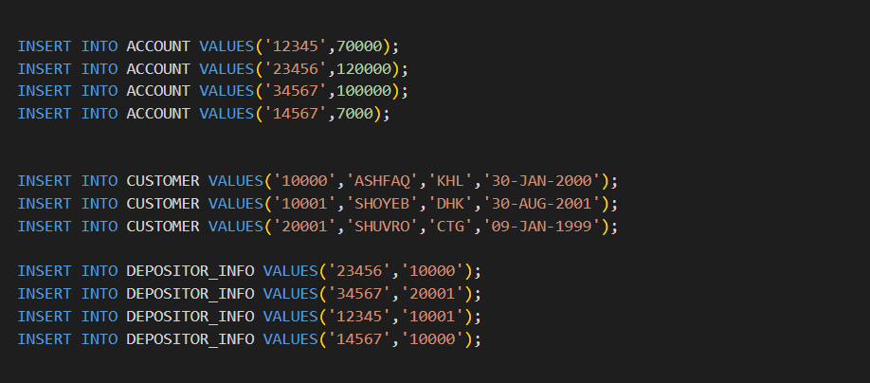

* We then perform the DML operations which are as follows:

1. We select the ACCOUNT_NO of those who have BALANCE more than 1,00,000 from ACCOUNT table with SELECT, FROM, WHERE command.
2. In the same way as above we select CUSTOMER_NAME who live in ‘KHL’ city from CUSTOMER table.
3. Again from CUSTOMER table we select the customer number of those person who has ‘A’ in their name. The ‘like’ operator is a string matching operator and by ‘%A%’ we denote at any part of the string if A is present.
4. Then we select all the different A_NO from DEPOSITOR_INFO table. To select different A_NO we use DISTINCT keyword.
5. Then we perform a Cartesian Product between ACCOUNT and DEPOSITOR_INFO table. To do it we simply select all the elements from ACCOUNT, DEPOSITOR_INFO.
6. Then we perform NATURAL JOIN between the CUSTOMER table and DEPOSITOR_INFO table which is done with the NATURAL JOIN keyword.

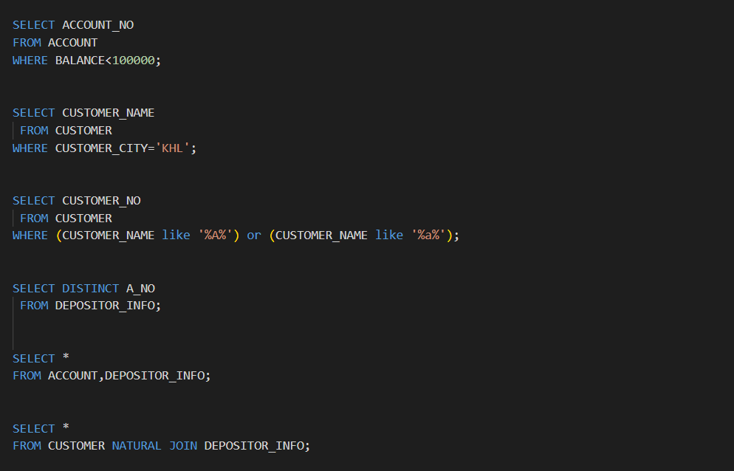

1. Then we find all the customer names and their city who have an account. Those who have an account will have an entry in DEPOSITOR_INFO table. So, we perform Cartesian Product between CUSTOMER, DEPOSITOR_INFO table and take only the meaningful values. From there we select the customer name and customer city.
2. After that we find all customer related information who have balance greater than 1000. First we do Cartesian Product among the three tables and then we take only the meaningful tuples and those tuples where account balance is more than 1000. From there we select only the customer number, customer name, customer city and date of birth. As a customer may have two or more accounts so we select only the distinct customer numbers.
3. Next we select all account related information where balance is in between 5000 and 10000 or their depositor lives in ‘DHK’ city.

For that at first we take only the meaningful tuples from the Cartesian product of the three tables. From there, we only take those tuples whose account balance is more than 5000 and less than 10000 or those customers who live in Dhaka city. We then select account number and balance from the result we’ve got.

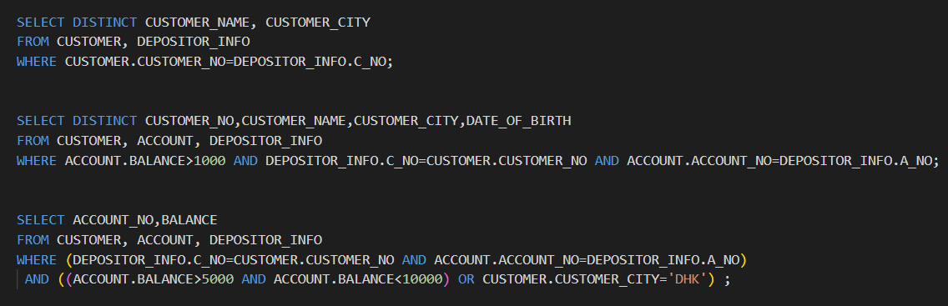

**Interesting Findings:**

* Learn about the problem of NATURAL JOIN.

**Problems faced and solution:**

* Didn’t know the format of DATE type in SQL. Had to google it.
* Faced difficulty to add constraint to a table through command prompt. Took help from YouTube to solve the problem.