**LAB REPORT**

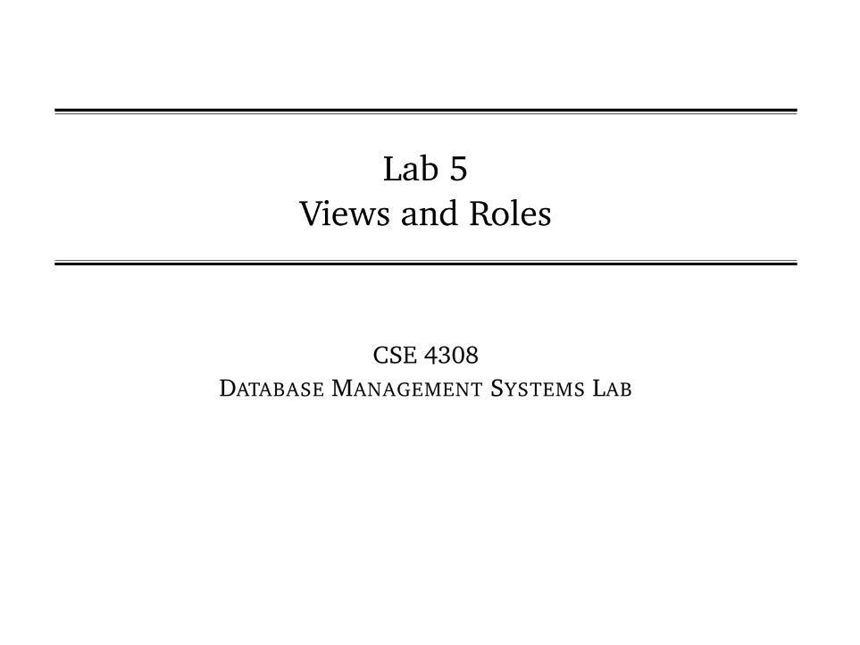

**NAME: CHOWDHURY ASHFAQ**

**STUDENT ID: 200042123**

**PROGRAM: SWE**

**GROUP: 1A**

**DATE: 08/10/22**

**Tasks:**

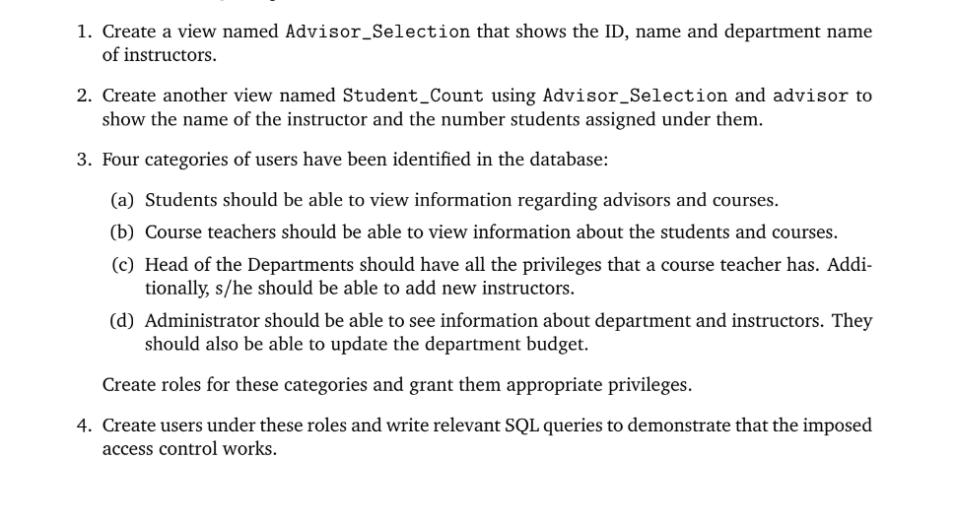

In this Lab Task we were given to perform various DDL (Data Definition Language) and DML ( Data Modification Language) operations.

**Analysis of the problem:**

Two files DDL+drop.sql and smallRelationsInsertFile.sql scripts were given and we need to perform various operations on them after executing them.

**Solution:**

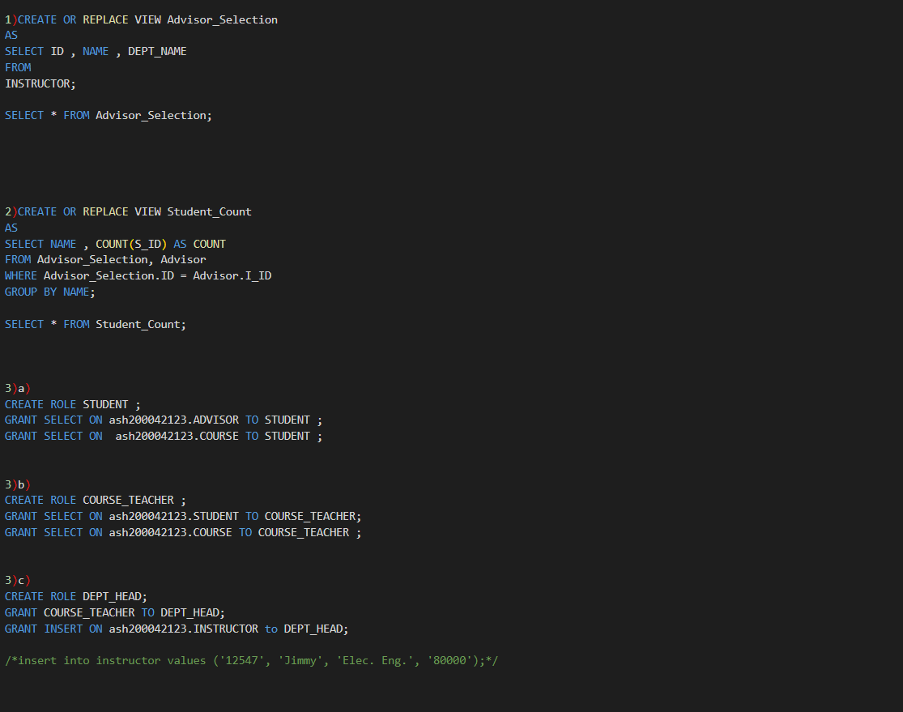

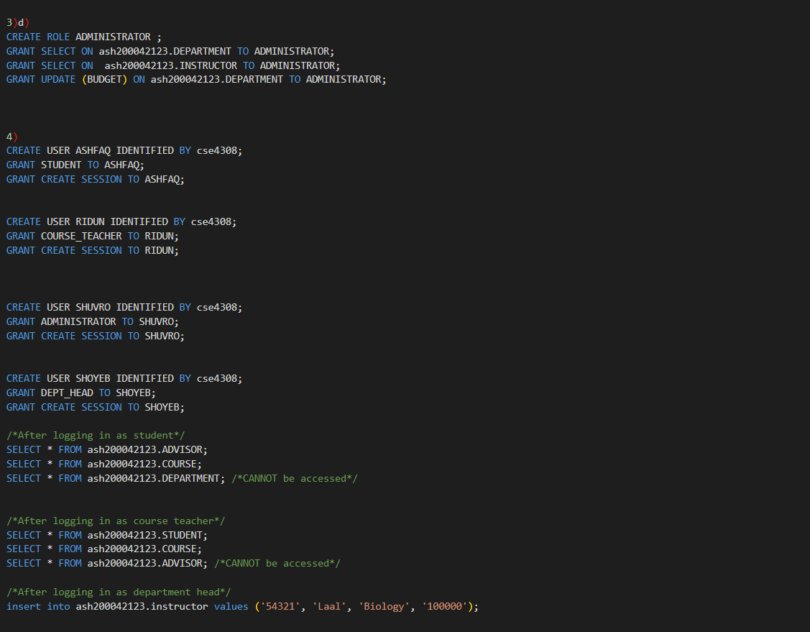

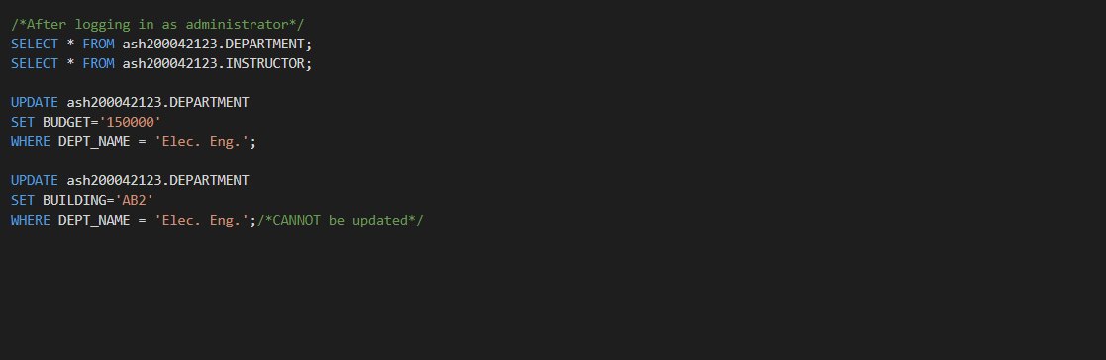

**OUTPUT:**

