**LAB REPORT**

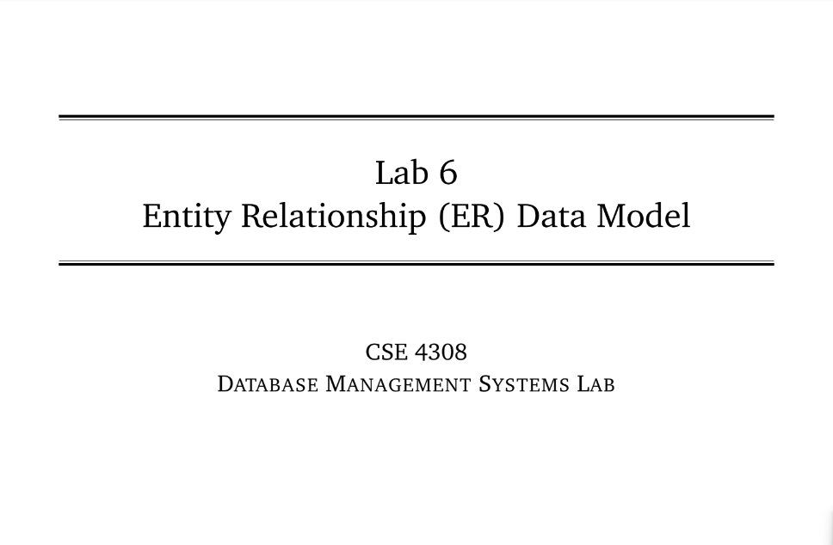

**NAME: CHOWDHURY ASHFAQ**

**STUDENT ID: 200042123**

**PROGRAM: SWE**

**GROUP: 1A**

**DATE: 16/10/22**

**Tasks:**

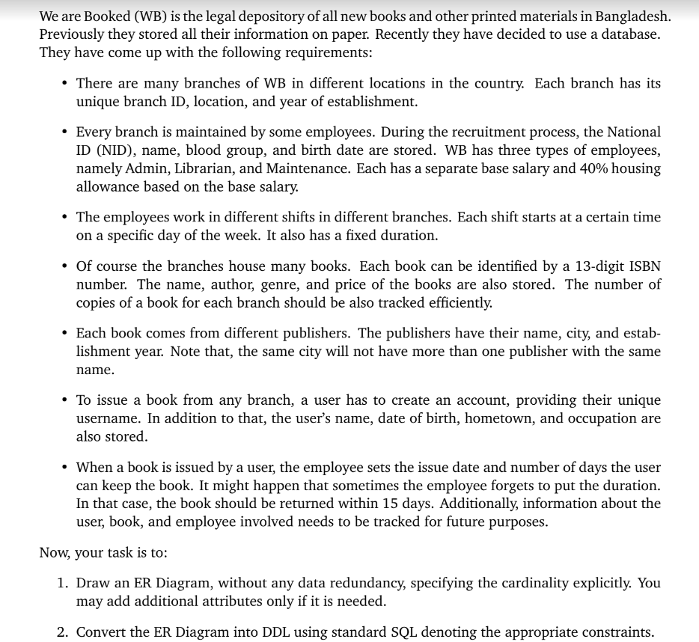

**Analysis of the problem:**

A scenario is given from where we need to draw the ER diagram and from that ER diagram we need to execute the corresponding DML operations.

**Solution:**

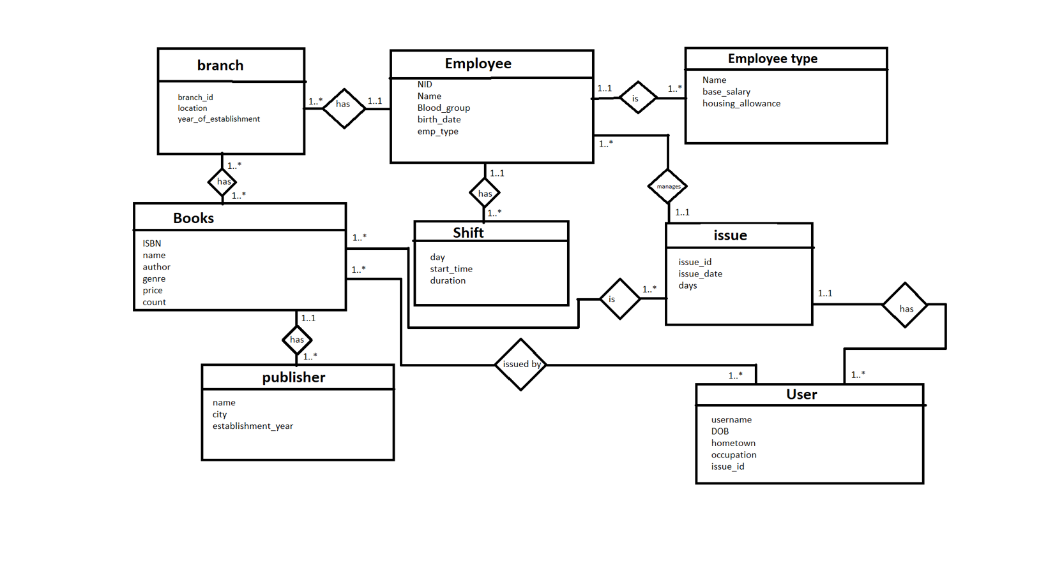

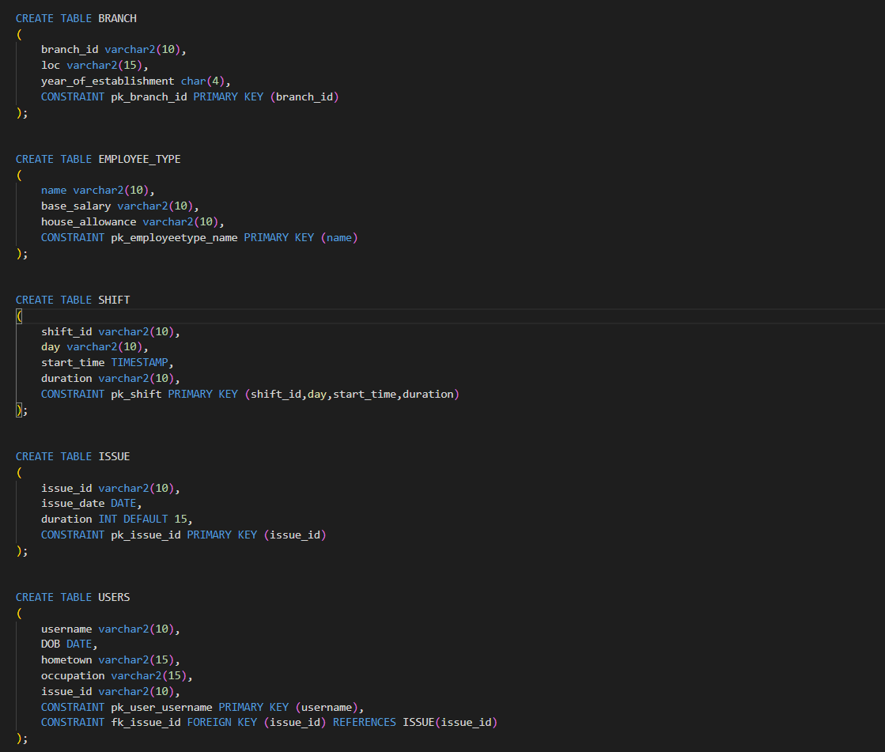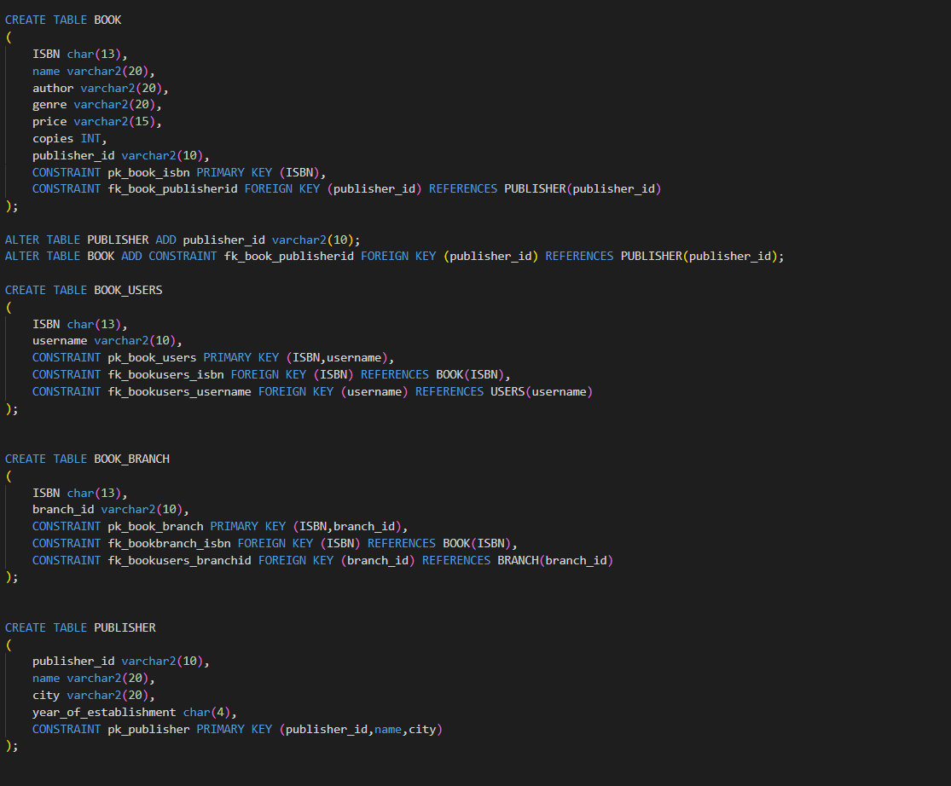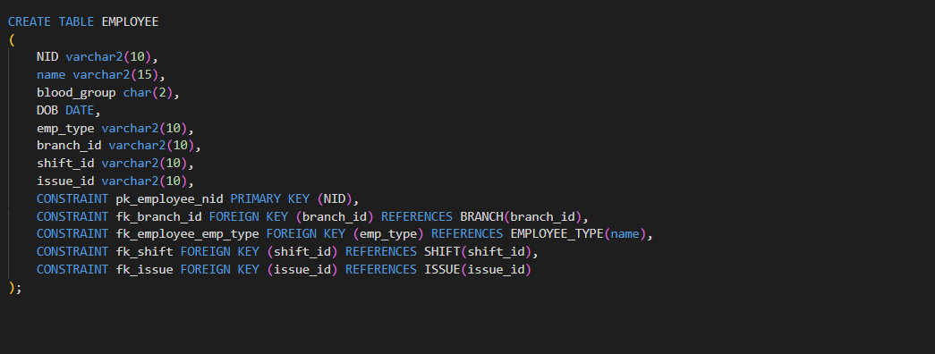

**Interesting Findings:**

Easy to execute DML’s after drawing ER diagram.