**LAB REPORT**

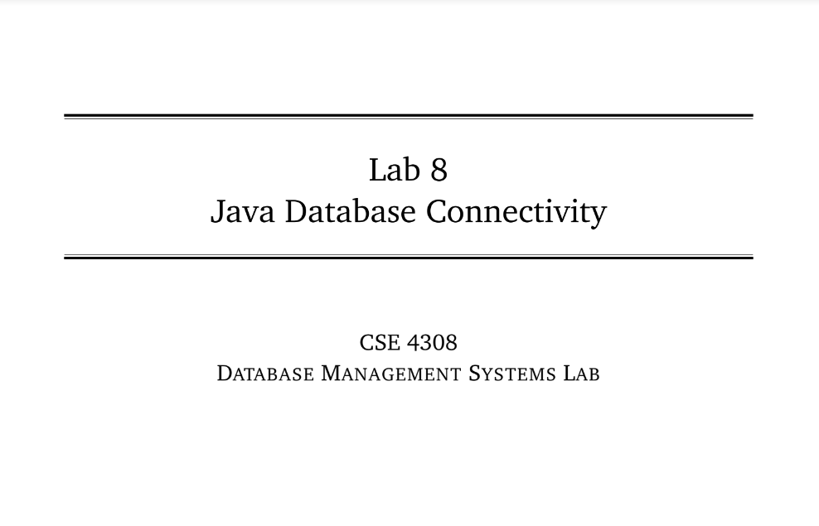

**NAME: CHOWDHURY ASHFAQ**

**STUDENT ID: 200042123**

**PROGRAM: SWE**

**GROUP: 1A**

**DATE: 30/10/22**

**Tasks:**

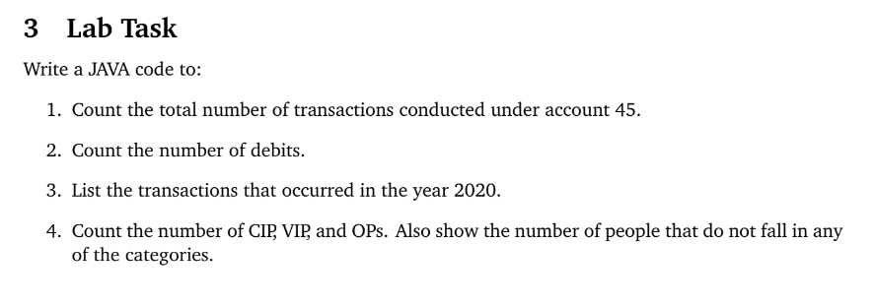

**Analysis of the problem:**

A database instance was given and we had to extract data with various conditions. The job was told to be done through Java.

To solve the tasks we need to setup the environment of IDE at first. The procedure was mentioned in the Lab manual. Following the procedure we set up the environment and also execute the table.sql file.

**Solution:**

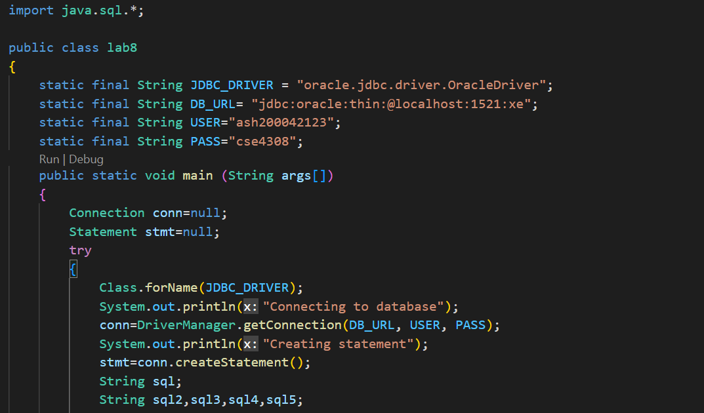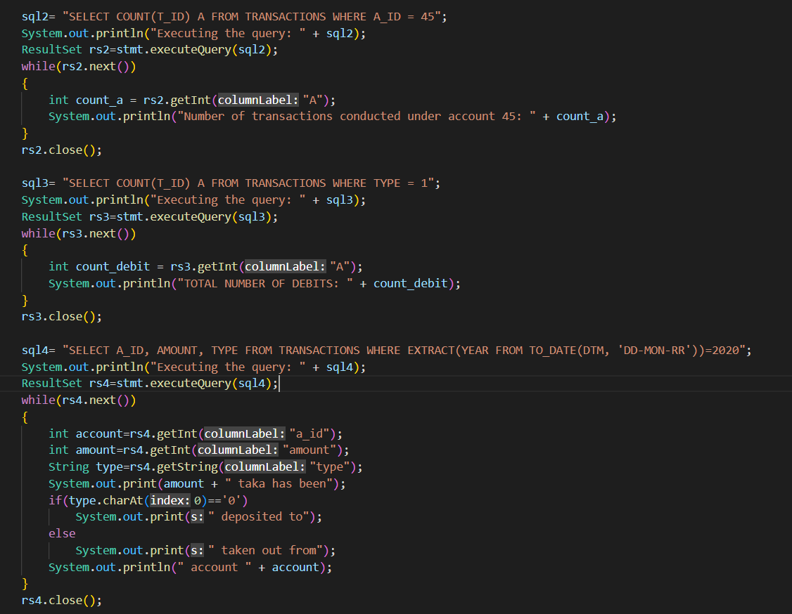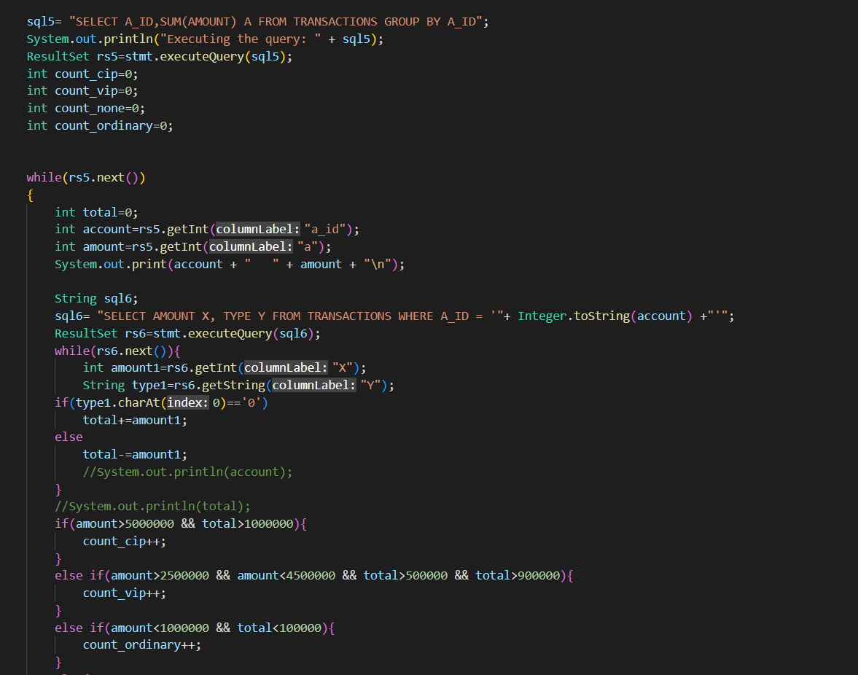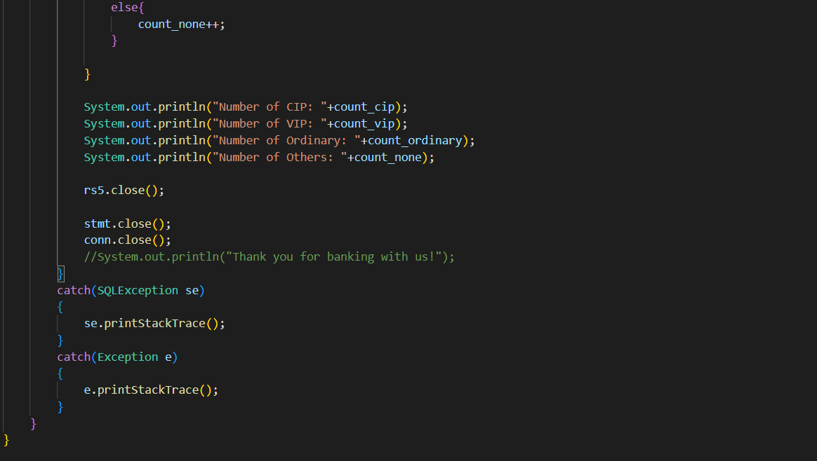

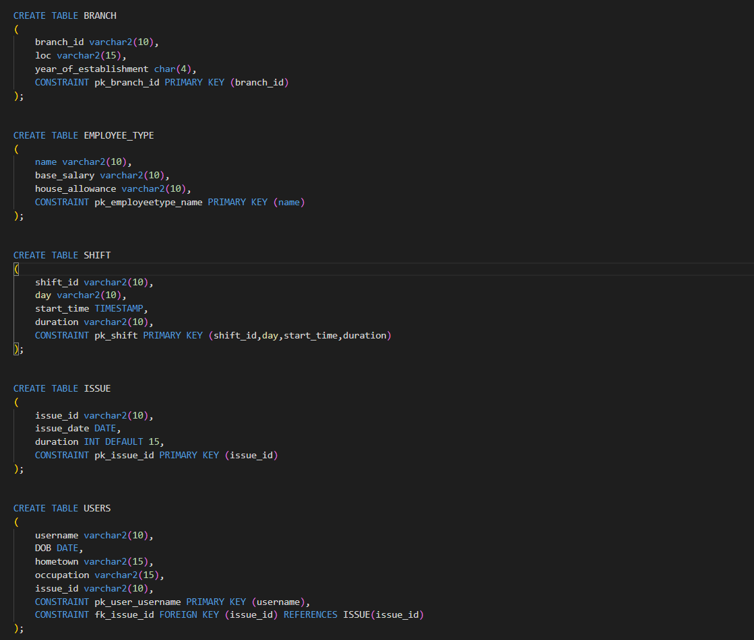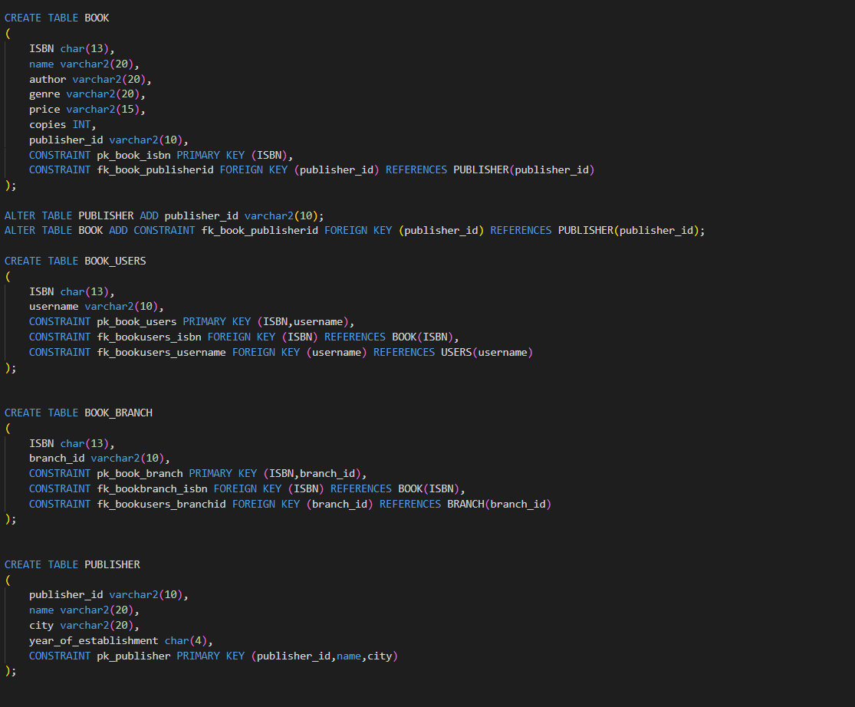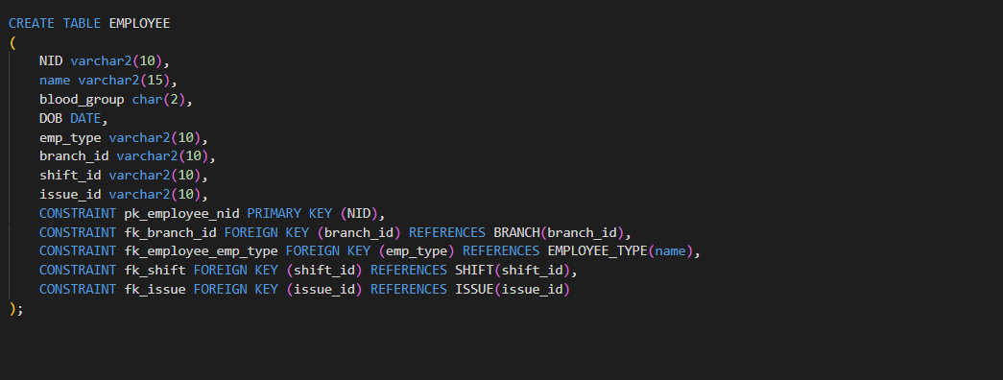

**Explanation:**

At first we need to make the connection with the database. The DB_URL, User and password is used for this reason.

The ‘conn=DriverManager.getConnection(DB_URL, USER, PASS);

Part makes the connection with database.

Next we need to write the required sql codes in a string which are named as sql1,sql2, sql3, sql4 and sql5. Next we execute the sql code and the results are stored in rs2, rs3, rs4, rs5 respectively.

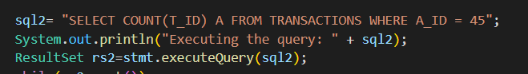

Next we use the data stored in ResultSet. A loop is executed which runs until there’s some data in the Resultset. After our work with a particular ResultSet is done we close that ResultSet.

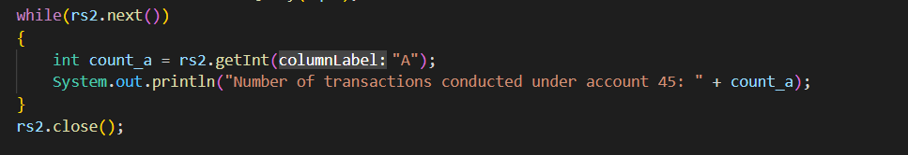

**OUTPUT:**

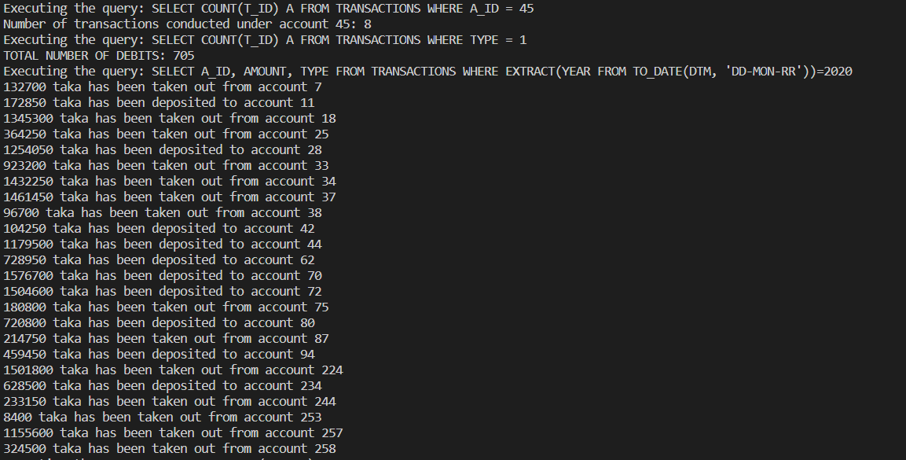

**Interesting Findings:**

Java and Sql together is very powerful.