**LAB REPORT**

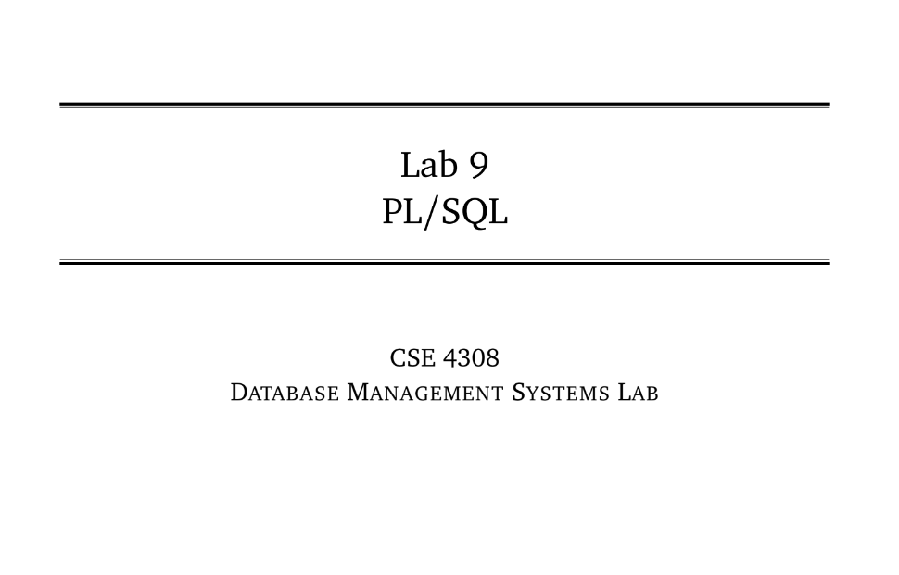

**NAME: CHOWDHURY ASHFAQ**

**STUDENT ID: 200042123**

**PROGRAM: SWE**

**GROUP: 1A**

**DATE: 06/11/22**

**Tasks:**

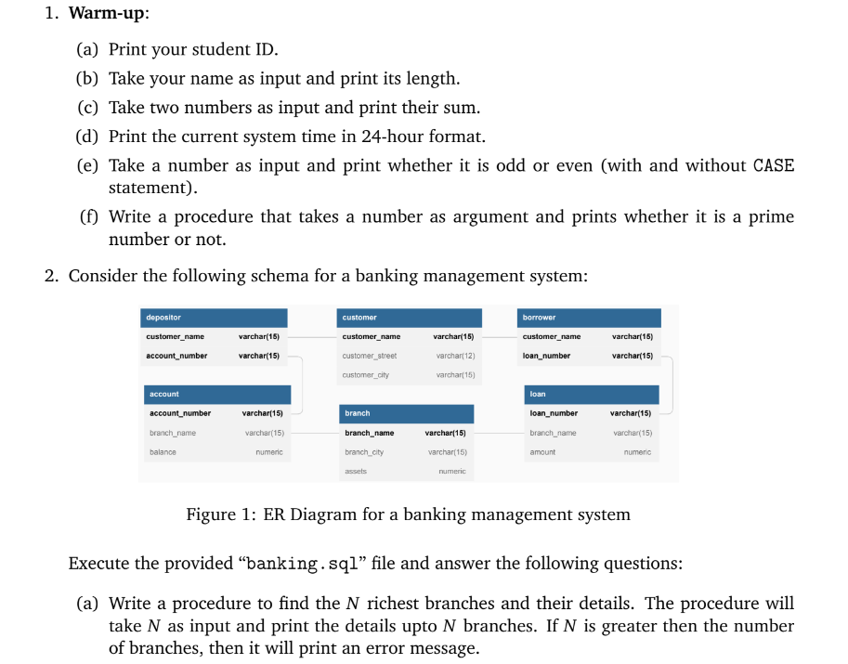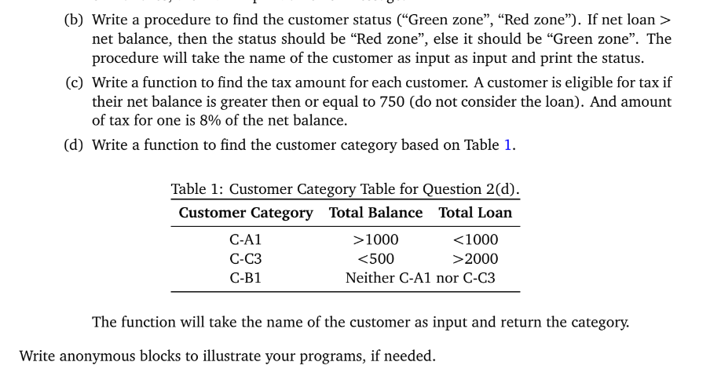

**Analysis of the problem:**

At first we needed to write some very basic statements using PL/SQL. Later we had to write some functions and procedures to perform some particular tasks mentioned above.

**Solution:**

