**LAB REPORT**

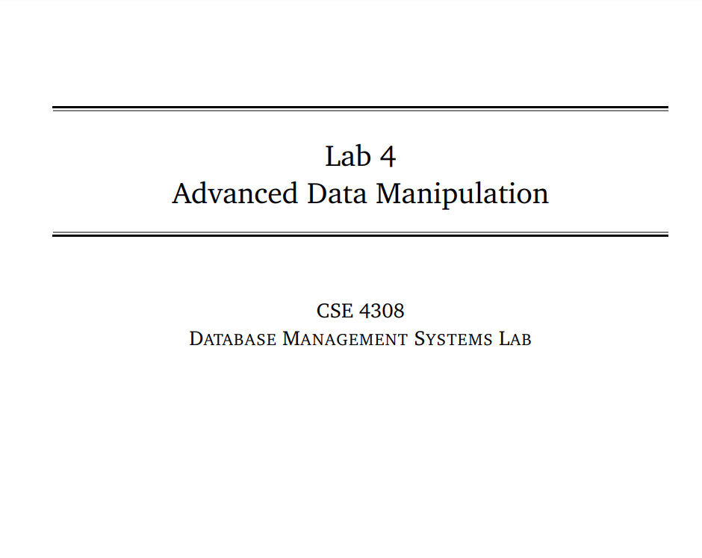

**NAME: CHOWDHURY ASHFAQ**

**STUDENT ID: 200042123**

**PROGRAM: SWE**

**GROUP: 1A**

**DATE: 18/09/22**

**Tasks:**

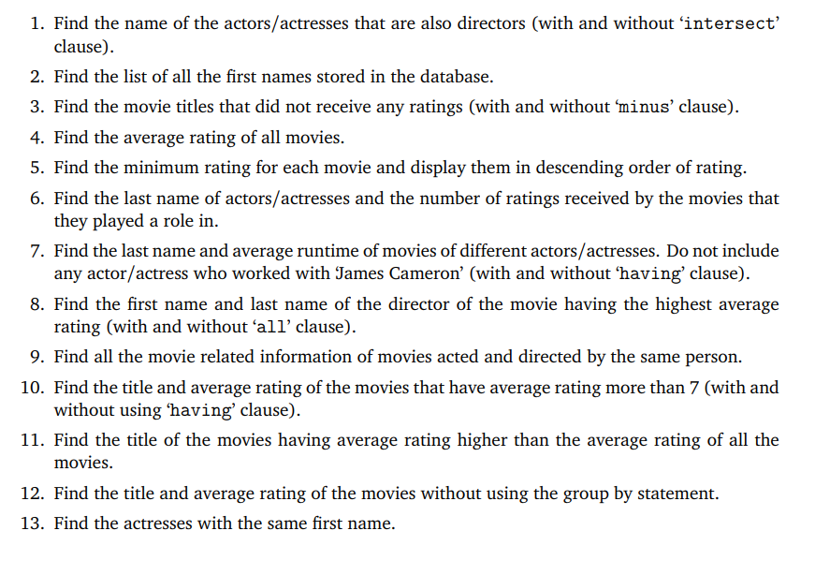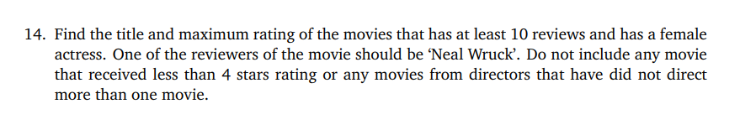

In this Lab Task we were given to perform various DDL (Data Definition Language) and DML ( Data Modification Language) operations.

**Analysis of the problem:**

A movie.sql file was given which contained all the necessary tables and Primary Key and Foreign Key. From that database we had to extract different information using different queries and clauses like Having , minus, all etc.

**Solution:**

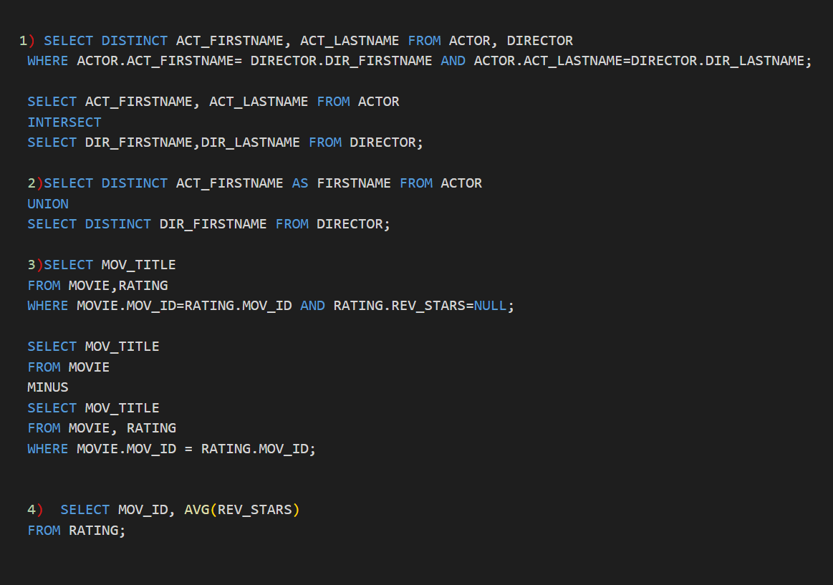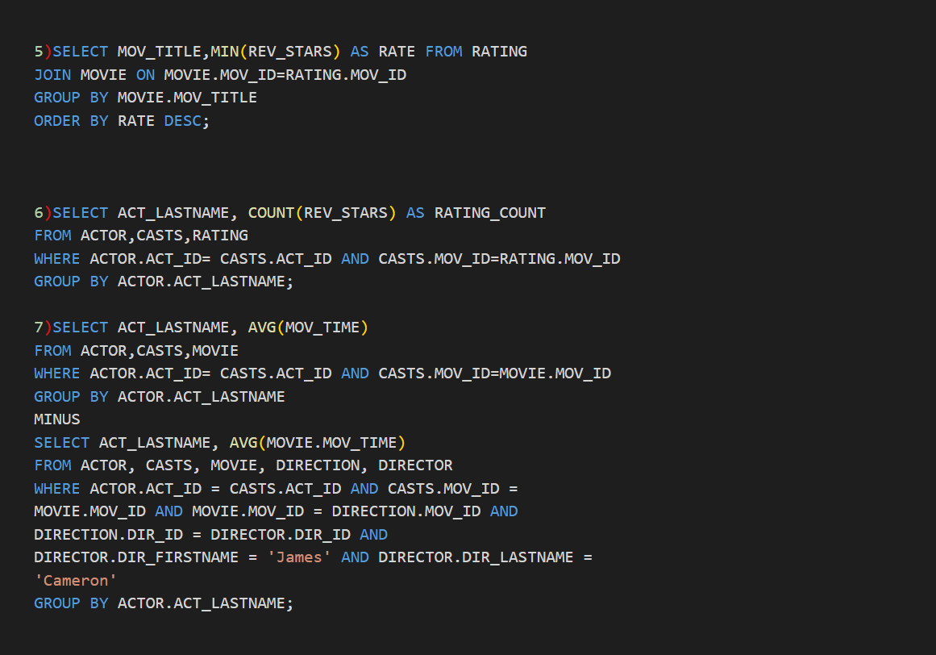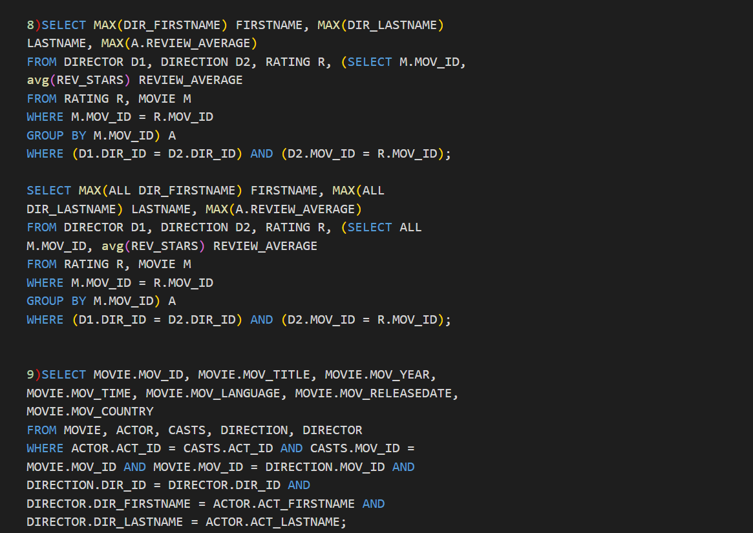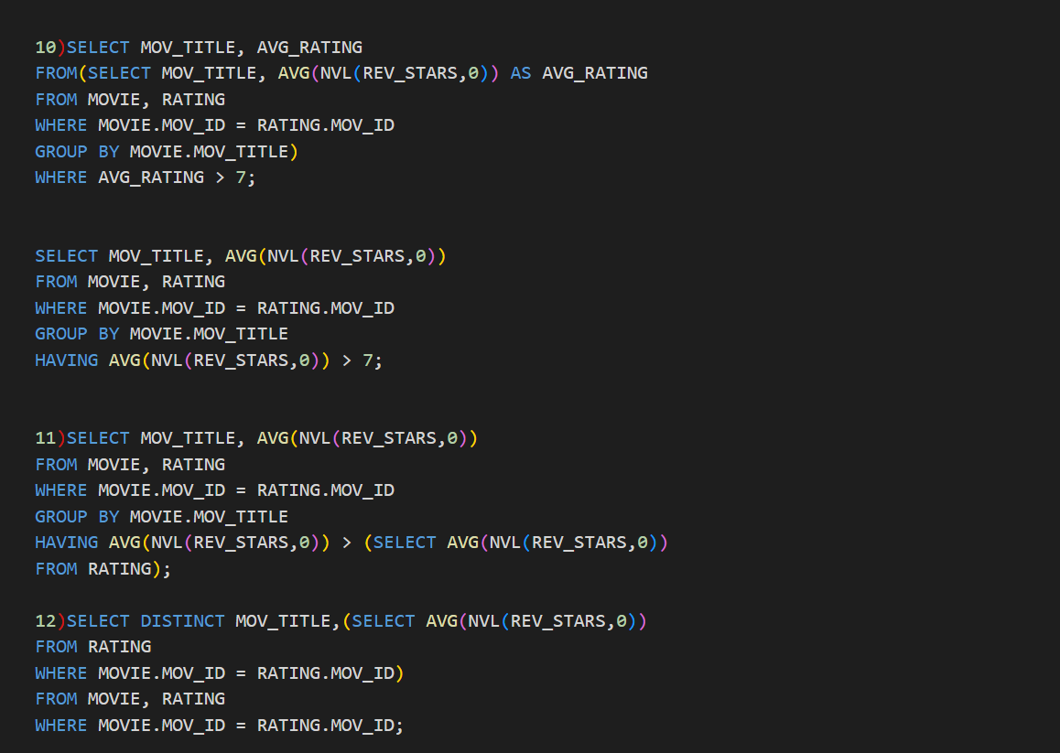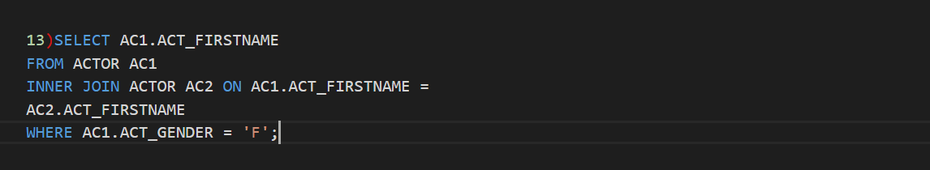

**Interesting Findings:**

* Learnt about intersect, union, minus and having.

**Problems faced and solution:**

* All of these things aren’t taught previously and we don’t even know what would be given in our next lab so it’s very hard for us to solve them at lab without prior knowledge.