**LAB REPORT**

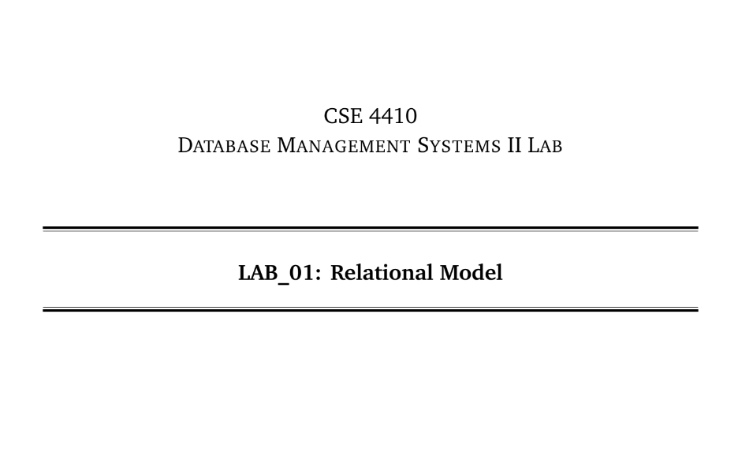

**NAME: CHOWDHURY ASHFAQ**

**STUDENT ID: 200042123**

**PROGRAM: SWE**

**GROUP: 1A**

**DATE: 13/01/23**

**Tasks:**

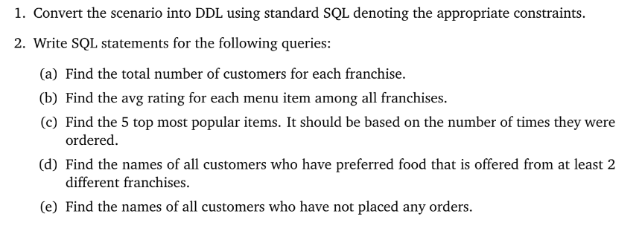

**Analysis of the problem:**

A scenario was given from where we needed to identify the entities to build an ERd diagram. The main reason to build the ERd diagram was to make the work of writing DDL statements for the given scenario easier.

With the ERd diagram we can identify the numbers of table required and write the code easily. Next we had to perform some queries too to extract information.

**Solution:**

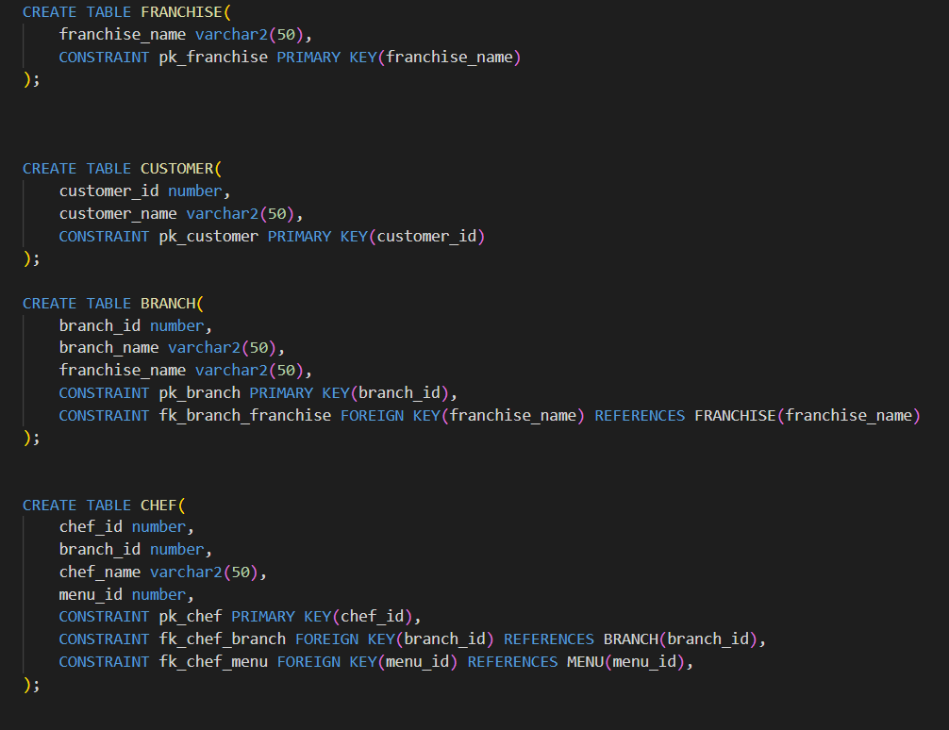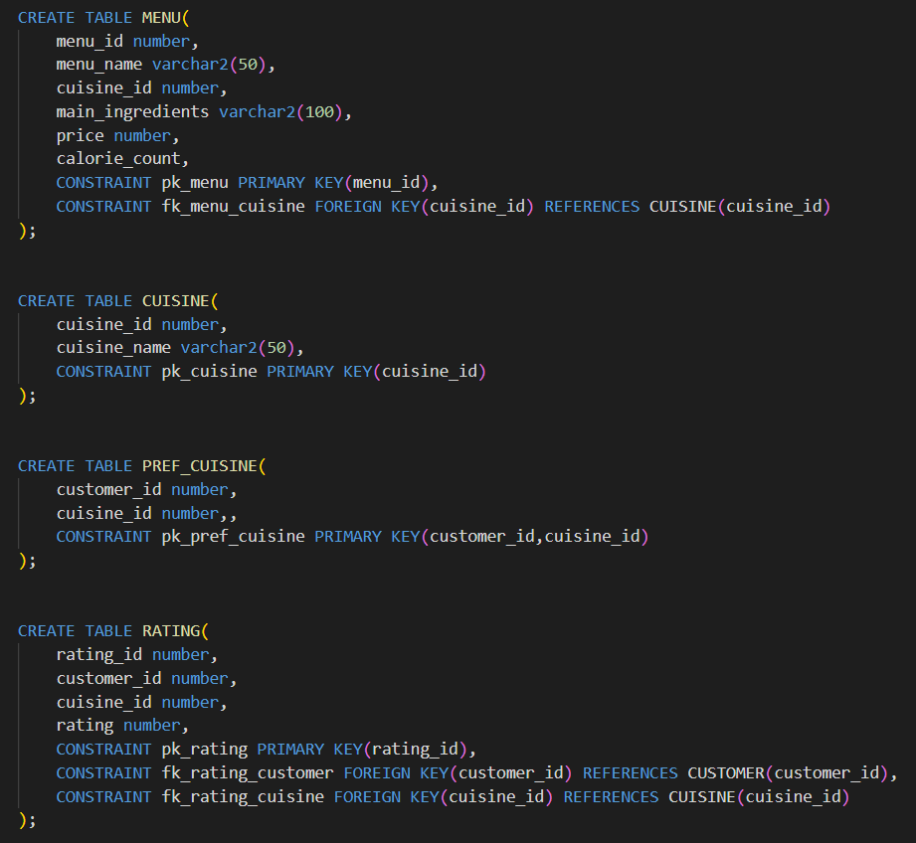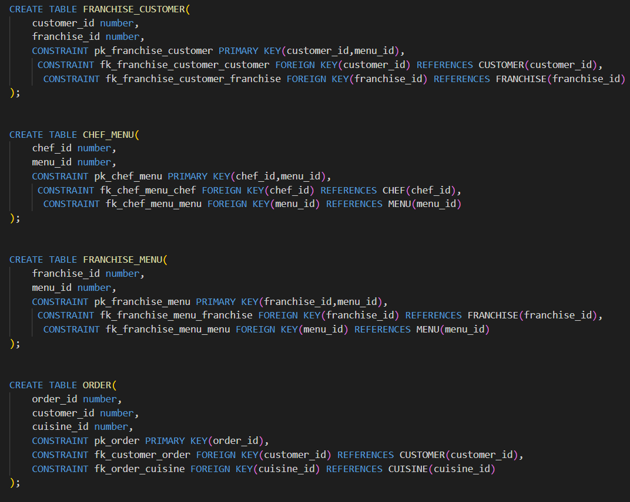 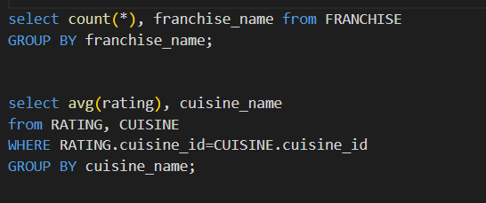

**Explanation:**

At first after reading the whole scenario I identified the entities at first and simultaneously the attributes of the entities where identified. Then I identified the relationships between the entities. As we know for many to many relationship we need a junction table so we identified the junction tables as well.

After the above process was completed we got twelve tables in total. The attributes, primary keys, and foreign keys of each of the entities where identified beforehand. So we just created the tables with the DDL statements with the help of the entity relationship diagram.

Once the tables where created I wrote some queries according to the necessity provided in the task.