**LAB REPORT**

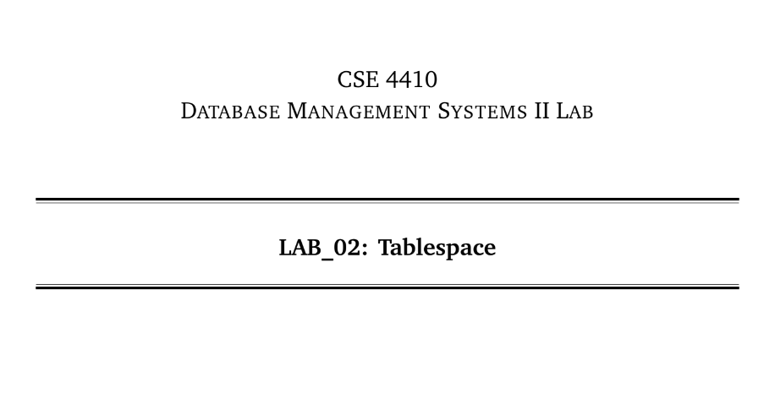

**NAME: CHOWDHURY ASHFAQ**

**STUDENT ID: 200042123**

**PROGRAM: SWE**

**GROUP: 1A**

**DATE: 15/01/23**

**Tasks:**

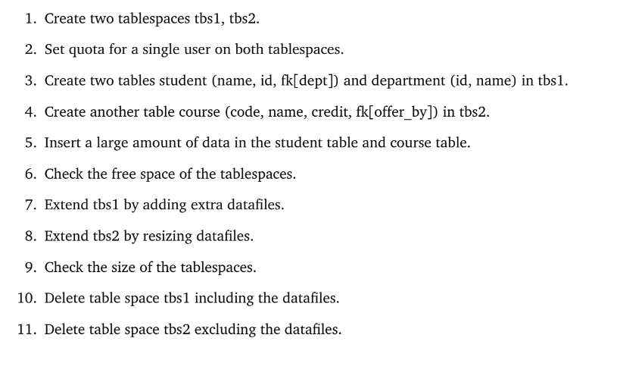

**Analysis of the problem:**

A new functionality got introduced to us which is table-space. Details about actions that can be performed on a table-space where given.

Some tasks where given which needed to be performed with those tutorials which were given.

**Solution:**

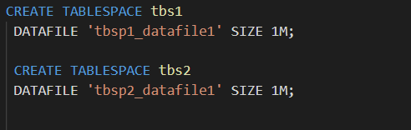 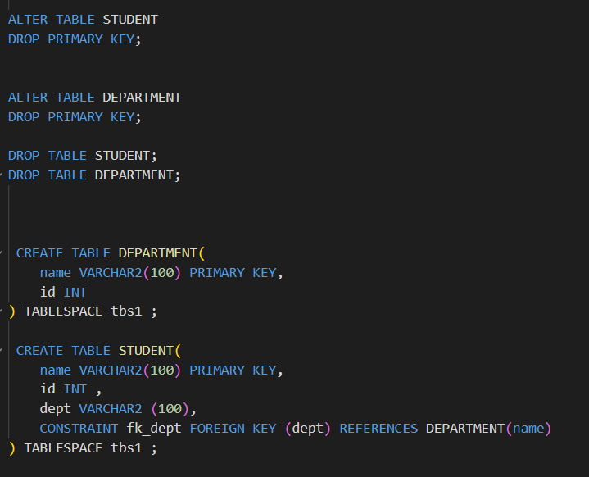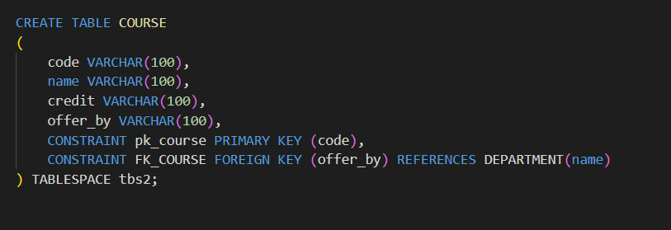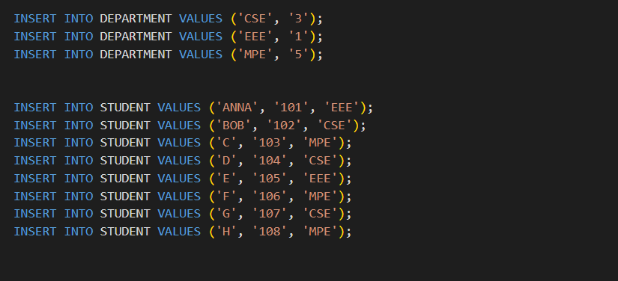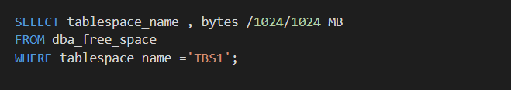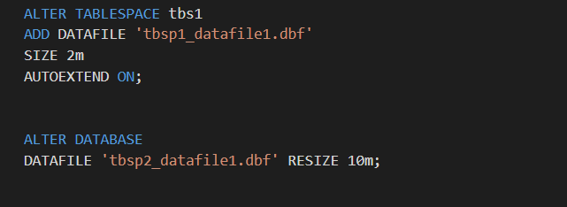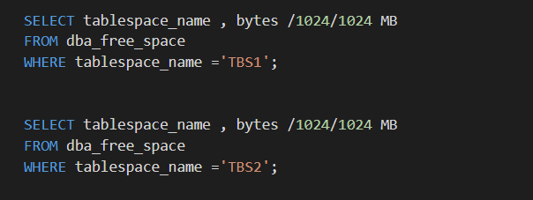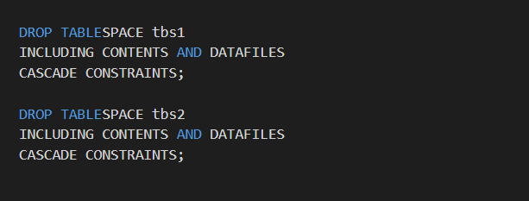

**Explanation:**

Table-space is a new concept to me. Table-space is used for a few purposes one of which is access control. There are other things which can be done through table-space.

At first we created two table-space tbs1 and tbs2 each of which contained a data file of size 1 megabyte. Next we set up a quota on the user ash200042123. Then we created two tables student and department on table-space tbs1 as mentioned in the question.

Then we create another table course which would be on tbs2. After that we insert some data on student and department table.

After that we check the amount of free-space available in each table-space which can be done using the dba_free_space. It has a special syntax which shows the amount of free space available in each table-space.

Table-spaces can be extended in two ways. One is by adding data-files and another is re-sizing an existing data-file. On tbs1 we add an data-file of size 2 megabyte. On tbs2 we resize the existing data-file to 10 megabyte. After that we check the size of the data files again using the previous syntax.

Next we drop both of the table-spaces along with the contents, and data-files.

**Problems Faced:**

As it was my first time using table-space so I faced some difficulty in the syntax.