**LAB REPORT**

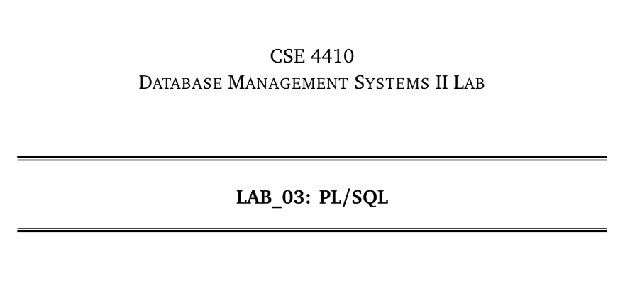

**NAME: CHOWDHURY ASHFAQ**

**STUDENT ID: 200042123**

**PROGRAM: SWE**

**GROUP: 1A**

**DATE: 03/02/23**

**Tasks:**

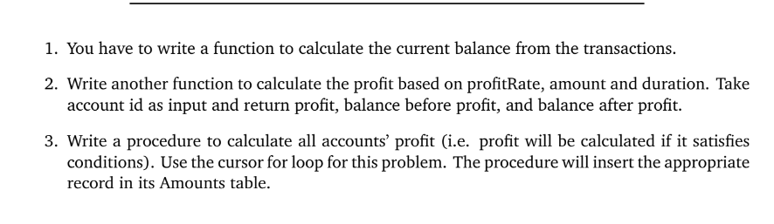

**Analysis of the problem:**

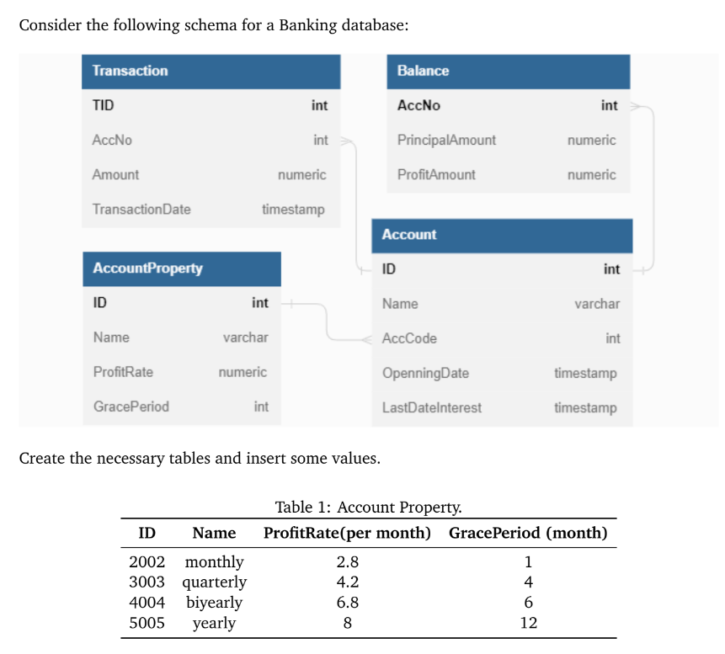

The above scenario was given which is of a b=Banking database. We had to write 2 functions and 1 procedure. The function of them where pre-defined.

**Solution:**

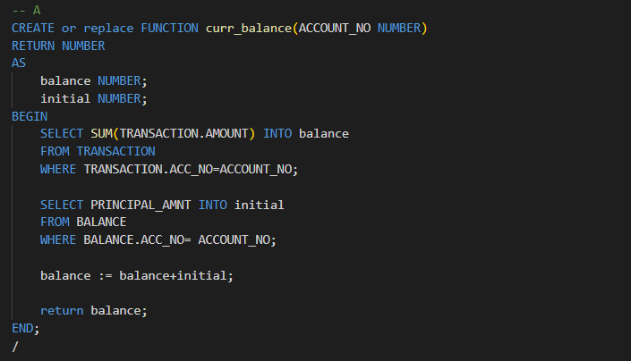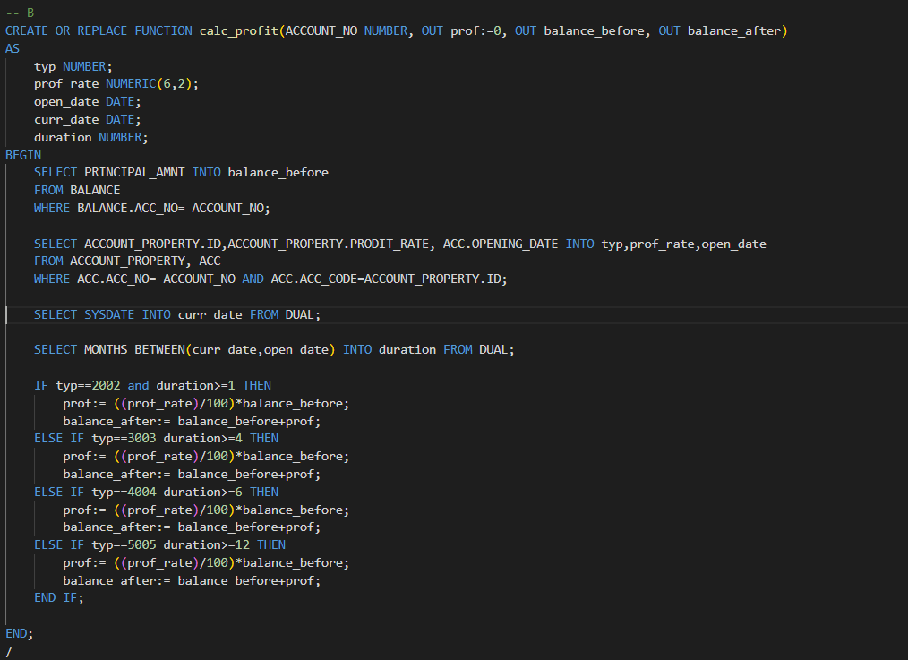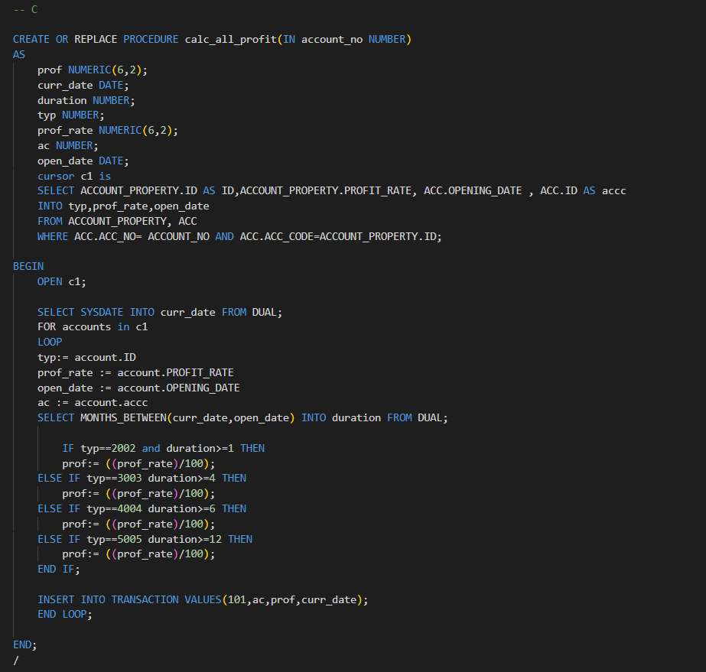

**Explanation:**

1. This is a PL/SQL function that calculates the current balance of a bank account. The function takes the account number as an input and returns the balance as a number. The function starts by finding the sum of all the transactions made on the account and stores it in the "balance" variable. Next, it retrieves the initial balance of the account from the "BALANCE" table and stores it in the "initial" variable. Finally, it adds the initial balance to the balance of all transactions to get the current balance, which is then returned as the result of the function.
2. This is a PL/SQL function that calculates the profit and balance of a bank account. The function takes the account number as an input and returns the profit, balance before and after the profit calculation as output parameters. The function starts by retrieving the initial balance of the account from the "BALANCE" table and storing it in the "balance_before" output parameter. Next, it retrieves the account type, profit rate and the opening date of the account from the "ACCOUNT_PROPERTY" and "ACC" tables. It also retrieves the current date from the database. The function then calculates the duration between the current date and the opening date of the account. Based on the account type and duration, the function calculates the profit and updates the balance after the profit calculation in the "balance_after" output parameter. Finally, it returns the profit as the result of the function.

The "calc_all_profit" procedure calculates the profit for all bank accounts with the given account number.

The procedure has a cursor "c1" which selects the account properties and opening date of the account from the ACCOUNT_PROPERTY and ACC tables. The procedure then loops through each account returned by the cursor, calculates the profit based on the type of account and duration, and inserts a new transaction into the TRANSACTION table with the calculated profit and current date.

**Problems Faced:**

Syntax is always a problem.