Project

Jersey Merchant Website

|  |  |  |  |
| --- | --- | --- | --- |
| **#** | **ID** | **Name** | **Contributions** |
| 1 | 200042123 | Chowdhury Ashfaq | Add product,  Track Order |
| 2 | 200042129 | Mostofa Washif | Update profile, |
| 3 | 200042157 | Md. Soyeb | Customer Registration, Drawing Use case Diagrams |
| 4 | 200042159 | Iftekharul Haque | Search Product, Buy Product |
| 5 | 200042167 | Md. Rafiur Rahman | Shop Registration, Payment |

**Jersey Merchant Website**

**User Scenario :**

This system will be used for ordering sportswear items by general people. Here the end users would be Customers (those who’d order), Admin(Persons, who’d manage the website and add new shops), and Shop and Payment processing partners.

The System Admin can add information about other users, especially the details about shops or add and delete new shops to the system. The admin can assign roles and can do all operations defined for other users. The system admin can also view the activity log.

Customers can sign up to the website using their phone number and password. Later the customer can log in to the system with a phone number and password. After logging in he/she can view his/her profile information and can update the profile information anytime. Profile information would be stored in the database. Customers can also order any available products from the website. There’d be options for both cash and online payment. If a customer chooses online payment then he/she can pay through an external system. The payment information should be stored in the database. Customers can search for any product on the website.

Any person who is not logged in can track the status of the order.

Shops can be added to the website after contacting the System Admin. The shop will be added only if the Admin Approves. If the shop user is approved then they can log in with a unique phone number and password. After logging in the shop, the user can track orders that have been placed after his shop. He/ she can update the status of the order. Furthermore, the shop user would be able to add new items and stock quantity. Information about products and stock would be stored in the database.

Shop users would be able to confirm an order and after it’s confirmed the customer would receive a tracking link in his/her number.

**Use-case Diagram:**

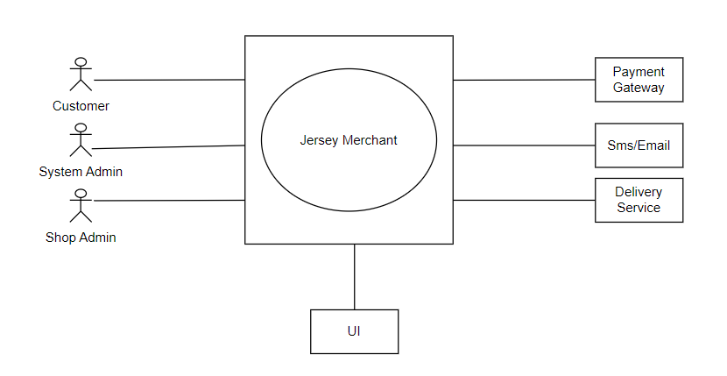

**Figure: Level 0**

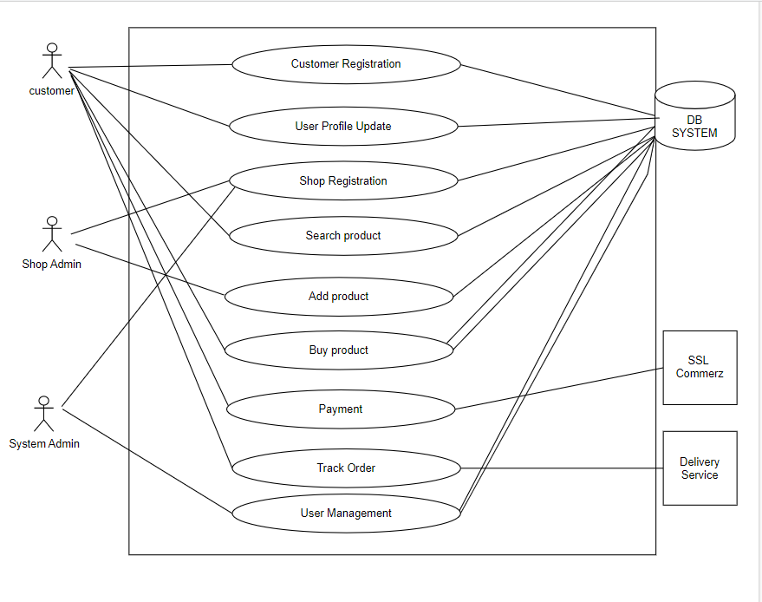

**Figure: Level 1**

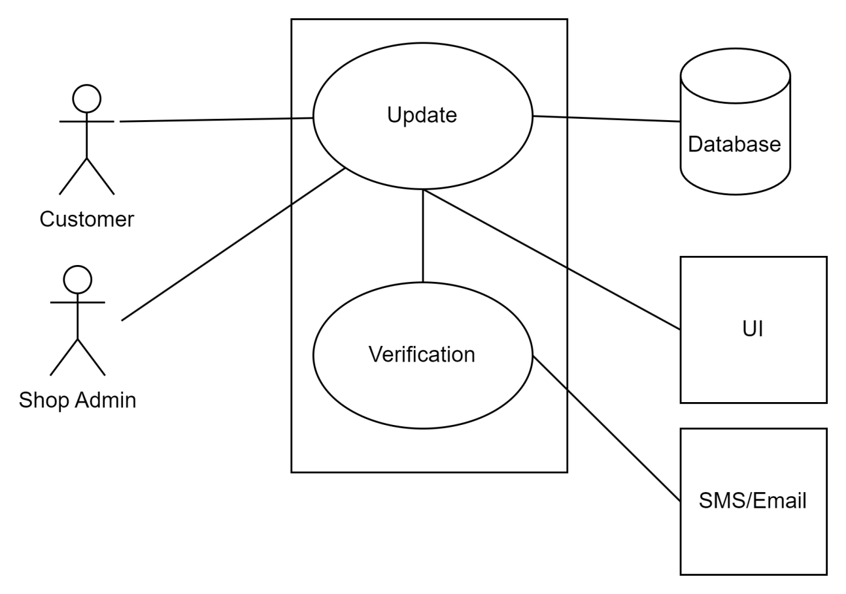

**Figure: Level 1.2**

**Use Case Name**: Add Product

**Iteration:**

1. Developed by: Mostofa Washif on 06 February, 2023

**Primary Actor:** Shop Owners

**Goal in the context:** The shop owners would be able to add new products.

**Preconditions:**

1. The shop owner must be registered and logged in with valid credentials.
2. Product has to be legal.

**Trigger:** Shop owner has a new product.

**Scenario:**

1. Shop owner has a new product.
2. Shop owner logs in to the website.
3. Goes to the add product section.
4. He/she enters all the required information to add a new product including product image.
5. Clicks on Add product button.

**Exceptions:**

* If the image size is too big the process won’t fulfill.
* If product quantity is set to 0 then the product would not be added to the database.

**Priority:** High

**When Available:** First increment.

**Frequency of use:** High

**Channel to actor:** Website interface

**Secondary actors:** Database

**Channel to secondary actors:** The website communicates with the database through API calls.

**Open issues**:

1. How to validate the legality of the products?
2. How to authenticate the stock of the shop?

**Use Case Name**: Track Order

**Iteration:**

1. Developed by: Chowdhury Ashfaq on 06 February, 2023

**Primary Actor:** Customers

**Goal in the context:** Customer has ordered and wants to know the update of the order.

**Preconditions:**

1. Placing an order would generate a tracking link.
2. Must have a valid tracking link.

**Trigger:** Order has been placed..

**Scenario:**

1. Customer has placed an order.
2. A tracking link was generated and delivered to customer.
3. Customer wants to know the update of the order and clicks on the link.
4. The data is fetched from the database and shown to the customer.

**Exceptions:**

* Invalid tracking link won’t work.
* Too old tracking link may not work.

**Priority:** Low

**When Available:** Second increment.

**Frequency of use:** Low

**Channel to actor:** Website interface

**Secondary actors:** Database

**Channel to secondary actors:** The website communicates with the database.

**Open issues**:

1. How long will the link be valid?
2. Will real time tracking be available?