Project

Jersey Merchant Website

| **#** | **ID** | **Name** | **Contributions** |
| --- | --- | --- | --- |
| 1 | 200042123 | Chowdhury Ashfaq | Add product,  Track Order |
| 2 | 200042129 | Mostofa Washif | Update profile, |
| 3 | 200042157 | Md. Soyeb | Customer Registration, Drawing Use case Diagrams |
| 4 | 200042159 | Iftekharul Haque | Search Product, Buy Product |
| 5 | 200042167 | Md. Rafiur Rahman | Shop Registration, Payment |

**Jersey Merchant Website**

**User Scenario :**

This system will be used for ordering sportswear items by general people. Here the end users would be Customers (those who’d order), Admin(Persons, who’d manage the website and add new shops), and Shop and Payment processing partners.

The System Admin can add information about other users, especially the details about shops or add and delete new shops to the system. The admin can assign roles and can do all operations defined for other users. The system admin can also view the activity log.

Customers can sign up to the website using their phone number and password. Later the customer can log in to the system with a phone number and password. After logging in he/she can view his/her profile information and can update the profile information anytime. Profile information would be stored in the database. Customers can also order any available products from the website. There’d be options for both cash and online payment. If a customer chooses online payment then he/she can pay through an external system. The payment information should be stored in the database. Customers can search for any product on the website.

Any person who is not logged in can track the status of the order.

Shops can be added to the website after contacting the System Admin. The shop will be added only if the Admin Approves. If the shop user is approved then they can log in with a unique phone number and password. After logging in the shop, the user can track orders that have been placed after his shop. He/ she can update the status of the order. Furthermore, the shop user would be able to add new items and stock quantity. Information about products and stock would be stored in the database.

Shop users would be able to confirm an order and after it’s confirmed the customer would receive a tracking link in his/her number.

**Use-case Diagram:**

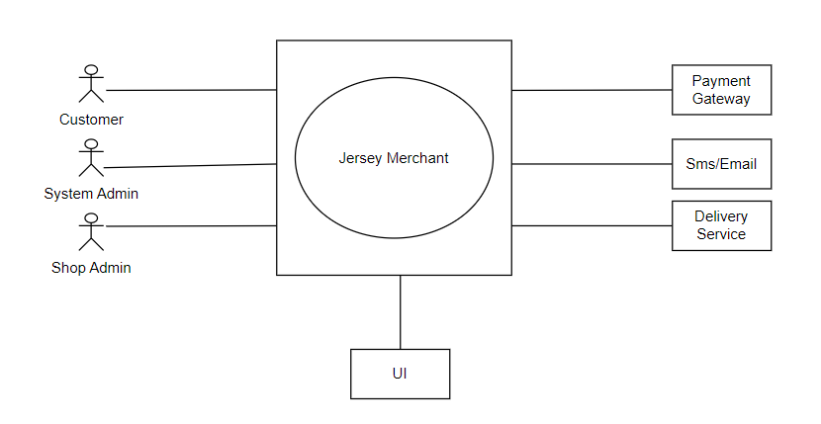

**Figure: Level 0**

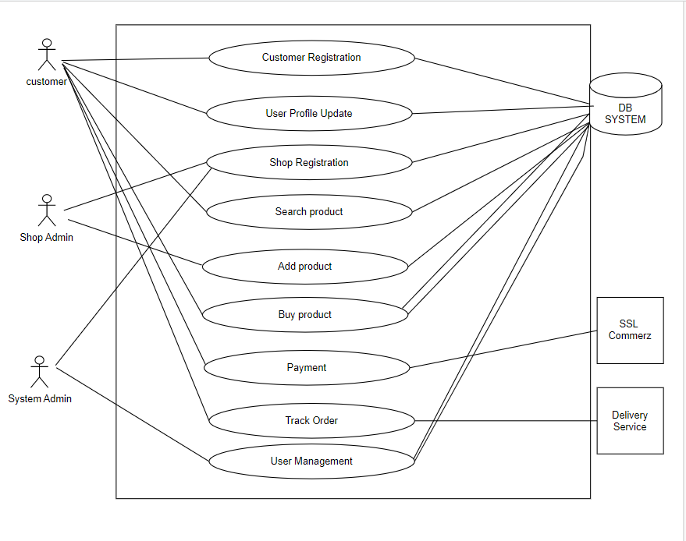

**Figure: Level 1**

**Use Case Name**: Customer Registration

**Iteration:**

1. Developed by: Md. Soyeb on 06 February 2023

**Primary Actor:** Customers

**Goal in the context:** The customers can register and create an account for purchasing products on the website.

**Preconditions:**

1. The user must have valid email and phone number
2. The user location must be within the same region

**Trigger:** The user needs to visit the website and click on “sign up”.

**Scenario:**

1. The customer visits the website and clicks on the “sign up” button.
2. The website prompts the customer to enter their email address and phone number.
3. The customer enters their email address and phone number.
4. The website verifies if the email and phone number are valid and if the customer is located in the same region.
5. If the email and phone number are valid and the customer is located in the same region, the website prompts the customer to enter their name, date of birth, and location.
6. The customer enters their name, date of birth, and location.
7. The website verifies if the customer is at least 13 years old.
8. If the customer is at least 13 years old, the website prompts the customer to create a password and confirms the password.
9. The customer creates a password and confirms the password.
10. The website creates an account for the customer and logs them in.
11. The customer can now purchase products on the website.

**Exceptions:**

* Invalid email or phone number - prompts customers to enter valid information.
* Location not supported - informs customers their location is not supported.
* Invalid password - prompts customers to enter valid password.
* Account already exists - informs customers and prompts them to log in.

**Priority:** High

**When Available:** First increment.

**Frequency of use:** High

**Channel to actor:** Website interface

**Secondary actors:** Database

**Channel to secondary actors:** The website communicates with the verification system and the account management system through API calls interacting with the database.

**Open issues:**

* How to accurately verify the customer's phone number and email address?
* How to ensure the protection of the customer's personal and sensitive information during the registration process?
* How to make the registration process user-friendly and intuitive for the customer?

**Use case Diagram:**

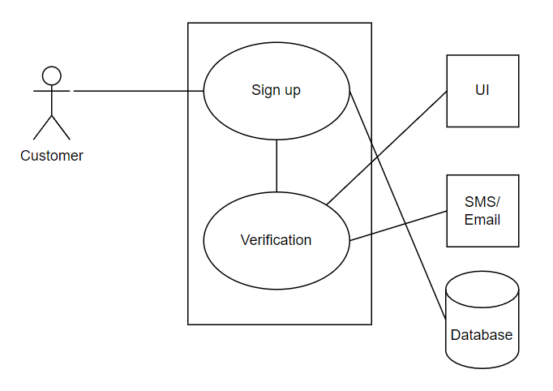

**Figure: Level 1.1**

**Use Case Name:** Shoṗ registration

**Iteration:**

1. Developed by: Md. Rafiur Rahman on 06 February 2023

**Primary Actor:** Shop Admin

**Goal in the context:** Shop admin can register their shops on the website.

**Preconditions:**

1. The shop must have a valid email and phone number.
2. The shop location must belong in the same region.
3. The shop must be at least 18 years old.
4. The shop must have a valid Trade license.

**Trigger:** The user needs to visit the website and click on “sign up” as shop owner.

**Scenario:**

1. The user visits the website and clicks on the “sign up” button.
2. The website prompts the user to enter their email address and phone number.
3. The user enters their email address and phone number.
4. The website verifies if the email and phone number are valid if the user is located in the same region.
5. If the email and phone number are valid and the shop is located in the same region, the website prompts the user to enter their shop name, Trade license number, date of birth and location.
6. The user enters their shop name, Trade license number, date of birth and location.
7. The website verifies if the user is at least 18 years old.
8. If the customer is at least 18 years old, the website prompts the user to create a password and confirms the password.
9. The user creates a password and confirms the password.
10. The website creates an account for the user and logs them in.
11. The user can now add products to the website.

**Exceptions:**

* Invalid email or phone number - prompts user to enter valid information.
* Location not supported - informs user their location is not supported.
* Age requirement not met - informs user they must be at least 18 years old.
* Trade license number not valid - informs user that the Trade license number is not valid.
* Invalid password - prompts userto enter valid password.
* Account already exists - informs user and prompts them to log in.

**Priority:** High

**When Available:** First increment.

**Frequency of use:** High

**Channel to actor:** Website interface

**Secondary actors:** Database

**Channel to secondary actors:** The website communicates with the verification system and the account management system through API calls interacting with the database.

**Open issues:**

* How to accurately verify the user’s phone number and email address?
* How to ensure that the user is at least 18 years old before creating an account?
* How to ensure the protection of the user’s personal and sensitive information during the registration process?
* How to make the registration process user-friendly and intuitive for the users?

**Use Case Name**: User Profile Update

**Iteration:**

1. Developed by: Wasif & Ashfaq on 06 February 2023
2. Last Modification: (if you change the initial design of a use case)

**Primary Actor:** Customers and shop owners

**Goal in the context:** Updating information regarding address,email,phone number and product information.

**Preconditions:**

1. The user must have a personal account within the website.
2. The user has to be logged in.

**Trigger:** Clicking on the “Update profile” section.

**Scenario:**

1. A user needs to at first log in.
2. After that he has to go to the update profile section.
3. User enters the updated information.
4. Then he clicks the save all changes button.
5. If the phone number or email is different from the previous phone number and email the system will check their validity through email verification and number verification.

**Exceptions:**

* If the updated phone number or email is invalid the information will not be updated and show an error message.

**Priority:** Moderate.

**When Available:** First increment. (based on the importance it may change)

**Frequency of use:** low (i.e., it will be rarely by users)

**Channel to actor:** Website UI

**Secondary actors:** Database

**Channel to secondary actors:** through internet access to the database.

**Open issues:**

* How many times a user will be able to update the information in a day?

**Usecase Diagram:**

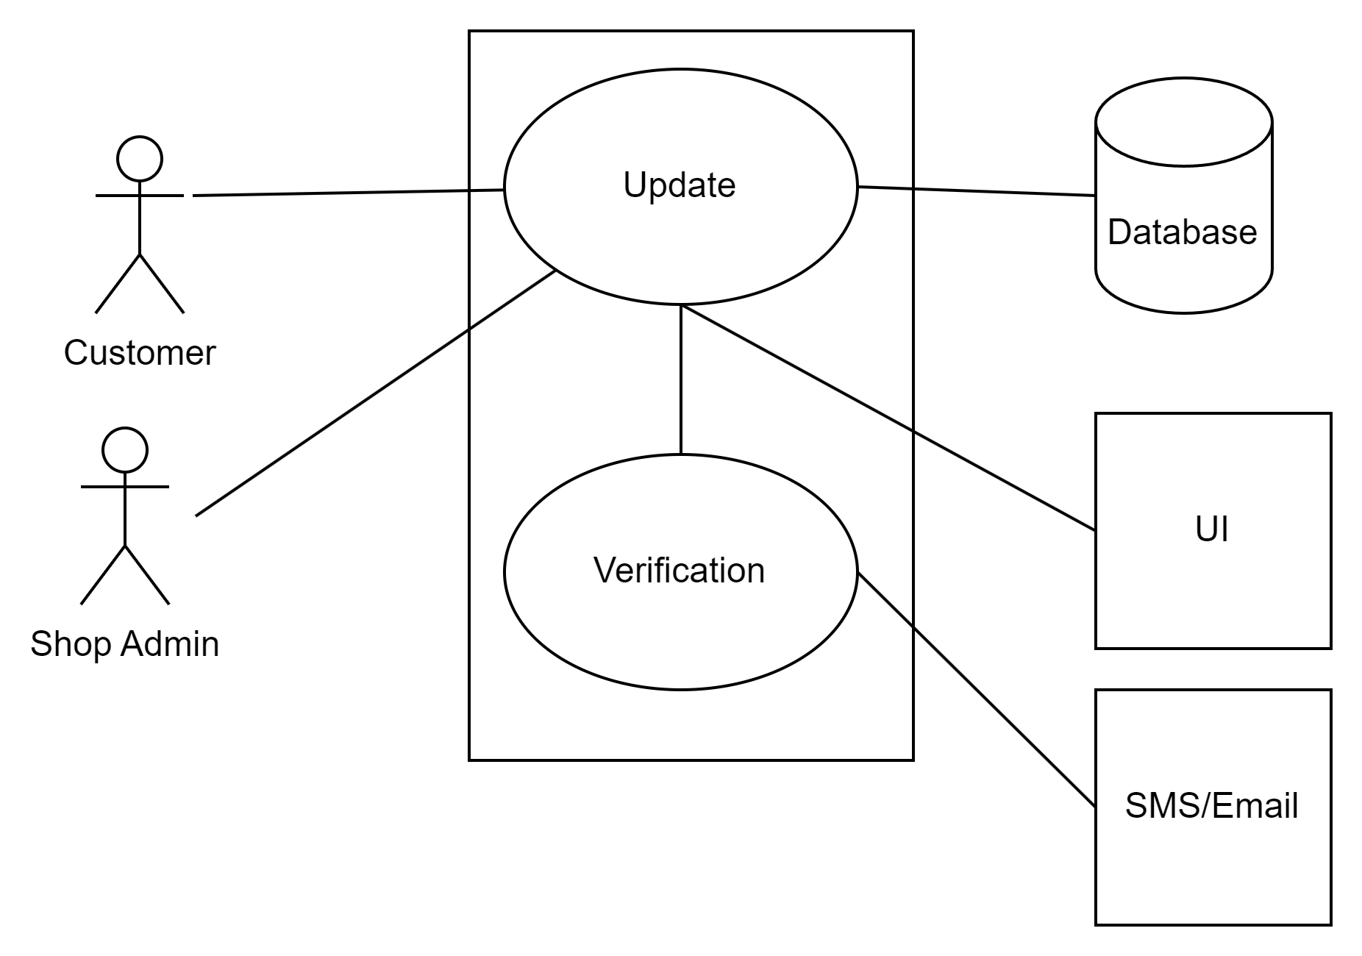

**Figure: Level 1.1**

**Use Case Name**: Search Product

**Iteration:**

1. Developed by: Iftekharul Haque Shuvro on 06 February, 2023

**Primary Actor:** Customers

**Goal in the context:** The customers can search and find the desired products on the website.

**Preconditions:**

1. The user must know the product keywords for searching

**Trigger:** The customer needs to search for a product on the website.

**Scenario:**

1. The customer visits the website.
2. The customer clicks on the “search” button.
3. The website prompts the customer to enter the name, keywords or description of the product they are looking for.
4. The customer enters the name, keywords or description of the product they are looking for.
5. The website searches the database for the desired product.
6. The website displays the results of the search, including the name, description, and price of each product.
7. The customer selects a product from the results.
8. The website displays the details of the selected product, including a description, images, and available options.
9. The customer can now add the product to their shopping cart or continue browsing other products.

**Exceptions:**

* Product not found - informs the customer that the product they are looking for is not available on the website.
* reprompt

**Priority:** High

**When Available:** First increment.

**Frequency of use:** High

**Channel to actor:** Website interface

**Secondary actors:** Database

**Channel to secondary actors:** The website communicates with the database

**Open issues:**

1. How to ensure that the search results are relevant and accurate?
2. How to make the search process user-friendly and intuitive for the customer?
3. How to ensure that the customer can easily find the desired product on the website?

**Use case Diagram:**

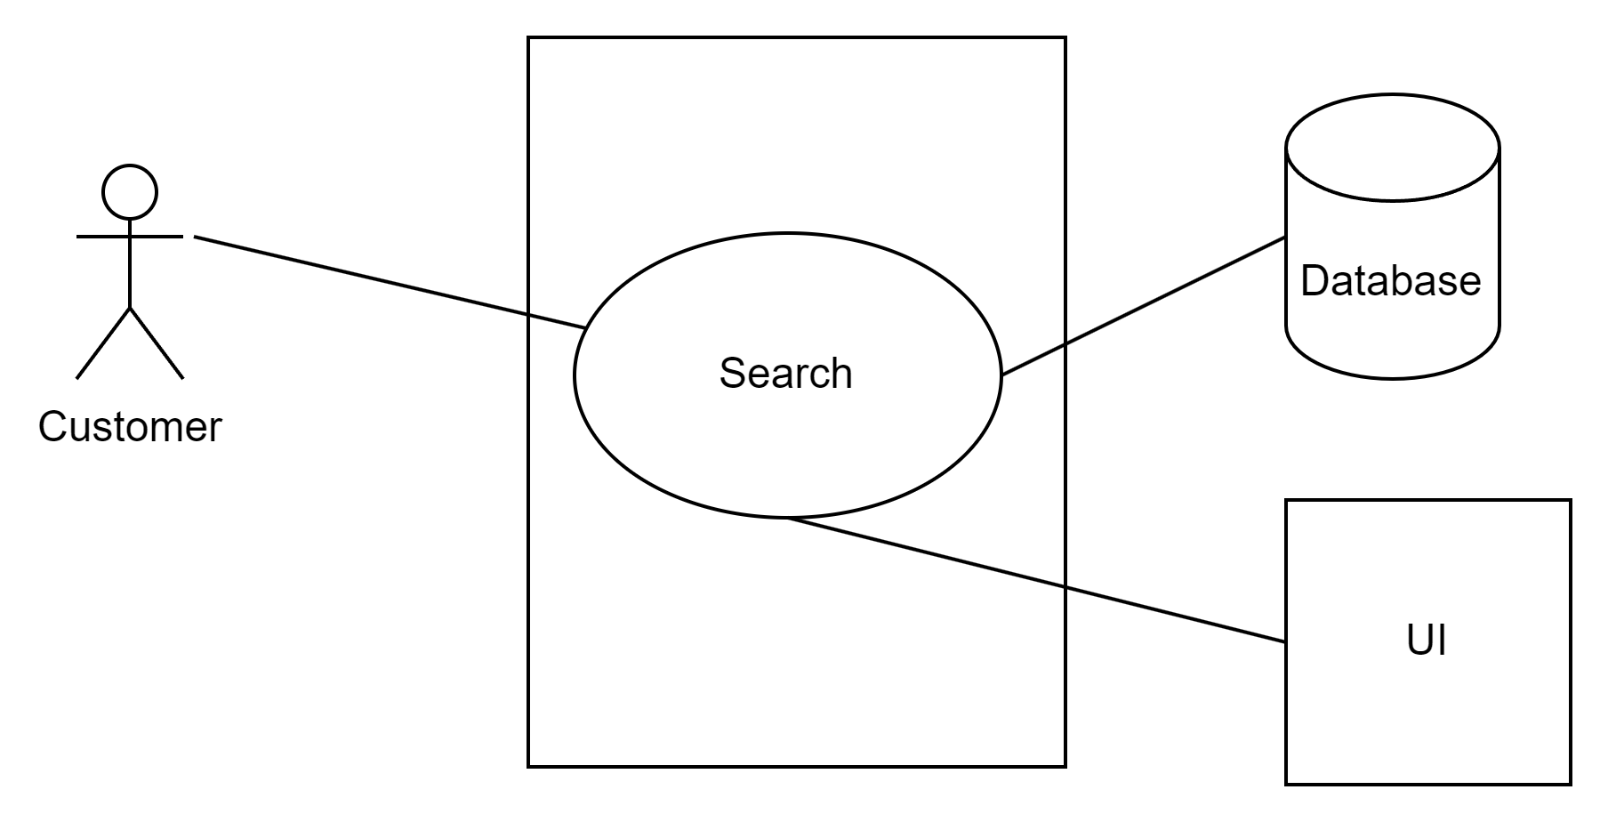

**Figure: Level 1.4**

**Use Case Name**: Add Product

**Iteration:**

1. Developed by: Mostofa Washif on 06 February, 2023

**Primary Actor:** Shop Owners

**Goal in the context:** The shop owners would be able to add new products.

**Preconditions:**

1. The shop owner must be registered and logged in with valid credentials.
2. Product has to be legal.

**Trigger:** Shop owner has a new product.

**Scenario:**

1. Shop owner has a new product.
2. Shop owner logs in to the website.
3. Goes to the add product section.
4. He/she enters all the required information to add a new product including product image.
5. Clicks on Add product button.

**Exceptions:**

* If the image size is too big the process won’t fulfill.
* If product quantity is set to 0 then the product would not be added to the database.

**Priority:** High

**When Available:** First increment.

**Frequency of use:** High

**Channel to actor:** Website interface

**Secondary actors:** Database

**Channel to secondary actors:** The website communicates with the database through API calls.

**Open issues**:

1. How to validate the legality of the products?
2. How to authenticate the stock of the shop?

**Use Case Name:** Buy Product

**Iteration:**

1. Developed by: Iftekharul Haque Shuvro on 06 February, 2023

**Primary Actor:** Customers

**Goal in the context:** The customer can purchase products on the website.

**Preconditions:**

1. The customer must have a registered account.
2. The customer must have added the selected product to their shopping cart.

**Trigger:** The customer clicks on the "checkout" button in the cart webpage.

**Scenario:**

1. The customer logs in to their account.
2. The customer selects a product and adds it to their shopping cart.
3. The customer clicks on the "checkout" button.
4. The website prompts the customer to review their shopping cart and select a shipping address.
5. The customer reviews their shopping cart and selects a shipping address.
6. The website calculates the total cost of the purchase, including shipping.
7. The customer selects a payment method and enters payment information.
8. For online payment, the website verifies the customer's payment information.
9. If the payment is approved, the website processes the order and updates the customer's account information.
10. The website sends a confirmation email to the customer.

**Exceptions:**

* Invalid payment information - informs the customer that their payment information is invalid and prompts them to enter valid information.
* Shipping address not supported - informs the customer that their selected shipping address is not supported.
* Product out of stock - informs the customer that the selected product is out of stock and prompts them to select a different product.

**Priority:** High

**When Available:** First increment.

**Frequency of use:** High

**Channel to actor:** Website interface

**Secondary actors:** Payment gateway, shipping service.

**Channel to secondary actors:** The website communicates with the payment gateway and shipping service through API calls to complete the purchase process.

**Open issues:**

* How to ensure the security of the customer's payment information during the purchase process?
* How to accurately calculate and display the total cost of the purchase, including shipping and tax?
* How to provide a user-friendly and efficient checkout process for the customer?

**Use Case Name:** Payment

**Iteration:**

1. Developed by: Md. Rafiur Rahman on 06 February 2023

**Primary Actor:** Customers

**Goal in the context:** The customers can pay their payable amount using .

**Preconditions:**

1. User must have an account
2. User must have at least a payment method

**Trigger:** The user needs to click on payment.

**Scenario:**

**Exceptions:**

* Insufficient fund - informs the customer that their account has not sufficient funds.
* Incorrect PIN - informs the customer that their PIN is incorrect.

**Priority:** High

**When Available:** First increment.

**Frequency of use:** High

**Channel to actor:** Website interface

**Secondary actors:** Database and Payment gateway

**Channel to secondary actors:** The website communicates with the verification system and the account management system through API calls interacting with the database.

**Open issues:**

* How to
* How to make the registration process user-friendly and intuitive for the users?

**Use Case Name**: Track Order

**Iteration:**

1. Developed by: Chowdhury Ashfaq on 06 February, 2023

**Primary Actor:** Customers

**Goal in the context:** Customer has ordered and wants to know the update of the order.

**Preconditions:**

1. Placing an order would generate a tracking link.
2. Must have a valid tracking link.

**Trigger:** Order has been placed..

**Scenario:**

1. Customer has placed an order.
2. A tracking link was generated and delivered to customer.
3. Customer wants to know the update of the order and clicks on the link.
4. The data is fetched from the database and shown to the customer.

**Exceptions:**

* Invalid tracking link won’t work.
* Too old tracking link may not work.

**Priority:** Low

**When Available:** Second increment.

**Frequency of use:** Low

**Channel to actor:** Website interface

**Secondary actors:** Database

**Channel to secondary actors:** The website communicates with the database.

**Open issues**:

1. How long will the link be valid?
2. Will real time tracking be available?