**POMP model on Foreign Exchange Rate**

**I. Data Set**

* The data set I use is downloaded from <https://www.federalreserve.gov/releases/h10/hist/dat00_uk.htm>
* It is a collection of daily foreign exchange rate.
* The unit is pound/US dollars.
* The data set covers the data from 1/4/2000 to 4/8/2016.
* It has 4244 observations with 2 variables (date and foreign exchange rate). The data set is too big for calculation. So I may take a certain interval, say Jan to May in 2015, to reduce the size.
* Another problem for the data set is that there are missing values (the points at the top of the plot below). It is mainly because the market is closed on that day. For example, Christmas and Thanksgiving. For this situation, I may need to fill this entry with some value. I am thinking about the average number before its previous and next day.

**II. Plot**

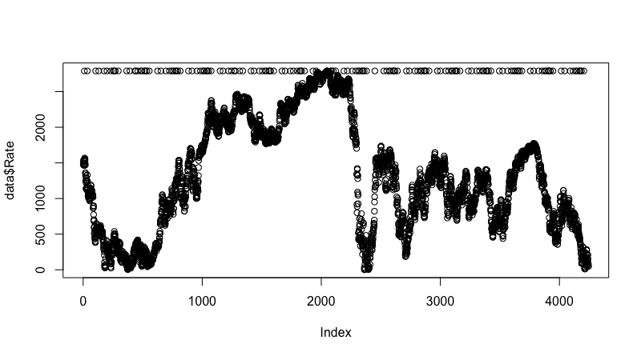

**III. Models and Proposed Methods**

In the paper from <http://www.jmlr.org/proceedings/papers/v28/wu13.pdf> , it mentions that GARCH could be applied to fit the data.

I think I could try to build a POMP model and compare the result with the GARCH model. I am starting to find the framework of the POMP model.

**Reference**

Data is from

<https://www.federalreserve.gov/releases/h10/hist/dat00_uk.htm>

Related Analysis from

<http://www.jmlr.org/proceedings/papers/v28/wu13.pdf>

BGM

<http://epublications.bond.edu.au/cgi/viewcontent.cgi?article=1131&context=ejsie>

Wiki for BGM

<https://en.wikipedia.org/wiki/Geometric_Brownian_motion>

not loged, 2601:3000, 400 data

delta = 1,

N.0=500,e.0=1,mu=1,delta=1,sigma=1, good

Delta = 2,

N.0=500,e.0=0,mu=0,delta=1,sigma=1.1, good for the latter part, better than 1

Delta = 3, good

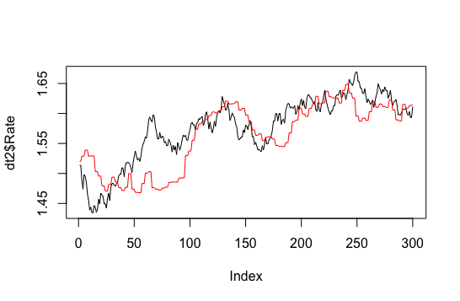

Delta = 4,

Logged, not good

N.0 400, 500, 600 amptitude

E.0 No major effect

Mu, larger, more increasing trend, 0 to 1

Delta = 0, increasing trend, larger, more variation (amptitude), interval 0 to 1

Sigma, larger, more variation(amptitude), around 1 (0.5-1.5)

GARCH (not good), student project

<http://homepage.stat.uiowa.edu/~kcowles/s166_2010/Kimproject.pdf>

slice, get interval, global search