OntoRisk BI: An Ontology-Driven Semantic Data Warehouse for Proactive Business Risk Intelligence
Aishwarya Patil  Reg. No. 235890068 | Thiriveedhi Venkata Subba Sai Teja  Reg. No. 235890021 | Dhruv Naveen  Reg. No. 235890154 | Shaswat Das  Reg. No. 235890222

Abstract—Businesses learn about operational risks such as monsoon flooding, port congestion, export bans, supplier failures and product recalls from news text, which conventional business-intelligence (BI) tools cannot query. This paper presents OntoRisk BI, an open, reproducible pipeline that converts business news into structured, queryable risk intelligence. Organisations, locations, dates and risk-vocabulary terms are recognised with spaCy; a transparent paragraph-level co-occurrence rule turns them into risk events that are stored twice: as RDF triples linked to a compact six-class OWL ontology, and as rows of a DuckDB star schema joined to the triples through a semantic bridge table. FP-Growth association-rule mining and k-Means clustering run over the warehouse, and a Streamlit dashboard exposes KPIs, OLAP roll-up and drill-down, the mined rules, the cluster map and a SPARQL console. On a 240-article Indian-context corpus the pipeline extracts 387 risk events and 6,068 triples, passes all six SPARQL integrity checks with zero orphan warehouse keys, and achieves extraction precision of 72.4%, recall of 92.6% and F1 of 81.2% against ground truth. It mines 27 association rules (strongest lift 3.96) and five interpretable clusters, and runs end to end in about 29 s.
Index Terms—Business intelligence, ontology, semantic web, RDF, SPARQL, data warehouse, star schema, OLAP, named entity recognition, association rules, FP-Growth, k-Means clustering, supply chain risk.

I. Introduction
Supply chains and the firms that depend on them are exposed to a wide range of disruptions: extreme weather, transport bottlenecks, regulatory change, supplier distress and reputational incidents [1], [2]. In the Indian context these risks have a strong regional and seasonal signature: the south-west monsoon (June–September) floods warehouses and roads, cyclones affect the eastern coast in October and November, container ports such as Nhava Sheva, Mundra and Chennai suffer congestion, and policy decisions taken in New Delhi (GST revisions, import duties, export bans) ripple across sectors.
Most early signals of such risks appear first in news text. Text, however, is unstructured: a BI analyst cannot slice it by region and quarter, join it to other facts, or mine it for patterns. Text-mining outputs usually live apart from the warehouse, while semantic-web technology [3], which gives data explicit meaning, is rarely combined with dimensional modelling and OLAP practice [4]. Small and medium enterprises in particular lack an affordable way to bridge the two.
OntoRisk BI addresses this gap. Its contribution is integration rather than novelty in any single layer: a semantic layer, a dimensional warehouse and a data-mining layer are combined in one open, reproducible pipeline, each in the simplest form that still produces a genuine artefact for the next layer. The specific contributions are:
- a compact OWL ontology (six classes, two object properties) for business-risk events, with impact and provenance modelled as data properties;
- a transparent, auditable extraction layer (spaCy NER, a curated 63-term risk vocabulary and a paragraph-level co-occurrence rule) whose precision is measured against ground truth;
- a hybrid warehouse in which every fact row of a DuckDB star schema is linked to its RDF triples through a shared event identifier, so SQL and SPARQL results can be joined;
- FP-Growth association rules and k-Means clusters mined from the warehouse, re-computed interactively for any OLAP slice;
- an interactive dashboard and a fully tested, deployable code base.
Section II reviews related work, Section III describes the architecture, Section IV details the methodology and Section V the implementation. Section VI reports results, Section VII discusses limitations and future work, and Section VIII concludes.

II. Related Work

A. Ontologies and the Semantic Web
An ontology is an explicit specification of a shared conceptualisation [5]. The W3C semantic-web stack represents knowledge as RDF triples [6], describes vocabularies with OWL [7] and queries graphs with SPARQL [8]. Methodological guidance recommends starting from competency questions and keeping the class hierarchy minimal [9]; Protégé is the de-facto editor for inspecting and reasoning over OWL ontologies [10]. OntoRisk BI follows this advice: the ontology is generated as code with RDFLib, opens in Protégé, and is validated with SPARQL.

B. Data Warehousing and OLAP
Inmon defines the warehouse as a subject-oriented, integrated, time-variant store [11], while Kimball’s dimensional approach organises it as star schemas of facts and conformed dimensions [4]. OLAP operations (roll-up, drill-down, slice and dice) over such schemas are the core of BI [12]. Embedded columnar engines such as DuckDB bring this analytical model to a single process without a server [13].

C. Semantic Data Warehouses
Several works combine semantic-web data with warehouses. Nebot and Berlanga build multidimensional warehouses from semantically annotated data [14], and Abelló et al. survey the use of semantic-web technologies for exploratory OLAP [15]. These systems typically assume curated RDF sources; OntoRisk BI instead produces the RDF from raw news text and keeps the triples and the fact rows linked one-to-one.

D. Information Extraction and Pattern Mining
Named entity recognition (NER) identifies organisations, places and dates in text [16]; spaCy provides fast statistical NER pipelines [17]. For pattern discovery, Apriori [18] and FP-Growth [19] mine frequent itemsets and association rules, and k-Means [20] with the silhouette coefficient [21] is the standard baseline for partitional clustering. OntoRisk BI applies these well-understood techniques to the risk events extracted from text.

III. System Architecture
Fig. 1 shows the pipeline. It is organised as four layers and eight independently testable stages, each implemented as one Python module and orchestrated by run_pipeline.py:
- Acquisition and NLP — corpus collection, text cleaning and preprocessing, NER and risk-term tagging;
- Semantic layer — the co-occurrence relation rule, impact scoring, RDF generation against the ontology and SPARQL validation;
- Hybrid warehouse — Pandas ETL with data-quality checks into a DuckDB star schema plus a triple–fact bridge;
- Mining and presentation — FP-Growth rules, k-Means clusters, evaluation, figures and the Streamlit dashboard.
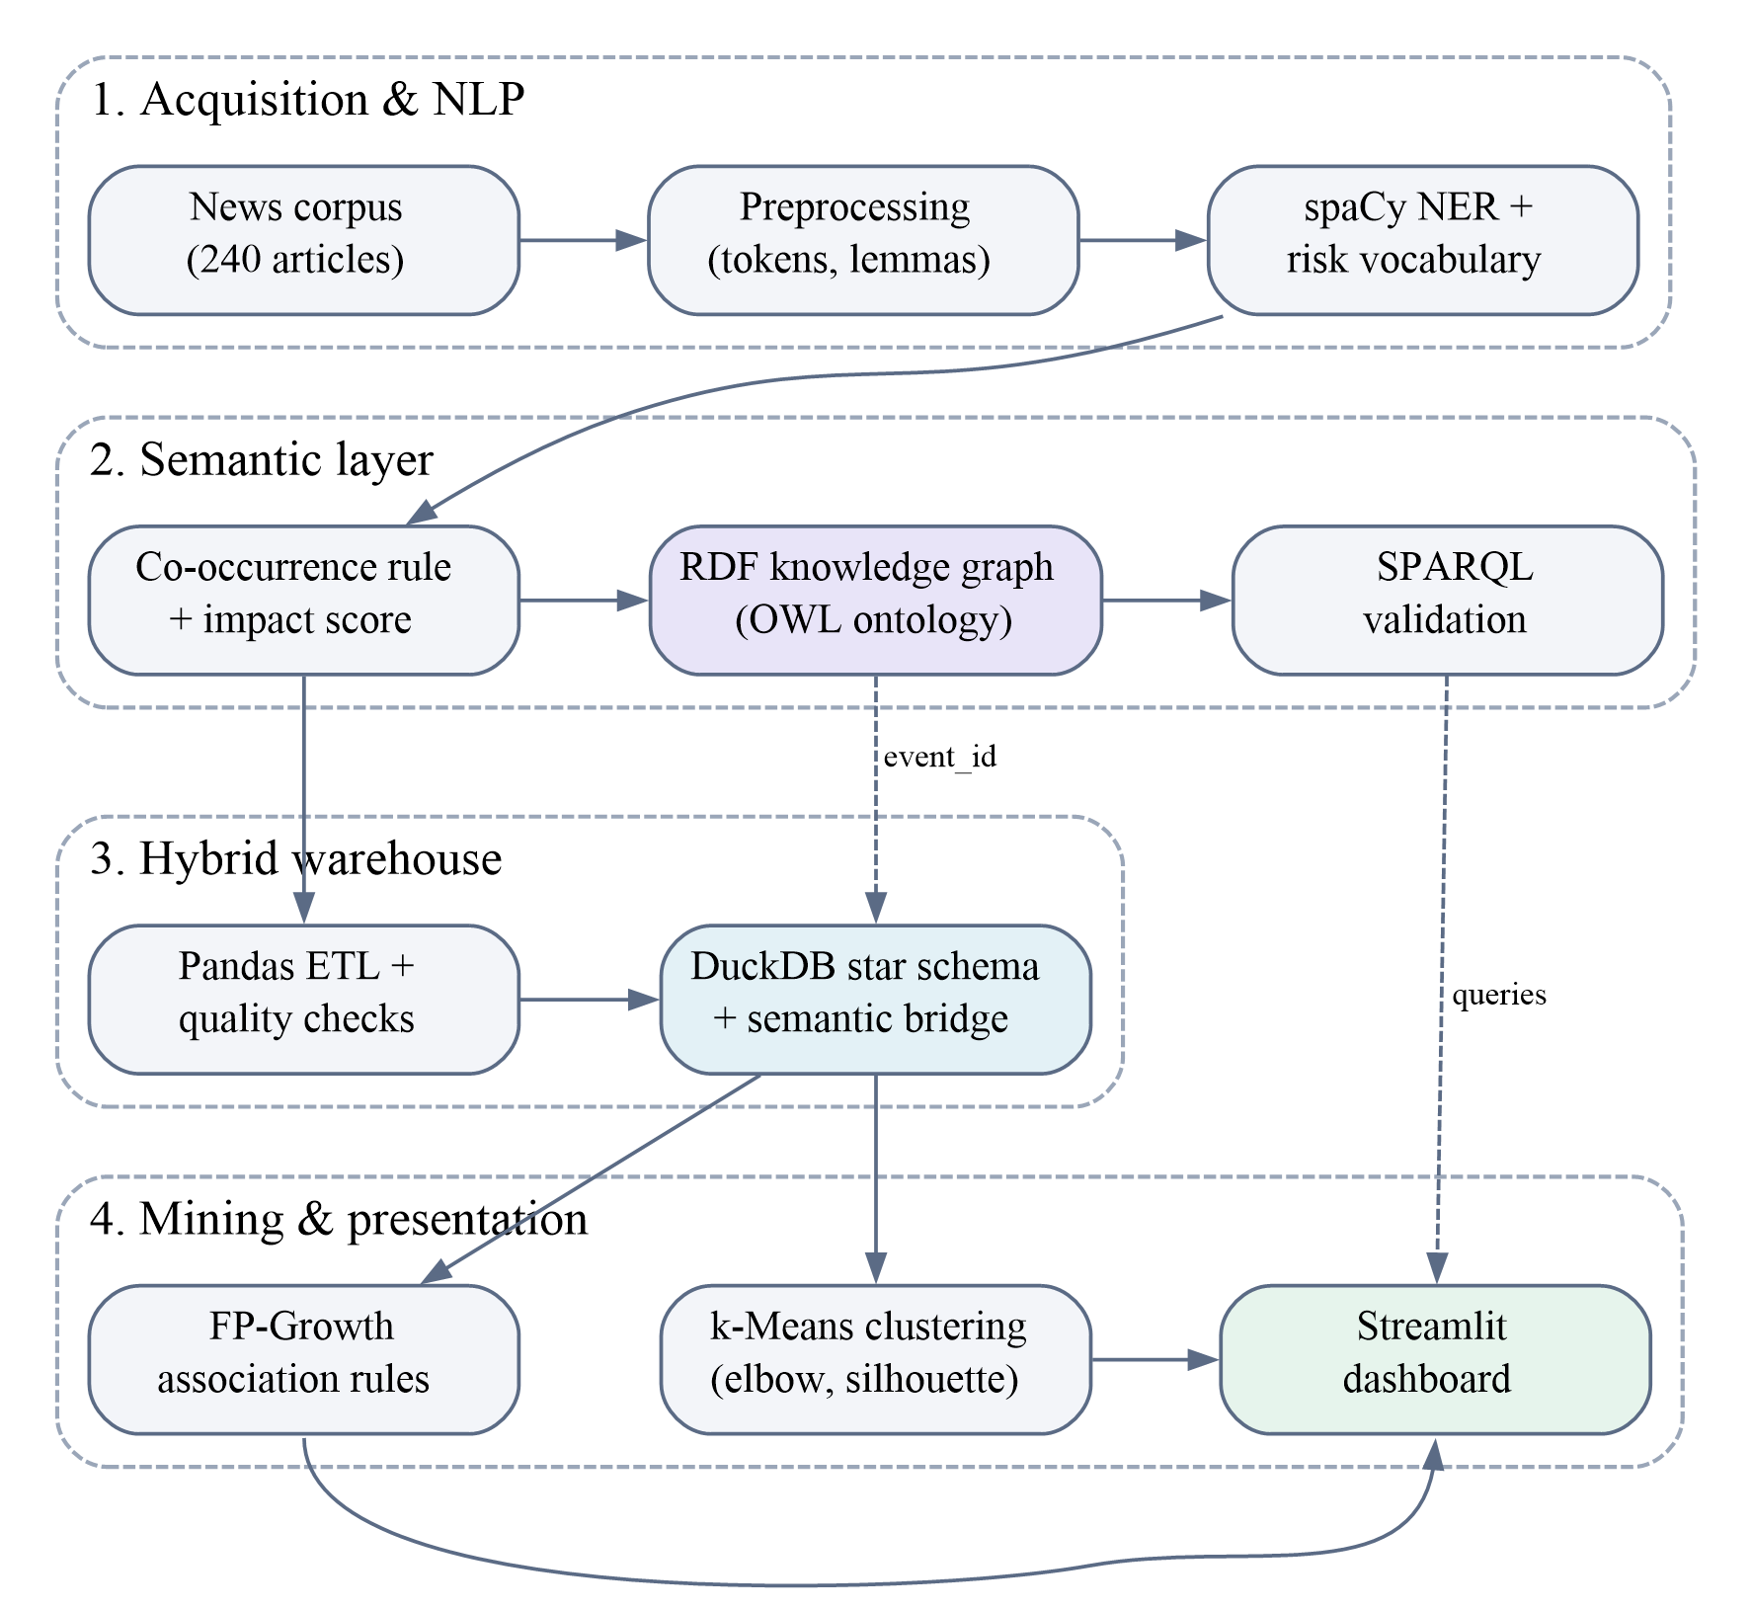
Fig. 1. OntoRisk BI architecture. Solid arrows show data flow; dashed arrows show the event_id link between the knowledge graph and the warehouse and the SPARQL queries issued from the dashboard.
All paths, namespaces and thresholds live in a single configuration module, so the whole pipeline can be re-pointed at another corpus by editing one file or passing --input news.csv.

IV. Methodology

A. Corpus Collection
The system accepts any public news CSV with a text column (e.g. an Indian business-news dataset); a loader maps common column names (title/headline, text/content/body, date/published_at, source) onto the project schema. For evaluation, a reproducible synthetic corpus is generated from templates: companies are fictional, but places, risk categories and seasonality follow the Indian context (monsoon in June–September, cyclones in October–November, port congestion at Nhava Sheva, Mundra and Chennai, policy news from New Delhi). Each article deliberately contains realistic noise (analyst remarks, second places, generic mentions) so that the extraction rule produces some spurious events. Because the generator knows which organisation, place and risk were really involved, it also writes a gold-standard file of 297 true events, which allows precision and recall to be measured automatically. The default corpus contains 243 raw records covering four sectors (Supply Chain & Logistics, Retail, Finance and Manufacturing) between January 2024 and December 2025.

B. Preprocessing and Named Entity Recognition
Each article is split into paragraphs (falling back to the whole article if no paragraph breaks exist). For analysis, text is tokenised, lemmatised and stripped of stop-words, punctuation and numbers with spaCy. NER is run with en_core_web_sm on the original paragraphs, because capitalisation and function words are needed for recognition; ORG, GPE, LOC and DATE entities are kept [17]. Organisation names are normalised (possessives and leading articles removed) and places are mapped to region, state and country through a gazetteer of Indian states and key foreign ports.
Risk terms are tagged with spaCy’s PhraseMatcher over a curated vocabulary of 63 weighted terms in five risk types (Table I). Matching is case-insensitive and longest-match-first, so “port congestion” wins over “congestion”. Each term carries a weight from 1 to 3; a separate list of intensity cues (e.g. severe, halted, crore versus minor, resumed) raises or lowers the severity of an article.
TABLE I
Risk Vocabulary by Risk Type
Risk type | Sub-type | Terms | Examples
Weather | Monsoon / natural disaster | 15 | monsoon, heavy rainfall, flood
Logistics | Port congestion / transport | 13 | port congestion, vessel backlog
Policy | Regulatory / policy change | 13 | export ban, import duty, GST revision
Supplier | Supplier failure / shortage | 11 | supplier insolvency, chip shortage
Reputational | Brand / reputational incident | 11 | product recall, data breach

C. Co-occurrence Relation Extraction and Impact Scoring
No model is trained; relations are extracted by a transparent rule. For every paragraph that contains at least one organisation, one location and one risk-vocabulary term, a RiskEvent is created for each (organisation, location, risk type) combination, and the triples ⟨entity, affects, event⟩ and ⟨event, locatedIn, location⟩ are generated, together with data-property triples for score, severity, date and provenance. Before the rule fires, duplicates of the same (article, organisation, place, risk type) are merged, and when an organisation is linked to both a city and its own state only the more specific city is kept.
Each event receives an impact score I on a 0–10 scale from a transparent heuristic:
I = 1.5w_{max} + 0.8 min(m−1, 2) + 1.6s + l + 0.5 (1)
clipped to [0, 10], where w_{max} is the highest weight of the matched terms, m the number of mentions of that risk type in the article, s the summed intensity of the article’s cue words and l = 1 if the event comes from the lead paragraph. The severity band is Low for I < 4, Medium for 4 ≤ I < 7 and High for I ≥ 7.

D. Ontology Design
The ontology (Fig. 2, Table II) is deliberately compact. It has six mutually disjoint classes and exactly two object properties: affects (Entity → RiskEvent) and locatedIn (RiskEvent → Location, declared functional because every event occurs in one place). Everything else, including impact score, severity band, risk category, dates and provenance, is modelled as one of 19 data properties rather than as additional classes. The five risk types and the 63 vocabulary terms are added as named individuals. The ontology is generated with RDFLib [22] and serialised both as Turtle and as RDF/XML that opens directly in Protégé for browsing and HermiT reasoning.
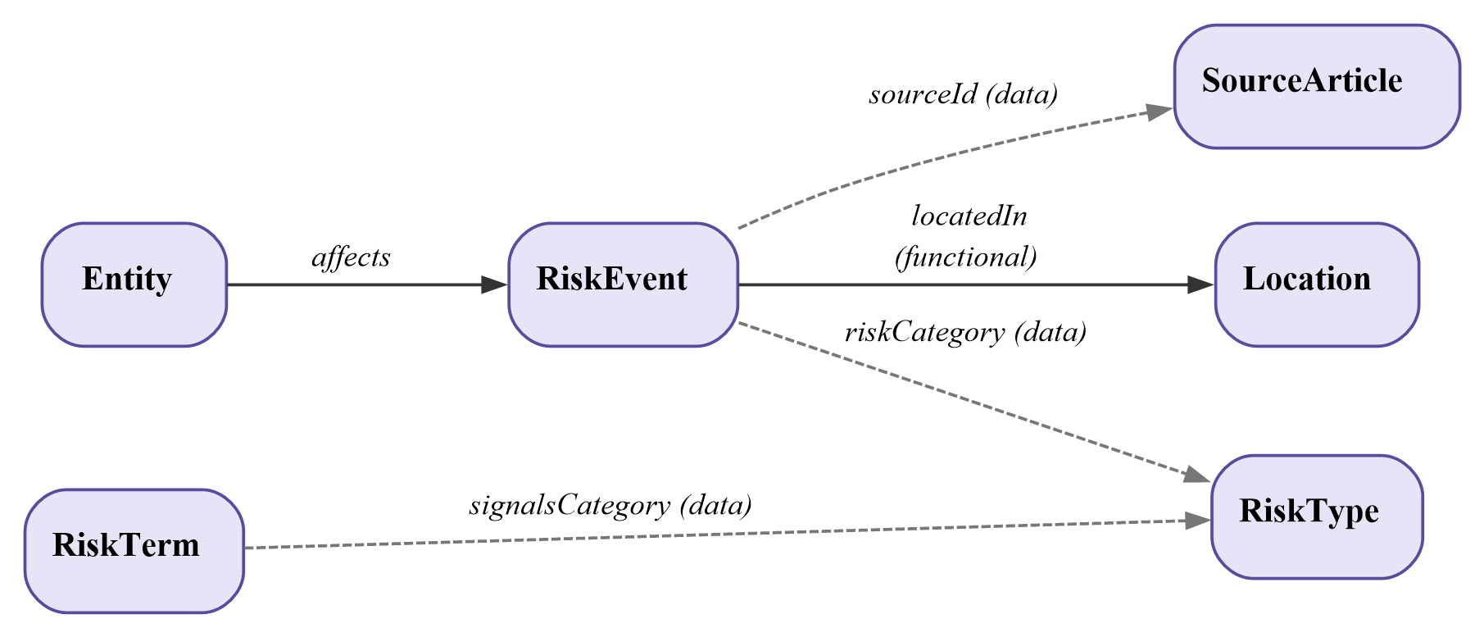
Fig. 2. OntoRisk ontology. Solid edges are the two object properties; dashed edges are data properties that reference other classes by value.
TABLE II
Ontology Classes
Class | Meaning
RiskEvent | A business-risk occurrence detected in text
Entity | An organisation affected by a risk event
Location | City, port, state or country of the event
RiskType | Weather, logistics, policy, supplier or reputational
SourceArticle | The news article an event came from (provenance)
RiskTerm | A vocabulary keyword that signals a risk type

E. Semantic Validation with SPARQL
After triple generation, six SPARQL queries act as integrity tests on the knowledge graph [8]: the ontology must declare exactly six classes and two object properties; every RiskEvent must have a location and an affected entity; no affects or locatedIn triple may violate its declared domain or range; and each of the five risk types must have events. The pipeline fails loudly if any check does not hold.

F. ETL and the Hybrid Warehouse
Articles pass through a Pandas [23] ETL stage that removes empty texts, duplicate identifiers, duplicate texts and unparseable dates, and normalises whitespace. Events are then loaded into a DuckDB [13] star schema (Fig. 3) following Kimball’s dimensional model [4]: a fact table FACT_RISKEVENT with the measures impact score, severity and mention count, and three dimensions — time (date, week, month, quarter, year), location (place, region, state, country) and risk type (category, sub-type). Entity name, sector and source identifier are kept as degenerate attributes on the fact row.
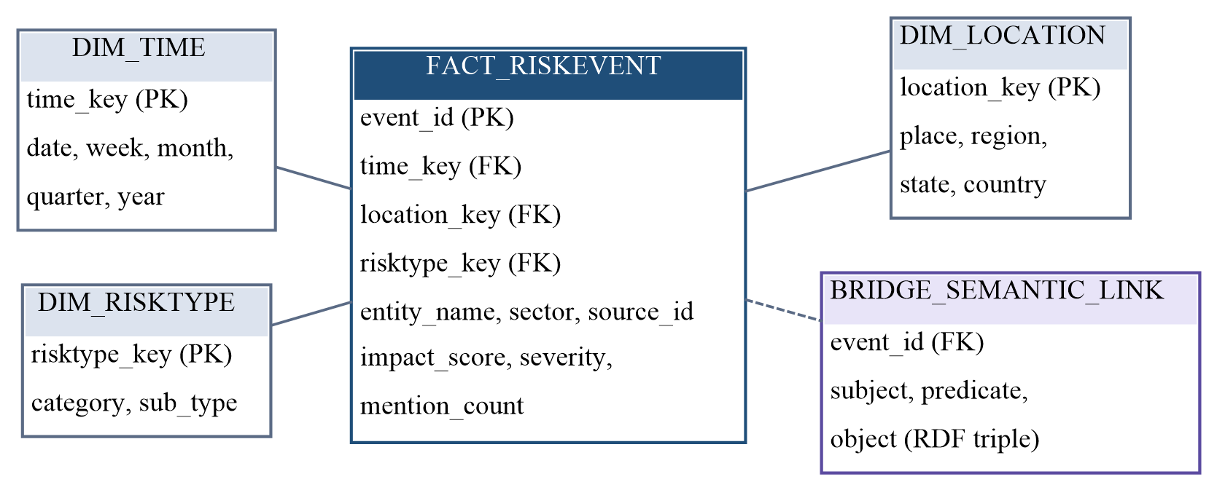
Fig. 3. Star schema of the hybrid warehouse. The dashed link is the semantic bridge that stores every RDF triple of an event under the event’s identifier.
The semantic side of the warehouse is the table BRIDGE_SEMANTIC_LINK (event_id, subject, predicate, object), which stores every triple produced for an event. Because the same identifier appears as the eventId data property in the graph, a SQL query can jump from a fact row to its triples and a SPARQL result can jump back to the fact row. After loading, referential checks confirm that no fact row has an orphan dimension key, a missing measure or no triples.

G. Association-Rule Mining
Each risk event becomes a transaction of items risktype=t, region=r, sector=s and severity=b, plus co_risk=t′ for every other risk type reported in the same article; this last item allows cross-risk rules such as weather ⇒ logistics to surface. Frequent itemsets are mined with FP-Growth [19] as implemented in mlxtend [24], and Apriori [18] is run as a cross-check. For a rule X ⇒ Y over the transaction set T:
supp(X) = |{t ∈ T : X ⊆ t}| / |T| (2)
conf(X ⇒ Y) = supp(X ∪ Y) / supp(X) (3)
lift(X ⇒ Y) = conf(X ⇒ Y) / supp(Y) (4)
Rules are kept when support ≥ 0.05, confidence ≥ 0.60 and lift ≥ 1.10 and are ranked by lift. In the dashboard the rules are re-mined for whatever region, period and risk-type slice is selected (with at least 25 events), so the rule table always describes the data in view.

H. k-Means Clustering
Each event is described by ten standardised features: impact score, mention count, the month encoded as sine and cosine (so that December is adjacent to January), a monsoon-season flag and a one-hot encoding of the five risk types. k-Means [20] minimises the within-cluster sum of squares
J = Σ_{k} Σ_{x∈C(k)} ‖x − μ_{k}‖² (5)
for k = 2…10 using scikit-learn [25]. The number of clusters is chosen at the knee of the inertia curve (the point of maximum distance from the chord joining its ends, in the spirit of Kneedle [26]) and validated with the mean silhouette coefficient [21]
s(i) = (b(i) − a(i)) / max{a(i), b(i)} (6)
where a(i) is the mean distance of event i to its own cluster and b(i) to the nearest other cluster. PCA [27] projects the vectors to two dimensions for the scatter plot, and each cluster is labelled automatically from its mean impact, dominant risk type and monsoon share.

I. Interactive Dashboard
The dashboard, built with Streamlit [28] and Plotly [29], has five pages reachable from a sidebar: Overview, Association rules, Clusters, Knowledge graph and Event log. Sidebar filters (region, time period, risk type, and rule-mining thresholds) and a global search box over entities, places and sectors apply to every page. Four KPIs summarise the selection: the Risk Exposure Index, the average impact score, the number of events in view and the confidence of the strongest rule, where
REI = Σ_{e} I_{e} · w(sev_{e}), w ∈ {1, 2, 3} (7)
for Low, Medium and High severity. The data layer behind the dashboard is a set of pure functions that are unit-tested independently of the user interface.

V. Implementation
The system is written in Python 3.13. Table III lists the main libraries and their role. The code base is organised as one module per stage under src/ontorisk/, the dashboard under dashboard/, and 17 pytest tests that cover every stage, including a headless run of the whole dashboard with Streamlit’s AppTest harness. If spaCy or DuckDB is unavailable, the code falls back to a rule-based recogniser and to SQLite with an identical schema, and records which back-end was used in outputs/metrics.json.
TABLE III
Technology Stack
Layer | Technology | Role
NLP | spaCy 3.8, en_core_web_sm | Tokens, lemmas, NER, PhraseMatcher
Semantic | RDFLib 7, OWL 2, SPARQL 1.1 | Ontology, triples, validation
ETL | pandas 3 | Cleaning and quality checks
Warehouse | DuckDB 2.0 | Star schema, OLAP queries
Mining | mlxtend 0.25, scikit-learn 1.9 | FP-Growth, Apriori, k-Means, PCA
Presentation | Streamlit 1.66, Plotly | Dashboard and charts
Quality | pytest, Git/GitHub | Tests, versioning, deployment

The complete pipeline runs end to end in 29.3 s on a laptop. The dashboard is deployed on Streamlit Community Cloud directly from the project’s GitHub repository; because the built warehouse and mining outputs are versioned, the deployed application does not need to re-run the pipeline.

VI. Results and Discussion

A. Data Quality and NER
Of 243 raw records, the ETL stage rejected one empty text, one duplicate identifier and one unparseable date, leaving 240 clean articles (Table IV). NER and vocabulary tagging found 503 location, 399 organisation, 256 date and 432 risk-term mentions (1,590 in total), covering 32 distinct organisations and 39 distinct places.
TABLE IV
ETL Data-Quality Report
Check | Records
Raw records read | 243
Rejected: empty text | 1
Rejected: duplicate id | 1
Rejected: duplicate text | 0
Rejected: invalid date | 1
Clean articles loaded | 240

B. Extraction Quality
Against the gold standard, the co-occurrence rule produced 387 events, of which 280 were correct, and recovered 275 of the 297 true events (Table V). Precision is 72.4%, recall 92.6% and F1 81.2%, where
P = TP/(TP+FP), R = TP/(TP+FN), F₁ = 2PR/(P+R) (8)
The high recall and moderate precision are exactly what a co-occurrence rule is expected to deliver: it rarely misses an event but also links organisations to incidental places or risks mentioned in the same paragraph. Precision is highest for logistics (83.2%) and supplier (82.8%) risks, whose vocabulary is specific, and lowest for weather (60.5%) and policy (62.2%), where words such as monsoon or GST often appear as background context. A random sample of 50 triples was also prepared for manual review, giving a sample precision of 74%, consistent with the automatic figure.
TABLE V
Extraction Quality Against Ground Truth
Metric | Value
Predicted events | 387
Correct events (TP) | 280
Gold events / found | 297 / 275
Precision | 72.4%
Recall | 92.6%
F1 score | 81.2%
Precision: logistics / supplier | 83.2% / 82.8%
Precision: reputational | 70.0%
Precision: policy / weather | 62.2% / 60.5%
Manual sample precision (n = 50) | 74%

C. Knowledge Graph and Warehouse Integrity
The knowledge graph contains 6,068 triples, 5,605 of them generated instance (A-Box) triples. All six SPARQL validation queries pass (Table VI). The warehouse holds 387 fact rows, 183 time members, 32 locations, 5 risk types and 1,935 bridge rows (Table VII); referential checks report zero orphan keys, zero null measures and zero facts without triples, so the semantic and dimensional views are fully consistent.
TABLE VI
SPARQL Validation Checks
Check | Result | Status
Ontology declares six classes | 6 | Pass
Exactly two object properties | 2 | Pass
Events without a location | 0 | Pass
Events without an affected entity | 0 | Pass
Domain / range violations | 0 | Pass
Events per risk type | 113 / 86 / 74 / 64 / 50 | Pass

TABLE VII
Warehouse Tables and Integrity
Table / check | Rows
FACT_RISKEVENT | 387
DIM_TIME | 183
DIM_LOCATION | 32
DIM_RISKTYPE | 5
BRIDGE_SEMANTIC_LINK | 1,935
STG_ARTICLES (staging) | 240
Orphan keys / null measures | 0 / 0
Facts without triples | 0

D. Descriptive Analytics
Logistics is the most frequent risk type (113 events), followed by weather (86), policy (74), supplier (64) and reputational (50). Geographically, the West (121 events) and South (118) dominate, reflecting the port-heavy western and southern coasts, while policy risk is concentrated in the North (Fig. 4). Weather events are the most severe: 62% of them fall in the High band, compared with 12% of reputational events (Fig. 5). Weighting by severity, weather accounts for the largest share of the Risk Exposure Index (31%, 1,822 of 5,802), ahead of logistics (29%).
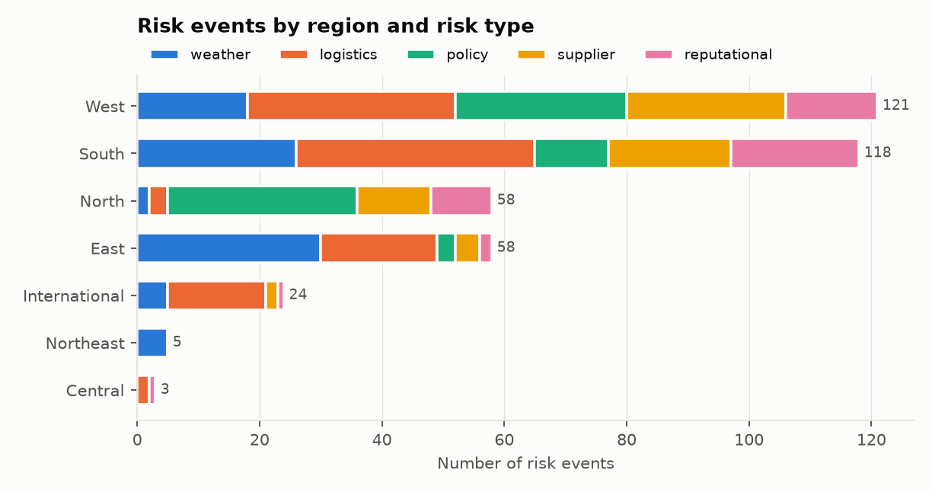
Fig. 4. Risk events by region and risk type (387 events).
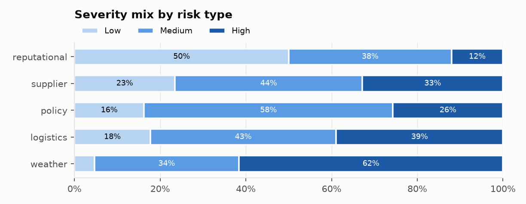
Fig. 5. Severity mix (Low, Medium, High) within each risk type.
The seasonal pattern is pronounced (Fig. 6): weather events rise sharply from June and peak in September at the end of the south-west monsoon, and logistics events track them through the same months, a first visual hint of the weather–logistics association that the rule miner later quantifies.
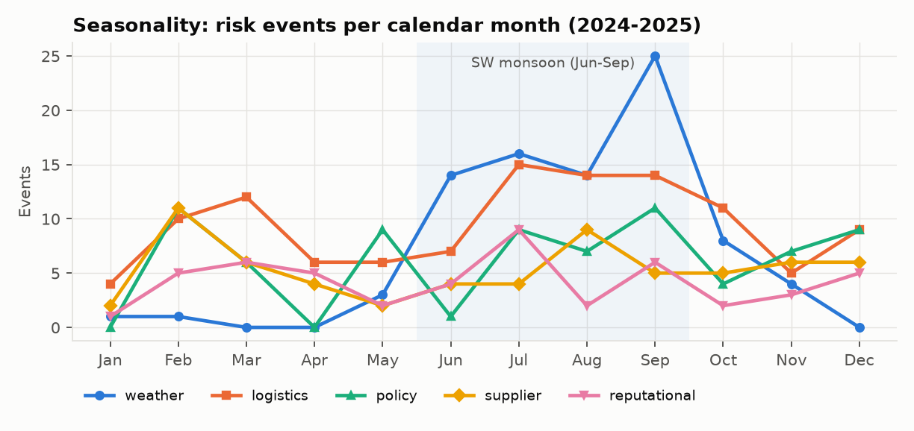
Fig. 6. Seasonality: risk events per calendar month over 2024–2025; the shaded band marks the south-west monsoon.

E. Association Rules
FP-Growth found 103 frequent itemsets and 27 rules that satisfy all three thresholds; Apriori produced an identical rule set, confirming the implementation. Table VIII and Fig. 7 show the strongest rules. The top rule states that a High-severity event in the Supply Chain & Logistics sector that co-occurs with a logistics risk is a weather event in 88% of cases, 3.96 times the base rate. Its mirror image (weather in the same sector implies a co-occurring logistics risk, lift 3.23) confirms that monsoon disruption and transport disruption travel together. A second family links policy risk to the Finance sector and to co-occurring supplier risk (lift 3.16–3.44), consistent with regulatory changes that propagate to input supply.
TABLE VIII
Top Association Rules by Lift
Antecedent ⇒ consequent | Sup. | Conf. | Lift
co-risk logistics, SC&L, High ⇒ weather | 0.057 | 0.88 | 3.96
Finance, Medium ⇒ policy | 0.059 | 0.66 | 3.44
co-risk logistics, SC&L ⇒ weather | 0.080 | 0.76 | 3.40
co-risk logistics, High ⇒ weather | 0.096 | 0.74 | 3.33
policy, Medium ⇒ co-risk supplier | 0.067 | 0.60 | 3.30
weather, SC&L, High ⇒ co-risk logistics | 0.057 | 0.76 | 3.23

In Table VIII, SC&L abbreviates the Supply Chain & Logistics sector and “co-risk” marks another risk type reported in the same article.
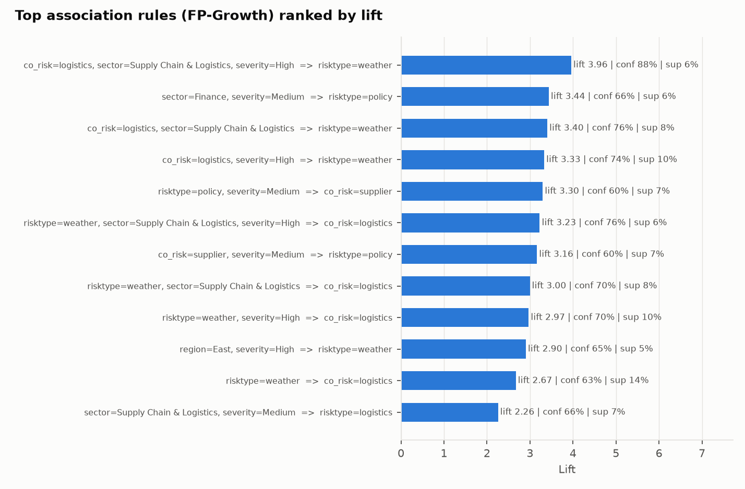
Fig. 7. Top twelve FP-Growth rules ranked by lift, annotated with confidence and support.

F. Clusters of Risk Events
The inertia curve has its knee at k = 5 (Fig. 8). The silhouette score at k = 5 is 0.239; k = 2 scores slightly higher (0.271) but merely separates high- from low-impact events, so the elbow choice was kept for interpretability. The first two principal components explain 37.9% and 18.4% of the variance. The five clusters (Table IX, Fig. 9) are clearly interpretable: a high-impact monsoon weather cluster (C1, 84% weather, 90% in monsoon months, 78% High severity), a high-impact all-year cluster led by logistics (C2, 97% High), a moderate policy cluster (C3, 61% policy) and two low-impact mixed clusters that differ only in season (C0 off-monsoon, C4 monsoon).
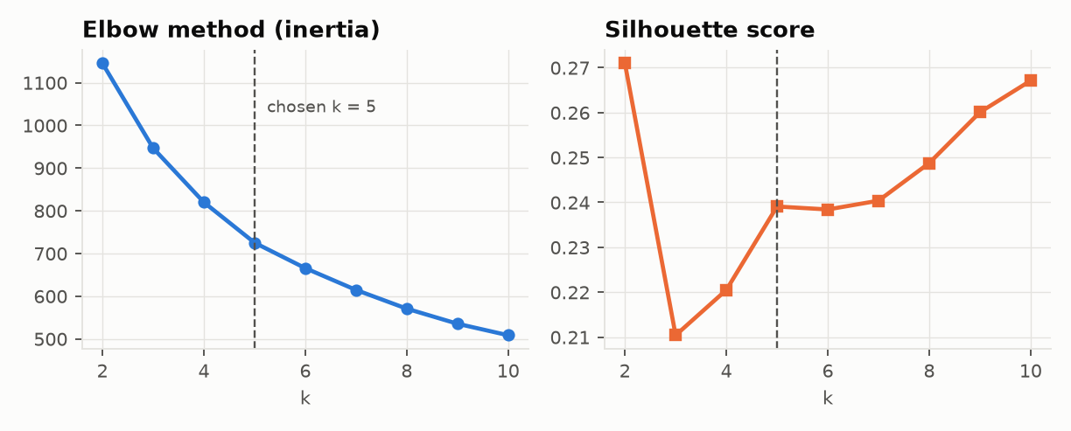
Fig. 8. Choosing k: inertia (elbow) and mean silhouette score for k = 2…10; the dashed line marks the chosen k = 5.
TABLE IX
Cluster Profiles (k = 5)
Cluster | Size | Avg. impact | Dominant type | Monsoon
C0 | 108 | 4.32 | logistics (36%) | 0%
C1 | 67 | 8.57 | weather (84%) | 90%
C2 | 88 | 8.56 | logistics (46%) | 51%
C3 | 51 | 5.18 | policy (61%) | 24%
C4 | 73 | 4.44 | reputational (26%) | 100%

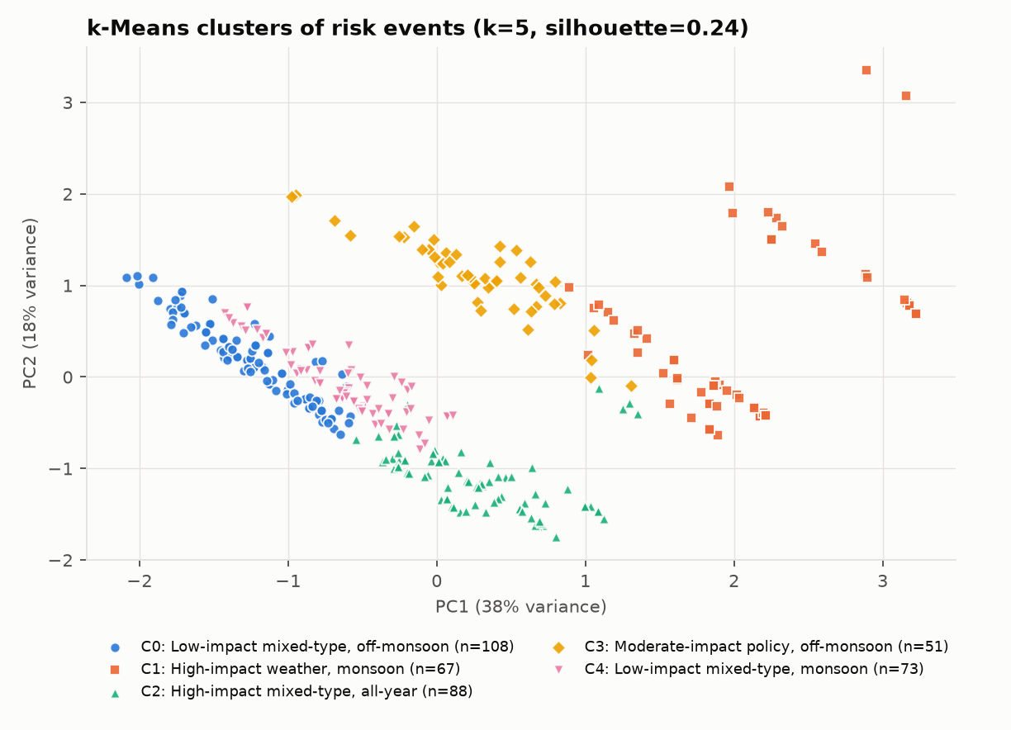
Fig. 9. k-Means clusters of the 387 risk events projected onto the first two principal components.

G. Dashboard Outputs
Fig. 10(a) shows the Overview page for the full data set: a Risk Exposure Index of 5,802, an average impact of 6.16 out of 10, all 387 events in view and a top-rule confidence of 88%. Every element responds to the filters; for example, restricting the region to the West re-computes the KPIs, the OLAP cube and the association rules for that slice only. Fig. 10(b) shows the rules page, where the strongest rule is stated in plain language next to a support–confidence map of all rules (bubble size encodes lift) and the full rule table. Fig. 11 shows the interactive cluster map with cluster profiles, and Fig. 12 the SPARQL console, here listing all events affecting one organisation with their type, place and score, and the searchable event log that traces every event back to its source article.
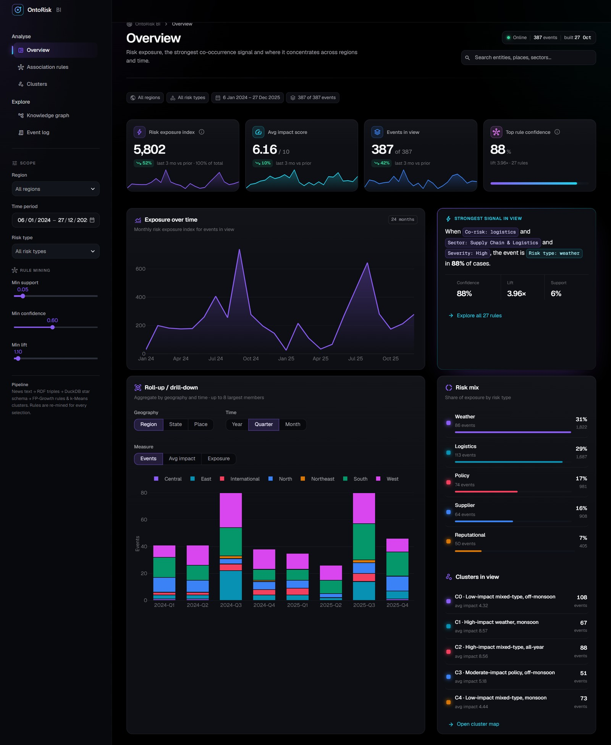  (a) Overview | 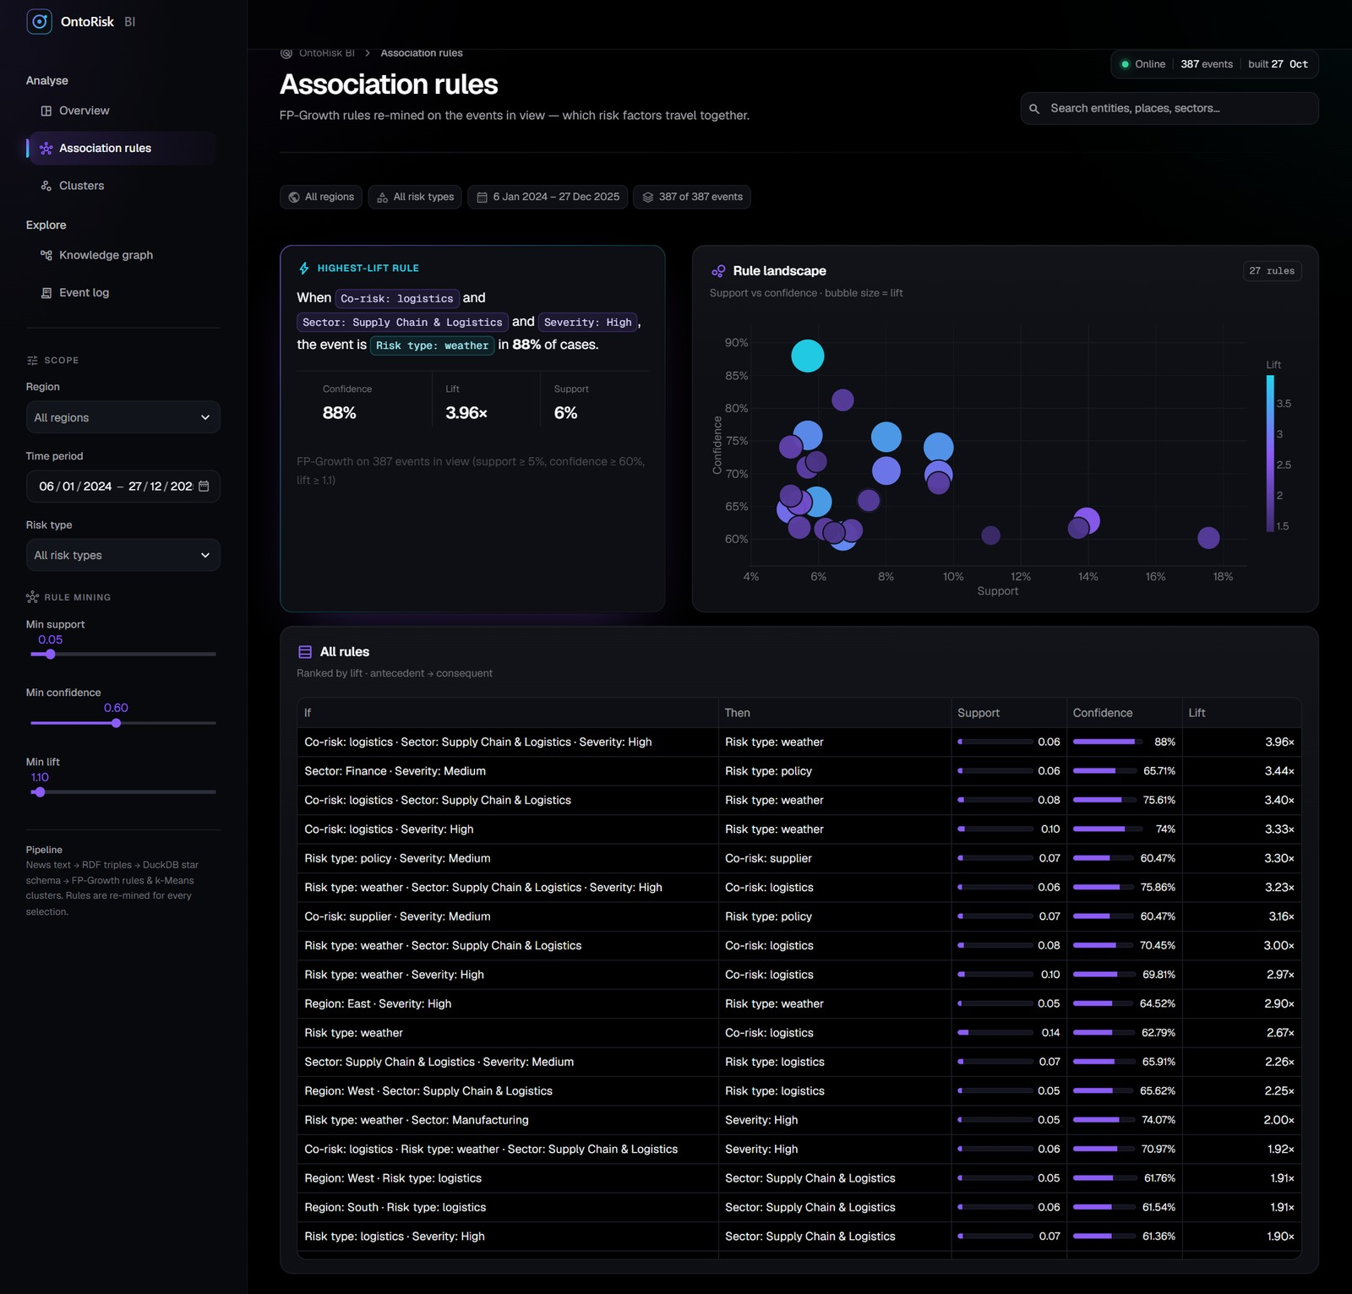  (b) Association rules
Fig. 10. Dashboard pages. (a) Overview: sidebar navigation and OLAP filters, KPI cards with monthly sparklines, exposure trend, strongest rule in view, roll-up/drill-down cube, risk mix and cluster summary. (b) Association rules: highest-lift rule, rule landscape (support vs. confidence, bubble size = lift) and the ranked rule table.
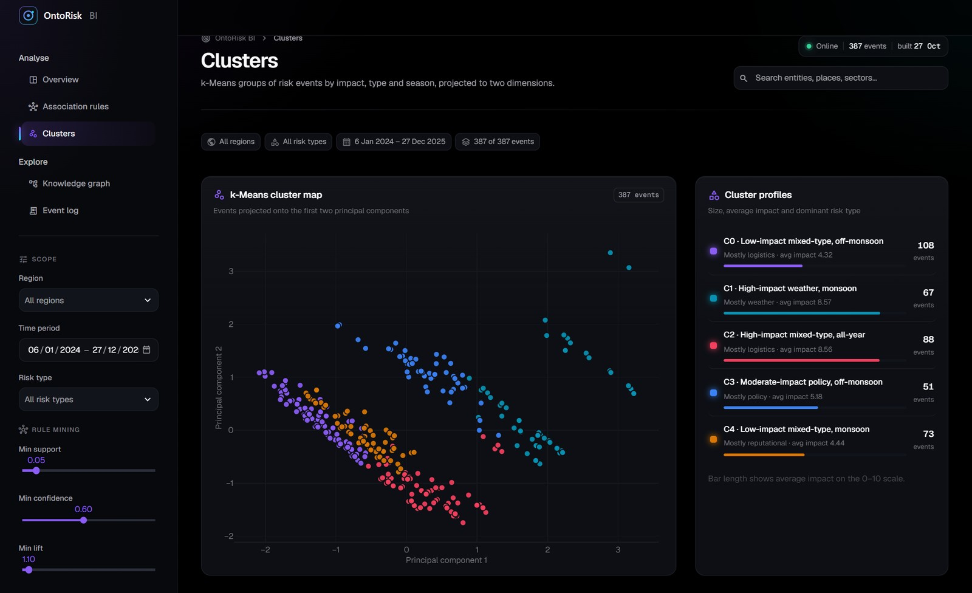
Fig. 11. Dashboard — Clusters page: k-Means cluster map in PCA space with per-cluster size, dominant risk type and average impact.
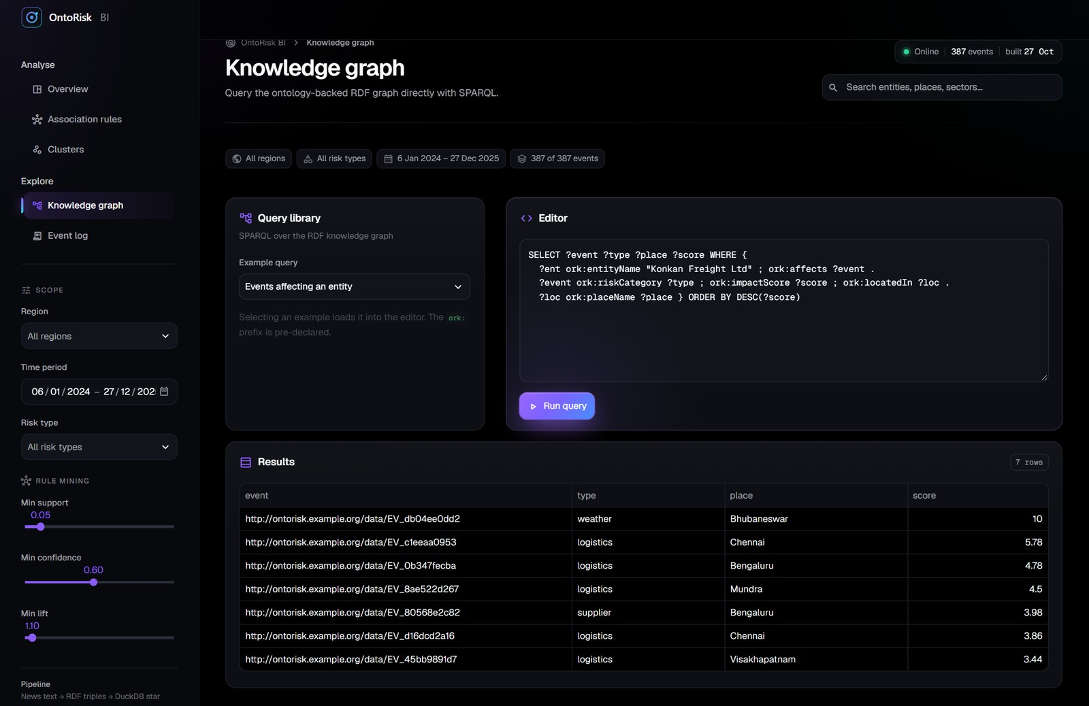  (a) Knowledge graph: SPARQL query and results | 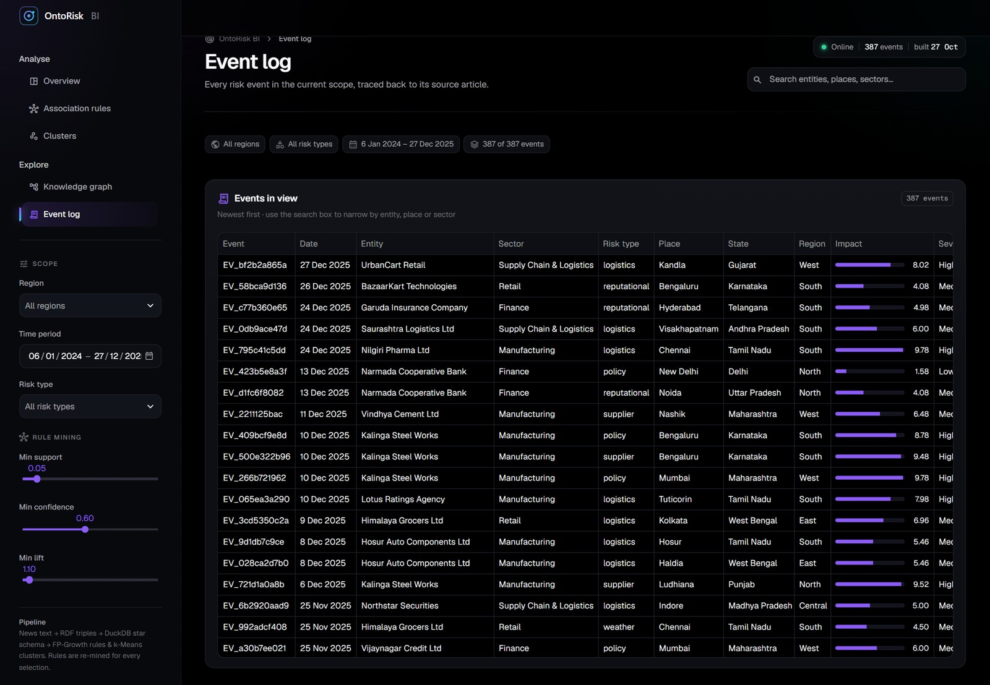  (b) Event log with global search
Fig. 12. Dashboard — exploration pages. (a) A SPARQL query over the RDF knowledge graph returning the events that affect one organisation. (b) The event log of the current scope, linked to source articles.

VII. Limitations and Future Work
The study has several limitations. The bundled corpus is synthetic, so the mined patterns demonstrate the method rather than real-world findings, and 240 articles is a modest sample. The co-occurrence rule produces spurious triples (precision 72.4%). The ontology records association, not causation, and has no causal taxonomy. Entity and source are degenerate attributes, adequate at this scale but not for hierarchical browsing. Processing is batch-oriented over historical text, there is no supervised severity classifier (no labels are available), and the impact score is a transparent heuristic rather than a calibrated financial measure.
Future work follows directly from these limitations:
- replace the co-occurrence rule with learned relation extraction, e.g. a fine-tuned transformer [30], and add causal relations (causes, mitigates) to the ontology;
- train a severity classifier once a labelled subset exists, use DBSCAN [31] for outlier events and add rule-based alerting over the mining outputs;
- promote entity and source to full dimensions with slowly changing history, and ingest live news and social-media feeds;
- link entities to Wikidata [32] and company registries, and move the graph to a triple store with OWL reasoning;
- evaluate on a large real-world news corpus across more sectors and geographies.

VIII. Conclusion
OntoRisk BI shows that a small, transparent pipeline can turn unstructured business news into risk intelligence that is simultaneously meaningful (an OWL ontology and SPARQL-validated RDF graph), analysable (a DuckDB star schema supporting OLAP) and mined (FP-Growth rules and k-Means clusters), with every fact row linked to its triples. On an Indian-context corpus it extracted 387 risk events with 92.6% recall and 72.4% precision, passed all semantic and referential integrity checks, and surfaced interpretable patterns, most notably the strong coupling of monsoon weather and logistics disruption (lift 3.96) and a distinct high-impact monsoon cluster. The open, tested and deployed implementation provides a practical base for small enterprises and for the learned-extraction and causal-modelling extensions outlined above.
Acknowledgment
The authors thank Dr. Sathiyaraj Rajendran, Associate Professor, Department of Computer Science and Engineering, Manipal Institute of Technology Bengaluru, for his guidance throughout this project, and the department for its support.
References
[1] C. S. Tang, “Perspectives in supply chain risk management,” Int. J. Prod. Econ., vol. 103, no. 2, pp. 451–488, 2006.
[2] W. Ho, T. Zheng, H. Yildiz, and S. Talluri, “Supply chain risk management: A literature review,” Int. J. Prod. Res., vol. 53, no. 16, pp. 5031–5069, 2015.
[3] T. Berners-Lee, J. Hendler, and O. Lassila, “The Semantic Web,” Sci. Amer., vol. 284, no. 5, pp. 34–43, May 2001.
[4] R. Kimball and M. Ross, The Data Warehouse Toolkit: The Definitive Guide to Dimensional Modeling, 3rd ed. Indianapolis, IN, USA: Wiley, 2013.
[5] T. R. Gruber, “A translation approach to portable ontology specifications,” Knowl. Acquis., vol. 5, no. 2, pp. 199–220, 1993.
[6] R. Cyganiak, D. Wood, and M. Lanthaler, “RDF 1.1 concepts and abstract syntax,” W3C Recommendation, Feb. 2014. [Online]. Available: https://www.w3.org/TR/rdf11-concepts/
[7] W3C OWL Working Group, “OWL 2 Web Ontology Language document overview (second edition),” W3C Recommendation, Dec. 2012. [Online]. Available: https://www.w3.org/TR/owl2-overview/
[8] S. Harris and A. Seaborne, “SPARQL 1.1 query language,” W3C Recommendation, Mar. 2013. [Online]. Available: https://www.w3.org/TR/sparql11-query/
[9] N. F. Noy and D. L. McGuinness, “Ontology development 101: A guide to creating your first ontology,” Stanford Knowl. Syst. Lab., Stanford, CA, USA, Tech. Rep. KSL-01-05, 2001.
[10] M. A. Musen, “The Protégé project: A look back and a look forward,” AI Matters, vol. 1, no. 4, pp. 4–12, 2015.
[11] W. H. Inmon, Building the Data Warehouse, 4th ed. Indianapolis, IN, USA: Wiley, 2005.
[12] S. Chaudhuri and U. Dayal, “An overview of data warehousing and OLAP technology,” ACM SIGMOD Rec., vol. 26, no. 1, pp. 65–74, 1997.
[13] M. Raasveldt and H. Mühleisen, “DuckDB: An embeddable analytical database,” in Proc. ACM SIGMOD Int. Conf. Manage. Data, 2019, pp. 1981–1984.
[14] V. Nebot and R. Berlanga, “Building data warehouses with semantic web data,” Decis. Support Syst., vol. 52, no. 4, pp. 853–868, 2012.
[15] A. Abelló et al., “Using semantic web technologies for exploratory OLAP: A survey,” IEEE Trans. Knowl. Data Eng., vol. 27, no. 2, pp. 571–588, Feb. 2015.
[16] D. Nadeau and S. Sekine, “A survey of named entity recognition and classification,” Lingvisticae Investigationes, vol. 30, no. 1, pp. 3–26, 2007.
[17] M. Honnibal, I. Montani, S. Van Landeghem, and A. Boyd, “spaCy: Industrial-strength natural language processing in Python,” Zenodo, 2020, doi: 10.5281/zenodo.1212303.
[18] R. Agrawal and R. Srikant, “Fast algorithms for mining association rules,” in Proc. 20th Int. Conf. Very Large Data Bases (VLDB), 1994, pp. 487–499.
[19] J. Han, J. Pei, and Y. Yin, “Mining frequent patterns without candidate generation,” in Proc. ACM SIGMOD Int. Conf. Manage. Data, 2000, pp. 1–12.
[20] J. MacQueen, “Some methods for classification and analysis of multivariate observations,” in Proc. 5th Berkeley Symp. Math. Statist. Probab., vol. 1, 1967, pp. 281–297.
[21] P. J. Rousseeuw, “Silhouettes: A graphical aid to the interpretation and validation of cluster analysis,” J. Comput. Appl. Math., vol. 20, pp. 53–65, 1987.
[22] RDFLib Team, “RDFLib: A Python library for working with RDF.” [Online]. Available: https://github.com/RDFLib/rdflib
[23] W. McKinney, “Data structures for statistical computing in Python,” in Proc. 9th Python Sci. Conf. (SciPy), 2010, pp. 56–61.
[24] S. Raschka, “MLxtend: Providing machine learning and data science utilities and extensions to Python’s scientific computing stack,” J. Open Source Softw., vol. 3, no. 24, p. 638, 2018.
[25] F. Pedregosa et al., “Scikit-learn: Machine learning in Python,” J. Mach. Learn. Res., vol. 12, pp. 2825–2830, 2011.
[26] V. Satopää, J. Albrecht, D. Irwin, and B. Raghavan, “Finding a ‘kneedle’ in a haystack: Detecting knee points in system behavior,” in Proc. 31st Int. Conf. Distrib. Comput. Syst. Workshops, 2011, pp. 166–171.
[27] I. T. Jolliffe, Principal Component Analysis, 2nd ed. New York, NY, USA: Springer, 2002.
[28] Snowflake Inc., “Streamlit documentation.” [Online]. Available: https://docs.streamlit.io
[29] Plotly Technologies Inc., “Collaborative data science,” Montréal, QC, Canada, 2015. [Online]. Available: https://plot.ly
[30] J. Devlin, M.-W. Chang, K. Lee, and K. Toutanova, “BERT: Pre-training of deep bidirectional transformers for language understanding,” in Proc. NAACL-HLT, 2019, pp. 4171–4186.
[31] M. Ester, H.-P. Kriegel, J. Sander, and X. Xu, “A density-based algorithm for discovering clusters in large spatial databases with noise,” in Proc. 2nd Int. Conf. Knowl. Discovery Data Mining (KDD), 1996, pp. 226–231.
[32] D. Vrandečić and M. Krötzsch, “Wikidata: A free collaborative knowledgebase,” Commun. ACM, vol. 57, no. 10, pp. 78–85, 2014.

