Mental Health Chat Bot

Group ID: 5

Yatharth Kale (111915140)

Ashish Shetty (111915121)

Yogeshwar Patil (111915143)

Rajeshwar Patil (111915099)

Vinat Goyal (111915139)

Introduction

The past few decades have seen a surge in mental health issues across the globe. Mental illnesses account for over 30% of years lived with disability worldwide [1]. Over the past 20 years, the focus on global mental health and its efforts to reduce mental health disparities has substantially increased. This is not country-specific but a global issue. [2] suggests that mental health constitutes 28% of the total burden of disease in the UK, compared to 16% for cancer and heart diseases. Another research [3] suggests that one in four people in the UK experiences mental health problems in a given year. A study by National Alliance on Medical Illness (NAMI) indicates that 1 in 5 adults in the USA needs medical attention. The post-COVID has seen a rise in these numbers. People needing attention and comfort has increased exponentially since COVID-19. [4] Discusses the impact of COVID-19 on the mental health of people.

It becomes more vital to address mental issues since psychiatric treatment in low- and middle-income countries (LMICs) is often limited [5]. [6] Discusses the issues faced by lower-middle-income countries like that of eastern Europe and Central Asia. In India, only 0.29 Psychiatrists, 0.07 Psychologists, and 0.36 other paid mental health workers are available per 100,000 people (World Health Organization, 2018). Both private and public firms are granting vast funds for solving this issue. Measures are being taken and proposed to reach out to the people in need of medical health attention.

AI is among the favorite methods to be used. Chatbots for AI healthcare and management are being deployed on a large scale to diagnose people and help them with their health. Chatbots have the potential to increase access to mental health interventions. Chatbots help reach out to the people from deprived classes and those who traditionally have been reluctant to seek mental health advice [7]. These chatbots do not restrict themselves to diagnosis. They also enact “more than human” care and counsels the user. Many chatbots even help users with bad habits of smoking and alcohol, which become the primary reason for impaired mental health [8].

Today, there are many chatbots available online, but the problem is that these chatbots are generally paid. It becomes problematic for people from a poor background to afford these chatbots. It becomes vital and motivational to make chatbots for such people. We make a chatbot that diagnoses users based on Natural Language Processing (NLP) and the fuzzy logic model. Based on the diagnosis, the software either suggest some self-care methods/ articles to the user or book an appointment with a doctor/ professional with user consent.

Functional requirements:

1. User Sign up and Login.
2. Template based questions to know the user and understand the severity of the user.
3. Sentiment analysis using an AI model for assessing the mental severity of the user.
4. Take user consent for interaction with an associate or psychologist.
5. Book Appointment of Psychologist based on the severity assessment by the model.
6. Track mood history: Based on the recent interactions, patterns can be found in the mood of the user.
7. Application usage history.
8. Self-care feature like recommending relevant articles.

Nonfunctional requirements

1. Confidentiality of user’s interaction with bot.
2. Availability of system 24/7.
3. Complementarity: Mention the limitations of the applications.
4. Design constraints: Android application.
5. Should work both online and offline.
6. Follow mHONcode and HIPAA guidelines.
7. Easily maintainable.
8. Dynamic data: Data needs to be updated periodically.

|  |  |
| --- | --- |
| **Identification** | **Priority** |
| Template Based Questions | High |
| Assessing severity | High |
| User Consent | High |
| Book Appointment | High |
| User signup and login | Medium |
| Mood Tracker | Medium |
| Application Usage History | Low |
| Self-care features | Low |

Hardware Requirements:

1. 8 GB RAM
2. x86_64 CPU architecture; 2nd generation Intel Core or newer, or AMD CPU with support for a Windows Hypervisor
3. 64-bit Microsoft® Windows® 8/10
4. 8 GB of available disk space minimum (IDE + Android SDK + Android Emulator)
5. 1280 x 800 minimum screen resolution

Software Requirements:

1. Android 4.4 KitKat or above.
2. Android Studio 4.2
3. Java
4. MySQL
5. Python
6. Tensorflow

Spiral Model

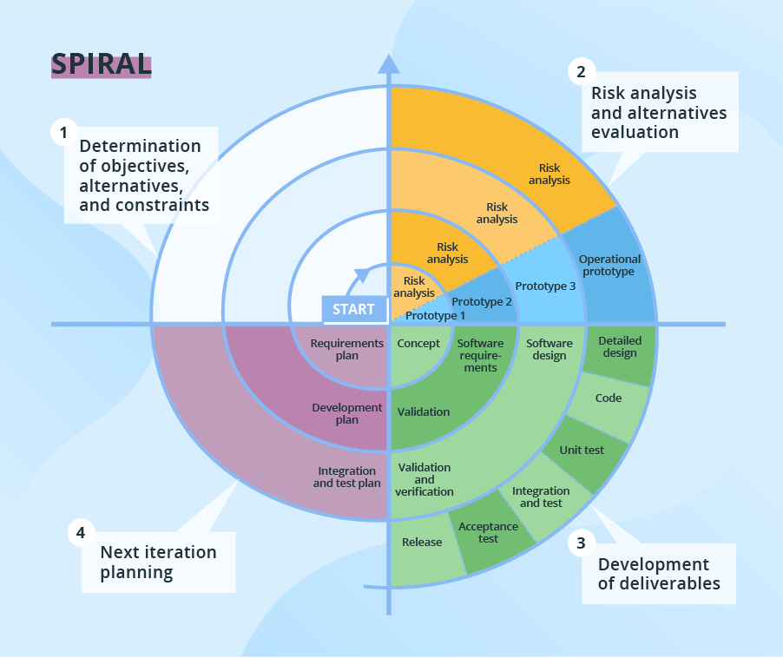

Spiral model proposes a risk driven approach, the risks are minimized by repeated use of prototypes. The spiral model has four phases: Planning, Design, Construct and Evaluation. A software project repeatedly passes through these phases in iterations. Each loop of the spiral is called a Phase of the software development process. The exact number of phases needed to develop the product can be varied depending upon the project risks. Risk assessment mitigates risks and reduces the potential for setbacks.

This method is more flexible than waterfall, allowing us to create a near-perfect design by prototyping. Since the projects involves several fields like NLP and Android development, prototyping can help to assess how they will work together. Prototyping enables us to take feedback from users and medical experts in order to make early changes to the system.

UML Diagram

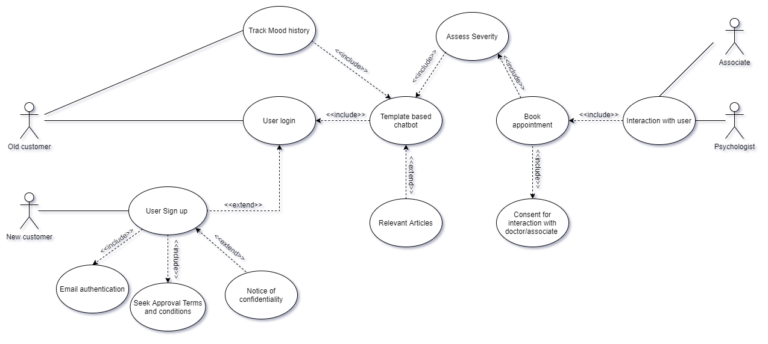

1)Actors

a) New Customers

b) Old Customers

c) Associate

d) Supporting actors : Consulting Doctors

2) Use Cases

a) User SignUp

b) Email Authentication

c) Seek Approval Terms and Conditions

d) Notice of Confidentiality

e) User Login

f) Template based chatbot

g) Relevant articles

h) Assess Severity

i) Book Appointment

j) Consent for interaction with doctors or associates

k) Interaction with user

l) Track mood history

References

[1] Vigo D, Thornicroft G, Atun R. Estimating the true global burden of mental illness. Lancet Psychiatry 2016;3(2):171–8.

[2] http://dx.doi.org/10.14236/ewic/HCI2017.24

[3] McManus S, Meltzer H, Brugha T, Bebbington P, Jenkins R (eds), 2009. Adult psychiatric morbidity in England, 2007: Results of a household survey. [online] NHS Information Centre for Health and Social Care, pp.1-274. Available at: http://www.hscic.gov.uk/catalogue/PUB02931/adulpsyc-morbres-hou-sur-eng-2007-rep.pdf [Accessed 03 Mar. 2017].

[4] 10.1080/09638237.2020.1757052

[5] Wainberg ML, Scorza P, Shultz JM, et al. Challenges and opportunities in global mental health: A research-to-practice perspective. Curr. Psychiatry Rep. 2017;19(5):28.

[6] https://doi.org/10.1016/j.lanepe.2021.100182

[7] https://doi.org/10.1016/j.ijmedinf.2019.103978

[8] https://doi.org/10.1016/j.drugpo.2020.102910