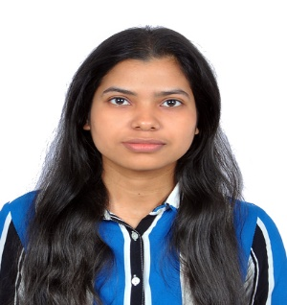
ASHWARYA BHARTI
Bangalore, Karnataka
📞 +91 8252953694
📧ashwaryabharti705@gmail.com

(26) Ashwarya Bharti | LinkedIn

CAREER OBJECTIVE
MCA student with a strong foundation in software development and exposure to telecommunications and
cloud-native technologies. Possess knowledge of telecom protocols, Kubernetes, and test automation.
Seeking an entry-level role to apply Java, Python, and networking skills in building scalable solutions.

SKILLS
Programming Languages: Java, Python, JavaScript
Web Development: HTML, CSS
Databases: MySQL
Telecommunication & Networking: Telecom Basics, VoLTE / IMS, Diameter / DRA , SIP
Cloud & DevOps: Kubernetes
Testing & Automation: Robot Framework
Tools: Git, VS Code, Microsoft Excel, Word, PowerPoint
Behavioral Skills:Teamwork, Leadership, Communication, Time Management

EDUCATION

Master of Computer Applications— Vellore Institute of Technology, Bhopal
(ExpectedGraduation: May 2026 | CGPA: 8.73)

Bachelorof Computer Applications — Amity University, Patna
(Graduated: May 2026 | CGPA: 8.14 )

INTERSHIP

Google Cloud Generative AI Virtual Internship | Feb 2025

Gaining hands-on exposure to Generative AI concepts and workflows using Google Cloud Platform.

Learning to work with cloud-based AI services, model integration, and responsible AI fundamentals

PROJECTS

TechSahay (Patented Project)

Developed a full-stack platform to facilitate old device donations and promote sustainability.

Streamlined donation workflows and improved digital accessibility to reduce e-waste.

AmiEvent
- Built a college event management system using the MERN stack.
- Automated event registrations and enabled real-time updates to improve user engagement.

CERTIFICATIONS
- Azure DevOps – GUVI
- MERN Stack – InternNexus
- Core Concepts of Java – DevTown
- Introduction to Networks – Cisco Networking Academy

LANGUAGES
Hindi | English
HOBBIES
- Reading non-fiction literature
- Playing Badminton

