Change / modified

­­­­­System Level Configuration:

(Listing all system level list)

git config --system –l

setting all the username and user email id:

(git config --system user.name edurekha)

(git config --system user.email [aishu.devang5@gmail.com](mailto:aishu.devang5@gmail.com))

Global level configuration

$$$$ git config -- global user.name Aishwarya

$$$git config –-global user.email aishu.devang5@gmail.com

Listing the files here

$$git config –-global –l

Local command can be used only within the git..

$$ git config –-local user.name Aishwarya

$$ git config –local user.email [aishu.devang5@gmail.com](mailto:aishu.devang5@gmail.com)

To list all file($$$git config –list)

To list only system level files ($$$git config –system –l).

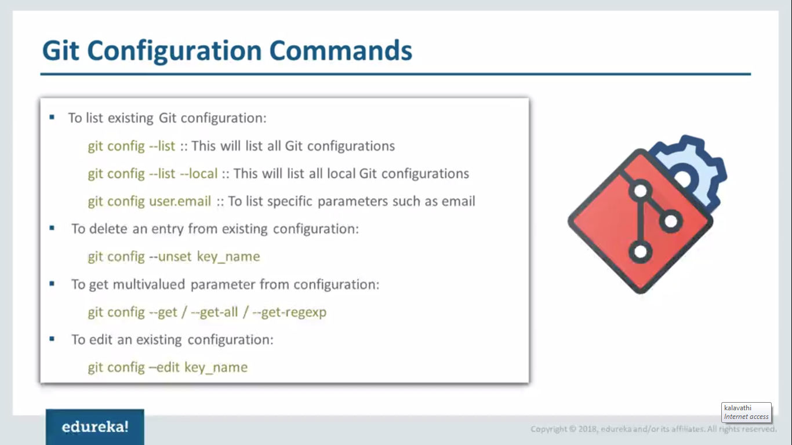

To remove the directory($$$ rm –rf edureka/)

To create directory(($$ mkdir edureka)

To create directory($$$ mkdir myproject)

To change into directory ($$$ cd myproject)

To initialize the git repository($$$ git init)

To list all commands ($$$ ls –al)

To list git repository files($$$ ls –l .git/)

To display the content of files($$$ cat .git/config)

Now we can configure the username and email id locally

($$$ git config user.name edureka)

($$$ git config user.email [aishu.devang5@gmail.com](mailto:aishu.devang5@gmail.com))

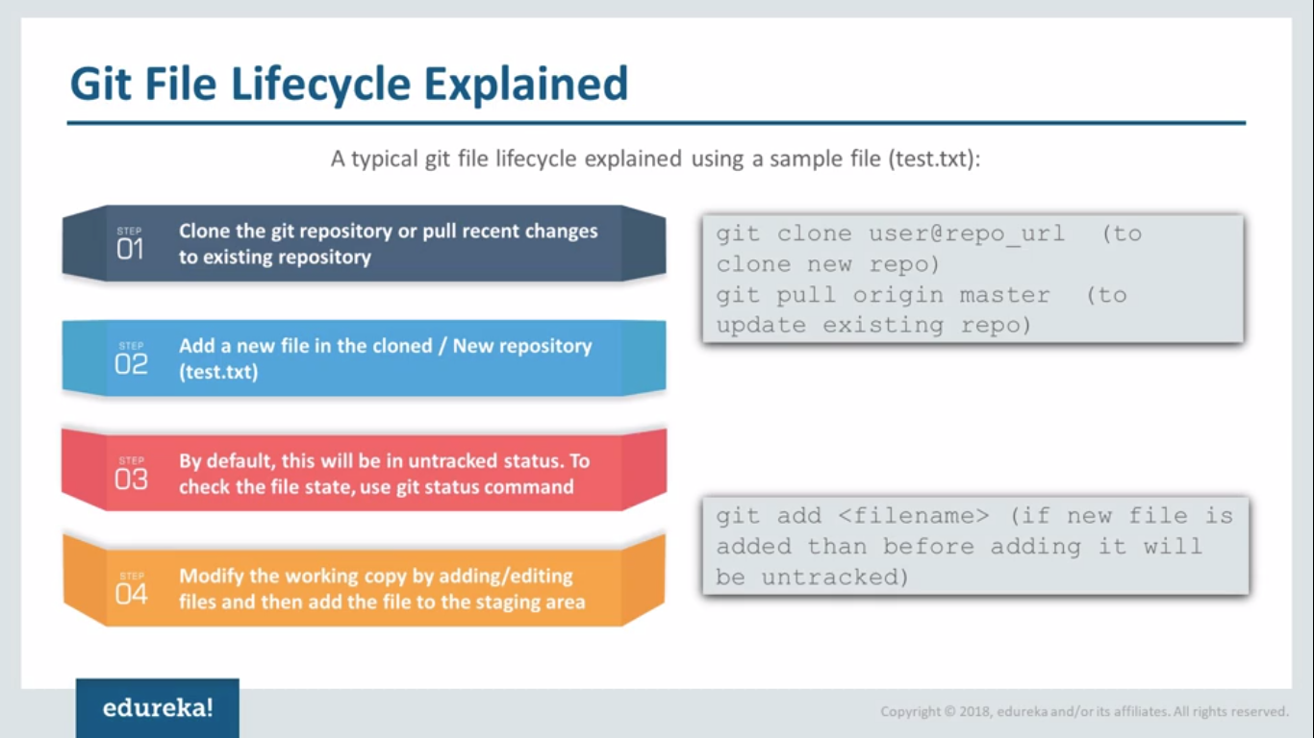

To create new files($$$ touch text.txt)

To check the status of the file($$$ git status)

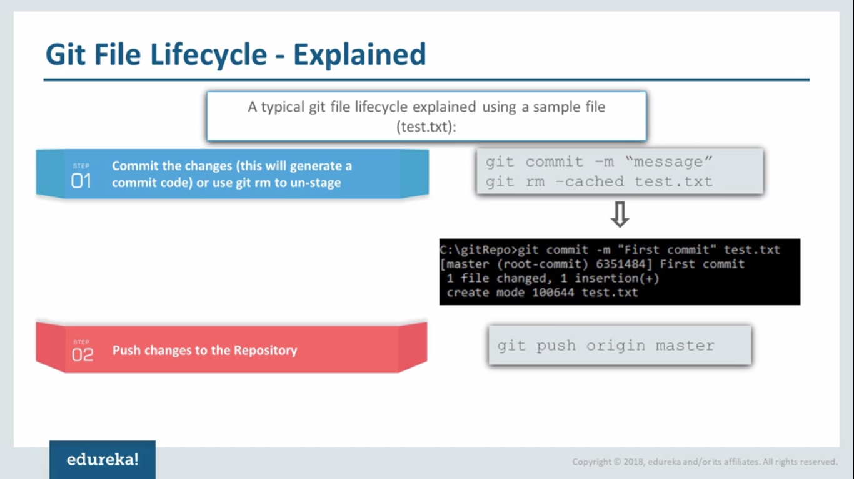

To remove the staged files ($$$ git rm –cached text.txt)it will automatically comes to unstaged area.

After modifiying we can commit using command ($$$ git commit –m “first tracked commit”

Remote repository

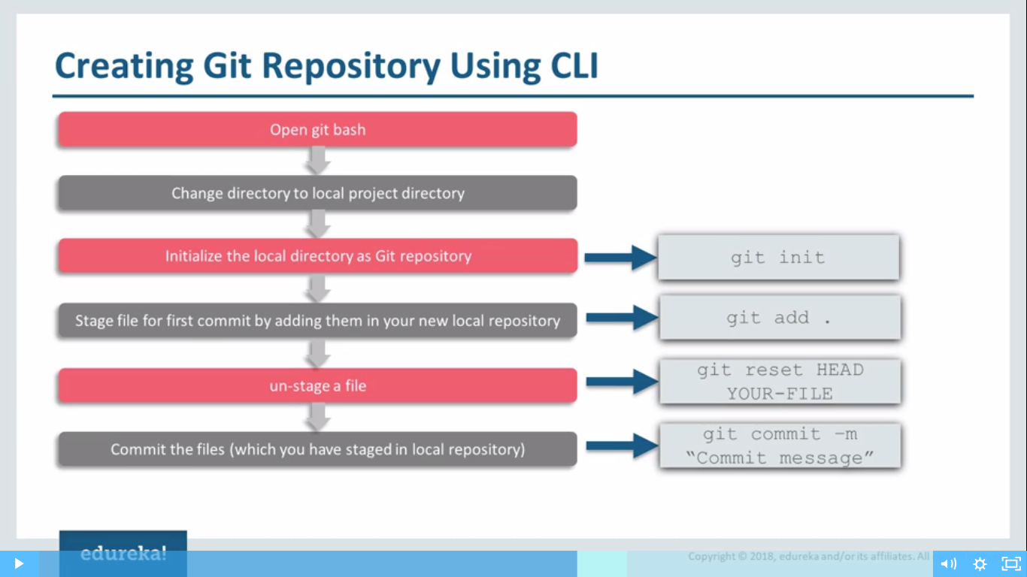

Open terminal again in the git folder

To check the git logs($$$ git log)



To clone the projects from remote repository to the local repository($$$ git clone url)

After can go into the folder and check for all the files inside.$$$ls

To check which branch we are($$$git branch)

To check remote($$$git remote)

Now changing the readme file.($$$vi README.mdown)

$$$git status

To add into the staging area($$$git add \*)

($$$git status)

Commitng to the local system($$$git commit –m “adding to stage”)

Pusing updates from local repository (branch name) to remote repository(origin repository)

($$$git push origin master

