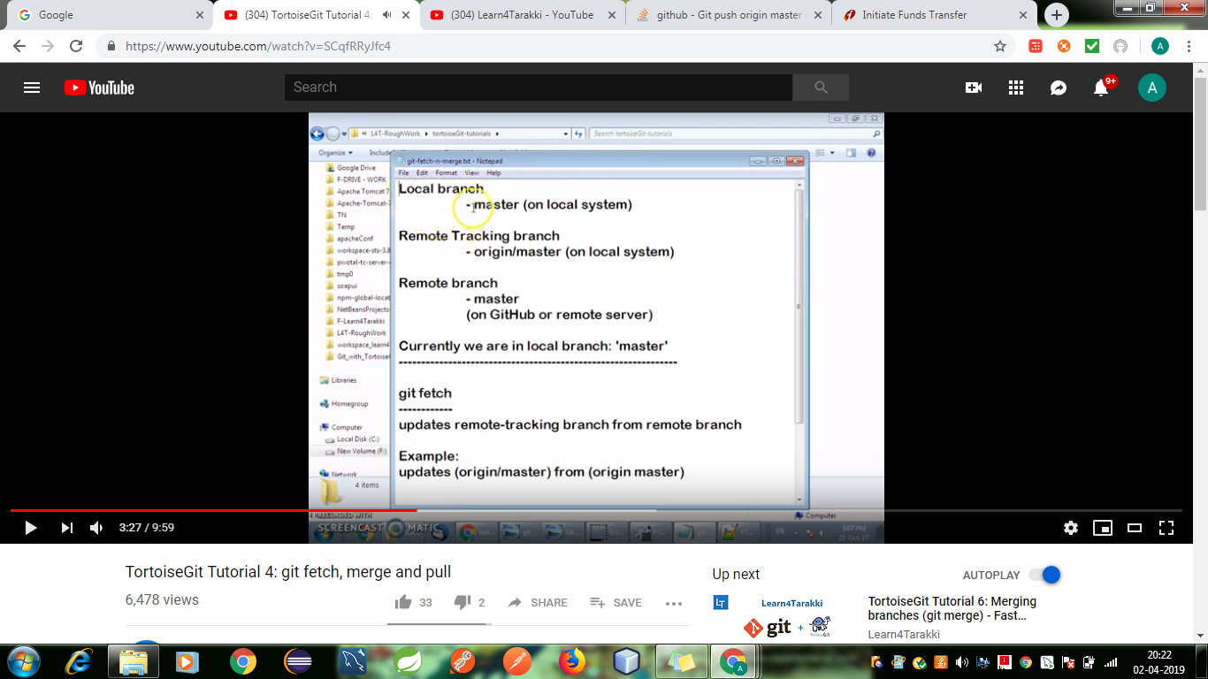

To clone

* Get the url from remote repository and clone it in the folder where do you want to clone it.

Create , switch or delete branch using tortoiseGit

Got to the specific folder where do we want to create branch from there we have to right click and create the branch.

Next check for browse reference...

* Once the branch got created we have to check out to that specific branch – tortoiseGit -> switch/checkout .
* Tortoisegit ->push.

Imp, local branch and remote tracking branch.

If we want local branch to be tracked by remote tracking branch then we have to got to that branch right click and update.