

CAB302 Assignment 2

Ashley Cottrell

Radhimas Djan

n9721436 | nxxxxxxx | 27/05/2018

# Technical Description

# GUI Test Report

Note: Due to my PC having a high DPI display and java 8 not having support for high dpi scaling the pictures below will appear to have small buttons, slight blurriness in text and other issues such as the window title being really big compared to the rest of the program.

When the program is first run export manifest, import manifest and import sales log button are disabled

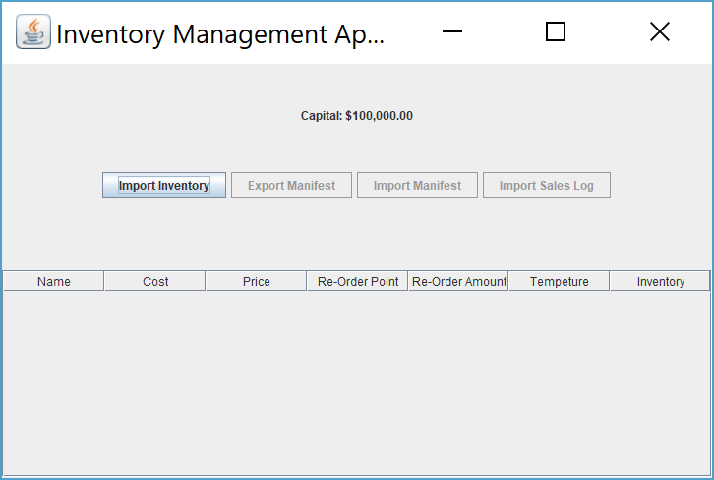

Upon Clicking the import inventory button a file chooser window will upon Which will allow the user to select a CSV file. The file chooser window has been setup to only show CSV files unless the user changes the file type to all files.

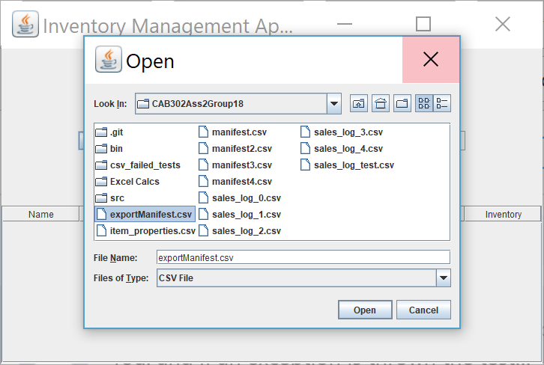

Once the program imports and item properties file the import inventory button will be disabled and the export manifest button will be enabled. The inventory will also be sorted and displayed in a table, allowing for easy access to the items information.

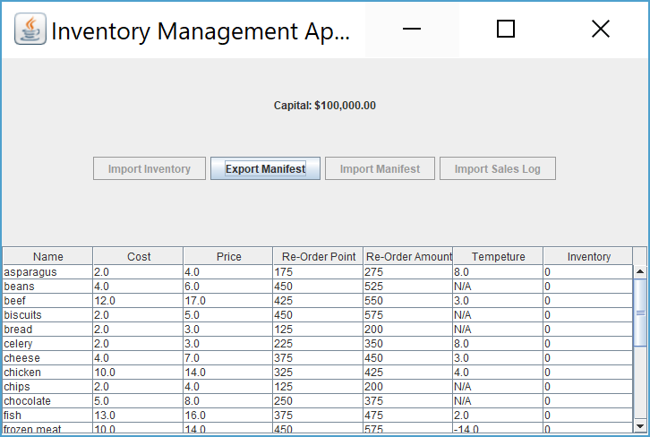

Upon clicking the export manifest button, the program will export the manifest to a CSV file called exportManifest.csv in the program directory and will display a message informing the user that the file has been exported.

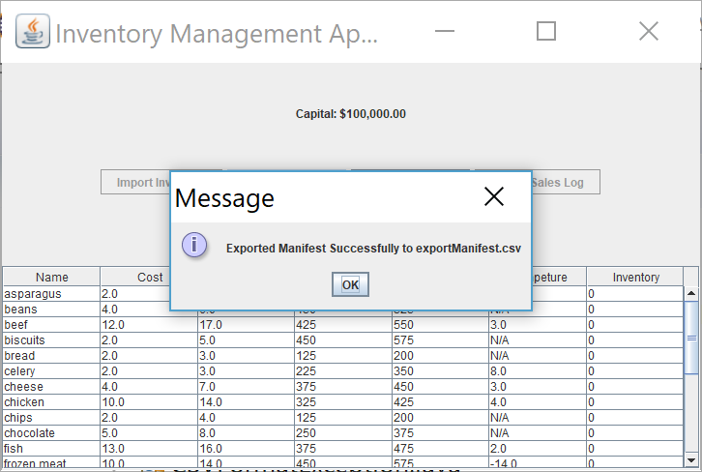

Upon successful export the will then enable import manifest button and upon clicking the button a file chooser window will open up and the user will select the exported manifest file.

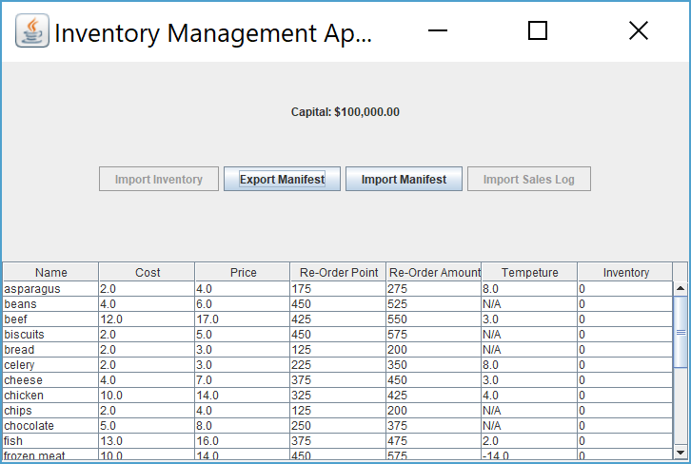

Upon success full import the table and capital will be updated accordingly and the sales log button is enabled and the program is fully setup and ready to be used. The user can now import sales logs which involve selecting a sales log using the file chooser window.

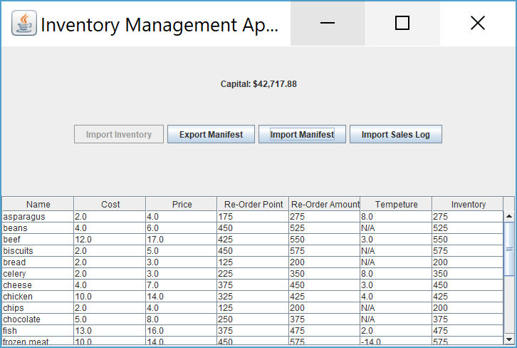

The program upon successful import will update capital and the table to show the updated data.

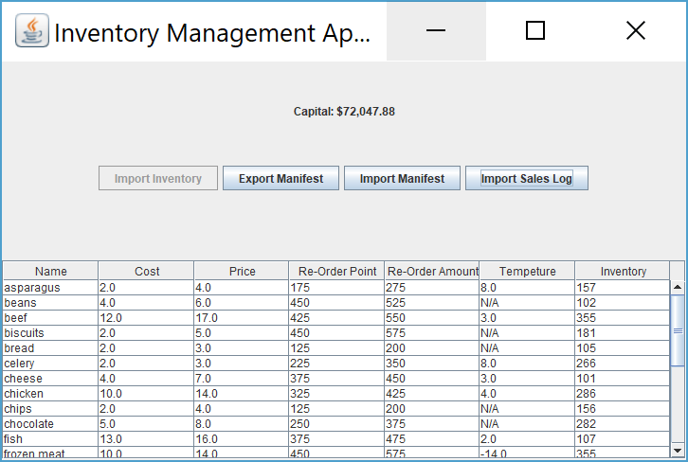

## Exceptions Handling

When the program encounters an error an exception will be thrown and displayed is a message box alerting the user to the problem so they can fix it.

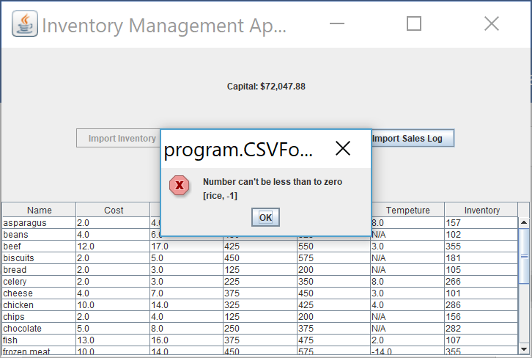

List of exception thrown by the program

CSVFormatException

* Item_Properties.csv
  + Item contains incorrect number of columns
  + Manufacture cost is not a number
  + Sell price is not a number
  + Re-order point is not a number
  + Re-order Amount is not a number
  + Temperature is not a number
  + Number can't be less than or equal to zero
  + Temperature is greater than 10 degrees
  + Temperature is less than -20 degrees
* Manifest.csv
  + Item contains incorrect number of columns
  + Truck type can only be >Refrigerated or >Ordinary
  + Amount Purchased is not a number
  + Number can't be less than or equal to zero
* Sales_Log.csv
  + Item contains incorrect number of columns
  + The number sold is not a number
  + Number can't be less than to zero

StockException

* + Item doesn’t exist in inventory
  + Cannot sell more items than are in the inventory

DeliveryException

* + Item doesn’t exist in inventory
  + No Items Need to re orderd