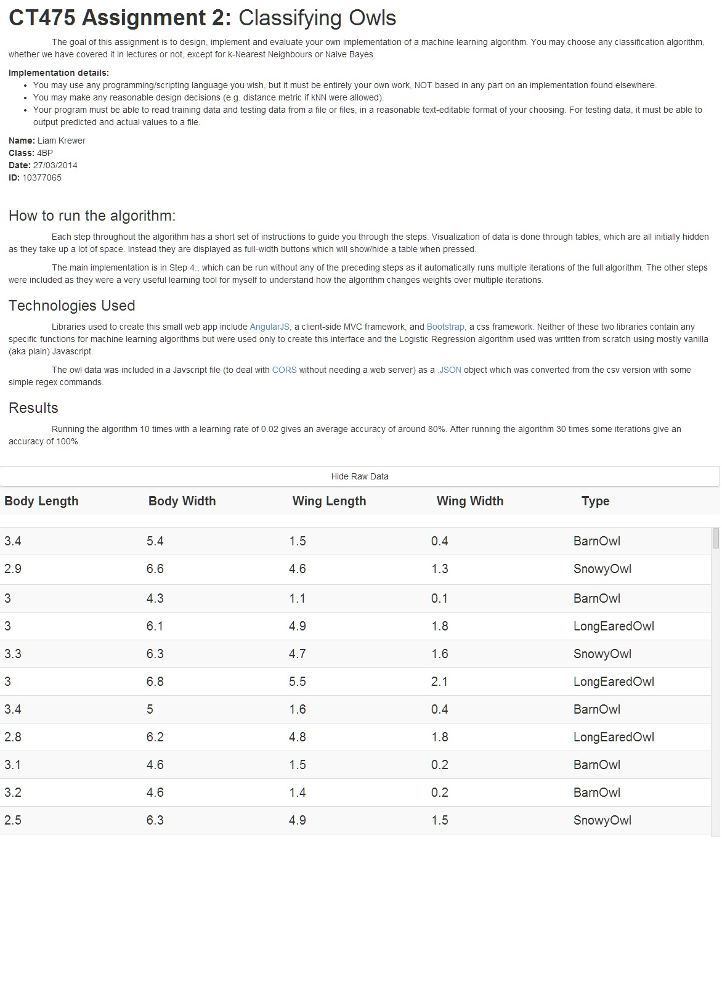

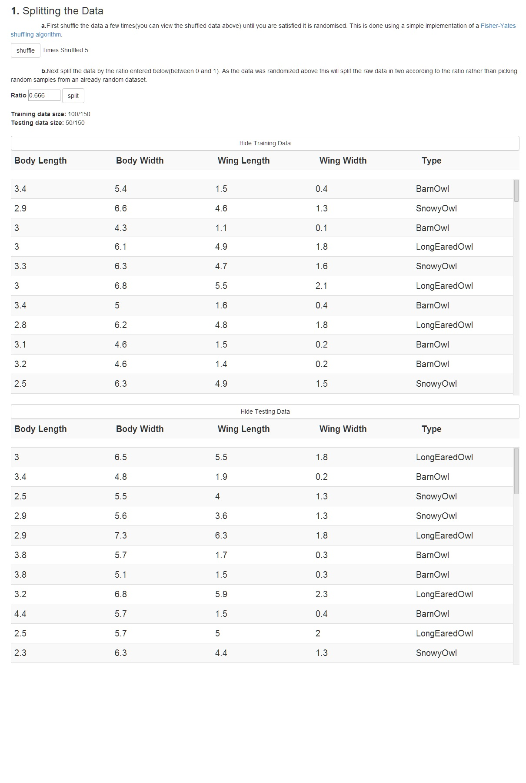

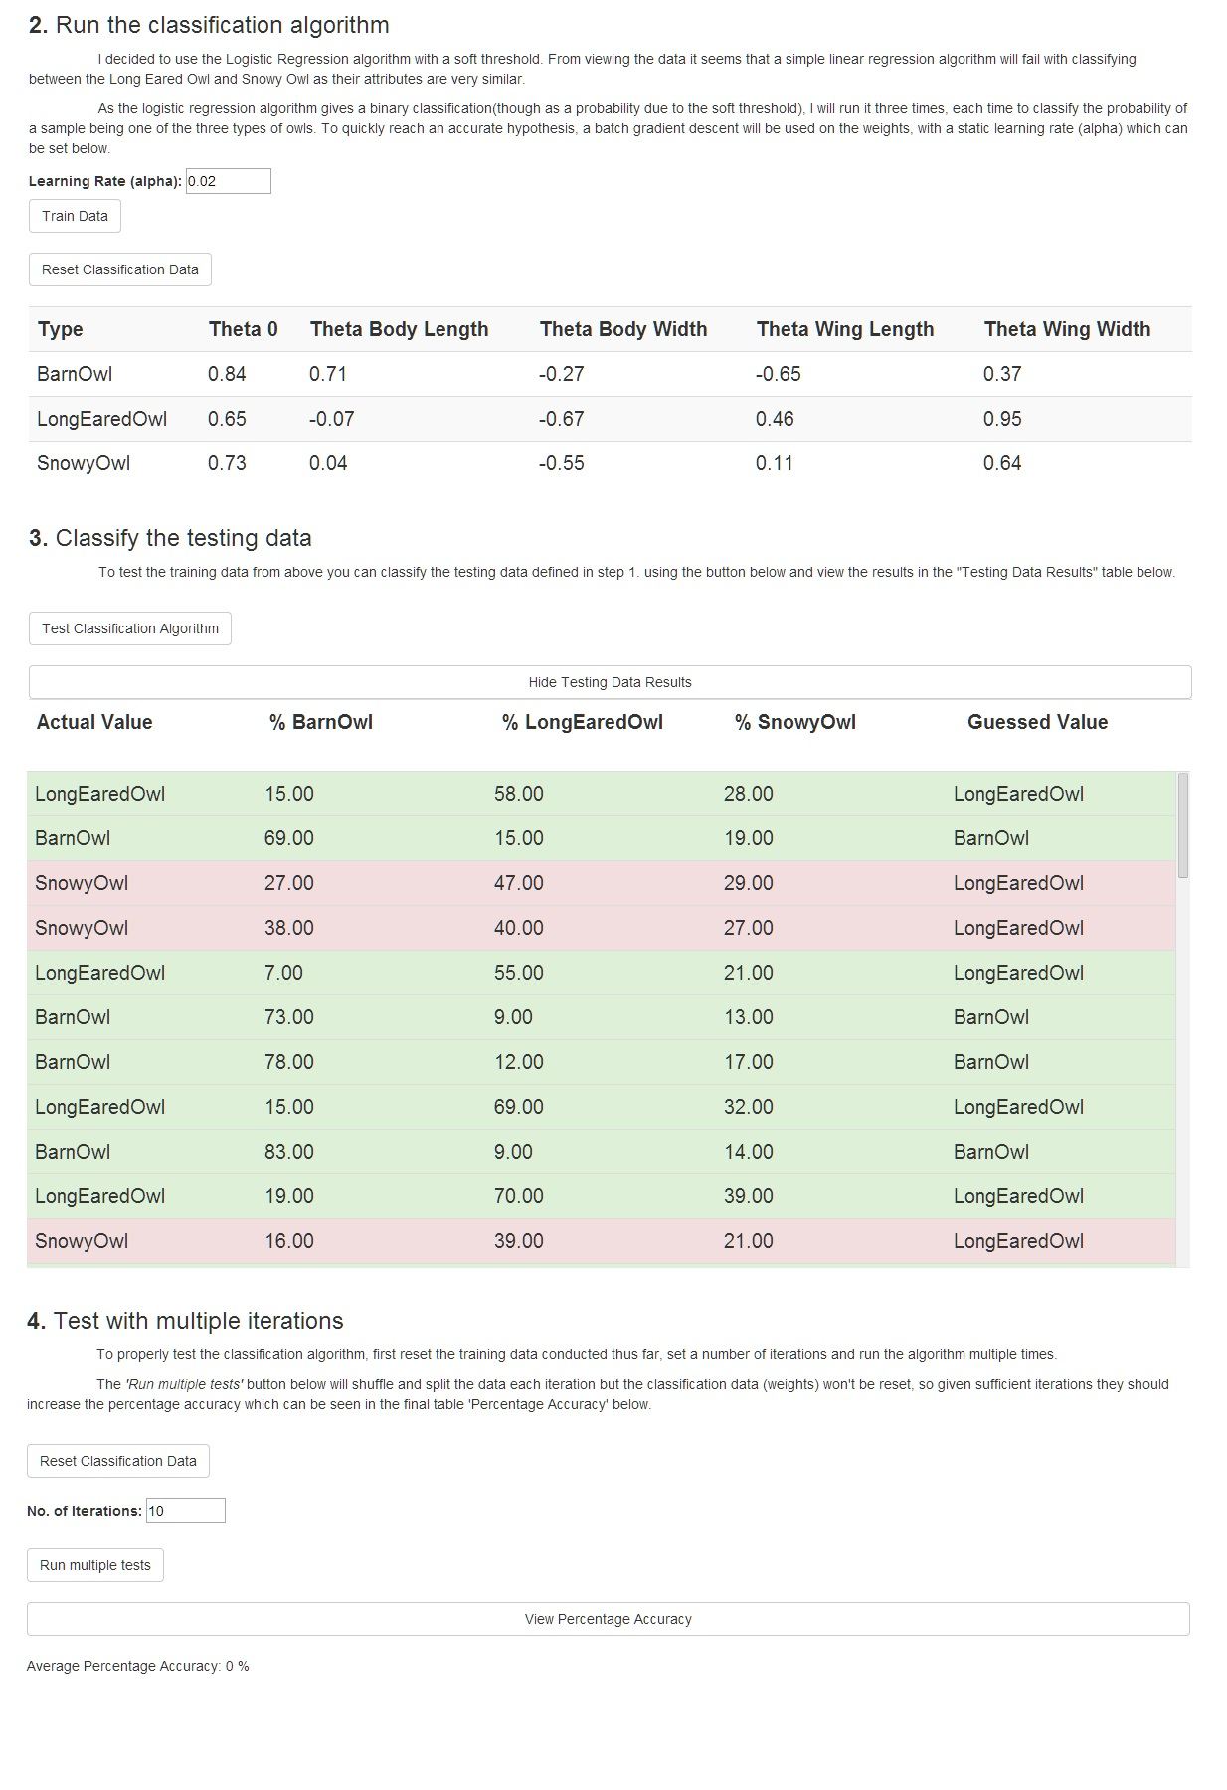

Desciption

The above writeup was generated by my code as a web application. It is available live at:

<https://googledrive.com/host/0Bygd3T-0o7uAY0NnX3dyQVdQTDQ/index.html>

(rather than typing it in, i have included it as a link in the note on the Blackboard upload and in the .pdf file)

It was written in HTML, JS and CSS, with the data as a JSON object and using the libraries described in the Technologies used section above.

Below is the Javascript code which was used for the website. The HTML and CSS were omitted as they don’t contain any algorithms and are used purely to display the results and make them interactive. Though as the website is statically hosted using Google Drive, the entire code is available here: <https://drive.google.com/folderview?id=0Bygd3T-0o7uAY0NnX3dyQVdQTDQ&usp=sharing>

Appendix (Code)

Owls.js

*//Defined this code to work with the AngularJS Framework*

app = angular.module("owlsApp",[]);  
app.controller("classifierCtrl",function($scope,$http){  
  
 $scope.owls = owls;*//The sample data is stored in a separate file as a JSOn object*  
 $scope.iterations = 10;  
 $scope.learningRate = 0.02;  
 $scope.percentageAccuracy = [];  
 var maxValues = {  
 bodyLength: 0,  
 wingLength: 0,  
 bodyWidth: 0,  
 wingWidth: 0  
 };  
 $scope.data = {  
 training: [],  
 testing: [],  
 testResults: []  
 };  
 $scope.timesShuffled = 0;  
 $scope.classification = {  
 BarnOwl:[1,1,1,1,1],  
 LongEaredOwl:[1,1,1,1,1],  
 SnowyOwl: [1,1,1,1,1]  
 };  
 *//get the max values to normalize the dataset*  
 for(var i =0;i<owls.length;i++){  
 temp = owls[i];  
 temp.splice(0,0,1);  
 $scope.owls[i] = temp;  
 }  
 *//array shuffle based on Fisher-Yates shuffle https://en.wikipedia.org/wiki/Fisher%E2%80%93Yates_shuffle*  
 *//for an array of length n, it takes a random element between 0 and n, switches it with element n, and repeats with*   
 *//n-1 until n = 0*  
 $scope.shuffleArray = function(array){  
 var index = 0,  
 temp = {};  
 for(length = array.length-1;length > 0;length--){  
 index = Math.floor(Math.random()*length);  
 temp = array[length];  
 array[length] = array[index];  
 array[index] = temp;  
 }  
 $scope.timesShuffled ++;  
 };

*//split the raw shuffled data by the given ratio in two*  
 $scope.split = function(array,ratio){  
 var lengthA = Math.ceil(array.length*ratio),  
 deepCopy = JSON.parse(JSON.stringify(array));  
 $scope.data = {  
 training: deepCopy.splice(0,lengthA),  
 testing: deepCopy,  
 testResults: []  
 };  
 };  
  
 *//classify the entire training data once*  
 $scope.classifyTrainingData = function(){  
 trainType("BarnOwl",$scope.data.training);  
 trainType("LongEaredOwl",$scope.data.training);  
 trainType("SnowyOwl",$scope.data.training);  
 }  
  
 *//run the train function on the whole dataset to train for a type of owl*  
 function trainType(type,samples){  
 for(var i =0;i<samples.length;i++){  
 train(type,samples[i]);  
 }  
 };  
  
 *//train the model properties(aka weights) using a batch gradient descent*  
 function train(type,sample){  
 var actual = (type == sample[5])? 1 : 0,  
 s = sigmoidal(type,sample),  
 error = actual - s;  
 for(var i =0;i<$scope.classification[type].length;i++){  
 $scope.classification[type][i] += $scope.learningRate*error*sample[i];  
 }  
 };  
  
 *//get the sigmoidal of a sample dataset being a type of owl using*   
 *//given weigths (model properties)*  
 function sigmoidal(type,sample){  
 var weights = $scope.classification[type],  
 z = 0;  
 for(var i =0;i<weights.length;i++){  
 z += weights[i]*sample[i];  
 }  
 return 1/(1+Math.pow(Math.E,-z));   
 }  
  
 *//use the model properties to classify each testing sample.*  
 $scope.test = function(){  
 for(var i =0; i< $scope.data.testing.length;i++){  
 var test = {  
 BarnOwl: sigmoidal("BarnOwl",$scope.data.testing[i]).toFixed(2),  
 LongEaredOwl: sigmoidal("LongEaredOwl",$scope.data.testing[i]).toFixed(2),  
 SnowyOwl: sigmoidal("SnowyOwl",$scope.data.testing[i]).toFixed(2),  
 actual: $scope.data.testing[i][5],  
 guessed: null,  
 correct: null  
 }  
 var max = Math.max(test.BarnOwl,test.LongEaredOwl,test.SnowyOwl);  
 if(max == test.BarnOwl)test.guessed = "BarnOwl";  
 else if(max == test.LongEaredOwl)test.guessed = "LongEaredOwl";  
 else if(max == test.SnowyOwl)test.guessed = "SnowyOwl";  
 test.correct = (test.guessed == test.actual);  
 $scope.data.testResults.push(test);  
 }  
 };  
  
 *//reset all training data*  
 $scope.resetClassification = function(){  
 $scope.classification = {  
 BarnOwl:[1,1,1,1,1],  
 LongEaredOwl:[1,1,1,1,1],  
 SnowyOwl: [1,1,1,1,1]  
 };  
 $scope.percentageAccuracy = [];  
 };  
  
 *//train multiple times, each time with different testing and training data*  
 $scope.trainIterations = function(){  
  
 for(var i =0;i<$scope.iterations;i++){  
 $scope.shuffleArray($scope.owls);  
 $scope.split($scope.owls,$scope.ratio);  
 $scope.classifyTrainingData();  
 $scope.test();  
 var correct = 0;  
 for(var j = 0;j<$scope.data.testResults.length;j++){  
 if($scope.data.testResults[j].correct)correct ++;  
 }  
 console.log("iterations",i);  
 $scope.percentageAccuracy.push((correct/$scope.data.testResults.length)*100);  
 }  
 };  
 *//Calculate the average percentage of correct guesses by the algorithm for all of the iterations*

*//conducted by the trainIterations function above.*  
 $scope.averagePercentage = function(){  
 var total = 0;  
 for(var i =0;i <$scope.percentageAccuracy.length;i++)  
 total += $scope.percentageAccuracy[i];  
 if($scope.percentageAccuracy.length == 0)return 0;  
 return (total)/$scope.percentageAccuracy.length;  
 };  
});