Ad Hoc Positioning System (APS) algorithm on Motes

Konstantinos Kleisouris
kkonst@cs.rutgers.edu

December 14, 2001

1 Introduction

We have implemented the Ad Hoc Positioning System (APS) [1] algorithm as a TinyOS [2] application so that it runs on motes. The APS solves the problem of self-locating the nodes in an ad hoc network where only a limited fraction of nodes has self-locating capability (GPS enhanced). This algorithm is meant to run on sensor networks, which are characterized by low powered nodes, low mobility and large size. Sensor networks can be classified as ad hoc networks, whenever deterministic placement of nodes is not possible. APS would be really appropriate for indoor location aware applications, where the networks are not characterized by highly mobile and unpredictable topology, but rather by a deployment of nodes that is temporary and ad hoc. The cost to supply all nodes of these kinds of networks (that are actually sensor networks) with a self-positioning system is not justifiable.

Many times attaching a GPS system on every node of an ad hoc network is not a preferred solution for several reasons. First of all, it might be very costly to support thousands or tens of thousands of nodes with such a system. Moreover, GPS reception might not be accessible or might require power that is not available in a limited powered network. Finally, the form factor (size of nodes) might render a GPS system unsuitable to nodes of an ad hoc network. Given the characteristics of a sensor network (low powered, large scale), it is plausible why APS is appropriate for such networks, while a GPS would be inefficient.

2 APS Algorithm

The APS is a distributed algorithm that does not need special infrastructure and provides absolute positioning. It requires that at least 3 GPS enhanced nodes, called landmarks, are present in the network. The coordinates of the landmarks and the distances to the landmarks are propagated in a hop by hop fashion and are not emitted to cover the entire network. Broadcasting the coordinates to the entire network would result in high power usage, collisions in local communication and coverage problems when moving. Furthermore, the algorithm does not assume fixed positions for the landmarks, and thus it is suitable for networks whose configuration might change.

Once an arbitrary node, not GPS enhanced, gets the coordinates of at least 3 landmarks and estimates of the distances to these landmarks, it can compute its own position in the plain using a procedure similar to GPS calculation. This procedure, which is explained in section 3, is iterative and starts with an initial estimate of the position of the node. In our case, we choose the centroid of the landmarks as an initial estimate.

As mentioned above, propagation of messages takes place in a hop by hop fashion, which means that every node communicates only with its immediate neighbors. Apart from getting the coordinates of the landmarks, a node has to estimate the distance to them. It is clear, that the immediate neighbor of a landmark can estimate the distance to the landmark by direct signal strength measurement. This estimate is propagated to the neighbors, which in turn use this estimate with the direct signal strength measurement from their own neighbors to infer their own distance to the landmarks. So, finally, the whole network is able to calculate the distance to the landmarks in a controlled flood manner. Complexity of signaling is proportional to the total number of landmarks and the average degree of every node.

3 Estimation of position

The APS uses an iterative process to calculate the position of a node. In every step of this iterative process, a triangulation algorithm is applied to the distances to 3 or more nodes that are GPS enhanced. The first step starts with an apriori estimated location which, in subsequent steps, is corrected towards the real location.

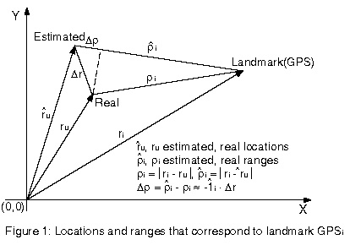

In the figure above, let be the real location (unknown), the estimated location (known), 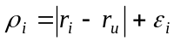 and 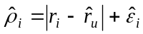 the respective ranges of the real and estimated location to GPS-node . If is the unit vector of 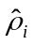, then 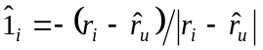 and if 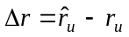, then the correction 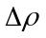 of the ranges can be approximated as 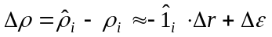. Performing the previous approximation for every GPS node (we assume that there are at least 3), we get the following linear system, in which the unknown is 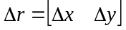.

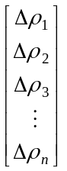 = 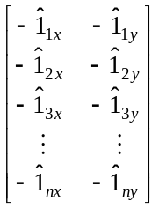 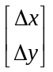

In every iteration, the values 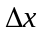, 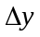 are applied to the current position estimate, and thus new range corrections 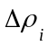 and unit vectors have to be calculated. The iteration process stops when the length of 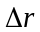 is below a given threshold.

The linear system presented above has more equations than unknowns; there are 2 unknowns 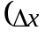, 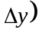 and there are at least 3 linear equations (since we use the distances to at least 3 nodes GPS enhanced). This system can be solved using the least square method, which is presented in section 3.2.

3.1 Pseudo-code of the APS algorithm

Below we give the APS algorithm in pseudo-code form. This code is executed by a node that does not know its location.

1. epsilon =10⁻³, maxiterations=100, alt_{x}=0, alt_{y}=0, newerror=0, olderror=10000
2. Get the coordinates of at least 3 landmarks
3. Calculate an estimate of the coordinates of the location
One way of getting this estimate is the centroid: estimate_{x}=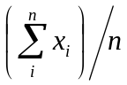, estimate_{y}=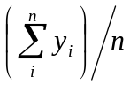
where 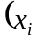, 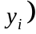 are coordinates of landmarks
4. While (true)
5. iterations++;
6. Calculate unit vectors
where, is the location of a landmark
is the location of the current estimate
7. Calculate ranges 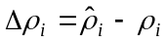
where, 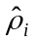 is calculated as 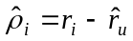
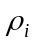 can be gotten from the signal strength of a packet that was sent by a landmark
- Define matrix 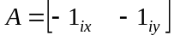 and vector 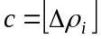
- Solve the linear system =
where, is the unknown
the system is solved using the least square method
10. newerror=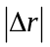
if (newerror < epsilon)
break;
if (newerror > olderror)
estimate_{x} = alt_{x}; estimate_{y} = alt_{y}; olderror=newerror
else
alt_{x} = estimate_{x} - ; alt_{y} = estimate_{y} - ;
estimate_{x} += ; estimate_{y} += ; olderror=newerror
end if

11. if (iterations > maxiterations)
break;

3.2 More equations than unknowns

When there are more linear equations than unknowns, it is usually impossible to find a solution which satisfies all the equations. In this case, one looks for a solution, which approximately satisfies all the equations. Let be a matrix 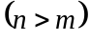, a 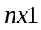 vector and a 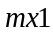 vector in the following linear system, where is the vector of unknowns while , are known.

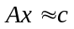 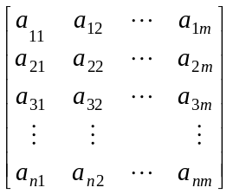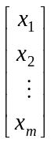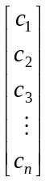 (1)

Since approximately satisfies (1), let be an error vector, such that:

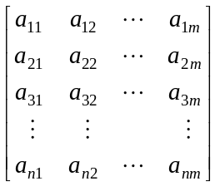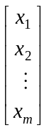-=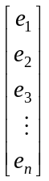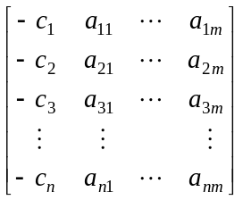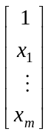=

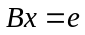 (2)

where is a matrix containing and . The 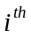 component of may be written as a dot product in the following way:

= 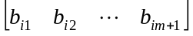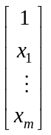 = 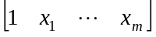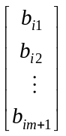

We would like to be such, so that it minimizes the sum squared error 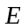, which is defined as follows:

= 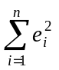= 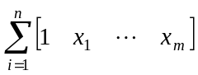 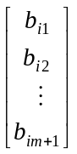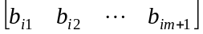

= 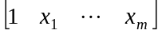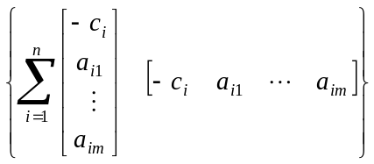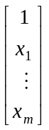 (3)

The matrix, call it 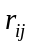, defined by the summation in (3), is symmetrical, positive (more strictly nonnegative) definite, since is a sum of squared . In order for to minimize, we should require 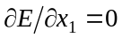, 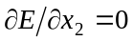, … , 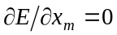, thus getting one equation for each unknown.

In order to understand the rest of the least squared method, we give the following example of 2 unknowns.

Example
If we have two unknowns, namely 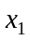, 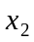, equation (3) becomes:

= 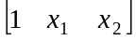 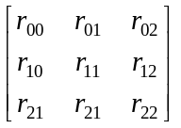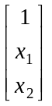 (4)

and requiring to minimize in (4), we get the following equations:

0 = 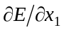= 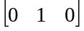 + 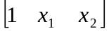 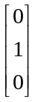 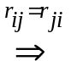

0 = = 2 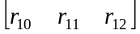 (5)
Likewise, differentiating with respect to gives
0 = 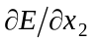= 2 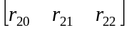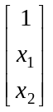 (6)

Equations (5) and (6) may be combined as:

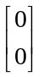 = 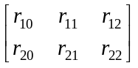 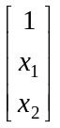 (7)

This is a linear system of two equations and two unknowns. The matrix in (7) lacks only a top row to be equal to the matrix of (4). To give it that row, we may augment (7) by

= 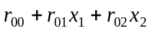 (8)

where (8) may be regarded as a definition of a new variable . Putting (8) on top of (7) we get

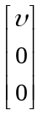 = 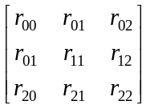 (9)
The solution of (9) or (7) is that set of , for which is a minimum. To get an interpretation of , we may multiply both sides of (9) by 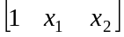, getting

= = (10)

Comparing (10) with (4), we see that is the minimum value of .

Rewriting (3) in partitioned matrix form, we have for the error

= 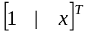 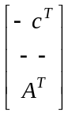 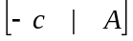 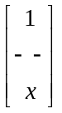 (11)

The final equation in (11) may be split into

= 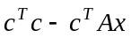 (12)
0 = 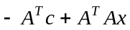 (13)

where (13) represents simultaneous equations to be solved for . Therefore, equation (3) is rewritten as (12), (13). Equation (13) is the one that we should set up in a computer. It is easily remembered by a quick and dirty derivation. We began with equations and then multiplying both sides with 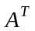 we get 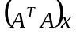 = 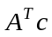, which is (13).

3 Signal Strength Characteristics

As was mentioned previously, a node that receives a message from one of its neighbors uses the signal strength of the message to estimate the distance from its neighbor. There are several factors that influence the strength of the received signal.

- Distance separation: The strength of the signal received is inversely proportional to the distance separating the two nodes. The greater the distance the weaker the signal.
- Node orientation: The relationship between the transmitted signal from a node to the alignment of a searching node is very important. Nodes have antennas to detect and transmit signals. The strongest signal a receiving node can get at a given distance occurs when its antenna is aligned parallel to the transmitting node’s field. The weakest signal at a given distance happens when a receiving node’s antenna is perpendicular to the transmitting node’s field.
- Signal volume: A node may have a volume control, which allows the searcher to amplify the signal received from a transmitting node. The higher the volume setting the larger the bracket size. So, it is important to turn the volume setting as low as comfortable for the searcher.
- Sensitivity to obstructions: Obstacles cause drastic variations in signal strength readings.

4 Experimental Results

We tried to see how the signal strength varies according to the distance inside a building. We conducted our experiment on the 3rd floor of Core Building along a corridor. We used two motes and we made sure that they were placed on surfaces that had the same distance from the floor. Furthermore, the motes were on the same line of sight and there were no obstacles between them. One of the motes generated radio packets and the other one received them. Initially the motes were 1 foot apart and then we started moving one of them away from the other until the motes were positioned at the two corners of the building. The results we got are summarized in the following table, which shows the strength and the variance for several distances.

Distance (feet) | Signal Strength (mean) | Variance | Std. Dev.
1 | 597.9699 | 480.7291 | 21.92554
2 | 589.9060 | 174.9248 | 13.22591
4 | 582.8972 | 1007.900 | 31.74736
8 | 582.7317 | 211.7062 | 14.55013
16 | 569.7556 | 253.4357 | 15.91966
36 | 549.9807 | 685.0190 | 26.17287
56 | 535.3153 | 513.1698 | 22.65325
76 | 554.1448 | 150.1912 | 12.25525
96 | 537.7681 | 232.1271 | 15.23572
116 | 514.2161 | 222.0148 | 14.90016
136 | 514.4277 | 339.5333 | 18.42643
156 | 522.2799 | 237.4748 | 15.41022
176 | 494.5000 | 217.8727 | 14.76051

The signal strength for a given distance is the average (mean) of the signal strengths of a number of packets (600-720 packets) that were broadcast from one mote and received from the other. From our results we can clearly see that the signal strength reduces as the distance increases, as was indicated in the previous section. Moreover, although our motes do not have volume control, we realized from our experiment that the batteries (AA) of the motes affected the signal strength; for a given distance, the average signal strength is smaller, if a battery has been used, than if it has not been used at all. Furthermore, the signal strengths were more dispersed for longer distances than for smaller distances. The table below gives us the histogram for the various distances.

Dist.  Sig. Strength | 1 | 2 | 4 | 8 | 16 | 36 | 56 | 76 | 96 | 116 | 136 | 156 | 176
[460, 470) | 6 | 1 | 16 | 2 | 3 | 26 | 23 | 3 | 4 | 4 | 12 | 5 | 30
[470, 480) | 3 | 2 | 22 | 1 | 7 | 24 | 9 | 3 | 6 | 17 | 20 | 10 | 90
[480, 490) | 5 | 1 | 12 | 2 | 1 | 4 | 7 | 0 | 8 | 32 | 38 | 11 | 87
[490, 500) | 2 | 2 | 4 | 5 | 2 | 3 | 13 | 4 | 5 | 42 | 58 | 39 | 131
[500, 510) | 3 | 2 | 2 | 2 | 2 | 3 | 28 | 4 | 16 | 92 | 102 | 49 | 161
[510, 520) | 4 | 1 | 1 | 2 | 0 | 1 | 39 | 1 | 25 | 183 | 122 | 118 | 89
[520, 530) | 1 | 0 | 1 | 1 | 5 | 4 | 52 | 4 | 69 | 189 | 139 | 176 | 6
[530, 540) | 1 | 1 | 2 | 1 | 6 | 21 | 106 | 10 | 143 | 62 | 111 | 229 | 0
[540, 550) | 1 | 3 | 3 | 2 | 11 | 93 | 195 | 68 | 333 | 13 | 32 | 49 | 0
[550, 560) | 0 | 3 | 1 | 5 | 30 | 225 | 157 | 362 | 91 | 0 | 2 | 0 | 0
[560, 570) | 3 | 3 | 1 | 5 | 34 | 210 | 16 | 196 | 1 | 0 | 0 | 0 | 0
[570, 580) | 4 | 6 | 1 | 34 | 548 | 48 | 1 | 1 | 2 | 0 | 0 | 0 | 0
[580, 590) | 3 | 55 | 14 | 615 | 19 | 11 | 1 | 0 | 0 | 0 | 0 | 0 | 0
[590, 600) | 16 | 569 | 640 | 5 | 3 | 0 | 0 | 0 | 0 | 0 | 0 | 0 | 0
[600, 610) | 612 | 0 | 0 | 0 | 0 | 0 | 0 | 0 | 0 | 0 | 0 | 0 | 0
[610, …) | 0 | 0 | 0 | 0 | 0 | 0 | 0 | 0 | 0 | 0 | 0 | 0 | 0
Samples# | 664 | 649 | 720 | 682 | 671 | 673 | 647 | 656 | 703 | 634 | 636 | 686 | 594

The graphs of this page depict the average signal strength and variance versus the distance.

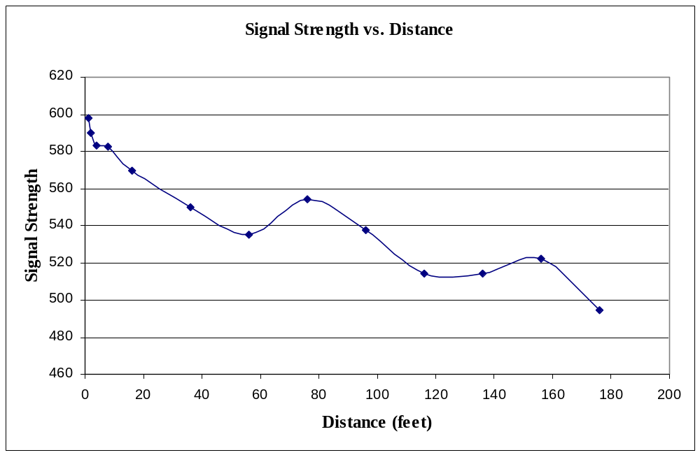
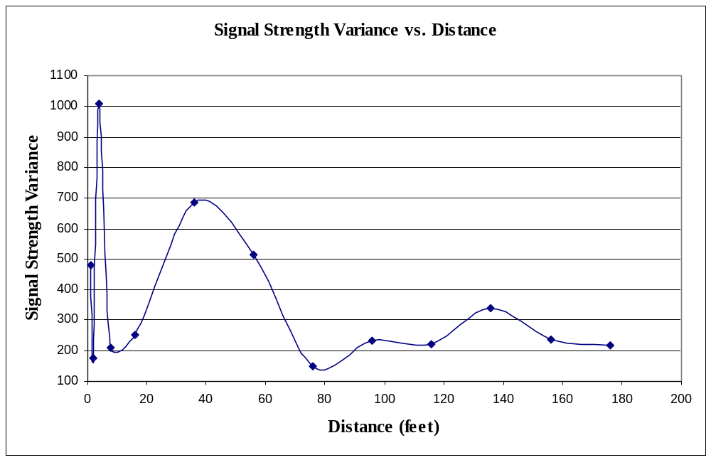

We tried to find a function that would approximately give us the signal strength for a given distance. This function can then be inverted, so that given a signal strength we can estimate the distance that separates two motes. The inverted function can then be plugged into the APS algorithm.

Given the graph of Signal Strength vs. Distance that we presented above, we tried to approximate the data with a function of the form
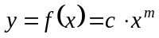 (14)

where, will represent the signal strength and will represent the distance.

In order to find the values of and we made equation (14) linear, by taking the logarithm of both sides, and then we applied the least squares method.

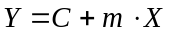 (15)

where, 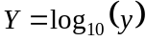, 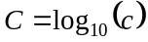 and 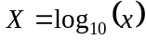

We would like and to minimize the following sum squared error :

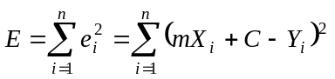 (16)

where, 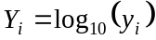 is the logarithm of the signal strengths
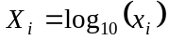 is the logarithm of the distances

In order for and to minimize in (16), we should require:

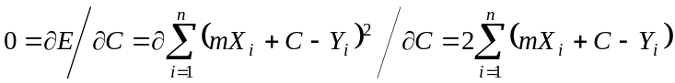 (17)

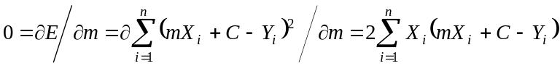 (18)

Equations (17) and (18) constitute a linear system of two equations with two unknowns, namely and . Solving this system we get:

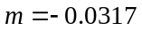 and

Substituting the values of and into (14) we have:

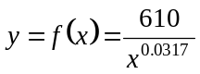 (19)

Below, we give the values of the function for various distances, as well as the corresponding graph.

Distance (feet) | Signal Strength (sample) | Signal Strength (function)
1 | 597.9699 | 610
2 | 589.9060 | 596.74279
4 | 582.8972 | 583.77371
8 | 582.7317 | 571.08648
16 | 569.7556 | 558.67499
36 | 549.9807 | 544.49644
56 | 535.3153 | 536.92332
76 | 554.1448 | 531.75066
96 | 537.7681 | 527.82728
116 | 514.2161 | 524.67034
136 | 514.4277 | 522.03143
156 | 522.2799 | 519.76590
176 | 494.5000 | 517.78216

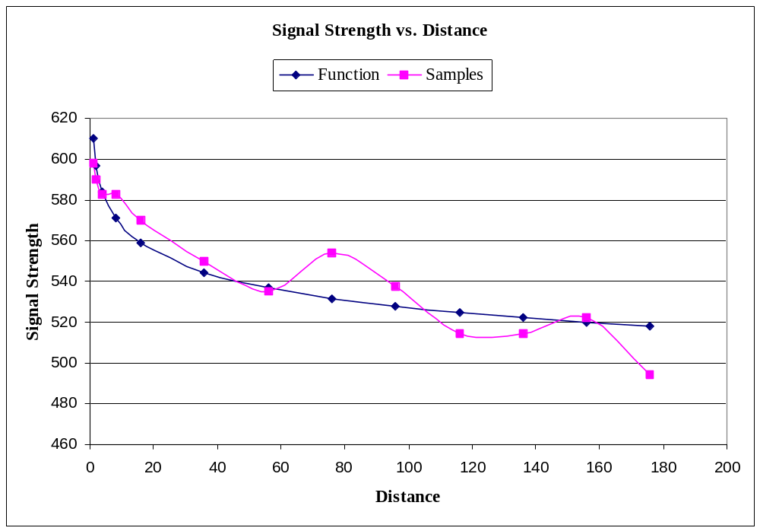

References
  - Ad-Hoc Positioning System algorithm
Dragos Niculescu, Badri Nath
http://athos.rutgers.edu/dataman/papers/aps.ps
  - TinyOS programming environment
http://tinyos.millennium.berkeley.edu/
  - Orienting a beacon
http://www.geocities.com/Yosemite/Trails/1996/orient.html
  - More equations than unknowns
http://sepwww.stanford.edu/sep/prof/fgdp/c6/paper_html/node2.html

