İST-309-02

Örnekleme

Tabakalı Rastgele Örnekleme

Ramazan Erduran
21821809
ramazan.erduran@hacettepe.edu.tr


İçindekiler Tablosu:
Giriş: 1
1. Kısım: 3
2. Kısım: 3
3. Kısım: 4
4. Kısım: 5
Kullanılan kodlar (r) : 6
R Kodları: 6
Kaynakça: 9

Kısım:
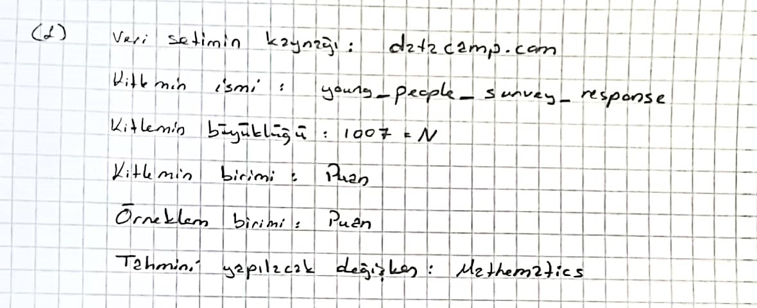

Kısım:
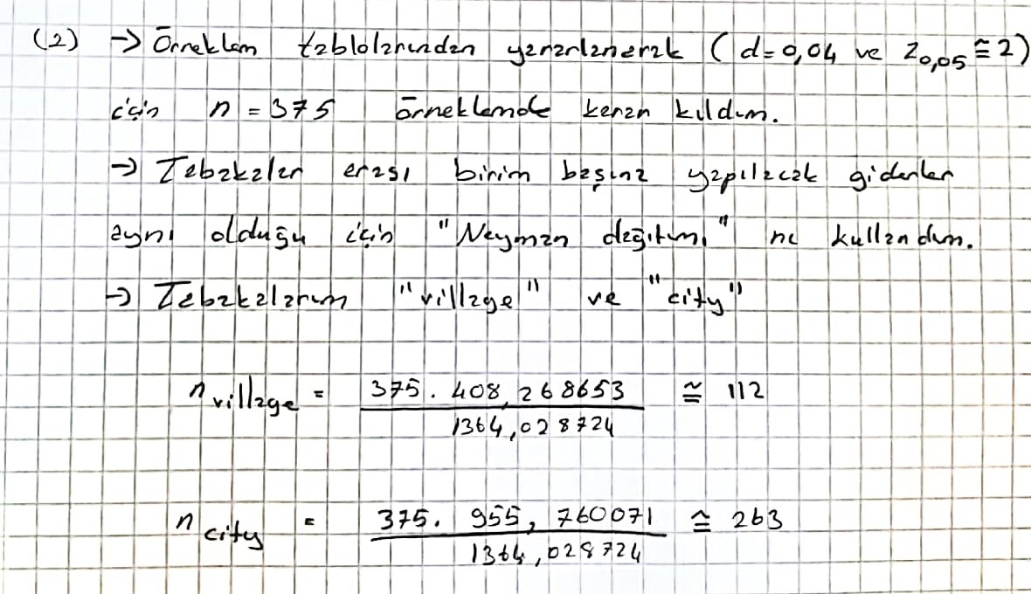

Kısım:
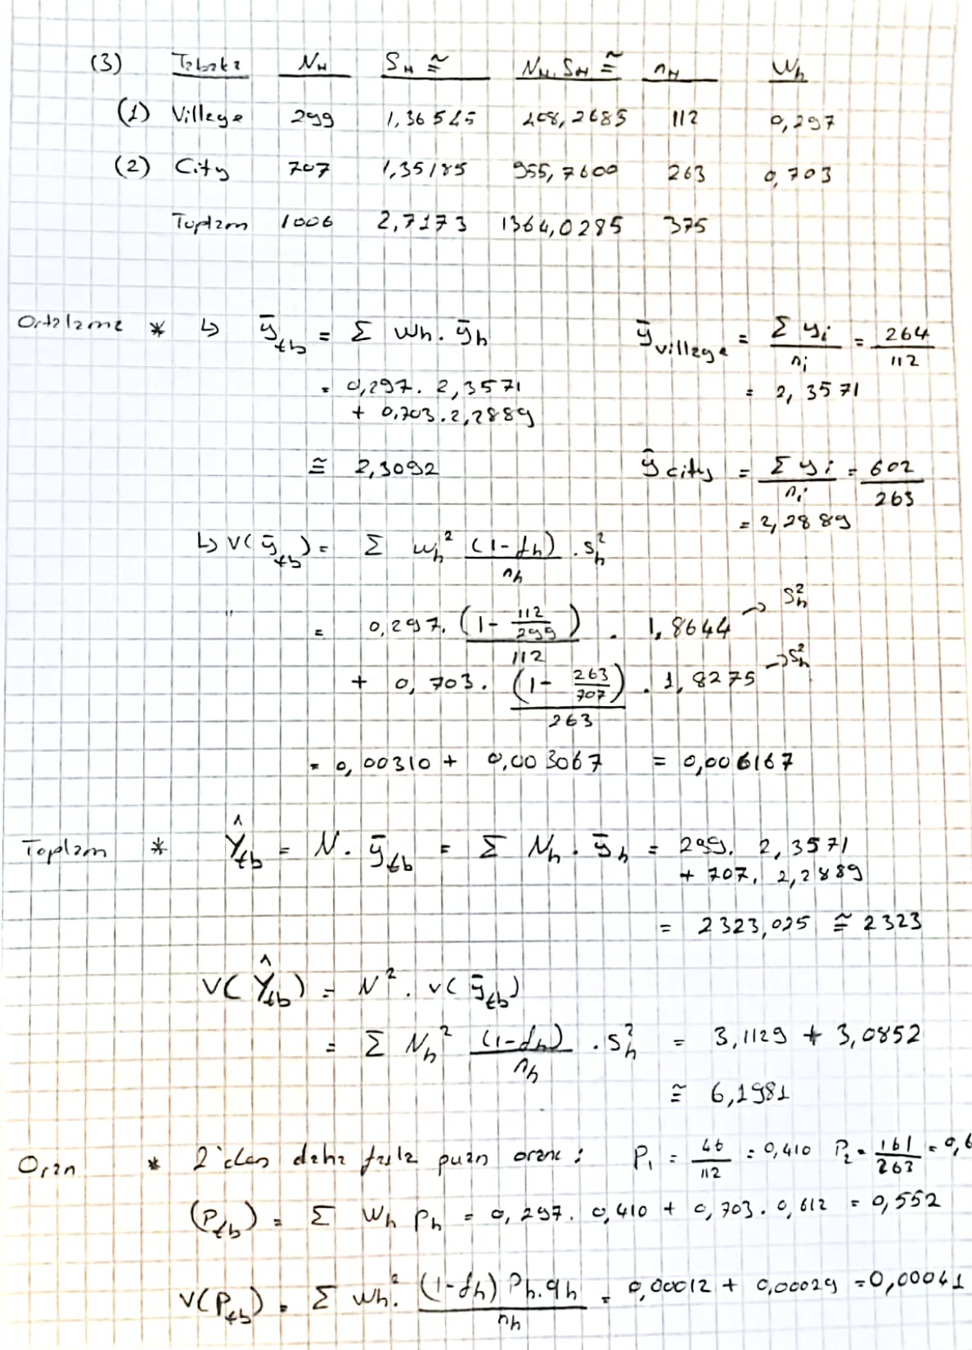

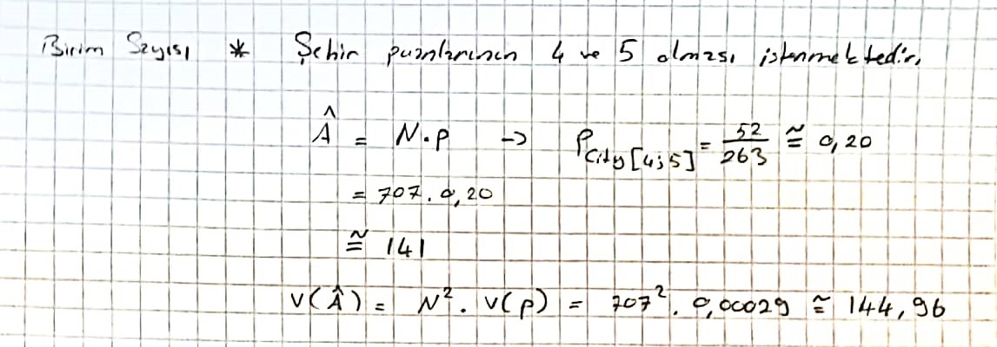

Kısım:
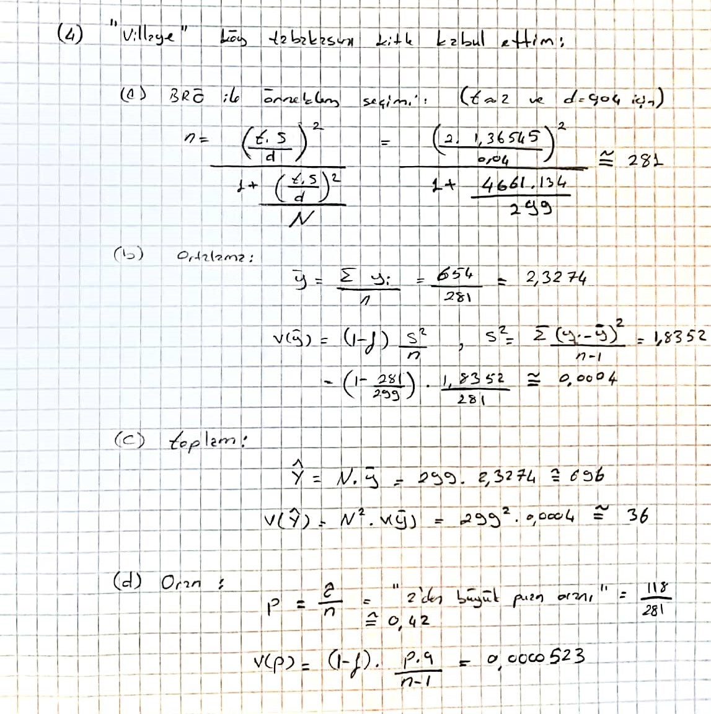
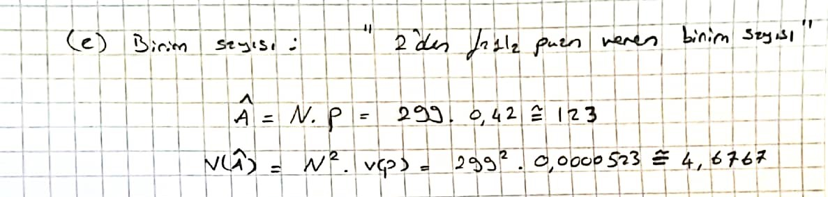

Kullanılan kodlar (r) :

R Kodları:
library(readr)
library(dplyr)
library(PracTools)
library(writexl)
library(tibble)

ypsr <- read_csv("C:/Users/lenovo/Desktop/Data_Camp/young-people-survey-responses.csv")
View(ypsr)

###ypsr verisi:
ypsr_math <- ypsr %>%
filter(`Village - town` %in% c("village","city")) %>%
summarize(Gender=Gender, `Village - town`=`Village - town`, Mathematics = Mathematics) %>%
arrange(`Village - town`)

ypsr_math_village <- ypsr %>%
filter(`Village - town` == "village") %>%
summarize(Gender=Gender, `Village - town`=`Village - town`, Mathematics = Mathematics , ) %>%
arrange(`Village - town`)

ypsr_math_city <- ypsr %>%
filter(`Village - town` == "city") %>%
summarize(Gender=Gender, `Village - town`=`Village - town`, Mathematics = Mathematics) %>%
arrange(`Village - town`)

ypsr_math$Mathematics[is.na(ypsr_math$Mathematics)]=0
ypsr_math_city$Mathematics[is.na(ypsr_math_city$Mathematics)] = 0
ypsr_math_village$Mathematics[is.na(ypsr_math_village$Mathematics)] = 0

#write_xlsx(ypsr_math,"D:\\Hacettepe\\Örnekleme\\Hwork\\ypsr_math.xlsx")
#write_xlsx(ypsr_math_village,"D:\\Hacettepe\\Örnekleme\\Hwork\\ypsr_math_village.xlsx")
#write_xlsx(ypsr_math_city,"D:\\Hacettepe\\Örnekleme\\Hwork\\ypsr_math_city.xlsx")

count(ypsr_math_city)
count(ypsr_math_village)

###Sh lar:
tot<-0
for (i in ypsr_math_city$Mathematics){
ortdan_farki <- (i- mean(ypsr_math_city$Mathematics))^2
tot=tot+ortdan_farki
}
sqrt(tot/(706))

tot2<-0
for (i in ypsr_math_village$Mathematics){
ortdan_farki <- (i- mean(ypsr_math_village$Mathematics))^2
tot2=tot2+ortdan_farki
}
sqrt(tot2/(298))

### Örneklem çekme:
smpl_village_math <- sample(ypsr_math_village$Mathematics,112,replace=F)
village_math_samp <- as.data.frame(list(village_math=smpl_village_math))

smpl_city_math <- sample(ypsr_math_city$Mathematics,263,replace=F)
city_math_samp <- as.data.frame(list(city_math=smpl_city_math))

#write_xlsx(city_math_samp,"C:\\Users\\lenovo\\Desktop\\Hworks\\ornekleme\\smpl_city_math.xlsx")
#write_xlsx(village_math_samp,"C:\\Users\\lenovo\\Desktop\\Hworks\\ornekleme\\smpl_village_math.xlsx")

ypsr_math <- add_column(ypsr_math, reference=NA)
ypsr_math <- select(ypsr_math, c(-referans,-Referans))
ypsr_math <- select(ypsr_math, -reference)

###Yh lar:
tot_village=0
for (j in village_math_samp$village_math){
tot_village=tot_village+j
}
village_ort_orn <- tot_village/112

tot_city=0
for (j in city_math_samp$city_math){
tot_city=tot_city+j
}
city_ort_orn <- tot_city/263
ypsr_ort <- mean(ypsr_math$Mathematics)

###2 den fazla puan oranları:
city_2_oran <- city_math_samp %>%
count(city_math>2)
city_2_oran

village_2_oran <- village_math_samp %>%
count(village_math>2)
village_2_oran

city_4 <- city_math_samp %>%
count(city_math>=4)

###village değişkenini kitle kabul ettim:
village_samp_2 <- sample(ypsr_math_village$Mathematics,281,replace=F)
village_samp_2 <- as.data.frame(list(village_samp_2))
village_samp_2 <- village_samp_2 %>%
summarize(datas=village_samp_2$c.1..1..1..1..1..5..5..3..5..3..2..3..1..5..1..4..1..5..3..3..)

tot_village_2=0
tot_suq_village_2=0
for (i in village_samp_2$datas){
tot_suq_village_2 = (i-mean(village_samp_2$datas))^2 + tot_suq_village_2
tot_village_2=tot_village_2 + i
}
tot_village_2
tot_suq_village_2/280

count_village_samp_2=0
for (i in village_samp_2$datas){
if(i >2 ){
count_village_samp_2=count_village_samp_2+1
}
else{
next
}
}
count_village_samp_2

Kaynakça:
1-) Verilerin (kitle) alındığı site: Datacamp 06/12/2021 tarihinde erişildi.
2-) Verilerin analizinde kullanılan kaynak: R Programming / R Studio

