Hydrogen in Homes Briefing Paper

Introduction

A motion on Green Hydrogen was brought to Autumn Conference 2021, to clarify the party’s position on hydrogen production and uses. The motion and its briefing paper can be found at [1]. This included proposals to use hydrogen in homes in policies EN010 and EN021. The briefing paper for that motion [1] did state that the hydrogen use for heat in homes would be limited. This has been incorporated into background documentation and Energy Policy Model (available at [3]). The briefing paper also noted that E3G (the Climate think tank) opposed this use.

Motion

The proposed H2 homes motion is to remove the support for hydrogen in homes from the policies EN010 and EN021. It also clarifies the relationship between policy EN022 and local planning policy. This change to EN022 is not a substantive change to policy and will not be addressed further in this briefing paper. The motion text is available on the agenda forum at [2].

Current Position

Government Policy Options. The government in its Carbon Budget Delivery Plan (page 21) has different hydrogen scenarios according to whether there will be extensive use for hydrogen for heating buildings (4 million homes by 2035 on p170) or whether there will be more focus on heat pumps. The government decision on hydrogen in homes is expected in 2026.

The Green Party (GPEW) supports the more heat pump option for homes.. This is not clear in the current policy, as the detail is only included in the background documentation.

Arguments against using hydrogen to heat homes

Green Hydrogen Availability. Ongoing work by the Green Party energy policy modelling (see [3]) anticipates a shortage of Green Hydrogen over the next decade. This is largely due to lack of surplus electricity being available. This is backed up by other work (see below). Given this, use must be limitied to situations where there are few other options, such as in some industrial processes. Although there are some differences of opinion about priorities, the hydrogen ladder, shown below, gives an idea of these priorities with “domestic heating” way down. So we do not want to appear to prioritise this in Green Party policy.

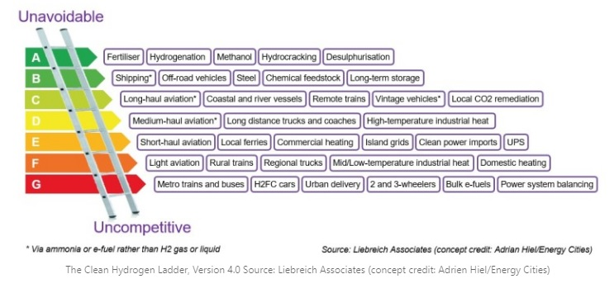Hydrogen Network. Although some of the existing gas network may be usable for hydrogen, considerable additional investment will be needed to ensure that the transmission and distribution to millions of homes can support this. See [5] page 80 for the costs of this. The costs will be much more limited if the distribution of hydrogen is just to selected industries and transport hubs.

Hydrogen as a Greenhouse Gas. Concerns have been raised about leaking hydrogen (fugitive hydrogen) acting as a greenhouse gas (see [6]). Although initial calculations have shown that this is not likely to be too significant in a Green Party scenario (see EPM at [3]), it is a precautionary argument that, until this impact is better understood, we avoid having a large domestic distribution network.

Dangers. An industry expert, (Hannah Bronwin of SSE), in a recent workshop, expressed the view that any hydrogen explosion could set back the cause of hydrogen by years, and thus impacting climate mitigation. Removing the domestic network will lower the risk of such a high profile explosion.

Costs

Extensive costings of the proposed hydrogen infrastructure are included in the Energy Policy Model (available at [3]). This includes use of surplus electricity generation, electrolysers, storage, distribution and end appliances (eg in a hydrogen boiler or in an industrial process). No direct comparison has been made of an option with and without hydrogen in homes. However it is clear that a solution that supplied all the requirements for hydrogen in the ladder above, from A to F, would be a very expensive solution. It will be much cheaper to use electricity generated directly to heat homes using a heat pump, than build out a system with enough spare electricity to produce enough hydrogen, with all the conversion losses involved, for all these uses.

In the trade -offs involved in the Energy Policy Model, only ~2 TWh (~3% of all hydrogen in a decade) of hydrogen has been allocated for homes heating about 1% of homes. Thus changing this to zero will have only a small impact on investment,.

Counter-arguments

The support for use of hydrogen in homes is usually coupled with continuing to use fossil fuels, with or without carbon capture, and potentially much larger quantities of hydrogen being available. This blue hydrogen use is against party policy.

The use of hydrogen ready gas boilers will have less impact on householders who can use gradually increasing hydrogen blends without any need for extra investment behaviour change. But while individuals and communities hold out the hope that their home or area will have a truly emissions-free hydrogen supply the roll out of heat pumps may be delayed.

Particularly for homes that are hard to treat for insulation, or are in conservation areas where external appearance to homes is to be avoided, hydrogen boilers could be attractive to householders. Heat pumps may be hard to deploy without visual impacts or be less effective in some homes.

Campaigns

We will want to be clear about this in the next General Election manifesto. We have been explicitly requested to make this policy change by Caroline Lucas’s office to align with her work and campaigning.

Policy Process

It is expected that this motion will be submitted to the Autumn 2023 conference, proposed by the Climate Emergency Policy Working Group (CEPWG) and supported by the Energy Policy Working Group (EPWG). It is also expected to be endorsed by these PWGs for accreditation. The two PWGs have worked closely on proposing this motion.

This makes energy policy more succinct.

This briefing paper contains relevant background material, costings, research, consideration of counter arguments, relevance to campaigns. It is posted on the members’ website at [2].

If this motion is passed, other documentation, such as the Energy Policy Background Paper and Energy Policy Model, available on the EPWG Green Space will be updated. This briefing paper will not be maintained.

An extensive consultation within and outwith the Green Party will take place.

References

[1] Green Hydrogen motion <https://spaces.greenparty.org.uk/s/climate-change-policy/cfiles/browse/index?fid=745>

[2] H2 Motion and Briefing Paper

[3] EPWG Green Space <https://spaces.greenparty.org.uk/s/energy-policy-working-group/>

[4] Carbon Budget Delivery Plan <https://assets.publishing.service.gov.uk/government/uploads/system/uploads/attachment_data/file/1147369/carbon-budget-delivery-plan.pdf>

[5] Hydrogen Supply Chain Evidence <https://assets.publishing.service.gov.uk/government/uploads/system/uploads/attachment_data/file/760479/H2_supply_chain_evidence_-_publication_version.pdf>

[6] Fugitive Hydrogen Emissions in a Future Hydrogen Economy <https://assets.publishing.service.gov.uk/government/uploads/system/uploads/attachment_data/file/1067137/fugitive-hydrogen-emissions-future-hydrogen-economy.pdf>

Tony Firkins  
27 June 2023